

**Part 1:** **TITLE, AUTHORS, APPROVALS, etc**

|  |  |  |
| --- | --- | --- |
| **Code assigned:** | ***2023.025B*** |  |
| **Short title:** To create two new genera - *Aziravirus* and *Santhidvirus* - of Gordonia siphophages [*Caudoviricetes*] | | |
|  | | |

**Author(s) and email address(es)**

|  |  |
| --- | --- |
|  |  |
| Kurtböke I, Turner D, Moraru C, Tolstoy I, Kropinski AM | IKurtbok@usc.edu.au; Dann2.Turner@uwe.ac.uk; liliana.cristina.moraru@uol.de; tolstoy@ncbi.nlm.nih.gov; Phage.Canada@gmail.com |

**Author(s) institutional address(es) (optional)**

|  |
| --- |
| University of the Sunshine Coast, Queensland, Australia [IK]  University of the West of England, Bristol, UK [DT]  Carl von Ossietzky Universität Oldenburg, Germany [CM]  National Center for Biotechnology Information, MD, USA [IT]  University of Guelph, Ontario, Canada [AMK] |

**Corresponding author**

|  |
| --- |
| Andrew M. Kropinski |

**List the ICTV Study Group(s) that have seen this proposal**

|  |
| --- |
| Actinophage Study Group |

**ICTV Study Group comments and response of proposer**

|  |
| --- |
|  |

**ICTV Study Group votes on proposal**

|  |  |  |  |
| --- | --- | --- | --- |
| **Study Group** | **Number of members** | | |
| **Votes support** | **Votes against** | **No vote** |
|  |  |  |  |
|  |  |  |  |

**Authority to use the name of a living person**

|  |  |
| --- | --- |
| **Is any taxon name used here derived from that of a living person (Y/N)** | N |

|  |  |  |
| --- | --- | --- |
| **Taxon name** | **Person from whom the name is derived** | **Permission attached (Y/N)** |
|  |  |  |
|  |  |  |
|  |  |  |

**Submission dates**

|  |  |
| --- | --- |
| Date first submitted to SC Chair | May 2023 |
| Date of this revision (if different to above) |  |

**ICTV-EC comments and response of the proposer**

|  |
| --- |
|  |

**Part 2:** **NON-TAXONOMIC PROPOSAL**

**Text of proposal**

|  |
| --- |
|  |

**Part 3:** **TAXONOMIC PROPOSAL**

**Name of accompanying Excel module**

|  |
| --- |
| 2023.025B.N.v1.Caudoviricetes_Gordonia_2ng.xlsx |

**Abstract**

|  |
| --- |
| We have created two new genera representing The Actinobacteriophage Database clusters CT and DY. Both of these represent siphoviruses, one lytic (*Aziravirus*) and the other temperate (*Santhidvirus*). |

**Text of proposal**

|  |  |
| --- | --- |
| |  | | --- | | **Species demarcation criteria:** Two phages are assigned to the same species if their genomes are more than 95% identical over their genome length for isolates.  These values can be calculated by a number of tools, such as BLASTn [1,2] – usually calculated using intergenomic distance calculator VIRIDIC [3].  **Genus demarcation criteria:** In search for criteria that create cohesive and distinct genera that are reproducible and monophyletic, the Bacterial Viruses Subcommittee has established 70% nucleotide identity of the genome length as the cut-off for genera. Genus-level groupings should always be monophyletic in the signature genes, as tested with a phylogenetic tree [10]. | |

**Supporting evidence**

**Proposal Data:**

1. **Create a new genus, *Aziravirus*, containing two species**
2. **Create a new genus, *Santhivirus*, containing four species**



**Figure 1. VIRIDIC heat map:** VIRIDIC (Virus Intergenomic Distance Calculator; VIRIDIC (Virus Intergenomic Distance Calculator; [3]; http://rhea.icbm.uni-oldenburg.de/VIRIDIC/) computes pairwise intergenomic distances/similarities amongst phage genomes. Data values which are bordered in black correspond to strains. Abbreviations: phg = phage; Gord = Gordonia.







**Figure 2. ViPTree analysis:** ViPTree analysis (https://www.genome.jp/viptree/; [4]) is based upon Rohwer and Edwards (2002) famous Phage Proteomic Tree [5]. The phages of interest are indicated with **red lines and stars**.

**Taxonomic Proposals:**

1. **Create a new genus, *Aziravirus*, containing two species**

**Origin of the name of this taxon:** The name of this taxon derives directly from the name of one of the first virus of its type Gordonia phage Azira

**Historical aspects:** This lytic siphophage was isolated from a Tampa, FL (USA) soil against Gordonia rubripertincta NRRL B-16540 by Coen McGarrah (University of South Florida, USA) as part of the Science Education Alliance-Phage Hunters Advancing Genomics and Evolutionary Science program. The genome has 10 nt 3’-cohesive termini (CGGTAGGCAT). The Actinobacteriophage Database considers this phage to be part of Cluster CT.

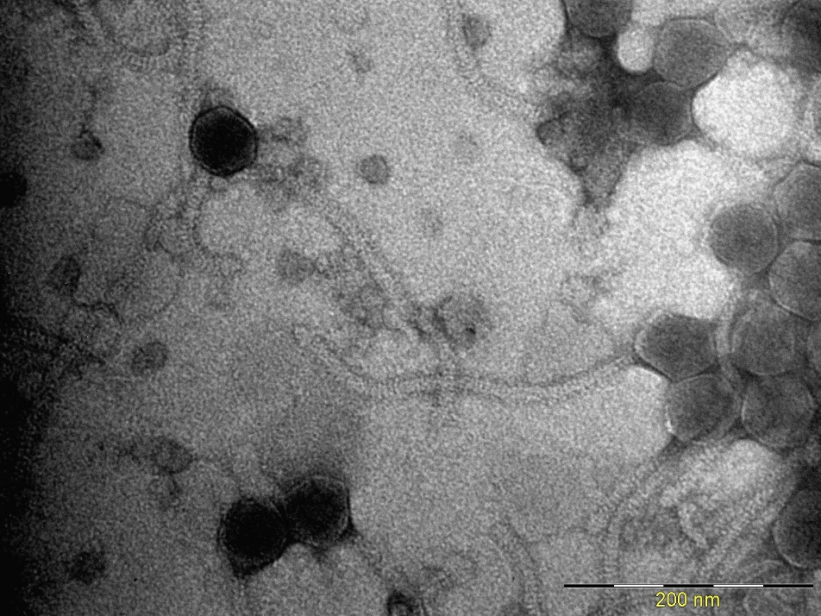

**Electron micrograph:** Electron micrographs of negatively stained Gordonia phage Azira (<https://phagesdb.org/phages/Azira/>). Limited permission was granted by The Actinobacteriophages Database (<https://phagesdb.org/>), funded by the Howard Hughes Medical Institute, to use this electron micrograph for this taxonomy proposal; it cannot be reused without permission of The Actinobacteriophages Database.

**Genome summary:**

|  |  |  |  |  |  |  |
| --- | --- | --- | --- | --- | --- | --- |
| Phage name | INSDC | Size (Kb) | GC% | Protein | Overall % DNA sequence identity (*) | Overall % homologous proteins (**) |
| Gordonia phage Azira | [OQ709211.1](https://www.ncbi.nlm.nih.gov/nuccore/OQ709211.1) | 45.34 | 61.9 | [67](https://www.ncbi.nlm.nih.gov/genome/browse/#!/proteins/127515/2174191|Gordonia phage Azira/viral segment/) | 100 | 100 |
| Gordonia phage Gibbous | [MN310549.1](https://www.ncbi.nlm.nih.gov/nuccore/MN310549.1) | 45.81 | 60.5 | [68](https://www.ncbi.nlm.nih.gov/genome/browse/#!/proteins/84864/708421|Gordonia phage Gibbous/viral segment/) | 76.1 | 88.1 |

**(*) determined using VIRIDIC [3]**

**(**) determined using CoreGenes 3.5 [6]**

**Conclusion:** On the basis of DNA (Fig. 1) and protein (Fig. 2) similarity this is a cohesive genus.

1. **Create a new genus, *Santhidvirus*, containing four species**

**Origin of the name of this taxon:** The name of this taxon derives directly from the name of one of the first virus of its type Gordonia phage Santhid

**Historical aspects:** This temperate siphophage was isolated from Orange City, IA (USA) soil against Gordonia terrae 3612 by Krista Riensche, Ashley VanEgdom, Gideon Fynaardt (Northwestern College, USA) as part of the Science Education Alliance-Phage Hunters Advancing Genomics and Evolutionary Science program. The genome has 10 nt 3’-cohesive termini (TCCGGAGGTA). The Actinobacteriophage Database considers this phage to be part of Cluster DY.

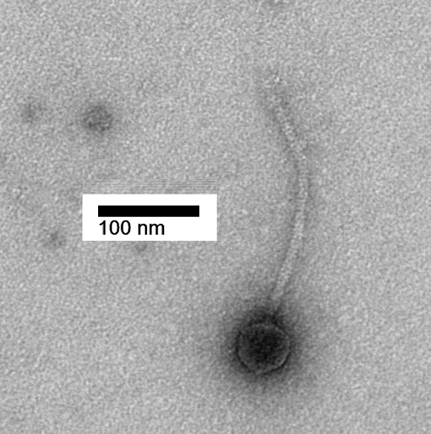

**Electron micrograph:** None available for Santhid**.** Electron micrographs of negatively stained Gordonia phage Reyja (<https://phagesdb.org/phages/Reyja/>). Limited permission was granted by The Actinobacteriophages Database (<https://phagesdb.org/>), funded by the Howard Hughes Medical Institute, to use this electron micrograph for this taxonomy proposal; it cannot be reused without permission of The Actinobacteriophages Database.

**Genome summary:**

|  |  |  |  |  |  |  |
| --- | --- | --- | --- | --- | --- | --- |
| Phage name | INSDC | Size (Kb) | GC% | Protein | Overall % DNA sequence identity (*) | Overall % homologous proteins (**) |
| Gordonia phage Santhid | [OM818327.1](https://www.ncbi.nlm.nih.gov/nuccore/OM818327.1) | 39.29 | 67.7 | [60](https://www.ncbi.nlm.nih.gov/genome/browse/#!/proteins/112723/1828253|Gordonia phage Santhid/viral segment/) | 100.0 | 100 |
| Gordonia phage Tarzan | [OQ709200.1](https://www.ncbi.nlm.nih.gov/nuccore/OQ709200.1) | 40.55 | 67.3 | [64](https://www.ncbi.nlm.nih.gov/genome/browse/#!/proteins/127531/2174207|Gordonia phage Tarzan/viral segment/) | 76.8 | 88.3 |
| Gordonia phage Reyja | [MK814759.1](https://www.ncbi.nlm.nih.gov/nuccore/MK814759.1) | 41.5 | 67.4 | [65](https://www.ncbi.nlm.nih.gov/genome/browse/#!/proteins/79550/511579|Gordonia phage Reyja/viral segment/) | 80.5 | 90.0 |
| Gordonia phage Jojo24 | [MZ209302.1](https://www.ncbi.nlm.nih.gov/nuccore/MZ209302.1) | 40.58 | 67.5 | [63](https://www.ncbi.nlm.nih.gov/genome/browse/#!/proteins/107061/1720780|Gordonia phage Jojo24/viral segment/) | 85.4 | 90.0 |

**(*) determined using VIRIDIC [3]**

**(**) determined using CoreGenes 3.5 [6]**

**Conclusion:** On the basis of DNA (Fig. 1) and protein (Fig. 2) similarity this is a cohesive genus.

1. **Create a new subfamily, *Ebclasvirinae*, for these three genera**

**Origin of the name of this taxon:** This taxon is named after The Actinobacteriophage Database Cluster EB to which all these phages belong.

**Rationale:** This new subfamily consists of three genera, *Armstrongvirus, Dismasvirus* and *Arroyovirus*, which possess ca. 40 kb genomes 68 mol%G+C) genomes which share at least 48.2% DNA sequence similarity and 45 protein homologs (65.2%). These values are consistent with the establishment of a subfamily [10].

**References**

1. Sayers EW, Beck J, Bolton EE, Bourexis D, Brister JR, Canese K, Comeau DC, Funk K, Kim S, Klimke W, Marchler-Bauer A, Landrum M, Lathrop S, Lu Z, Madden TL, O'Leary N, Phan L, Rangwala SH, Schneider VA, Skripchenko Y, Wang J, Ye J, Trawick BW, Pruitt KD, Sherry ST. Database resources of the National Center for Biotechnology Information. Nucleic Acids Res. 2021 Jan 8;49(D1):D10-D17. doi: 10.1093/nar/gkaa892. PMID: 33095870

2. O'Leary NA, Wright MW, Brister JR, Ciufo S, Haddad D, McVeigh R, et al. Reference sequence (RefSeq) database at NCBI: current status, taxonomic expansion, and functional annotation. Nucleic Acids Res. 2016;44(D1):D733-45. doi: 10.1093/nar/gkv1189. PMID: 26553804.

3. Moraru C, Varsani A, Kropinski AM. VIRIDIC-A Novel Tool to Calculate the Intergenomic Similarities of Prokaryote-Infecting Viruses. Viruses. 2020 Nov 6;12(11):1268. doi: 10.3390/v12111268. PMID: 33172115; PMCID: PMC7694805. http://kronos.icbm.uni-oldenburg.de/viridic/

4. Nishimura Y, Yoshida T, Kuronishi M, Uehara H, Ogata H, Goto S. ViPTree: the viral proteomic tree server. Bioinformatics. 2017; 33(15):2379-2380. doi:10.1093/bioinformatics/btx157. PubMed PMID: 28379287. https://www.genome.jp/viptree/

5. Rohwer F, Edwards R. The Phage Proteomic Tree: a genome-based taxonomy for phage. J Bacteriol. 2002 Aug;184(16):4529-35. PubMed PMID: 12142423

6. Turner D, Reynolds D, Seto D, Mahadevan P. CoreGenes3.5: a webserver for the determination of core genes from sets of viral and small bacterial genomes. BMC Res Notes. 2013;6:140. doi: 10.1186/1756-0500-6-140. PMID: 23566564.

7. Davis P, Seto D, Mahadevan P. CoreGenes5.0: An Updated User-Friendly Webserver for the Determination of Core Genes from Sets of Viral and Bacterial Genomes. Viruses. 2022 Nov 16;14(11):2534. doi: 10.3390/v14112534. PMID: 36423143; PMCID: PMC9693508.

8. Dereeper A, Guignon V, Blanc G, Audic S, Buffet S, Chevenet F, Dufayard JF, Guindon S, Lefort V, Lescot M, Claverie JM, Gascuel O. Phylogeny.fr: robust phylogenetic analysis for the non-specialist. Nucleic Acids Res. 2008;36(Web Server issue):W465-9. doi: 10.1093/nar/gkn180. Epub 2008 Apr 19. PMID: 18424797.

9. Anisimova M, Gascuel O. Approximate likelihood-ratio test for branches: A fast, accurate, and powerful alternative. Syst Biol. 2006;55(4):539-52. PMID: 16785212. DOI: 10.1080/10635150600755453.

10. Turner D, Kropinski AM, Adriaenssens EM. A Roadmap for Genome-Based Phage Taxonomy. Viruses. 2021 Mar 18;13(3):506. doi: 10.3390/v13030506. PMID: 33803862; PMCID: PMC8003253.