

**Part 1:** **TITLE, AUTHORS, APPROVALS, etc**

|  |  |  |
| --- | --- | --- |
| **Code assigned:** | ***2023.013B*** |  |
| **Short title:** create one genus, *Bunatrivirus*, containing one species, *Bunatrivirus* B13, in the class *Caudoviricetes* | | |
|  | | |

**Author(s) and email address(es)**

|  |  |
| --- | --- |
| Kazantseva OA, Piligrimova EG, Shadrin AM | [olesyakazantseva@bk.ru](mailto:olesyakazantseva@bk.ru); [e.piligrimova@ibpm.ru](mailto:e.piligrimova@ibpm.ru); andrey2010s@gmail.com |

**Author(s) institutional address(es) (optional)**

|  |
| --- |
|  |

**Corresponding author**

|  |
| --- |
| Kazantseva OA |

**List the ICTV Study Group(s) that have seen this proposal**

|  |
| --- |
| *Caudoviricetes* Study Group |

**ICTV Study Group comments and response of proposer**

|  |
| --- |
|  |

**ICTV Study Group votes on proposal**

|  |  |  |  |
| --- | --- | --- | --- |
| **Study Group** | **Number of members** | | |
| **Votes support** | **Votes against** | **No vote** |
|  |  |  |  |
|  |  |  |  |

**Authority to use the name of a living person**

|  |  |
| --- | --- |
| **Is any taxon name used here derived from that of a living person (Y/N)** | N |

|  |  |  |
| --- | --- | --- |
| **Taxon name** | **Person from whom the name is derived** | **Permission attached (Y/N)** |
|  |  |  |
|  |  |  |
|  |  |  |

**Submission dates**

|  |  |
| --- | --- |
| Date first submitted to SC Chair | May 2023 |
| Date of this revision (if different to above) |  |

**ICTV-EC comments and response of the proposer**

|  |
| --- |
|  |

**Part 2:** **NON-TAXONOMIC PROPOSAL**

**Text of proposal**

|  |
| --- |
|  |

**Part 3:** **TAXONOMIC PROPOSAL**

**Name of accompanying Excel module**

|  |
| --- |
| 2023.013B.N.v1.Bunatrivirus_ng.xlsx |

**Abstract**

|  |
| --- |
| We propose a new genus, *Bunatrivirus*, containing one phage species, *Bunatrivirus* B13, a temperate *Bacillus*-infecting bacteriophage with a siphovirus morphotype. |

**Text of proposal**

|  |  |
| --- | --- |
| |  | | --- | | *Bacillus* phage В13 was isolated by mitomycin C induction from its host strain *B. cereus* VKM B-13. On the propagating host *B. cereus* VKM B-370, B13 formed turbid plaques with an approximate diameter of 1-1.5 mm. When propagated on VKM B-370 in LB broth, even at the highest multiplicity of infection (MOI =10), the phage did not ensure complete lysis of the culture. B13 encodes a site-specific integrase, the presence of which, along with the phage’s plaque morphotype and growth dynamics, indicates a temperate lifestyle.  The B13 genome is 36,864 bp long, with 53 predicted CDSs and the GC-content of 34.8%. The whole-genome arrangement is typical of temperate phages, with the majority of genes (90.6%) located on one strand and several lysogenic pathway genes located on the other strand. The tail genes of B13 are typical of phages with a siphovirus morphotype (long non-contractile flexible tail).  It was confirmed experimentally through a restriction analysis that the phage uses the 3′-*cos* DNA packaging mechanism [1].  We have chosen 95% DNA sequence identity as the criterion for species demarcation. The calculated BLASTN identity of the B13 genome to the known viruses is significantly less than 95% (calculated as % coverage multiplied by % identity), suggesting the virus represents a new phage species.  We have chosen the previously established cut-off of 70% nucleotide identity of the full genome length as the genus demarcation threshold [2]. As of August 2022, the closest relative, *Bacillus* phage phi4J1, is only 31% identical to B13 at the nucleotide level (total BLASTN identity, calculated as % coverage multiplied by % identity), meaning that B13 cannot be assigned to any of the existing phage genera.  We therefore propose the creation of a new phage genus, *Bunatrivirus*, containing one phage species, *Bunatrivirus* B13. | |

**Supporting evidence**

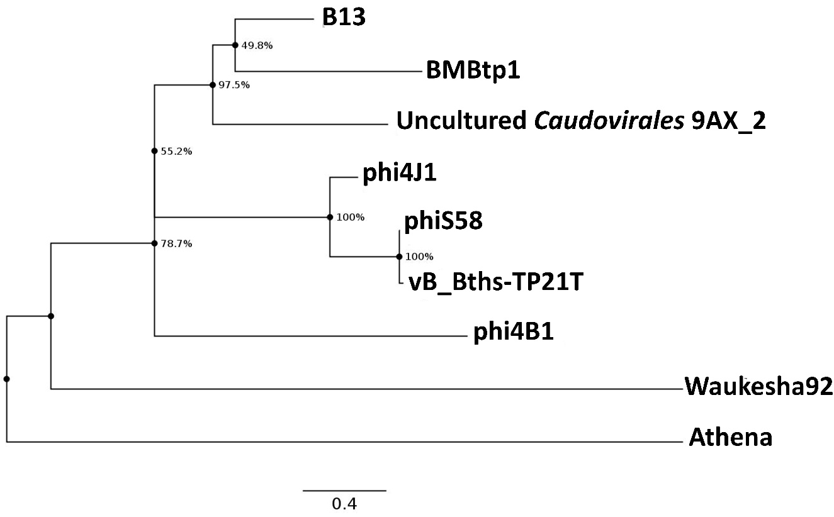

Figure 1 - The Maximum Likelihood phylogram inferred from a ClustalW alignment of the concatenated sequences of all the proteins encoded by B13 and the closest viruses. Node numbers represent bootstrap support values (out of 1000 replicates). Scale bar represents the number of amino-acid substitutions per site.

**References**

1) Kazantseva OA, Piligrimova EG, Shadrin AM (2022) Novel *Bacillus*-Infecting Bacteriophage B13—The Founding Member of the Proposed New Genus *Bunatrivirus*. Viruses 14, 2300.

https://doi.org/10.3390/v14102300

2) Turner D, Kropinski AM, Adriaenssens EM (2021) A roadmap for genome-based phage taxonomy. Viruses 13.3: 506.

<https://doi.org/10.3390/v13030506>