

**Part 1:** **TITLE, AUTHORS, APPROVALS, etc**

|  |  |  |
| --- | --- | --- |
| **Code assigned:** | ***2023.012B*** |  |
| **Short title:** **To create seventeen (17) new species in the genus *Schiekvirus* andeleven (11) new species in the genus *Kochikohdavirus* (Subfamily: *Brockvirinae*, Family: *Herelleviridae*)** | | |
|  | | |

**Author(s) and email address(es)**

|  |  |
| --- | --- |
| Wittmann J, Adriaenssens EM, Turner D, Moraru C | [Johannes.Wittmann@dsmz.de](mailto:Johannes.Wittmann@dsmz.de); [Evelien.adriaenssens@quadram.ac.uk](mailto:Evelien.adriaenssens@quadram.ac.uk); [Dann2.Turner@uwe.ac.uk](mailto:Dann2.Turner@uwe.ac.uk); [liliana.cristina.moraru@uol.de](mailto:liliana.cristina.moraru@uol.de) |

**Author(s) institutional address(es) (optional)**

|  |
| --- |
| Leibniz Institute DSMZ – German Collection of Microorganisms and Cell Cultures GmbH, Braunschweig, Germany [JW]  Quadram Institute Bioscience, Norwich Research Park, Norwich, UK [EMA]  Department of Applied Sciences, University of the West of England, Bristol, UK [DM]  Carl von Ossietzky Universität Oldenburg, Germany [CM] |

**Corresponding author**

|  |
| --- |
| J Wittmann |

**List the ICTV Study Group(s) that have seen this proposal**

|  |
| --- |
| *Schitoviridae* Study Group, Bacterial and Archaeal Viruses Subcommittee  *Herelleviridae* Study Group, Bacterial and Archaeal Viruses Subcommittee |

**ICTV Study Group comments and response of proposer**

|  |
| --- |
|  |

**ICTV Study Group votes on proposal**

|  |  |  |  |
| --- | --- | --- | --- |
| **Study Group** | **Number of members** | | |
| **Votes support** | **Votes against** | **No vote** |
|  |  |  |  |
|  |  |  |  |

**Authority to use the name of a living person**

|  |  |
| --- | --- |
| **Is any taxon name used here derived from that of a living person (Y/N)** | N |

|  |  |  |
| --- | --- | --- |
| **Taxon name** | **Person from whom the name is derived** | **Permission attached (Y/N)** |
|  |  |  |
|  |  |  |
|  |  |  |

**Submission dates**

|  |  |
| --- | --- |
| Date first submitted to SC Chair | May 2023 |
| Date of this revision (if different to above) |  |

**ICTV-EC comments and response of the proposer**

|  |
| --- |
|  |

**Part 2:** **NON-TAXONOMIC PROPOSAL**

**Text of proposal**

|  |
| --- |
|  |

**Part 3:** **TAXONOMIC PROPOSAL**

**Name of accompanying Excel module**

|  |
| --- |
| 2023.012B.N.v1.Brockvirinae_28ns.xlsx |

**Abstract**

|  |
| --- |
| Here, we propose the creation of seventeen (17) new species in the genus *Schiekvirus* and the creation of eleven (11) new species in the genus *Kochikohdavirus* based on genome-based comparisons. |

**Text of proposal**

|  |  |  |  |  |  |  |  |  |  |  |  |  |  |  |  |  |  |  |  |  |  |  |  |  |  |  |  |  |  |  |  |  |  |  |  |  |  |  |  |  |  |  |  |  |  |  |  |  |  |  |  |  |  |  |  |  |  |  |  |  |  |  |  |  |  |  |  |  |  |  |  |  |  |  |  |  |  |  |  |  |  |  |  |  |  |
| --- | --- | --- | --- | --- | --- | --- | --- | --- | --- | --- | --- | --- | --- | --- | --- | --- | --- | --- | --- | --- | --- | --- | --- | --- | --- | --- | --- | --- | --- | --- | --- | --- | --- | --- | --- | --- | --- | --- | --- | --- | --- | --- | --- | --- | --- | --- | --- | --- | --- | --- | --- | --- | --- | --- | --- | --- | --- | --- | --- | --- | --- | --- | --- | --- | --- | --- | --- | --- | --- | --- | --- | --- | --- | --- | --- | --- | --- | --- | --- | --- | --- | --- | --- | --- | --- |
| |  |  |  |  |  |  |  |  |  |  |  |  |  |  |  |  |  |  |  |  |  |  |  |  |  |  |  |  |  |  |  |  |  |  |  |  |  |  |  |  |  |  |  |  |  |  |  |  |  |  |  |  |  |  |  |  |  |  |  |  |  |  |  |  |  |  |  |  |  |  |  |  |  |  |  |  |  |  |  |  |  |  |  |  |  | | --- | --- | --- | --- | --- | --- | --- | --- | --- | --- | --- | --- | --- | --- | --- | --- | --- | --- | --- | --- | --- | --- | --- | --- | --- | --- | --- | --- | --- | --- | --- | --- | --- | --- | --- | --- | --- | --- | --- | --- | --- | --- | --- | --- | --- | --- | --- | --- | --- | --- | --- | --- | --- | --- | --- | --- | --- | --- | --- | --- | --- | --- | --- | --- | --- | --- | --- | --- | --- | --- | --- | --- | --- | --- | --- | --- | --- | --- | --- | --- | --- | --- | --- | --- | --- | | Here, we propose the creation of seventeen (17) new species in the genus *Schiekvirus* and the creation of eleven (11) new species in the genus *Kochikohdavirus* based on genome-based comparisons.  Several new candidates for the genus Schiekvirus were recently published [1-3].  Candidates for the genus *Kochikohdavirus* were recently published [4-6].  **Origin of the name of proposed taxa:** The names of all proposed species were derived from (simplified) names of exemplar isolates.  **Species demarcation criteria:** We have chosen 95% DNA sequence identity as the criterion for demarcation of species in this new genus. Each of the proposed species differs from the others with more than 5% at the DNA level as confirmed with VIRIDIC [7, 8].  The new species are:   |  |  |  | | --- | --- | --- | | *Schiekvirus Efsszw1* | MH791397.1 | Enterococcus phage EfsSzw-1 | | *Schiekvirus Shef13* | OL799258.1 | Enterococcus phage phiSHEF13 | | *Schiekvirus Tje1* | ON506927.1 | Enterococcus phage TJE1 | | *Schiekvirus bill* | OM966901.1 | Enterococcus phage vB_OCPT_Bill | | *Schiekvirus Gvesp1* | MZ333462.1 | Enterococcus phage GVEsP-1 | | *Schiekvirus Pef771* | MN241318.1 | Enterococcus phage PEf771 | | *Schiekvirus Efgrng* | MW004545.1 | Enterococcus phage EFGrNG | | *Schiekvirus A2* | MT856905.1 | Enterococcus phage vB_EfaM_A2 | | *Schiekvirus Tje2* | ON506928.1 | Enterococcus phage TJE2 | | *Schiekvirus bop* | ON125307.1 | Enterococcus phage vB_OCPT_Bop | | *Schiekvirus ben* | MN027503.1 | Enterococcus phage vB_OCPT_Ben | | *Schiekvirus 163* | CAJDKA010000002.1 | Enterococcus phage 163 | | *Schiekvirus Ccs1* | ON113170.1 | Enterococcus phage vB_OCPT_CCS1 | | *Schiekvirus Porthos* | LR990835.1 | Enterococcus phage Porthos | | *Schiekvirus Shef16* | OL799260.1 | Enterococcus phage phiSHEF16 | | *Schiekvirus if6* | MT909815.1 | Enterococcus phage iF6 | | *Schiekvirus sv113* | MZ147816.1 | Enterococcus phage 113 | | *Kochikohdavirus kv149* | CAJDJZ010000002.1 | Enterococcus phage vB_EfaH_149 | | *Kochikohdavirus Ef23* | MK721192.1 | Enterococcus phage vB_EfaM_Ef2.3 | | *Kochikohdavirus Sw5* | ON286976.1 | Enterococcus phage Sw5 | | *Kochikohdavirus Ef17h* | AP018714.1 | Enterococcus phage phiEF17H | | *Kochikohdavirus Ef19g* | LC596379.1 | Enterococcus phage EF19G | | *Kochikohdavirus PBEF19* | MN854830.2 | Enterococcus phage PBEF19 | | *Kochikohdavirus car* | ON113168.1 | Enterococcus phage vB_OCPT_Car | | *Kochikohdavirus mda2* | MW633168.1 | Enterococcus phage MDA2 | | *Kochikohdavirus kv53* | OQ420427.1 | Enterococcus phage 53 | | *Kochikohdavirus bob* | ON113169.1 | Enterococcus phage vB_OCPT_Bob | | *Kochikohdavirus EF24CP2* | AB609718.1 | Enterococcus phage phiEF24C-P2 | | |

**Supporting evidence**

**Electron micrograph:** None available



VIRIDIC heat map: VIRIDIC (Virus Intergenomic Distance Calculator; http://rhea.icbm.uni-oldenburg.de/VIRIDIC/) computes pairwise intergenomic distances/similarities amongst phage genomes [7, 8].

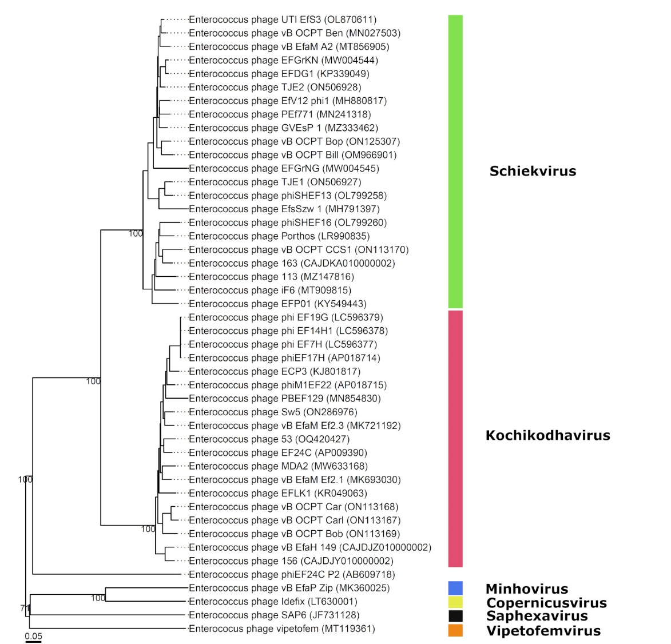

The entire analysis was carried out by the VICTOR web service (<https://victor.dsmz.de>), a method for the genome-based phylogeny and classification of prokaryotic viruses [9]. All pairwise comparisons of the amino acid sequences were conducted using the Genome-BLAST Distance Phylogeny (GBDP) method [10] under settings recommended for prokaryotic viruses (Meier-Kolthoff and Göker, 2017).

The resulting intergenomic distances were used to infer a balanced minimum evolution tree with branch support via FASTME including SPR postprocessing [11] for D6. Branch support was inferred from 100 pseudo-bootstrap replicates each. Trees were rooted at the midpoint [12] and visualized with ggtree [13].

**References**

1. Alkalay-Oren S., Gold N., Khalifa L., Yerushalmy O., Coppenhagen-Glazer S., Nir-Paz R., Hazan R. Complete Genome Sequences of Two Enterococcus faecalis Bacteriophages, EFGrKN and EFGrNG, Targeted to Phage Therapy. Microbiol Resour Announc. 2021 Apr 22;10(16):e00126-21. doi: 10.1128/MRA.00126-21. PMID: 33888497; PMCID: PMC8063640.
2. Tkachev P.V., Pchelin I.M., Azarov D.V., Gorshkov A.N., Shamova O.V., Dmitriev A.V., Goncharov A.E.. Two Novel Lytic Bacteriophages Infecting *Enterococcus* spp. Are Promising Candidates for Targeted Antibacterial Therapy. Viruses. 2022 Apr 16;14(4):831. doi: 10.3390/v14040831. PMID: 35458561; PMCID: PMC9030284.
3. Núñez-Sánchez M.A., Colom J., Walsh L., Buttimer C., Bolocan A.S., Pang R., Gahan C.G.M, Hill C. Characterizing Phage-Host Interactions in a Simplified Human Intestinal Barrier Model. Microorganisms. 2020 Sep 7;8(9):1374. doi: 10.3390/microorganisms8091374.
4. Del Rio B, Sánchez-Llana E, Martínez N, Fernández M, Ladero V, Alvarez MA. Isolation and Characterization of *Enterococcus faecalis-*Infecting Bacteriophages From Different Cheese Types. Front Microbiol. 2021 Jan 8;11:592172. doi: 10.3389/fmicb.2020.592172.
5. Del Rio B, Sánchez-Llana E, Redruello B, Magadan AH, Fernández M, Martin MC, Ladero V, Alvarez MA. *Enterococcus faecalis* Bacteriophage 156 Is an Effective Biotechnological Tool for Reducing the Presence of Tyramine and Putrescine in an Experimental Cheese Model. Front Microbiol. 2019 Mar 20;10:566. doi: 10.3389/fmicb.2019.00566.
6. Uchiyama J, Matsui H, Murakami H, Kato SI, Watanabe N, Nasukawa T, Mizukami K, Ogata M, Sakaguchi M, Matsuzaki S, Hanaki H. Potential Application of Bacteriophages in Enrichment Culture for Improved Prenatal *Streptococcus agalactiae* Screening. Viruses. 2018 Oct 10;10(10):552. doi: 10.3390/v10100552.
7. Moraru C. VIRIDIC (Virus Intergenomic Distance Calculator) computes pairwise intergenomic distances/similarities amongst phage genomes. <http://rhea.icbm.uni-oldenburg.de/VIRIDIC/>
8. Moraru C, Varsani A, Kropinski AM. VIRIDIC-A Novel Tool to Calculate the Intergenomic Similarities of Prokaryote-Infecting Viruses. Viruses. 2020 Nov 6;12(11):1268. doi: 10.3390/v12111268
9. Meier-Kolthoff JP, Göker M. VICTOR: Genome-based Phylogeny and Classification of Prokaryotic Viruses. Bioinformatics 2017, 33:3396-3404.
10. Meier-Kolthoff JP, Auch AF, Klenk H-P, Göker M: Genome sequence-based species delimitation with confidence intervals and improved distance functions. BMC Bioinformatics 2013, 14:60.
11. Lefort V, Desper R, Gascuel O: FastME 2.0: A comprehensive, accurate, and fast distance-based phylogeny inference program. Mol Biol Evol 2015, 32:2798-2800.
12. Farris JS: Estimating phylogenetic trees from distance matrices. Am Nat 1972, 106:645-667.
13. Yu G. Using ggtree to visualize data on tree-like structures. Curr Protoc Bioinforma 2020, 69:1–18.