This Word module should be used for all taxonomic proposals.

Please complete **Part 1** and:

either **Part 3** for proposals to create new taxa or change existing taxa

or **Part 2** for proposals of a general nature.

Submit the completed Word module, together with the accompanying Excel module named in Part 3, to the appropriate ICTV Subcommittee Chair.

For guidance, see the notes written in blue, below, and the help notes in file Taxonomic_Proposals_Help_2018.

**Part 1:** **TITLE, AUTHORS, etc**

|  |  |  |  |
| --- | --- | --- | --- |
| **Code assigned:** | ***2018.135B*** | | (to be completed by ICTV officers) |
| **Short title:** (e.g. “6 new species in the genus *Zetavirus”*)  **To create one new species,** ***Shigella* virus  *ISF002*, within the *T1virus* genus (to be renamed *Tunavirus*), *Tunavirinae* subfamily, and family *Siphoviridae*** | | | |
|  | | | |
| **Author(s):** | | | |
| Khashayar Shahin, University of Isfahan, Iran; JiangsuAcademy of Agricultural Sciences, China Majid Bouzari, University of Isfahan, Iran  Ran Wang, JiangsuAcademy of Agricultural Sciences, China | | | |
| **Corresponding author with e-mail address:** | | | |
| Majid Bouzari, [**bouzari@sci.ui.ac.ir**](mailto:bouzari@sci.ui.ac.ir)  Ran Wang, [**ranwang@jaas.ac.cn**](mailto:ranwang@jaas.ac.cn) | | | |
| **List the ICTV study group(s) that have seen this proposal:** | | | |
| A list of study groups and contacts is provided at <http://www.ictvonline.org/subcommittees.asp> . If in doubt, contact the appropriate subcommittee chair (there are six virus subcommittees: animal DNA and retroviruses, animal ssRNA-, animal ssRNA+, fungal and protist, plant, bacterial and archaeal) | | **Bacterial and Archaeal Viruses Subcommittee** | |
| **ICTV Study Group comments (if any) and response of the proposer:** | | | |
|  | | | |
|  | | | |
| Date first submitted to ICTV: | | | June 2018 |
| Date of this revision (if different to above): | | |  |

|  |
| --- |
| **ICTV-EC comments and response of the proposer:** |
|  |

**Part 2:** **NON-STANDARD**

Template for any proposal regarding ICTV procedures, rules or policy, not involving the creation of new taxonomy.

| **Text of proposal:** |
| --- |
|  |

**Part 3:** **PROPOSED TAXONOMY**

|  |
| --- |
| **Name of accompanying Excel module: 2018.135B.N.v1.Tunavirus_sp** |

The taxonomic changes you are proposing should be presented on an accompanying Excel module, 2017_TP_Template_Excel_module. Please enter the file name of the completed module in this box.

**Supporting material:**

| additional material in support of this proposal |
| --- |
| Please explain the reasons for the taxonomic changes you are proposing and provide evidence to support them. The following information should be provided, where relevant:   * **Species demarcation criteria**: Explain how new species differ from others in the genus and demonstrate that these differences meet the criteria previously established for demarcating between species. If no criteriahave previously been established, and if there will now be more than one species in the genus, please state the demarcation criteria you are proposing. * **Higher taxa**:   + There is no formal requirement to state demarcation criteria when proposing new genera or other higher taxa. However, a similar concept should apply in pursuit of a rational and consistent virus taxonomy.   + Please indicate the **origin of names** assigned to new taxa at genus level and above.   + For each new genus a **type species** must be designated to represent it. Please explain your choice. * **Supporting evidence**: The use of Figures and Tables is strongly recommended (note that copying from publications will require permission from the copyright holder). For phylogenetic analysis, try to provide a tree where branch length is related to genetic distance. |

**History:** Lytic phage vB_SsoS-ISF002 “was isolated from an untreated sewage sample collected from the wastewater treatment plant of Isfahan, Iran using *Shigella sonnei* (isolated from raw wastewater) as the host bacterium. The phage has an icosahedral head (65±2.1 nm) which is connected directly to a tail structure (Fig. 1). The tail was 196 ± 14 nm in length and 11.3 ± 0.9 nm in width. It also capable to lyse another species, *Shigella flexneri* (1).

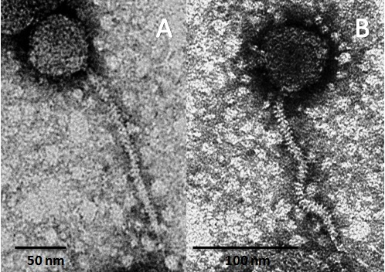

Fig. 1. Electron micrographs of vB_SsoSISF002 phage stained negatively with 2 % phosphotungstic acid (PTA) [2 % (wt/vol)].

**GenBank Summary:**

|  |  |  |  |  |  |
| --- | --- | --- | --- | --- | --- |
| Phage name | INSDC | Size (bp) | GC% | Total ORFs | Number of tRNA |
| vB_SsoS-ISF002 | MF093736 | 50564 | 45.53 | 76 | 0 |

**Genome analysis:**

The relatedness of the phage to phages taxa was confirmed using BLASTn and BLASTp (2); and, its map was drawn (Fig. 2). Finally the amino acid sequences of the tail fiber (ORF 20) (Fig 3-A) and large subunit of terminase (ORF 40) (Fig. 3-B) of phage vB_SsoS-ISF002 and other phages belonging to different genera of *Siphoviridae* were aligned in MEGA 7.0 using MUSCLE, and then a UPGMA (unweighted pair group method with arithmetic mean) phylogenetic tree was constructed with 2000 bootstrap replication (3).

We have chosen ≥95% DNA sequence identity as the criterion for demarcation of species in this genus (4). The proposed species differ from those of other species by more than 5% at the DNA level as confirmed with the BLASTN algorithm. According to Phylogenic tree (Fig. 3) and BLASTn analysis, vB_SsoS-ISF002 can be classified as a new species in the *T1virus* genus (this genus is currently proposed to be renamed *Tunavirus*; see proposal 2018.007B).

Therefore, we propose a new species, *Shigella* virus *ISF002*, within the *T1virus* genus, *Tunavirinae* subfamily, in *Siphoviridae* family.

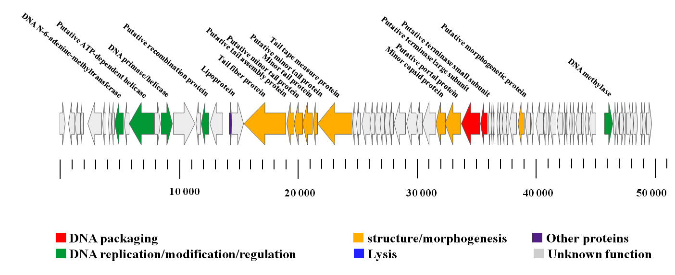

Fig. 2. Schematic representation of the linear dsDNA genome of the virulent phage vB_SsoS-ISF002

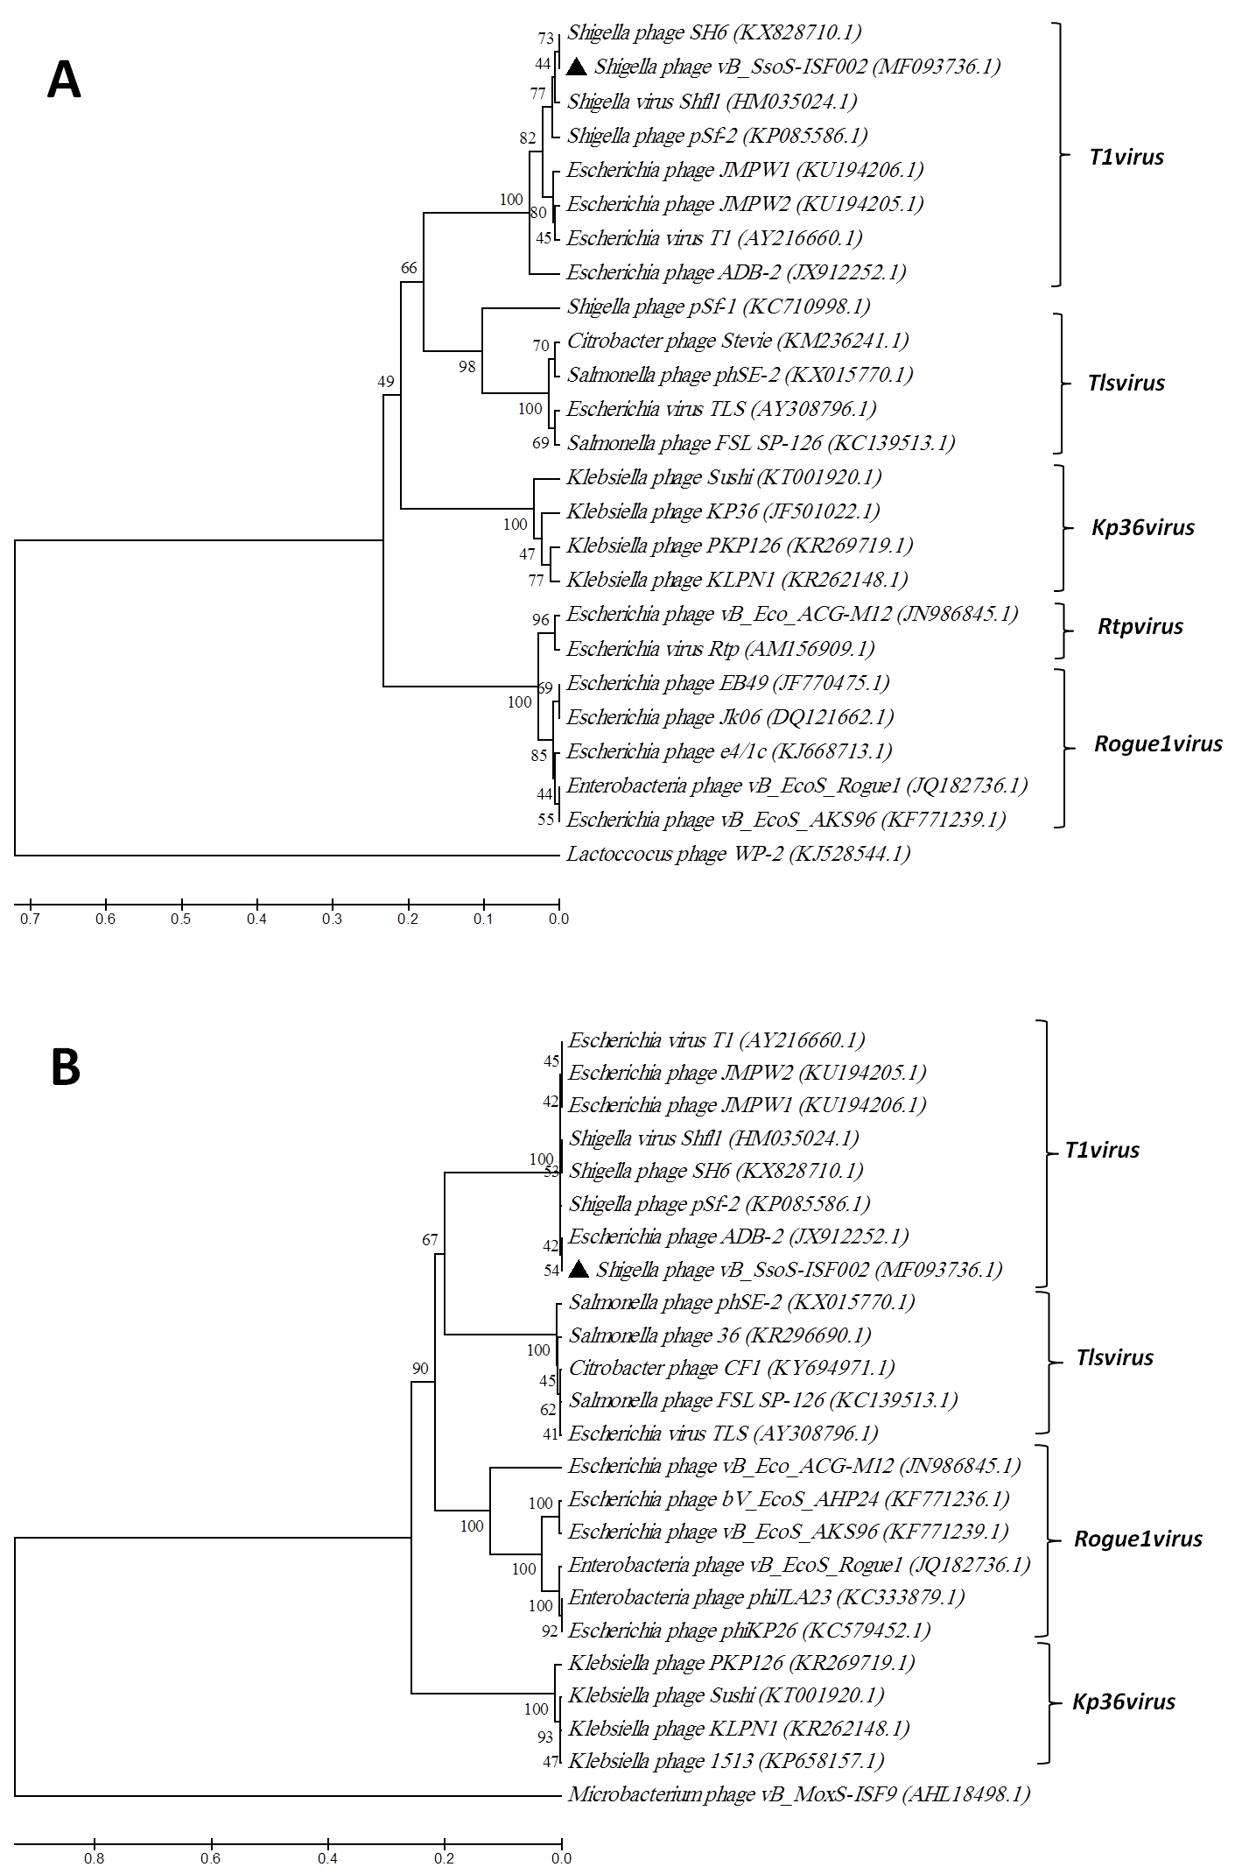

Fig. 3. Phylogenetic relationship of vB_SsoS-ISF002. Phylogenetic trees were constructed based on amino acid sequences of the tail fibre (a) and the large subunit of terminase (b) using the UPGMA method with 2000 bootstrap replications. The *Lactococcus garvieae* phage WP-2 tail fibre (a) and the *Microbacterium* phage vB_Mox-ISF9 large subunit of terminase (b) were used as out-groups. The GenBank accession numbers are also provided after phage names, in parentheses.

| **References:** |
| --- |
| 1. Shahin K, Bouzari M, Wang R. Isolation, characterization and genomic analysis of a novel lytic bacteriophage vB_SsoS-ISF002 infecting *Shigella sonnei* and *Shigella flexneri*. Journal of Medical Microbiology. 2018.  2. Altschul SF, Gish W, Miller W, Myers EW, Lipman DJ. Basic local alignment search tool. Journal of molecular biology. 1990;215(3):403-410.  3. Kumar S, Stecher G, Tamura K. MEGA7: Molecular Evolutionary Genetics Analysis version 7.0 for bigger datasets. Molecular biology and evolution. 2016;33(7):1870-1874.  4. Adriaenssens E, Brister JR. How to name and classify your phage: an informal guide. Viruses. 2017;9(4):70. |