This Word module should be used for all taxonomic proposals.

Please complete **Part 1** and:

either **Part 3** for proposals to create new taxa or change existing taxa

or **Part 2** for proposals of a general nature.

Submit the completed Word module, together with the accompanying Excel module named in Part 3, to the appropriate ICTV Subcommittee Chair.

For guidance, see the notes written in blue, below, and the help notes in file Taxonomic_Proposals_Help_2018.

**Part 1:** **TITLE, AUTHORS, etc**

|  |  |  |  |
| --- | --- | --- | --- |
| **Code assigned:** | ***2018.094B*** | | (to be completed by ICTV officers) |
| **Short title:** (e.g. “6 new species in the genus *Zetavirus”*)  **To create two (2) new species in the family *Inoviridae*** | | | |
|  | | | |
| **Author(s):** | | | |
| Petar Knezevic — University of Novi Sad (Serbia)  Evelien M. Adriaenssens — University of Liverpool (UK)  Andrew M. Kropinski — University of Guelph (Canada)  Rob Lavigne — KU Leuven (Belgium) | | | |
| **Corresponding author with e-mail address:** | | | |
| Petar Knezevic [petar.knezevic@dbe.uns.ac.rs](mailto:petar.knezevic@dbe.uns.ac.rs) | | | |
| **List the ICTV study group(s) that have seen this proposal:** | | | |
| A list of study groups and contacts is provided at <http://www.ictvonline.org/subcommittees.asp> . If in doubt, contact the appropriate subcommittee chair (there are six virus subcommittees: animal DNA and retroviruses, animal ssRNA-, animal ssRNA+, fungal and protist, plant, bacterial and archaeal) | |  | |
| **ICTV Study Group comments (if any) and response of the proposer:** | | | |
|  | | | |
|  | | | |
| Date first submitted to ICTV: | | | May 2018 |
| Date of this revision (if different to above): | | |  |

|  |
| --- |
| **ICTV-EC comments and response of the proposer:** |
|  |

**Part 2:** **NON-STANDARD**

Template for any proposal regarding ICTV procedures, rules or policy, not involving the creation of new taxonomy.

| **Text of proposal:** |
| --- |
|  |

**Part 3:** **PROPOSED TAXONOMY**

|  |
| --- |
| **Name of accompanying Excel module: 2018.094B.N.v1.Inoviridae_2sp** |

The taxonomic changes you are proposing should be presented on an accompanying Excel module, 2017_TP_Template_Excel_module. Please enter the file name of the completed module in this box.

**Supporting material:**

| additional material in support of this proposal |
| --- |
| Please explain the reasons for the taxonomic changes you are proposing and provide evidence to support them. The following information should be provided, where relevant:   * **Species demarcation criteria**: Explain how new species differ from others in the genus and demonstrate that these differences meet the criteria previously established for demarcating between species. If no criteriahave previously been established, and if there will now be more than one species in the genus, please state the demarcation criteria you are proposing. * **Higher taxa**:   + There is no formal requirement to state demarcation criteria when proposing new genera or other higher taxa. However, a similar concept should apply in pursuit of a rational and consistent virus taxonomy.   + Please indicate the **origin of names** assigned to new taxa at genus level and above.   + For each new genus a **type species** must be designated to represent it. Please explain your choice. * **Supporting evidence**: The use of Figures and Tables is strongly recommended (note that copying from publications will require permission from the copyright holder). For phylogenetic analysis, try to provide a tree where branch length is related to genetic distance. |

**Species demarcation criteria:** We have chosen 95% DNA sequence identity as the criterion for demarcation of species in this new genus. Each of the proposed species differs from the others with more than 5% at the DNA level as confirmed with the BLASTN algorithm.

**History:**

**New species *Xanthomonas virus Xf109***

Xanthomonas phage Xf109 infects *X. oryzae* and can persist in the bacterium as a prophage. Virions are filamentous, approx. 8 x 1,210 nm. The genome is 7,190 nt in size and contains 12 ORFs. It was proven that the phage integrates into the host genome at the attB/attP sequence 5'-TATACATTATGCGAA-3' (Yeh, 2016). Xanthomonas phage Xf409 shares 95% DNA identity, high percent of proteome and key genes similarity, so it should be considered as a strain of species *Xanthomonas virus Xf109* (Table 1). This species shows similarity to *Xanthomonas virus Cf1c* which infect *X. citri* and Stenotrophomonas virus SMA6 (Fig. 1 and 2). However, the similarities do not fulfill the current criteria for genus creation within the family *Inoviridae*.

**New species *Thermus virus OH3***

Thermus phage phiOH3 is isolated from a geothermal water sample and its host is a hyperthermophilic bacterium *Thermus thermophilus*. Virions are filamentous and flexible, 8 x 830 nm. Plaques are turbid and 0.5-1.1 mm in diameter. The virions are stable one hour at 70oC and in NaCl (1M), but sensitive to pH changes. The phage genome consists of 5,688 nt, with a GC% 69.5 and 8 ORFs predicted (Nagayoshi et al, 2016). The genome organization is characteristic for *Inoviridae* and key genes are present, although they show low percent of DNA (Table 2) and protein (Table 2 and Fig. 3) similarity to genes of other members of the family.

A sequence of Thermus phage phiOH16 is also available in GenBank. The phage biology has not yet been described, but according to the sequence its genome encodes one additional gene for transposase. However, similarity of DNA sequence of phages O3 and O16 is 97%, so Thermus phage OH16 can be considered as a strain of the species *Thermus virus O3*.

**GenBank characteristics of these viruses**

**Table 1.** Properties of the phages belonging to the species *Xanthomonas virus Xf109* (Xf109 and Xf409), and a peripherally related *Xanthomonas virus Cf1c* (Cf1c and XacF1) and *Stenotrophomonas virus SMA6*

|  |  |  |  |  |  |  |  |  |  |
| --- | --- | --- | --- | --- | --- | --- | --- | --- | --- |
| **Phage** | **GenBank accession No.** | **Genome length (nt)** | **Genome (mol%G+C)** | **No. CDS** | **DNA (% sequence identity)\*** | **Proteom homology (%)\*\*** | **Zot\*\*\*** | **CoatB** | **CoatA** |
| **Xf109** | KX181651 | 7190 | 59.6 | 12 | 100 | 100 | 100 | 100 | 100 |
| Xf409 | [KY853667](https://www.ncbi.nlm.nih.gov/nucleotide/1184850182?report=genbank&log$=nucltop&blast_rank=9&RID=KT65PHD1014) | 8280 | 59.7 | 14 | 95 | 92 | 98 | 97 | 97 |
| **Cf1c** | NC_001396 | 7308 | 58.1 | 9 | 34 | 67 | 32 | 17 | 20 |
| XacF1 | [AB910602](https://www.ncbi.nlm.nih.gov/nucleotide/666669499?report=genbank&log$=nucltop&blast_rank=2&RID=KUE6UUU5015) | 7325 | 58.2 | 13 | 34 | 67 | 32 | 34 | 9 |
| **SMA6** | HG315669 | 7648 | 62.6 | 11 | 27 | 75 | 70 | 0 | 49 |

* Determined using BLASTN; ** Determined using CoreGenes 3.5: **\*\*\***Determined using BLASTP

**Fig. 1.** progressiveMauve alignment (Darling et al, 2004) of the genomes of *Xanthomonas virus Xf109* , *Xanthomonas virus Cf1c* and *Stenotrophomonas virus SMA6*

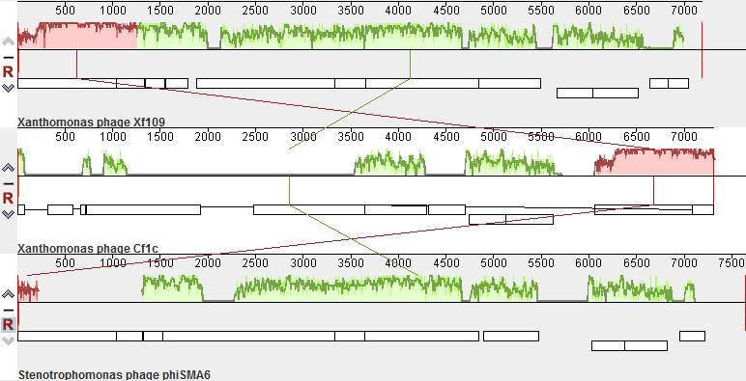

**Fig. 2.** Similarity of *Xanthomonas virus Xf109* when compared to other similar viruses, based on amino-acid sequence of coaA protein (A), coaB (B), and Zot (C), as shown using phylogeny.fr.

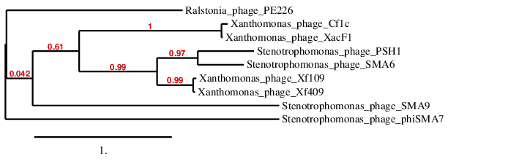

**B)**

**A)**

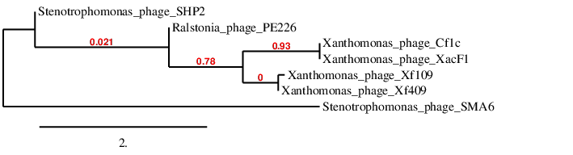

**C)**

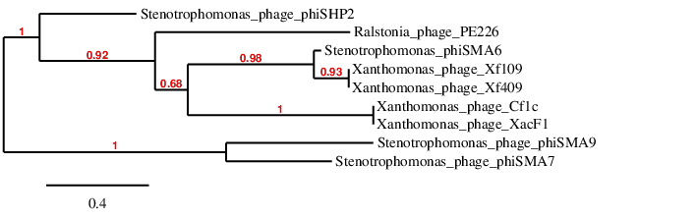

**Table 2.** Properties of the phages belonging to the species *Thermus virus OH3* and the peripherally related species (*Vibrio virus fs1, Pseudomonas virus Pf3* and *Propionibacterium virus B5)*.

|  |  |  |  |  |  |  |  |  |  |
| --- | --- | --- | --- | --- | --- | --- | --- | --- | --- |
| **Phage** | **GenBank accession No.** | **Genome length (nt)** | **Genome (mol%G+C)** | **No. CDS** | **DNA (% sequence identity)\*** | **Poteom homology (%)\*\*** | **Zot\*\*\*** | **CoatB** | **CoatA** |
| **OH3** | LC035386 | 5688 | 58.0 | 8 | 100 | 100 | 100 | 100 | 100 |
| OH16 | LC210520 | 6533 | 58.4 | 9 | 97 | 100 | 99 | 98 | 94 |
| **fs1** | D89074 | 6340 | 43.4 | 15 | 1 | 12.5 | 14 | 0 | 4 |
| **Pf3** | NC_001418.1 | 5833 | 45.4 | 9 | 0 | 12.5 | 4 | 0 | 4 |
| **B5** | AF428260 | 5806 | 64.3 | 10 | 1 | 12.5 | 17 | 21 | 19 |

* Determined using BLASTN; ** Determined using CoreGenes 3.5: **\*\*\***Determined using BLASTP

**Fig. 3.** Similarity of *Thermus virus OH3* when compared to other peripherally related viruses, based on amino-acid sequence of coaA protein (A), coaB (B), and Zot (C), as shown using phylogeny.fr.

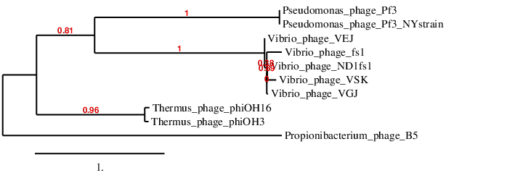

**B)**

**A)**

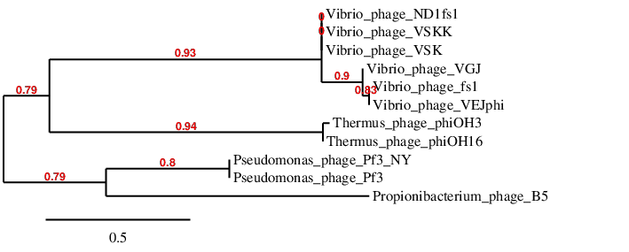

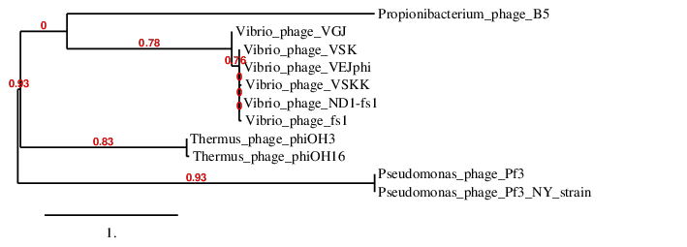

**C)**

| **References:** |
| --- |
| Nagayoshi, Y., Kumagae, K., Mori, K., Tashiro, K., Nakamura, A., Fujino, Y., Hiromasa, Y., Iwamoto, T., Kuhara, S., Ohshima, T., Doi, K. 2016. Physiological Properties and Genome Structure of the Hyperthermophilic Filamentous Phage phiOH3 Which Infects *Thermus thermophilus* HB8. Front Microbiol 7, 50.  Yeh,T.Y. Complete nucleotide sequence of a new filamentous phage, Xf109, which integrates its genome into the chromosomal DNA of *Xanthomonas oryzae*. Arch Virol 162 (2), 567-572.  Darling, A.C.E., Mau, B., Blattner, F.R., Perna, N.T. 2004. Mauve: multiple alignment of conserved genomic sequence with rearrangements. Genome Res14 (7), 1394-1403.  Dereeper A., Guignon V., Blanc G., Audic S., Buffet S., Chevenet F., Dufayard J.F., Guindon S., Lefort V., Lescot M., Claverie J.M., Gascuel O. 2008. Phylogeny.fr: robust phylogenetic analysis for the non-specialist. Nucleic Acids Res. 36(Web Server issue):W465-9. http://www.phylogeny.fr/index.cgi  Mahadevan, P., King, J.F. and Seto, D. (2009). CGUG: in silico proteome and genome parsing tool for the determination of "core" and unique genes in the analysis of genomes up to ca. 1.9 Mb. BMC Research Methods 2:168. http://binf.gmu.edu:8080/CoreGenes3.5/ |