This Word module should be used for all taxonomic proposals.

Please complete **Part 1** and:

either **Part 3** for proposals to create new taxa or change existing taxa

or **Part 2** for proposals of a general nature.

Submit the completed Word module, together with the accompanying Excel module named in Part 3, to the appropriate ICTV Subcommittee Chair.

For guidance, see the notes written in blue, below, and the help notes in file Taxonomic_Proposals_Help_2018.

**Part 1:** **TITLE, AUTHORS, etc**

|  |  |  |  |
| --- | --- | --- | --- |
| **Code assigned:** | ***2018.093B*** | | (to be completed by ICTV officers) |
| **Short title: To create one (1) new genus, *Gammatectivirus*, including one (1) species, within the family *Tectiviridae*** | | | |
|  | | | |
| **Author(s):** | | | |
| Mart Krupovic – Institut Pasteur (France)  Annika Gillis – Université catholique de Louvain (Belgium)  Claire le Marrec – Université de Bordeaux (France) | | | |
| **Corresponding author with e-mail address:** | | | |
| Mart Krupovic ([krupovic@pasteur.fr](mailto:krupovic@pasteur.fr)), Claire le Marrec ([clehenaff@enscbp.fr](mailto:clehenaff@enscbp.fr)) | | | |
| **List the ICTV study group(s) that have seen this proposal:** | | | |
| A list of study groups and contacts is provided at <http://www.ictvonline.org/subcommittees.asp> . If in doubt, contact the appropriate subcommittee chair (there are six virus subcommittees: animal DNA and retroviruses, animal ssRNA-, animal ssRNA+, fungal and protist, plant, bacterial and archaeal) | | **Bacterial and Archaeal Viruses Subcommittee** | |
| **ICTV Study Group comments (if any) and response of the proposer:** | | | |
|  | | | |
|  | | | |
| Date first submitted to ICTV: | | | May 2018 |
| Date of this revision (if different to above): | | |  |

|  |
| --- |
| **ICTV-EC comments and response of the proposer:** |

**Part 3:** **PROPOSED TAXONOMY**

|  |
| --- |
| **Name of accompanying Excel module:** 2018.093B.N.v1.Gammatectivirus |

The taxonomic changes you are proposing should be presented on an accompanying Excel module, 2017_TP_Template_Excel_module. Please enter the file name of the completed module in this box.

**Supporting material:**

| additional material in support of this proposal |
| --- |

The temperate Gluconobacter phage GC1 has been isolated from a juice sample collected during dry white wine making [1]. The bacteriophage infects *Gluconobacter cerinus*, an acetic acid bacterium which represents a spoilage microorganism during wine making. Transmission electron microscopy revealed tail-less icosahedral particles with a diameter of ~78 nm (Figure 1), similar to those belonging to the family *Tectiviridae*.

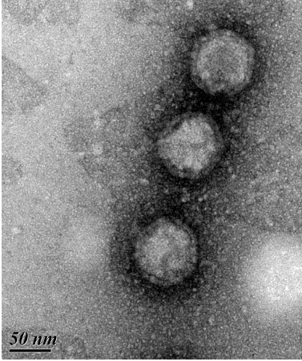**Figure 1.** Transmission electron micrograph of GC1 virions negatively stained with uranyl acetate. Scale bar, 50 nm. The figure is modified from Ref [1].

Genomic characterization of phage GC1 revealed further relationship to tectiviruses. The genome of GC1 is a linear double-stranded DNA molecule of 16,523 base pairs, containing terminal inverted repeats. Twelve of the 36 predicted gene products of GC1 have homologs in tectiviruses, with closer similarity to members of the genus *Alphatectivirus* (Figure 2). The shared genes encode for key proteins involved in DNA replication (protein-primed family B DNA polymerase (DNAP)) as well as in virion structure and assembly (major capsid protein, genome packaging ATPase and two minor structural proteins). The homologous genes occupy equivalent positions within the GC1 genome when compared to the genomic layout of other tectiviruses, with a notable inversion of the region encompassing the genes coding for the DNAP and putative terminal protein (Figure 2). Thus, morphological and genomic features of GC1 indicated that it is a divergent member of the family *Tectiviridae*.

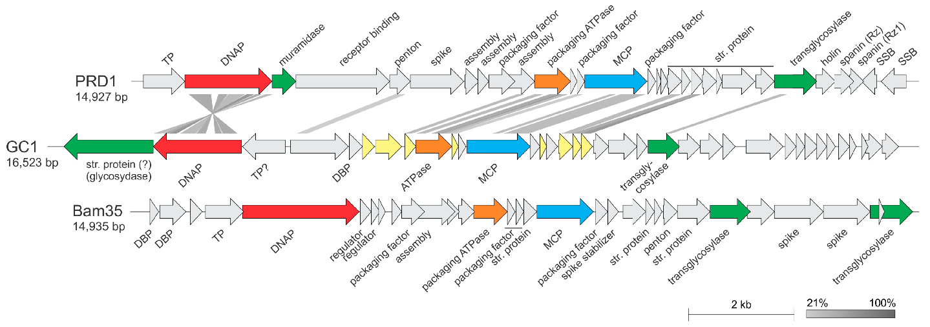

**Figure 2.** Comparison of the genome maps of bacteriophage GC1 (middle), alphatectivirus PRD1 (top) and betatectivirus Bam35 (bottom). The figure shows the similarity between translated nucleotide sequences as determined by the tblastx algorithm. Abbreviations: TP, terminal protein; DNAP, family B DNA polymerase; MCP, major capsid protein; str. protein, structural protein; SSB, single-stranded DNA-binding protein; DBP, DNA-binding protein. ORFs shared with alphatectiviruses are highlighted in light yellow. ORFs filled in grey do not have homologs in either of the other two genomes. The color code for gene function is DNAP (red), muramidase (green), packaging ATPase (orange), MCP (blue), transglycosylase (green). The figure is reproduced from Ref [1].

To explore the taxonomic position of GC1 within the family *Tectiviridae*, we performed maximum likelihood phylogenetic analysis of the three key proteins—MCP, packaging ATPase and DNAP—conserved in all members of the family. In all cases, GC1 formed a well-supported sister group to the tectiviruses from the genus *Alphatectivirus* (Figure 3a–c). Next, we calculated pairwise intergenomic distances between all sequenced tectiviruses with the Genome-BLAST Distance Phylogeny (GBDP) method using VICTOR tool (<https://victor.dsmz.de>). This genome-wide comparison also placed GC1 as a deep-branching sister group to the alphatectiviruses (Figure 3d). Consistently, sequence analyses of the GC1 gene products (Figure 2) also suggested that the virus is most closely related to phages of the genus *Alphatectivirus*. However, unlike other alphatectiviruses, GC1 is a temperate phage. Furthermore, whereas all currently known alphatectiviruses infect gammaproteobacteria, GC1 replicates in an alpharoteobacterial host. Finally, pairwise comparison of GC1 with other alphatectiviruses using BLASTN, as recommended by the ICTV Bacterial and Archaeal Viruses Subcommittee [2], did not reveal common regions of sufficient similarity at the nucleotide level. Collectively, these results confirm that GC1 is a highly divergent member of the family *Tectiviridae*, which cannot be placed into either of the two existing genera based on the recommended demarcation criteria [3]. Thus, we propose that GC1 be classified as a type species of a new genus, *Gammatectivirus*, within the family *Tectiviridae*.

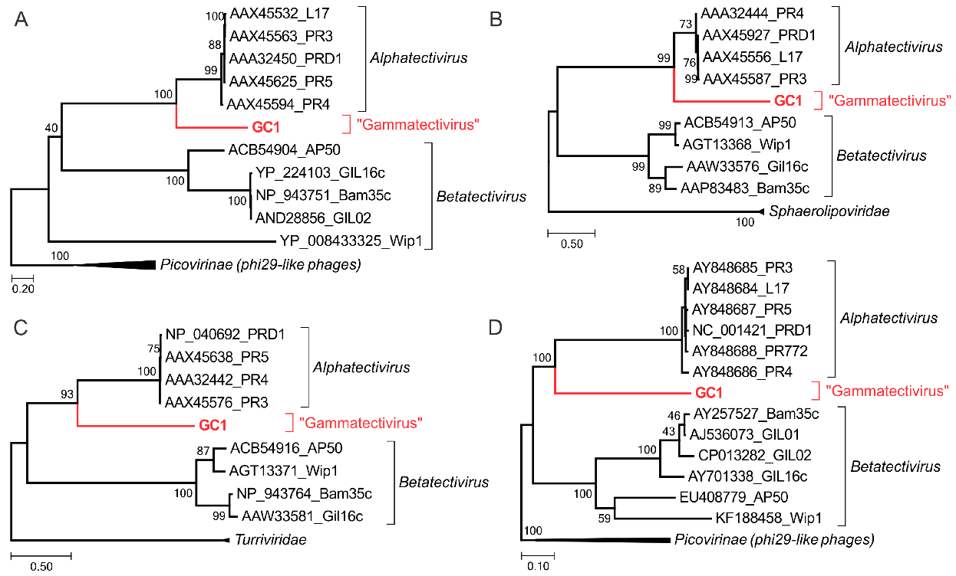

**Figure 3.** Phylogenetic relationship of GC1 compared with other tectiviruses based on the three conserved proteins: the major capsid protein (A), packaging ATPase (B) and DNAP (C). Phylogenetic tree computed using the Genome BLAST Distance Phylogeny (GBDP) strategy (D). Maximum likelihood phylogenetic trees (A–C) were computed using the best-fit substitution models for given alignments, as determined by PhyML [4]. The trees were rooted with taxa including the closest homologs of the corresponding proteins outside of the family *Tectiviridae*. Scale bars in (A–C) represent the number of substitutions per site, whereas in panel (D), the branch lengths are scaled according to the distance formula (d6) used for the calculation, i.e. sum of all identities found in high-scoring segment pairs between the two proteomes divided by total genome length. The figure is reproduced from Ref [1].

***Gammatectivirus* (new genus)**

**Genus demarcation criteria:** BLASTN, genomic comparisons and phylogenetic analyses (Figures 2 and 3), all indicate that the proposed genus, *Gammatectivirus*, is cohesive and distinct from other genera.

**Type species:** *Gluconobacter virus GC1*. Gluconobacter phage GC1 is the only described member of this genus.

**Genus name:** *Gammatectivirus*; from *gamma*, the third letter of the Greek alphabet, indicating third genus of this family and from Latin *tectus*, meaning “covered”.

**Species demarcation criteria**

Not applicable. There is only one species in the genus.

| **References:** |
| --- |
| [1] Philippe C, Krupovic M, Jaomanjaka F, Claisse O, Petrel M, le Marrec C. Bacteriophage GC1, a novel tectivirus infecting *Gluconobacter cerinus*, an acetic acid bacterium associated with wine-making. Viruses. 2018; 10(1): E39.  [2] Krupovic M, Dutilh BE, Adriaenssens EM, Wittmann J, Vogensen FK, Sullivan MB, Rumnieks J, Prangishvili D, Lavigne R, Kropinski AM, Klumpp J, Gillis A, Enault F, Edwards RA, Duffy S, Clokie MR, Barylski J, Ackermann HW, Kuhn JH. Taxonomy of prokaryotic viruses: update from the ICTV bacterial and archaeal viruses subcommittee. Arch Virol. 2016; 161(4):1095-9.  [3] Gillis A, Bin Jang, H, Mahillon J, Kuhn JH, Kropinski AM, Adriaenssens E, Lavigne R. ICTV Taxonomic Proposal 2017. 013B.A.v2. To rename the existing genus *Tectivirus* (proposed new name *Alphatectivirus*) in the family *Tectiviridae*, create a new genus, *Betatectivirus,* and include three (3) new species. International Committee on Taxonomy of Viruses (ICTV). 2017. Available online:  <https://talk.ictvonline.org/taxonomy/p/taxonomy-history?taxnode_id=20175073>  [4] Guindon S, Dufayard JF, Lefort V, Anisimova M, Hordijk W, Gascuel O. New algorithms and methods to estimate maximum-likelihood phylogenies: assessing the performance of PhyML 3.0. Syst Biol. 2010; 59(3):307-21. |