This Word module should be used for all taxonomic proposals.

Please complete **Part 1** and:

either **Part 3** for proposals to create new taxa or change existing taxa

or **Part 2** for proposals of a general nature.

Submit the completed Word module, together with the accompanying Excel module named in Part 3, to the appropriate ICTV Subcommittee Chair.

For guidance, see the notes written in blue, below, and the help notes in file Taxonomic_Proposals_Help_2018.

**Part 1:** **TITLE, AUTHORS, etc**

|  |  |  |  |
| --- | --- | --- | --- |
| **Code assigned:** | ***2018.003B*** | | (to be completed by ICTV officers) |
| **Short title:** (e.g. “6 new species in the genus *Zetavirus”*)  **To create one (1) new genus, *Farahnazvirus*, containing one (1) species in the family *Siphoviridae*** | | | |
|  | | | |
| **Author(s):** | | | |
| Andrew M. Kropinski, University of Guelph, Canada  Evelien M. Adriaenssens, University of Liverpool, UK  Isaac Zamani, University of Isfahan, Iran  Majid Bouzari, University of Isfahan, Iran  Giti Emtiazi, University of Isfahan, Iran  Seyed Mahdi Ghasemi, Shahid Ashrafi Esfahani University, Iran  Hyo-Ihl Chang, Korea University, Korea  Mahsa Yazdi, University of Isfahan, Iran | | | |
| **Corresponding authors with e-mail addresses:** | | | |
| Andrew M. Kropinski [Phage.Canada@gmail.com](mailto:Phage.Canada@gmail.com)  Majid Bouzari [bouzari@sci.ui.ac.ir](mailto:bouzari@sci.ui.ac.ir) | | | |
| **List the ICTV study group(s) that have seen this proposal:** | | | |
| A list of study groups and contacts is provided at <http://www.ictvonline.org/subcommittees.asp> . If in doubt, contact the appropriate subcommittee chair (there are six virus subcommittees: animal DNA and retroviruses, animal ssRNA-, animal ssRNA+, fungal and protist, plant, bacterial and archaeal) | | **Bacterial and Archaeal Viruses Subcommittee** | |
| **ICTV Study Group comments (if any) and response of the proposer:** | | | |
|  | | | |
|  | | | |
| Date first submitted to ICTV: | | | June 2018 |
| Date of this revision (if different to above): | | |  |

|  |
| --- |
| **ICTV-EC comments and response of the proposer:** |
|  |

**Part 2:** **NON-STANDARD**

Template for any proposal regarding ICTV procedures, rules or policy, not involving the creation of new taxonomy.

|  |
| --- |

**Part 3:** **PROPOSED TAXONOMY**

|  |
| --- |
| **Name of accompanying Excel module: 2018.003B.N.v1.Farahnazvirus** |

The taxonomic changes you are proposing should be presented on an accompanying Excel module, 2017_TP_Template_Excel_module. Please enter the file name of the completed module in this box.

**Supporting material:**

| additional material in support of this proposal |
| --- |
| Please explain the reasons for the taxonomic changes you are proposing and provide evidence to support them. The following information should be provided, where relevant:   * **Species demarcation criteria**: Explain how new species differ from others in the genus and demonstrate that these differences meet the criteria previously established for demarcating between species. If no criteriahave previously been established, and if there will now be more than one species in the genus, please state the demarcation criteria you are proposing. * **Higher taxa**:   + There is no formal requirement to state demarcation criteria when proposing new genera or other higher taxa. However, a similar concept should apply in pursuit of a rational and consistent virus taxonomy.   + Please indicate the **origin of names** assigned to new taxa at genus level and above.   + For each new genus a **type species** must be designated to represent it. Please explain your choice. * **Supporting evidence**: The use of Figures and Tables is strongly recommended (note that copying from publications will require permission from the copyright holder). For phylogenetic analysis, try to provide a tree where branch length is related to genetic distance. |

**Species demarcation criteria:** We have chosen 95% DNA sequence identity as the criterion for demarcation of species in this new genus. Each of the proposed species differs from the others with more than 5% at the DNA level as confirmed with the BLASTN algorithm.

**Source of the name of this taxon:** The name is derived from that of the first isolate of this type Microbacteriumphage vB_MoxS-ISF9

**History:** Lytic phage vB_MoxS-ISF9 “was isolated from an untreated sewage sample obtained from the wastewater treatment plant of Boroujen, Iran.” [1] using *Microbacterium oxydans* as the host bacterium. It has “an isometric head that was approximately 75 x 80 nm in diameter, with a long non-contractile tail (240 nm in length and 12 nm in width).” [1].

**GenBank Summary:**

|  |  |  |  |  |  |  |
| --- | --- | --- | --- | --- | --- | --- |
| Phage name | RefSeq No. | INSDC | Size (Kb) | GC% | Protein | tRNA(*) |
| vB_MoxS-ISF9 | NC_023859 | KJ173786 | 59.25 | 62.8 | 120 | 1 |

(*) None indicated in GenBank files. tRNAScan-SE 2.0 indicates an intron-containing arginyl tRNA (56201-56283)

**BLASTN homologs:** None, genomic orphan/singleton.

BLASTN (Table GenBank Summary) and phylogenetic analyses [2] all indicate that *Microbacterium* vB_MoxS-ISF9, is significantly different, and distinct from other genera within *Siphoviridae* family. Therefore, we propose a new genus, *Farahnazvirus,* containing one species in the family *Siphoviridae*.

**Electron micrograph:** Electron micrograph of negatively stained Microbacterium vB_MoxS-ISF9.

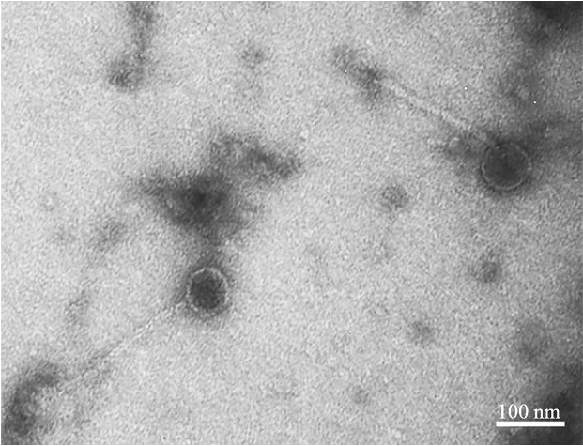

**Phylogeny:** The phylogenetic tree was constructed, using “one click” at phylogeny.fr [2], using the large subunit terminase protein of phage ISF9 and related phages. "The "One Click mode" is for the users that do not like to deal with program and parameter selection. It is a "default" mode which proposes a pipeline already set up to run and connect programs recognized for their accuracy and speed (MUSCLE for multiple alignment and PhyML for phylogeny) to reconstruct a robust phylogenetic tree from a set of sequences. It also includes the use of Gblocks to eliminate poorly aligned positions and divergent regions. "The usual bootstrapping procedure is replaced by a new confidence index that is much faster to compute. See: "Anisimova M., Gascuel O. Approximate likelihood ratio test for branches: A fast, accurate and powerful alternative (Syst Biol. 2006; 55(4):539-52)" for more details.



| **References:** |
| --- |
| 1: Zamani I, Bouzari M, Emtiazi G, Ghasemi SM, Chang HI. Complete genome sequence  of a novel phage, vB_MoxS-ISF9, infecting methylotrophic Microbacterium: first  report of a virulent Microbacterium phage. Arch Virol. 2014 Sep;159(9):2537-40.  2: Dereeper A, Guignon V, Blanc G, Audic S, Buffet S, Chevenet F, et al. Phylogeny. fr: robust phylogenetic analysis for the non-specialist. Nucleic Acids Research. 2008;36(suppl_2):W465-W9. |