

The International Committee on Taxonomy of Viruses

Taxonomy Proposal Form, 2024

**Part 1a: Details of taxonomy proposals**

|  |  |  |
| --- | --- | --- |
| **Title:** | Create a new family, “Eurekaviridae” of spindle-shaped archaeal virus | |
| **Code assigned:** | 2024.007A.N.v1.Eurekaviridae_newfam |

|  |  |  |  |
| --- | --- | --- | --- |
| **Author(s), affiliation and email address(es):** | | | |
| **Name** | **Affiliation** | **Email address** | **Corresponding author(s)** X |
| Coves M | PROSE, INRAE, Antony, France | marion.coves@inrae.fr |  |
| Krupovic M | Institut Pasteur, Université de Paris, Archaeal Virology Unit, Paris, France | mart.krupovic@pasteur.fr |  |
| Bize A | PROSE, INRAE, Antony, France | ariane.bize@inrae.fr | X |

**Part 1b: Taxonomy Proposal Submission**

|  |  |  |  |
| --- | --- | --- | --- |
| **ICTV Subcommittee:** | | | |
| Animal DNA Viruses and Retroviruses |  | Bacterial viruses |  |
| Animal minus-strand and dsRNA viruses |  | Fungal and protist viruses |  |
| Animal positive-strand RNA viruses |  | Plant viruses |  |
| Archaeal viruses | **X** | General - |  |

|  |
| --- |
| **List the ICTV Study Group(s) that have seen or have been involved in creating this proposal:** |
|  |

|  |  |  |  |
| --- | --- | --- | --- |
| **Optional – complete only if formally voted on by an ICTV Study Group:** | | | |
| **Study Group** | **Number of members** | | |
| **Votes in support** | **Votes against** | **No vote** |
|  |  |  |  |
|  |  |  |  |

|  |  |
| --- | --- |
| **Submission date:** | 26/06/2024 |

**Part 1c: Feedback from ICTV Executive Committee (EC) meeting**

|  |  |
| --- | --- |
| **Executive Committee Meeting Decision code:** | **X** |
| A – Accept |  |
| Ac – Accept subject to revision by relevant subcommittee chair. No further vote required |  |
| U – Accept without revision but with re-evaluation and email vote by the EC |  |
| Uc – Accept subject to revision and re-evaluation and email vote by the EC | **X** |
| Ud – Deferred to the next EC meeting, with an invitation to revise based on EC comments |  |
| J - Reject |  |
| W - Withdrawn |  |

|  |
| --- |
| **Comments from the Executive Committee:** |
| The EC voted Uc (see the table above for explanation) for this proposal. The changes that need to be made for this proposal to become acceptable are the following:  1. The genome sequence should be publicly available in GenBank.  2. Revise Figure 4 – “Salterproviridae” does not exist. The actual family name is *Halspiviridae* (it includes a genus *Salterprovirus*).  3. It was suggested to correct “aureus” to “aureum” in the species epithet.  Following these changes, the proposal will be voted upon by the EC via an email vote in the fall and, if accepted, proceed to the ratification stage. |

**Part 1d: Revised Taxonomy Proposal Submission**

|  |
| --- |
| **Response of proposer:** |
| Thank you for examining our request. Below is a point-to-point answer.   1. Regarding point one, the genome sequence has been attributed accession PQ167755 by GenBank and should be made publicly available on the 2nd of October according to GenBank services. 2. Figure 4 has been revised, *Salterproviridae* has been replaced by *Halspiviridae*. 3. “aureus” has been corrected to “aureum” in the species epithet. |

|  |  |
| --- | --- |
| **Revision date:** | 02/10/2024 |

**Part 3:** **TAXONOMIC PROPOSAL**

|  |
| --- |
| **Name of accompanying Excel module:** |
| 2024.007A.N.v1.Eurekaviridae_newfam.xlsx |

|  |  |  |  |
| --- | --- | --- | --- |
| **Taxonomic changes proposed:** | | | |
| Establish new taxon | **X** | Split taxon |  |
| Abolish taxon |  | Merge taxon |  |
| Move taxon |  | Promote taxon |  |
| Rename taxon |  | Demote taxon |  |
| Move and rename |  |

|  |  |  |
| --- | --- | --- |
| **Is any taxon name used here derived from that of a living person:** | | **N** |
| **Taxon name** | **Person from whom the name is derived** | **Attached X** |
|  |  |  |
|  |  |  |
|  |  |  |

|  |
| --- |
| **Abstract of Taxonomy Proposal:** |
| *Taxonomic rank(s) affected*:  We suggest creating a new family, a new genus and a new species for classification of a spindle-shaped archaeal virus predicted to infect *Methanosarcina* species.  *Description of current taxonomy*:  Three families of small spindle-shaped archaeal viruses are currently defined: *Fuselloviridae*, *Halspiviridae* and *Thaspiviridae.* In addition, several spindle-shaped viruses are still unclassified. No spindle-shaped viruses infecting a methanogen has been classified so far.  *Proposed* *taxonomic change(s):*  We suggest creating a new family (“Eurekaviridae”), a new genus (“Hesperidvirus“) and a new species (“Hesperidvirus aureum”) to classify a newly sequenced uncultured virus, *Methanosarcina* spindle-shaped virus 1 (MetSSV1).  *Justification*:  MetSSV1 genome has been obtained through metavirome co-assembly, from samples collected in mesophilic anaerobic digestion batch microcosms fed with biowaste. This genome is complete and circular. It encodes several copies of the major coat proteins similar to those of previously characterized spindle-shaped viruses. However, it does not show significant genomic similarity to other archaeal spindle-shaped viruses, which justifies the creation of a new family. |
|  |

|  |
| --- |
| * **Text of Taxonomy proposal:** |
| *Taxonomic rank(s) affected*:  We suggest creating a new family, a new genus and a new species of spindle-shaped archaeal virus to classify an uncultured virus predicted to infect *Methanosarcina*.  *Description of current taxonomy*:  The spindle-shaped viruses isolated to date exclusively infect archaea. Three families have so far been defined for these viruses: *Fuselloviridae*, which includes viruses infecting thermoacidophilic archaea of the order Sulfolobales; *Halspiviridae*, a family that includes a single virus infecting a halophilic host, belonging to the species *Haloarcula hispanica*; and finally *Thaspiviridae*, a family of viruses infecting the ammonia-oxidizing marine mesophilic archaea *Nitrosopumilus maritimus*. Additionally, several spindle shaped viruses are still unclassified.  Spindle-shaped viruses therefore appear to be relatively widespread in archaea, although none have yet been isolated from methanogenic archaea. Two archaeal spindle-shaped virus genomes have nevertheless been identified from metagenomic data [1], whose predicted hosts belong to the orders Methanomicrobiales and Methanosarcinales, respectively. Partial spindle-shaped viral genomes have also been obtained from anaerobic digestion microcosms fed with formate, where spindle-shaped particles have been directly observed by electron microscopy [2]. Finally, spindle-shaped particles have been also observed in anaerobic sediments [3].  *Proposed* *taxonomic change(s)*:  Methanosarcina spindle-shaped virus 1 (MetSSV1) genome has been sequenced from the metaviromes of anaerobic digestion microscosms fed with biowaste. Read mapping confirmed the homogeneous coverage of the assembled virus genome (Fig. 1). The genome was assembled as a circular contig of 17,905 bp and contains 30 open reading frames (Fig. 2). MetSSV1 does not show appreciable similarity to other characterized viruses at the nucleotide or protein level (Fig. 3). However, sensitive profile-profile comparisons showed that MetSSV1 genome contains 3 genes homologous to the major capsid proteins of previously isolated spindle-shaped viruses and hence the virus is likely to have a spindle-shaped morphology. Furthermore, spindle-shaped particles have been observed (among others) by transmission electron microscopy in the microcosm samples. MetSSV1 has been predicted to infect *Methanosarcina*, *in silico*, using CAT tool against the NCBI database [4]. The viral genome codes for a putative integrase, suggesting a potential for the temperate lifestyle.  *Demarcation criteria:*  There is presently no systematic criterium established for spindle-shaped viruses, which have much less sequenced representatives compared, for instance, to the cosmopolitan head-tailed phages. However, we propose using 95% sequence identity as a species demarcation criterion, to be consistent with the classification of other bacterial and archaeal DNA viruses.  *Justification*:  Phylogenomic analysis with ViPTree confirmed that MetSSV1 does not show close evolutionary relationship to other spindle-shaped viruses (Fig. 4). Thus, we propose to create a new genus and a new family for the classification of this virus, as summarized in Table 1.  *Origin of the name:*  Methanosarcinaspindle-shaped virus 1:   * In *“*Eurekaviridae*”, Eureka* means “I have found it” in Greek and it is the name of the most produced variety of lemons, reminiscent of the virion shape (lemon-shaped virus). * In “Hesperidvirus*”*, Hesperides refers to the Hesperides Garden. * In *“*Hesperidvirus aureum*”, a*ureum is the golden color of the Hesperides fruits. |

|  |
| --- |
| **References:** |
| 1. Medvedeva S, Borrel G, Krupovic M, Gribaldo S: **A compendium of viruses from methanogenic archaea reveals their diversity and adaptations to the gut environment**. *Nature Microbiology* 2023, **8**(11):2170-2182.  2. Ngo VQH, Enault F, Midoux C, Mariadassou M, Chapleur O, Mazéas L, Loux V, Bouchez T, Krupovic M, Bize A: **Diversity of novel archaeal viruses infecting methanogens discovered through coupling of stable isotope probing and metagenomics**. *Environmental Microbiology* 2022, **24**(10):4853-4868.  3. Borrel G, Colombet J, Robin A, Lehours A-C, Prangishvili D, Sime-Ngando T: **Unexpected and novel putative viruses in the sediments of a deep-dark permanently anoxic freshwater habitat**. *The ISME Journal* 2012, **6**(11):2119-2127.  4. von Meijenfeldt FAB, Arkhipova K, Cambuy DD, Coutinho FH, Dutilh BE: **Robust taxonomic classification of uncharted microbial sequences and bins with CAT and BAT**. *Genome Biology* 2019, **20**(1):217. |

|  |
| --- |
| **Tables, Figures:** |

<Start here>

**Table 1. Proposed taxonomy of virus MetSSV1**

|  |  |  |  |  |  |
| --- | --- | --- | --- | --- | --- |
| **Family** | **Genus** | **Species** | **Virus name** | **Genome length (bp)** | **Accession number** |
| *“*Eurekaviridae*”* | *“*Hesperidvirus*”* | “Hesperidvirus aureum” | Methanosarcina spindle-shaped virus 1 (MetSSV1) | 17905 | PQ167755 |

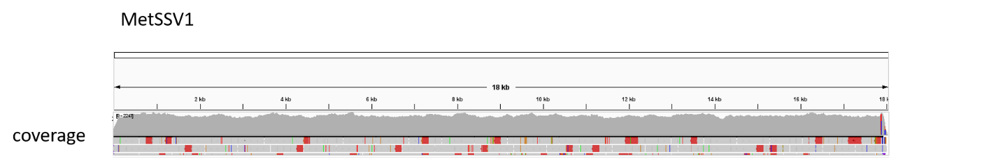

**Figure 1.** Coverage of Methanosarcinaspindle-shaped virus 1 genome following metavirome assembly and read mapping. Coverage values reached up to 2,247 and their average was above 1,000.

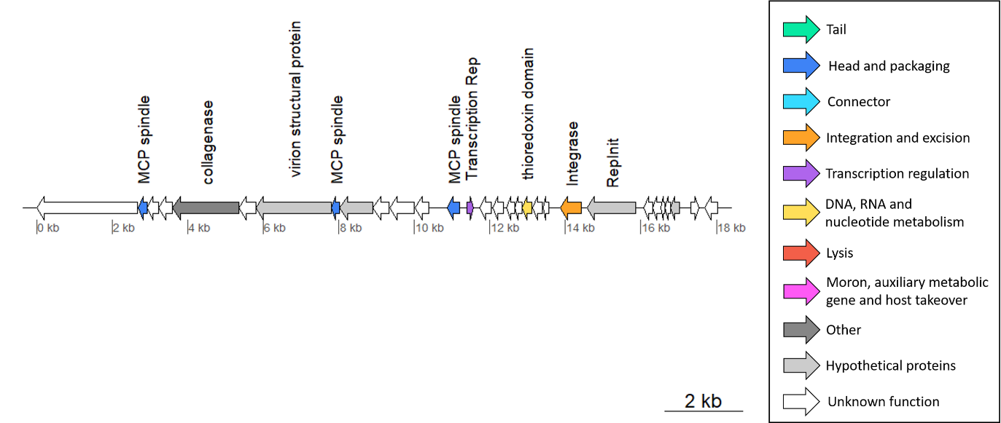

**Figure 2.** Genome map of Methanosarcinaspindle-shaped virus 1, with putative protein functions. Abbreviations: RepInit: Rolling-circle replication initiation endonuclease Rep; MCP spindle: homologous to a major coat protein of a previously characterized spindle-shaped virus.

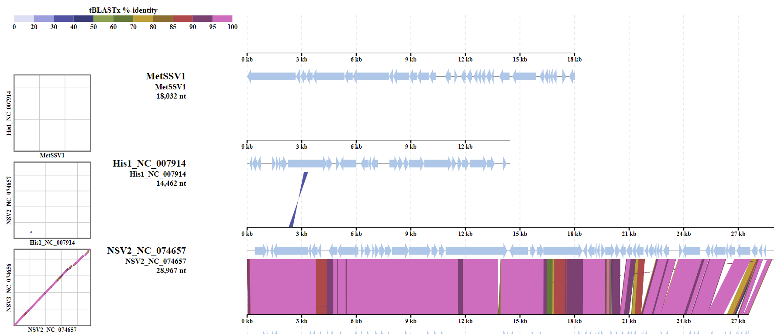

**Figure 3.** Genome map of Methanosarcinaspindle-shaped virus 1 and its comparison with other archaeal spindle-shaped viruses. Homologous regions based on tblastx comparison are connected through shadings with colors corresponding to % identity (the key is provided on the top). No significant similarity is thus detected between MetSSV1 and other known spindle-shaped archaeal viruses.

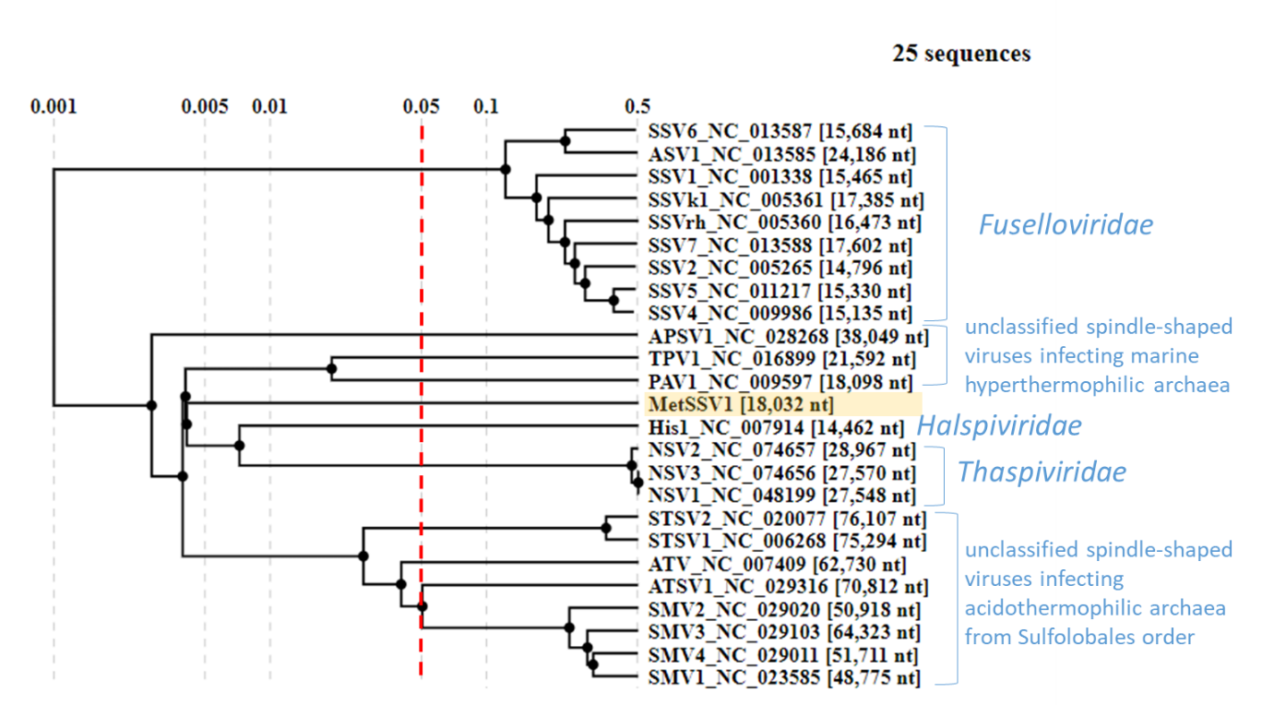

**Figure 4.** Classification of Methanosarcina spindle-shaped virus 1. The Viral Proteomic Tree (ViPTree) of archaeal spindle-shaped viruses. The tree is constructed using BIONJ based on all-versus-all genomic similarity matrix, and mid-point rooted. Branch lengths are log-scaled. The new family described in the proposal is highlighted with an orange color.