

The International Committee on Taxonomy of Viruses

Taxonomy Proposal Form, 2024

**Part 1a: Details of taxonomy proposals**

|  |  |  |
| --- | --- | --- |
| **Title:** | Create four new families for Bathyarchaeia viruses | |
| **Code assigned:** | 2024.005A.N.v1.Bathyarchaeia_4newfam |

|  |  |  |  |
| --- | --- | --- | --- |
| **Author(s), affiliation and email address(es):** | | | |
| **Name** | **Affiliation** | **Email address** | **Corresponding author(s)** X |
| Duan CH | Institute for Advanced Study, Shenzhen University, Shenzhen, China  The Hong Kong University of Science and Technology, Hong Kong, China | cduanab@connect.ust.hk |  |
| Liu Y | Institute for Advanced Study, Shenzhen University, Shenzhen, China | yangliu@szu.edu.cn |  |
| Liu Y | Institut Pasteur, Université de Paris, Archaeal Virology Unit, Paris, France | ying.liu@pasteur.fr |  |
| Liu LR | Institute for Advanced Study, Shenzhen University, Shenzhen, China | lirui.liu@szu.edu.cn |  |
| Cai MW | Institute for Advanced Study, Shenzhen University, Shenzhen, China | ytcaimingwei@gmail.com |  |
| Zhang R | Institute for Advanced Study, Shenzhen University, Shenzhen, China | ruizhang@szu.edu.cn |  |
| Zeng QL | The Hong Kong University of Science and Technology, Hong Kong, China | zeng@ust.hk |  |
| Koonin V E | National Center for Biotechnology Information, National Library of Medicine, National Institutes of Health, Bethesda, USA | koonin@ncbi.nlm.nih.gov |  |
| Krupovic M | Institut Pasteur, Université de Paris, Archaeal Virology Unit, Paris, France | mart.krupovic@pasteur.fr |  |
| Li M | Institute for Advanced Study, Shenzhen University, Shenzhen, China | limeng848@szu.edu.cn | X |

**Part 1b: Taxonomy Proposal Submission**

|  |  |  |  |
| --- | --- | --- | --- |
| **ICTV Subcommittee:** | | | |
| Animal DNA Viruses and Retroviruses |  | Bacterial viruses |  |
| Animal minus-strand and dsRNA viruses |  | Fungal and protist viruses |  |
| Animal positive-strand RNA viruses |  | Plant viruses |  |
| Archaeal viruses | **X** | General - |  |

|  |
| --- |
| **List the ICTV Study Group(s) that have seen or have been involved in creating this proposal:** |
|  |

|  |  |  |  |
| --- | --- | --- | --- |
| **Optional – complete only if formally voted on by an ICTV Study Group:** | | | |
| **Study Group** | **Number of members** | | |
| **Votes in support** | **Votes against** | **No vote** |
|  |  |  |  |
|  |  |  |  |

|  |  |
| --- | --- |
| **Submission date:** | 20/06/2024 |

**Part 1c: Feedback from ICTV Executive Committee (EC) meeting**

|  |  |
| --- | --- |
| **Executive Committee Meeting Decision code:** | **X** |
| A – Accept |  |
| Ac – Accept subject to revision by relevant subcommittee chair. No further vote required | **X** |
| U – Accept without revision but with re-evaluation and email vote by the EC |  |
| Uc – Accept subject to revision and re-evaluation and email vote by the EC |  |
| Ud – Deferred to the next EC meeting, with an invitation to revise based on EC comments |  |
| J - Reject |  |
| W - Withdrawn |  |

|  |
| --- |
| **Comments from the Executive Committee:** |
| The EC voted Ac (see the table above for explanation) for this proposal. The only revision requested is to add the etymology of the proposed taxon names (families, genera and species epithets). This information should be added at the end of the proposal text, under the Etymology section (which is currently empty). Following these changes, the proposal will proceed directly to the ratification stage. |

**Part 1d: Revised Taxonomy Proposal Submission**

|  |
| --- |
| **Response of proposer:** |
| The etymology for all taxon names has been provided in the appropriate section. |

|  |  |
| --- | --- |
| **Revision date:** | 04/09/2024 |

**Part 3:** **TAXONOMIC PROPOSAL**

|  |
| --- |
| **Name of accompanying Excel module:** |
| 2024.005A.N.v1.Bathyarchaeia_4newfam.xlsx |

|  |  |  |  |
| --- | --- | --- | --- |
| **Taxonomic changes proposed:** | | | |
| Establish new taxon | **X** | Split taxon |  |
| Abolish taxon |  | Merge taxon |  |
| Move taxon |  | Promote taxon |  |
| Rename taxon |  | Demote taxon |  |
| Move and rename |  |

|  |  |  |
| --- | --- | --- |
| **Is any taxon name used here derived from that of a living person:** | | **N** |
| **Taxon name** | **Person from whom the name is derived** | **Attached X** |
|  |  |  |
|  |  |  |
|  |  |  |

|  |
| --- |
| **Abstract of Taxonomy Proposal:** |
| Bathyarchaeia is an archaeal class widespread in marine and freshwater sediments. Here we propose four new families for viruses identified by metagenomics and associated with host of the Bathyarchaeia class. The families “Fuxiviridae” and “Kunpengviridae” include head-tailed viruses of the class *Caudoviricetes* in the realm *Duplodnaviria*. The family “Chiyouviridae” consists of filamentous viruses of the archaea-specific realm *Adnaviria*. The fourth putative family, “Huangdiviridae,” with only one representative genome, includes an archaea-specific spindle-shaped virus; the spindle-shaped viruses have not yet been classified at higher taxonomy ranks. |

|  |
| --- |
| * **Text of Taxonomy proposal:** |
| Bathyarchaeia represent a class of archaea common and abundant in sedimentary ecosystems [1-6]. The diverse metabolic potential of Bathyarchaeia contributes to their predominance in sedimentary environments, rendering them essential players in the global carbon cycle [5-8]. Most Bathyarchaeia species have been discovered through metagenomics, with only one species successfully isolated recently [9], whereas most virus sequences represent genome fragments [10-13]. Recently, four new bathyarchaeial viral groups with complete genomes were discovered through metagenomic approaches including CRISPR matching from different sedimentary environments [14].  Protein sharing network analysis showed these newly identified viral groups to share no similar proteins with other known prokaryotic viruses and formed four distinct groups (Fig .1), including a large group consist of six viral clusters, roughly equivalent to genus-level groups. Additionally, genome-wide sequence similarity and phylogenetic analysis of hallmark genes of Bathyarchaeia viruses (Fig. 2-4) revealed three distinct virus types, comprising four putative family-level groups.  The proposed family “Fuxiviridae” is represented by three nearly identical complete genomes (Fuxivirus) from hot springs (Fig. 1). Fuxivirus has a smaller genome compared to the typical size of archaeal viruses of the class *Caudoviricetes* (median size of 54.3 kb, n = 44), with a length of 31 982 bp (Fig. 5A). Fuxivirus encodes all the hallmark proteins of *Caudoviricetes*, namely, a HK97-like MCP (structure modeling by AlphaFold2), a portal protein (gene Fuxivirus_28), a terminase large subunit (LSU) (gene Fuxivirus_27), a tail tube protein (gene Fuxivirus_38), and several other tail components (Fig. 5A), which are similar to those of the previously characterized archaeal tailed viruses [15]. The proteome-based ViPTree [16] analysis and MCP phylogenetic analysis placed Fuxivirus into a group separate from other established families of *Caudoviricetes* viruses (Fig. 2).  The proposed family “Kunpengviridae” was detected in hydrothermal vents and includes one complete viral genome (Kunpengvirus), that is targeted by a single spacer (100% match) from Bathyarchaeia sp. QMXD of the order Jinwuousiales. Kunpengvirus encodes the hallmark capsid morphogenesis proteins of *Caudoviricetes*, as well as a suite of tail proteins including the baseplate protein (Fig. 5B). The proteome-based ViPTree analysis and MCP phylogenetic analysis also placed Kunpengvirus into a separate family with other established families of *Caudoviricetes* viruses (Fig. 2).  A unique viral genome (Huangdivirus) representing the proposed family “Huangdiviridae” was identified as an apparent provirus in Bathyarchaeia sp. QMYA of the order Baizomonadales from a deep-sea hydrothermal vent. Sensitive sequence comparison using HHblits identified three virus-encoded structural proteins (VPs) VP1–3 (Fig. 3 and Fig. 5C), homologous to the structural proteins of archaeal spindle-shaped viruses of the family *Fuselloviridae*, as well as an AAA+ ATPase (gene Huangdivirus_17, HHblits best hit to ATV ATPase, with 99.8% probability). Structural predictions for VP1 (gene Huangdivirus_21) and VP3 (gene Huangdivirus_28) indicated that both proteins contain two hydrophobic α-helices connected by a short turn (Fig. 3A) resembling the typical structure of the MCPs of spindle-shaped viruses [17]. Huangdivirus VP2 (gene Huangdivirus_19) is most closely related to the viral DNA-binding protein VP2 of Sulfolobus spindle-shaped virus 1 (SSV1) [18] (HHblits probability of 99.49%). As in the case of SSV1, we detected the consensus glycosylation motifs (N-X-S/T) in Huangdivirus VP1 and VP3, which may be glycosylated by the virus-encoded glycosyltransferase (gene Huangdivirus_40).  “Chiyouviridae” is a potential new family of filamentous viruses in the order *Ligamenvirales* (class *Tokiviricetes*, realm *Adnaviria*). “Chiyouviridae” was detected in a hot spring and represented by one complete viral genome (Chiyouvirus ) targeted by two spacers of Bathyarchaeia sp. JAGTQC in the order Bifangarchaeales (Fig. 5D). Phylogenomic analysis of all available *Tokiviricetes* [19] genomes recapitulated the previously established relationships and showed that Chiyouvirus forms a separate clade within the order *Ligamenvirales*, most closely related to the families *Rudiviridae* and *Ungulaviridae* (Fig. 4A). Whole proteome comparison showed <50% average amino acid identity (AAI) between protein homologs from Chiyouvirus and members of other viral families, with the highest AAI (46%) with the genus *Icerudivirus* of the family *Rudiviridae* (Fig. 4B). Similar to all members of the families *Ungulaviridae* and *Lipothrixviridae* but only some members of the family Rudiviridae [19], Chiyouvirus encodes two MCPs (genes Chiyouvirus_14 and Chiyouvirus_23), each comprising an alpha-helix bundle (Figs 4C and 5D). In addition, Chiyouvirus encodes a large minor structural protein (Fig. 5D and gene Chiyouvirus_18), a homolog of SIRV2 P1070 [20, 21]. Predictions for transmembrane proteins indicated that Chiyouvirus encodes eight potential transmembrane proteins (Fig. 5D) suggesting that it is a membrane-enveloped filamentous virus, similar to the adnaviruses in the families *Lipothrixviridae*, *Ungulaviridae*, and *Tristromaviridae* [22].  **Demarcation criteria**:  We propose using 95% sequence identity as a species demarcation criterion, to be consistent with the classification of other bacterial and archaeal viruses. Membership in the respective families will be established based on the global proteomic tree calculated using ViPTree and VICTOR as well as phylogenetic analysis of hallmark proteins.  **Etymology**  **Bathyarchaeia bifangarchaeales Fuxivirus 1**  We propose classifying Bathyarchaeia bifangarchaeales Fuxivirus 1 into a species *Taijivirus yinyang* within a genus *Taijivirus* in the new family *Fuxiviridae*.   * *Fuxiviridae*, Derived from Fuxi, a legendary figure in Chinese mythology known for his diverse talents and abilities. * *Taichivirus*, named after Taichi, a Chinese philosophical concept emphasizing the balance of opposing forces. * *yinyang*, the interconnected and complementary aspects of reality in Taichi philosophy.   **Bathyarchaeia jinwuousiales Kupengvirus 1**  We propose classifying Bathyarchaeia jinwuousiales Kupengvirus 1 into a species *Dafengvirus linsing* within a genus *Dafengvirus* in the new family *Kunpengviridae*.   * *Kunpengviridae*, named after Kunpeng, a mythical creature in Chinese mythology known for its transformative abilities. * *Dafengvirus*, meaning "great wind" in Chinese, symbolizing the powerful force of transformation associated with Kunpeng. * *linsing*, meaning "to rise or ascend," alluding to the mythical bird Kunpeng's ability to soar to great heights.   **Bathyarchaeia bifangarchaeales Chiyouvirus 1**  We propose classifying Bathyarchaeia bifangarchaeales Chiyouvirus 1 into a species *Kuivirus xiongnu* within a genus *Kuivirus* in the new family *Chiyouviridae*.   * *Chiyouviridae*, inspired by Chiyou, a symbol of war and invention in Chinese mythology. * *Kuivirus*, refers to the one-legged mountain demon in Chinese mythology, known for causing chaos and destruction. * *xiongnu*, named after the Xiongnu, a confederation of nomadic tribes in ancient China, known for their powerful military and complex relationship with the Chinese empire.   **Bathyarchaeia baizomonadales Huangdivirus 1**  We propose classifying Bathyarchaeia baizomonadales Huangdivirus 1 into *Xuanyuanvirus yandi* with a genus *Xuanyuanvirus* in the new family *Huangdiviridae*.   * *Huangdiviridae*, named after Huangdi, the legendary Chinese sovereign often associated with important inventions. * *Xuanyuanvirus*, another name for Huangdi in Chinese mythology. * *yandi*, a legendary Chinese ruler also known as Shennong, who is credited with the invention of agriculture and traditional Chinese medicine. |

|  |
| --- |
| **References:** |
| 1. Inagaki F, Nunoura T, Nakagawa S, Teske A, Lever M, Lauer A, et al. Biogeographical distribution and diversity of microbes in methane hydrate-bearing deep marine sediments on the Pacific Ocean Margin. Proc Natl Acad Sci USA. 2006;103(8):2815-20.  2. Kubo K, Lloyd KG, F Biddle J, Amann R, Teske A, Knittel K. Archaea of the Miscellaneous Crenarchaeotal Group are abundant, diverse and widespread in marine sediments. ISME J. 2012;6(10):1949-65. doi: 10.1038/ismej.2012.37.  3. Lloyd KG, Schreiber L, Petersen DG, Kjeldsen KU, Lever MA, Steen AD, et al. Predominant archaea in marine sediments degrade detrital proteins. Nature. 2013;496(7444):215-8. doi: 10.1038/nature12033.  4. Lazar CS, Biddle JF, Meador TB, Blair N, Hinrichs KU, Teske AP. Environmental controls on intragroup diversity of the uncultured benthic archaea of the miscellaneous C renarchaeotal group lineage naturally enriched in anoxic sediments of the W hite O ak R iver estuary (N orth C arolina, USA). Environ Microbiol. 2015;17(7):2228-38.  5. Zhou Z, Pan J, Wang F, Gu JD, Li M. Bathyarchaeota: globally distributed metabolic generalists in anoxic environments. FEMS Microbiol Rev. 2018;42(5):639-55. Epub 2018/05/24. doi: 10.1093/femsre/fuy023. PubMed PMID: 29790926.  6. Fillol M, Auguet JC, Casamayor EO, Borrego CM. Insights in the ecology and evolutionary history of the Miscellaneous Crenarchaeotic Group lineage. ISME J. 2016;10(3):665-77. Epub 2015/08/19. doi: 10.1038/ismej.2015.143. PubMed PMID: 26284443; PubMed Central PMCID: PMCPMC4817671.  7. Zhou Z, Liu Y, Lloyd KG, Pan J, Yang Y, Gu J-D, et al. Genomic and transcriptomic insights into the ecology and metabolism of benthic archaeal cosmopolitan, Thermoprofundales (MBG-D archaea). ISME J. 2019;13(4):885-901. doi: 10.1038/s41396-018-0321-8.  8. Pan J, Zhou Z, Béjà O, Cai M, Yang Y, Liu Y, et al. Genomic and transcriptomic evidence of light-sensing, porphyrin biosynthesis, Calvin-Benson-Bassham cycle, and urea production in Bathyarchaeota. Microbiome. 2020;8(1):43. doi: 10.1186/s40168-020-00820-1.  9. Khomyakova MA, Merkel AY, Mamiy DD, Klyukina AA, Slobodkin AI. Phenotypic and genomic characterization of Bathyarchaeum tardum gen. nov., sp. nov., a cultivated representative of the archaeal class Bathyarchaeia. Front Microbiol. 2023;14.  10. Nigro OD, Jungbluth SP, Lin HT, Hsieh CC, Miranda JA, Schvarcz CR, et al. Viruses in the Oceanic Basement. mBio. 2017;8(2). Epub 2017/03/09. doi: 10.1128/mBio.02129-16. PubMed PMID: 28270584; PubMed Central PMCID: PMCPMC5340873.  11. Yi Y, Liu S, Hao Y, Sun Q, Lei X, Wang Y, et al. A systematic analysis of marine lysogens and proviruses. Nat Commun. 2023;14(1):6013. doi: 10.1038/s41467-023-41699-4.  12. Krupovic M, Dolja VV, Koonin EV. The LUCA and its complex virome. Nat Rev Microbiol. 2020;18(11):661-70. doi: 10.1038/s41579-020-0408-x.  13. Li Z, Pan D, Wei G, Pi W, Zhang C, Wang J-H, et al. Deep sea sediments associated with cold seeps are a subsurface reservoir of viral diversity. ISME J. 2021;15(8):2366-78. doi: 10.1038/s41396-021-00932-y.  14. Duan C, Liu Y, Liu Y, Liu L, Cai M, Zhang R, et al. Diversity of Bathyarchaeia viruses in metagenomes and virus-encoded CRISPR system components. ISME Communications. 2024;4(1):ycad011. doi: 10.1093/ismeco/ycad011.  15. Liu Y, Demina TA, Roux S, Aiewsakun P, Kazlauskas D, Simmonds P, et al. Diversity, taxonomy, and evolution of archaeal viruses of the class Caudoviricetes. PLoS Biol. 2021;19(11):e3001442. doi: 10.1371/journal.pbio.3001442.  16. Nishimura Y, Yoshida T, Kuronishi M, Uehara H, Ogata H, Goto S. ViPTree: the viral proteomic tree server. Bioinform. 2017;33(15):2379-80. Epub 2017/04/06. doi: 10.1093/bioinformatics/btx157. PubMed PMID: 28379287.  17. Wang F, Cvirkaite-Krupovic V, Vos M, Beltran LC, Kreutzberger MAB, Winter J-M, et al. Spindle-shaped archaeal viruses evolved from rod-shaped ancestors to package a larger genome. Cell. 2022;185(8):1297-307.e11. doi: <https://doi.org/10.1016/j.cell.2022.02.019>.  18. Quemin Emmanuelle RJ, Pietilä Maija K, Oksanen Hanna M, Forterre P, Rijpstra WIC, Schouten S, et al. Sulfolobus Spindle-Shaped Virus 1 Contains Glycosylated Capsid Proteins, a Cellular Chromatin Protein, and Host-Derived Lipids. J Virol. 2015;89(22):11681-91. doi: 10.1128/jvi.02270-15.  19. Baquero DP, Contursi P, Piochi M, Bartolucci S, Liu Y, Cvirkaite-Krupovic V, et al. New virus isolates from Italian hydrothermal environments underscore the biogeographic pattern in archaeal virus communities. ISME J. 2020;14(7):1821-33. Epub 2020/04/24. doi: 10.1038/s41396-020-0653-z. PubMed PMID: 32322010; PubMed Central PMCID: PMCPMC7305311.  20. Quemin ER, Lucas S, Daum B, Quax TE, Kühlbrandt W, Forterre P, et al. First insights into the entry process of hyperthermophilic archaeal viruses. J Virol. 2013;87(24):13379-85. Epub 2013/10/04. doi: 10.1128/jvi.02742-13. PubMed PMID: 24089554; PubMed Central PMCID: PMCPMC3838266.  21. Prangishvili D, Koonin EV, Krupovic M. Genomics and biology of Rudiviruses, a model for the study of virus-host interactions in Archaea. Biochem Soc Trans. 2013;41(1):443-50. Epub 2013/01/30. doi: 10.1042/bst20120313. PubMed PMID: 23356326; PubMed Central PMCID: PMCPMC5898233.  22. Baquero DP, Liu Y, Wang F, Egelman EH, Prangishvili D, Krupovic M. Structure and assembly of archaeal viruses. Adv Virus Res. 2020;108:127-64. Epub 2020/01/01. doi: 10.1016/bs.aivir.2020.09.004. PubMed PMID: 33837715. |

|  |
| --- |
| **Tables, Figures:** |

**Table 1. Proposed taxonomy of Bathyarchaeia archaeal viruses.**

|  |  |  |  |  |  |  |  |  |  |  |
| --- | --- | --- | --- | --- | --- | --- | --- | --- | --- | --- |
| **Order** | **Family** | | **Genus** | | **Species** | | **Virus name** | **Genome length (bp)** | | **Accession number** |
|  | “Fuxiviridae” | “Taijivirus” | | “Taijivirus yinyang” | | Bathyarchaeia bifangarchaeales Fuxivirus 1 | | | 31982 | PP467601 |
|  | “Kunpengviridae” | “Dafengvirus” | | “Dafengvirus linsing” | | Bathyarchaeia jinwuousiales Kupengvirus 1 | | | 35774 | PP467599 |
| *Ligamenvirales* | “Chiyouviridae” | “Kuivirus” | | “Kuivirus xiongnu” | | Bathyarchaeia bifangarchaeales Chiyouvirus 1 | | | 26867 | PP467602 |
|  | “Huangdiviridae” | “Xuanyuanvirus” | | “Xuanyuanvirus yandi” | | Bathyarchaeia baizomonadales Huangdivirus 1 | | | 26578 | QMYA01000001 |

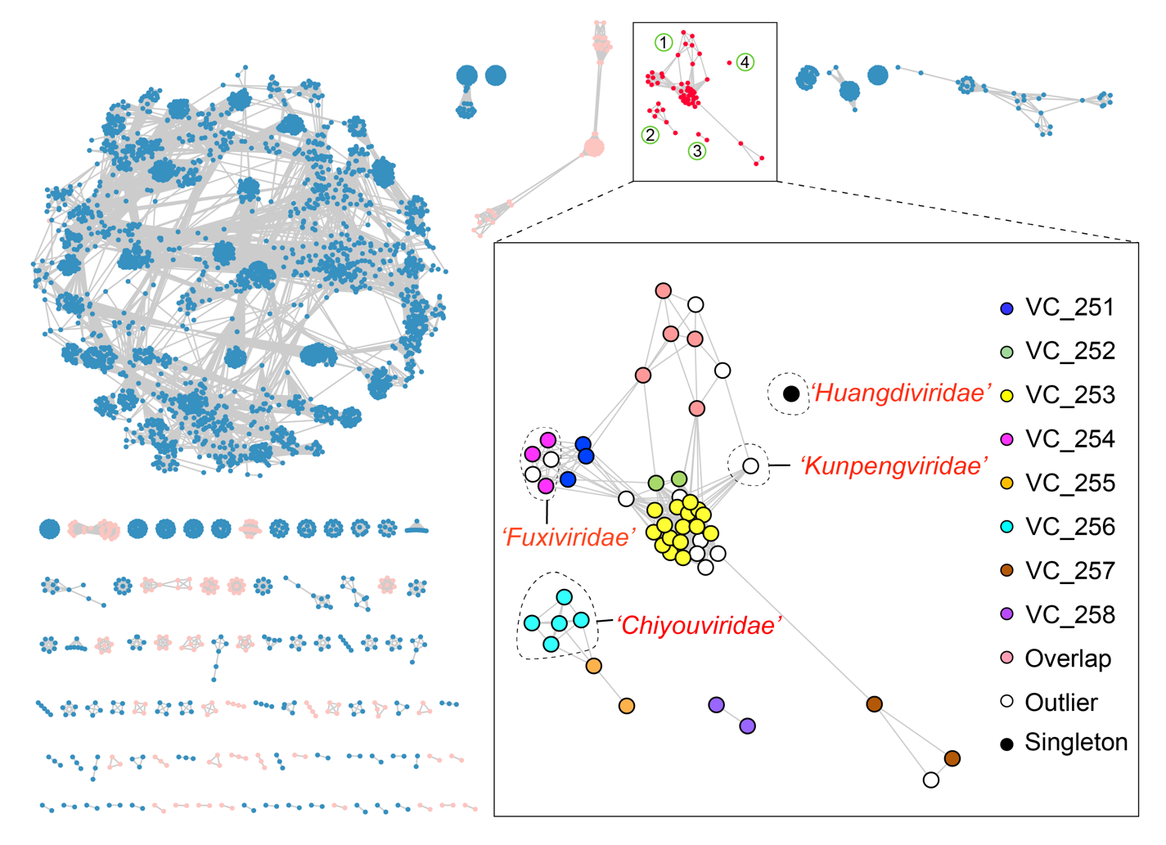Figure 1 Classification of Bathyarchaeia viruses based on the whole-genome protein-sharing network with other prokaryotic viruses; the whole-genome protein-sharing network analysis was constructed using vConTACT2 v.0.11.3 for the taxonomic assignment of 56 Bathyarchaeia viral genomes; Bathyarchaeia virus clusters are outlined with a rectangle in the complete network; Bathyarchaeia viruses are assigned to four distinct groups (numbered within circles), including one large cluster; viral clusters (VCs) are indicated by the colored spheres within the inset; the proposed virus families with complete genomes are separated by dashed lines and appended with the corresponding names; the light pink and light blue clusters outside of the inset represent archaeal and bacterial viruses, respectively; the networks were visualized with Cytoscape v.3.9.1.

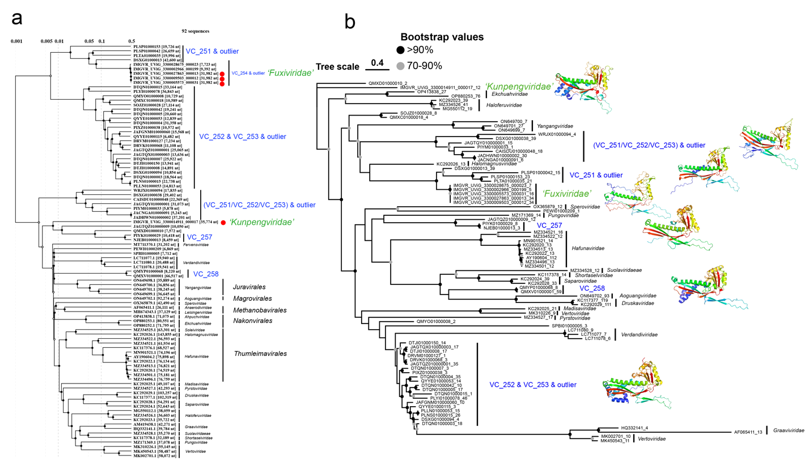

Figure 2 The genome-wide sequence similarity comparison, phylogenetic and modeling of major capsid of Bathyarchaeia viruses in realm Duplodnaviria. a) The proteomic tree displays the relationship between Bathyarchaeia viruses and archaea viruses in the realm Duplodnaviria, based on genome-wide sequence similarities. Bathyarchaeia virus families are labeled in green, and viruses with complete genomes are marked with a red circle. b) The maximum likelihood tree of major capsid proteins (MCPs) shows the relationship between Bathyarchaeia virus and archaeal virus. Bathyarchaeia virus families are labeled in green, and the 3D structure representing the MCP of each family is displayed next to it.

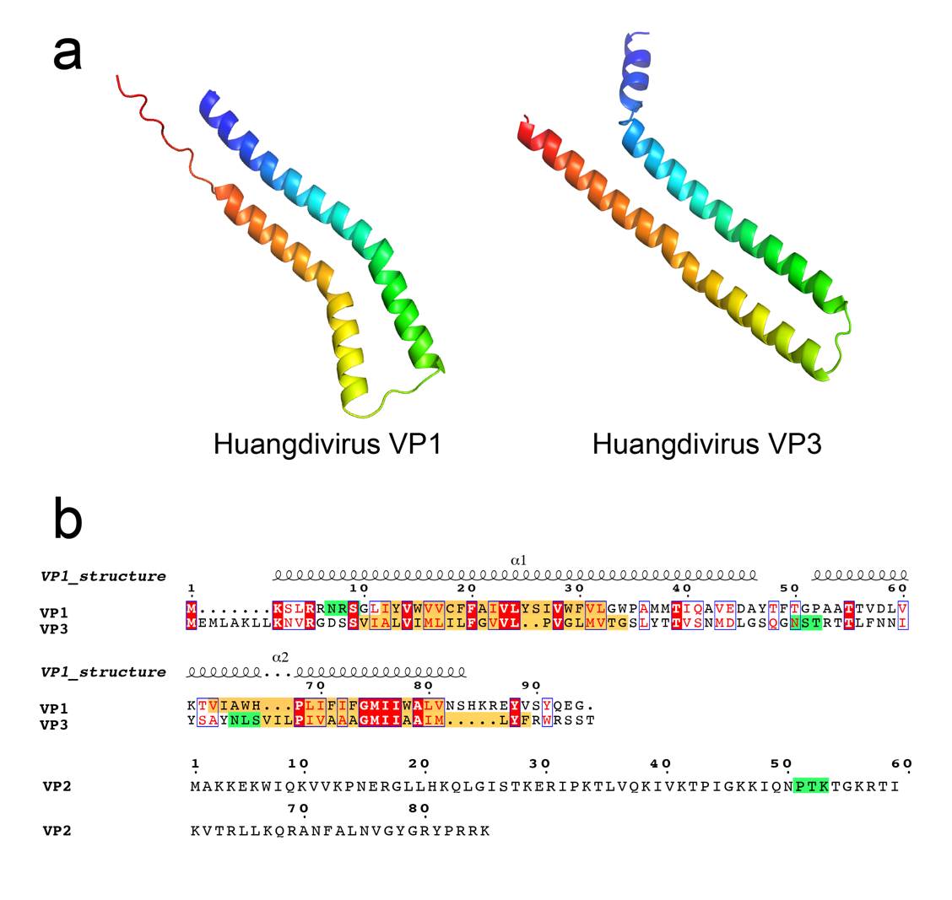

Figure 3 Huangdivirus structural proteins. a) Structural modeling of Huangdivirus capsid proteins VP1 and VP3, colored using a rainbow gradient from N-terminus (blue) to C-terminus (red). b) Sequence analysis of Huangdivirus structural proteins VP1-3, with predicted transmembrane domains highlighted in yellow and theoretical glycosylation consensus motifs (N-X-S/T) shown on a green background.

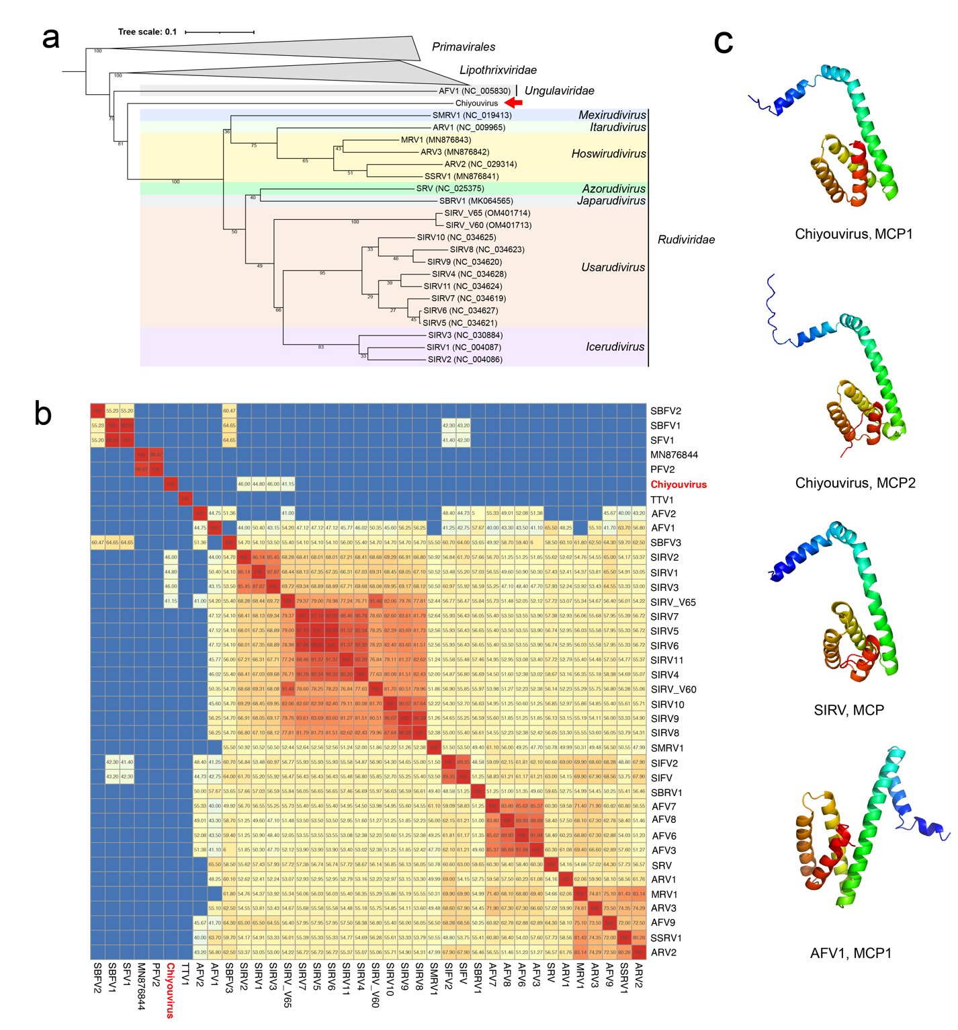

Figure 4 Genomic analysis of Chiyouvirus. a) Phylogenomic tree of Chiyouvirus (red arrow) alongside known members of the Tokiviricetes class, based on whole-genome amino acid analysis using VICTOR. Tree is rooted with Primavirales, and branch length represents GBDP distance formula D6. Branch support values are indicated with numbers. b) Whole-genome amino acid identity comparison of filamentous viruses in the Tokiviricetes class, conducted by EzAAI1. Chiyouvirus is highlighted in red. Only AAI values greater than 40% are displayed in the heatmap. c) Predicted structural model comparison of Bathyarchaeial Chiyouvirus major capsid proteins MCP1 and MCP2 with Icerudivirus SIRV (3J9X, chain A) and Captovirus AFV1 (5W7G, chain A) structures. Models are colored using a rainbow gradient from N-terminus (blue) to C-terminus (red).

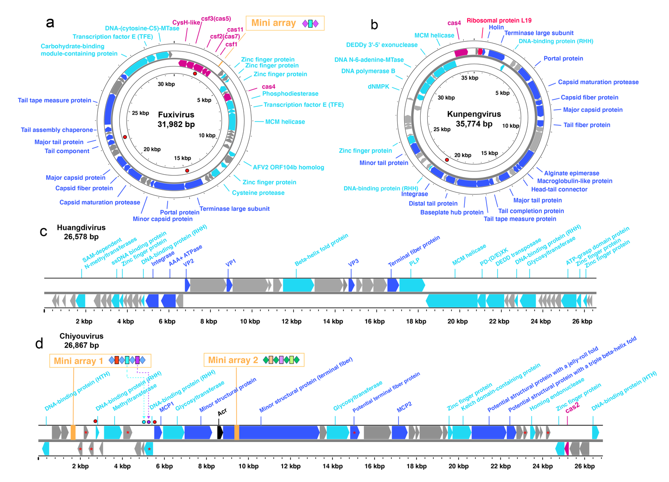

Figure 5 Maps of complete genomes of Bathyarchaeia viruses; (A) Genome map of Fuxivirus; (B) genome map of Kunpengvirus; (C) genome map of Huangdivirus; (D) genome map of Chiyouvirus; genes annotated by HHblits with a probability greater than 95% are shown as different colors; genes related to Type IV B CRISPR-Cas system, Cas4, and Cas2 are indicated in rose pink, mini-CRISPR array in vibrant orange, genes specific to viruses in dark blue, predicted Acr in black, other annotated genes in light blue; the positions of targeted protospacers are indicated with red circle; the organization of CRISPR mini-arrays is shown above the genome maps; in Chiyouvirus CRISPR Array 1, the self-targeting spacers are highlighted in light blue and purple; their corresponding target sites on the genome are marked with circles in the same color; transmembrane proteins of Chiyouvirus predicted using CCTOP [117] server are indicated with red asterisks.