

The International Committee on Taxonomy of Viruses

Taxonomy Proposal Form, 2024

**Part 1a: Details of taxonomy proposals**

|  |  |  |
| --- | --- | --- |
| **Title:** | Create one new family in the order *Magrovirales* (class *Caudoviricetes*) and one new order, ‘*Adrikavirales*’ within the class *Caudoviricetes* | |
| **Code assigned:** | 2024.002A.N.v1.Adrikavirales_neworder_2newfam |

|  |  |  |  |
| --- | --- | --- | --- |
| **Author(s), affiliation and email address(es):** | | | |
| **Name** | **Affiliation** | **Email address** | **Corresponding author(s)** X |
| Prabhu A | Australian Centre for Ecogenomics, the University of Queensland, Brisbane, Australia | apoorva.prabhu@uq.edu.au | **X** |
| Rinke C | University of Innsbruck, 6020 Innsbruck, Austria | christian.rinke@uibk.ac.at |  |

**Part 1b: Taxonomy Proposal Submission**

|  |  |  |  |
| --- | --- | --- | --- |
| **ICTV Subcommittee:** | | | |
| Animal DNA Viruses and Retroviruses |  | Bacterial viruses |  |
| Animal minus-strand and dsRNA viruses |  | Fungal and protist viruses |  |
| Animal positive-strand RNA viruses |  | Plant viruses |  |
| Archaeal viruses | **X** | General - |  |

|  |
| --- |
| **List the ICTV Study Group(s) that have seen or have been involved in creating this proposal:** |
|  |

|  |  |  |  |
| --- | --- | --- | --- |
| **Optional – complete only if formally voted on by an ICTV Study Group:** | | | |
| **Study Group** | **Number of members** | | |
| **Votes in support** | **Votes against** | **No vote** |
|  |  |  |  |
|  |  |  |  |

|  |  |
| --- | --- |
| **Submission date:** | 18/03/2024 |

**Part 1c: Feedback from ICTV Executive Committee (EC) meeting**

|  |  |
| --- | --- |
| **Executive Committee Meeting Decision code:** | **X** |
| A – Accept |  |
| Ac – Accept subject to revision by relevant subcommittee chair. No further vote required | **X** |
| U – Accept without revision but with re-evaluation and email vote by the EC |  |
| Uc – Accept subject to revision and re-evaluation and email vote by the EC |  |
| Ud – Deferred to the next EC meeting, with an invitation to revise based on EC comments |  |
| J - Reject |  |
| W - Withdrawn |  |

|  |
| --- |
| **Comments from the Executive Committee:** |
| The EC voted Ac (see the table above for explanation) for this proposal. The main request for the acceptance of this proposal is to update the GenBank record for the classified viruses with annotations. The GenBank record should minimally contain the coordinates of predicted genes, but additional useful information, such as functional annotations, are desirable. Following these changes, the proposal will proceed directly to the ratification stage. |

**Part 1d: Revised Taxonomy Proposal Submission**

|  |
| --- |
| **Response of proposer:** |
| Thank you for the comments, and we have updated the GenBank records. |

|  |  |
| --- | --- |
| **Revision date:** | 07/10/2024 |

**Part 3:** **TAXONOMIC PROPOSAL**

|  |
| --- |
| **Name of accompanying Excel module:** |
| 2024.002A.N.v1.Adrikavirales_neworder_2newfam.xlsx |

|  |  |  |  |
| --- | --- | --- | --- |
| **Taxonomic changes proposed:** | | | |
| Establish new taxon | **X** | Split taxon |  |
| Abolish taxon |  | Merge taxon |  |
| Move taxon |  | Promote taxon |  |
| Rename taxon |  | Demote taxon |  |
| Move and rename |  |

|  |  |  |
| --- | --- | --- |
| **Is any taxon name used here derived from that of a living person:** | | **N** |
| **Taxon name** | **Person from whom the name is derived** | **Attached X** |
|  |  |  |
|  |  |  |
|  |  |  |

|  |
| --- |
| **Abstract of Taxonomy Proposal:** |
| *Taxonomic rank(s) affected*: Magrovirus group E (unofficially assigned to the order *Magrovirales*; class *Caudoviricetes*) and a new order within the Class *Caudoviricetes*  *Description of current taxonomy*: Recently, the order *Magrovirales* has been created for viruses associated with Marine Group II Archaea (order Poseidoniales), belonging to the class *Caudoviricetes*. Within *Magrovirales*, the family *Aoguangviridae*, representing the group “Magrovirus B” has been created.  *Proposed* *taxonomic change(s):* Here we propose creating a new family ‘*Krittikaviridae*’, representing the group “Magrovirus E”, with one new genus ‘*Velanvirus*’, which will include the species ‘*Velanvirus brisbanense*’. In addition, we identified a virus associated with Poseidoniales, which belongs to a novel order within the Class *Caudoviricetes*. The new order is proposed to be named ‘*Adrikavirales*’ and include a new family ‘*Satyavativiridae*’. The genus and species representative for this order is ‘*Vyasavirus*’ and ‘*Vyasavirus brisbanense*’, respectively.  *Justification*: Most of the currently available magroviruses assigned to group E are not of high quality and do not have GenBank entries. Furthermore, Poseidoniales associated viruses assigned to an order other than *Magrovirales* have not been described. Hence, we propose the classification of viruses based on the demarcation criteria previously established for classification of archaeal tailed viruses (arTVs) infecting halophilic and methanogenic archaea [1]. |

|  |
| --- |
| * **Text of Taxonomy proposal:** |
| Viruses belonging to the class *Caudoviricetes* have gained considerable attention, since they represent an abundant and diverse group of viruses known to infect both bacterial and archaeal hosts. These viruses represent tailed viruses among archaeal viruses, and very few have been classified to date [1]. Recent studies [2,3] identified and described virus associated with possible halophilic and methanogenic hosts, as well as with the ecologically important ammonia-oxidizing class Nitrososphaeria and the globally distributed marine order Poseidoniales [4-7]. Recently, a new order has been created for viruses infecting the order Poseidoniales, named *Magrovirales* with genomic representation for one of the main subgroups, Magrovirus B (now named *Aoguangviridae*) [1]. In 2023, other subgroups, termed Magrovirus X and E have been proposed based on major capsid protein (mcp) and DNA polymerase family B (polB) phylogeny [7]. In this study, we recovered a complete viral genome for Magrovirus group E, for which we propose the rank of a new family and the name “*Krittikaviridae*”. In addition to this group, we also recovered a novel virus associated with Poseidoniales, which is not a magrovirus. For this virus we propose the novel order ‘*Adrikavirales*’ and the novel family ‘*Satyavativiridae*’.  The metagenomic analyses of surface water samples collected in the Brisbane River Estuary (Queensland, Australia) over a one-year period, yielded non-redundant viral genomes that clustered with the previously described Magrovirus groups A, B, C, D, E and X (**Fig. 1**). These genomes encode hallmark proteins of the class *Caudoviricetes*, including the major capsid protein, large subunit of the terminase, portal protein, DNA polymerase family B, and various tail proteins (Fig. 2), and therefore are genuine members of *Caudoviricetes*.  We recovered two complete circular genomes, named 139581_S182_79954 and PR24_contig_10065, respectively, using geNOMAD [11]. This tool assesses over 85,000 marker genes, most of them assigned to the class *Caudoviricetes*, to classify viruses with high confidence into class, order, and family ranks [11]. The two viruses recovered in this study (139581_S182_79954 and PR24_contig_10065) were given a high viral confidence score > 0.91 and were classified as *Caudoviricetes* by geNOMAD. Both viruses, with a length of 79.9 and 86.9 kb (**Table 1**), were estimated to be a 100% complete by checkV [8].  The circular viral genome 139581_S182_79954 was closely related to similar high-quality/complete sequences obtained from IMG/VR db, Ga0098046_1000012 and Ga0211558_10000038, which were classified as *Caudoviricetes* within IMG/VR db and we confirmed this assignment with geNOMAD. Both viral genomes were included in our analyses. Based on gene similarity networks (**Fig.1**) all three viruses clustered with reference viruses, that have been classified as Magrovirus group E and consisted of high-quality sequences that have not been deposited into public databases, i.e. GenBank.  The second complete viral genome, PR24_contig_10065, was identified to be associated with Poseidoniales, based on our iPHoP results (blast and iPHOP-RF) with a confidence score of 96.3%. iPHoP enables high-confidence host genus prediction, by only considering assignments with a high confidence score ≥90, i.e. an estimated false discovery rate below 10%. Furthermore, assignments with a score ≥95 are considered to represent very high confidence predictions (iPHoP score) (Roux et al. 2023). This novel Poseidoniales virus, PR24_contig_10065, formed a clade with similar high-quality/complete sequences from IMG/VR, such as Ga0527078_0751, Ga0213858_10000035, Ga0326499_1000160 and Ga0326492_1000186, all of which have no GenBank entries, but were classified as *Caudoviricetes* within IMG/VR db.  Here we propose the classification of viruses from the Brisbane River Estuary dataset, based on the demarcation criteria previously established for classification of archaeal tailed viruses (arTVs) infecting halophilic and methanogenic archaea [1]:  Species demarcation: members of the same species are defined by an Average Nucleotide Identity (ANI) of equal or greater than 95%.  Genus demarcation: members of the same genus share more than 60% of their proteins.  Family demarcation: viruses from different families share less than 10% of their proteins, and members from the same family share 20-50% of their proteins.  To estimate the proportion of shared genes, the EzAAI tool was used (http://leb.snu.ac.kr/ezaai) with default settings, which were 40% identity and 50% coverage. The output table was spread into a longer format (pivot) using the spread function in tidyr package in Rstudio (v4.2) and used to construct a heatmap with the pheatmap package.  **Magrovirus group E:** Our analysis confirmed that Poseidoniales viruses 139581_S182_79954, Ga0098046_1000012 and Ga0211558_10000038 form one cluster. The closest viral sequence to these genomes, Ga0211558_10000038, shares 34% of its proteins. Both Poseidoniales virus genomes have an ANI >95% and can be proposed as the same species. Hence, we propose a new genus, ‘*Velanvirus*’ and a new species ‘*Velanvirus brisbanense*’ for 139581_S182_79954. Magrovirus group E currently lacks genome sequence representatives with GenBank entries. Therefore, we propose creating the new family ‘*Krittikaviridae*’.  **Novel Poseidoniales virus group**: the viral genome PR24_contig_10065, and its closest relative Ga0213858_10000035, which share 79% of their proteins and have an ANI <95%, can be proposed as different species. Here we propose only one species representative for this group based on our recovered virus (PR24_contig_10065_pilon) , which is represented by the genus ‘*Vyasavirus*’ and the species ‘*Vyasavirus brisbanense*’, belonging to the novel family ‘*Satyavativiridae*’ and the order ‘*Adrikavirales*’.These viruses associated with the order Poseidoniales consistently formed a separate order level clade in the VipTree (Fig 4) and also separated in gene similarity networks (**Fig. 1**), hence we propose a new order ‘*Adrikavirales*’ and a new family ‘*Satyavativiridae*’.  We performed additional phylogenetic analyses to confirm the affiliation of these viral genomes with the class *Caudoviricetes*. We inferred a bootstrapped phylogenetic tree created from 296 major capsid protein (MCP) sequences (**Fig. 5**) which included MCP genes from novel viral genomes, reference archaeal viruses [5-7] and bacterial MCP sequences as an outgroup. Viruses associated with group E (‘*Krittikaviridae*’) formed a clade with group B (*Aoguangviridae*) and X. Viruses associated with Poseidoniales hosts (i.e. ‘*Adrikavirales*’) formed a separate clade with Thaumarchaeota viruses.  To further assess the placement of the newly named viruses among archaeal viruses, we inferred a proteome-based virus tree (ViPTree) by including both prokaryotic and eukaryotic dsDNA viruses and reference archaeal viruses [5-7] totaling 7062 viruses. In this tree, the newly named virus from the species ‘*Velanvirus brisbanenese*’ (group E) was placed within the *Magrovirales* stem (**Fig. 4**), whereas the one from ‘*Vyasavirus brisbanense*’ (PR24_contig_10065_pilon) was placed consistently within a clade containing archaeal viruses, but clustered outside of *Magrovirales* (**Fig. 6**). The combined prokaryotic and eukaryotic tree is provided within hyperlink:  In summary, we propose the following taxon names and provide their etymology:  Family  *Krittikaviridae* – (pronounced k-r-ih-t-ih-k-ah) named after Krittika, a legendary princess bathing in an Indian river (Ganga) according to ancient Indian mythology.  Genus  *Velanvirus* – (prounounced ve-lan) named after Velan, the child of Krittika, born and flowed in the waters, according to ancient Indian mythology.  Species  *Velanvirus brisbanense* – named after Velan, the child of Krittika, born and flowed in the waters, according to ancient Indian mythology, and after the isolation source from the Brisbane River.  Order  *Adrikavirales* – (pronounced Ah-d-r-ih-k-ah), named after the cursed apsara (celestial nymph), who took form of a fish in ancient Indian mythology.  Family  *Satyavativiridae* – (pronounced s-uh-t-y-uh-v-uh-t-ee), named after Satyavati, the child of Adrika, who later became an ancient Indian Queen in ancient Indian mythology.  Genus  *Vyasavirus* - (pronounced v-y-uh-s-aa) named after Vyasa, the child of Satyavati, a revered sage who compiled the Vedas in ancient Indian mythology.  Species  *Vyasavirus brisbanense* – named after Vyasa, the child of Satyavati, a revered sage who compiled the Vedas in ancient Indian mythology, and after the isolation source from the Brisbane River. |

|  |
| --- |
| **References:** |
| 1. Liu Y, Demina TA, Roux S, Aiewsakun P, Kazlauskas D, Simmonds P, Prangishvili D, Oksanen HM, Krupovic M (2021) Diversity, taxonomy, and evolution of archaeal viruses of the class Caudoviricetes. PLOS Biology 19:e3001442. PMID: 34752450. doi: 10.1371/journal.pbio.3001442.  2. Ahlgren NA, Fuchsman CA, Rocap G, Fuhrman JA (2019) Discovery of several novel, widespread, and ecologically distinct marine Thaumarchaeota viruses that encode amoC nitrification genes. ISME J 13(3):618-631. PMID: 30315316. doi: 10.1038/s41396-018-0289-4.  3. López-Pérez M, Haro-Moreno JM, de la Torre JR, Rodriguez-Valera F (2019) Novel Caudovirales associated with Marine Group I Thaumarchaeota assembled from metagenomes. Environ Microbiol 21(6):1980-1988. PMID: 30370610. doi: 10.1111/1462-2920.14462.  4. Philosof A, Yutin N, Flores-Uribe J, Sharon I, Koonin EV, Béjà O (2017) Novel Abundant Oceanic Viruses of Uncultured Marine Group II Euryarchaeota. Curr Biol 27(9):1362-1368. doi: 10.1016/j.cub.2017.03.052. PMID: 28457865  5. Nishimura Y, Watai H, Honda T, Mihara T, Omae K, Roux S, Blanc-Mathieu R, Yamamoto K, Hingamp P, Sako Y, Sullivan MB, Goto S, Ogata H, Yoshida T (2017). Environmental viral genomes shed new light on virus-host interactions in the ocean. Msphere, 2(2), 10-1128.  6. Zhou, Y., Zhou, L., Yan, S., Chen, L., Krupovic, M., & Wang, Y. (2023). Diverse viruses of marine archaea discovered using metagenomics. Environmental Microbiology, 25(2), 367-382.  7. Xu, B., Fan, L., Wang, W., Zhu, Y., & Zhang, C. (2023). Diversity, distribution, and functional potentials of magroviruses from marine and brackish waters. Frontiers in Microbiology, 14, 1151034.  8. Nayfach, S., Camargo, A. P., Schulz, F., Eloe-Fadrosh, E., Roux, S., & Kyrpides, N. C. (2021). CheckV assesses the quality and completeness of metagenome-assembled viral genomes. Nature biotechnology, 39(5), 578-585.  9. Nishimura Y, Yoshida T, Kuronishi M, Uehara H, Ogata H, Goto S (2017) ViPTree: the viral proteomic tree server. Bioinformatics 33:2379-2380. PMID: 28379287. doi: 10.1093/bioinformatics/btx157.  10. Bin Jang H, Bolduc B, Zablocki O, Kuhn JH, Roux S, Adriaenssens EM, Brister JR, Kropinski AM, Krupovic M, Lavigne R, Turner D, Sullivan MB (2019) Taxonomic assignment of uncultivated prokaryotic virus genomes is enabled by gene-sharing networks. Nature Biotechnology 37:632-639. PMID: 31061483. doi: 10.1038/s41587-019-0100-8.  11. Camargo, A.P., Roux, S., Schulz, F. et al. Identification of mobile genetic elements with geNomad. Nat Biotechnol (2023). https://doi.org/10.1038/s41587-023-01953-y |

|  |
| --- |
| **Tables, Figures:** |

**Supporting evidence**

|  |  |  |  |  |  |  |  |  |  |
| --- | --- | --- | --- | --- | --- | --- | --- | --- | --- |
| **Table1: Proposed taxonomy for viruses associated with Poseidoniales** | | | | | | | | | |
| **Virus ID** | **Contig length** | **Topology** | **Completeness** | **Total genes** | **Order** | **Family** | **Genus** | **Species** | **Accession number** |
| 139581_S182_79954 | 79,954 | Circular | 100 | 85 | *Magrovirales* | *Krittikaviridae* | *Velanvirus* | *Velanvirus brisbanense* | PP497039 |
| PR24_contig_10065 | 86,926 | Circular | 100 | 88 | *Adrikavirales* | *Satyavativiridae* | *Vyasavirus* | *Vyasavirus brisbanense* | PP497040 |

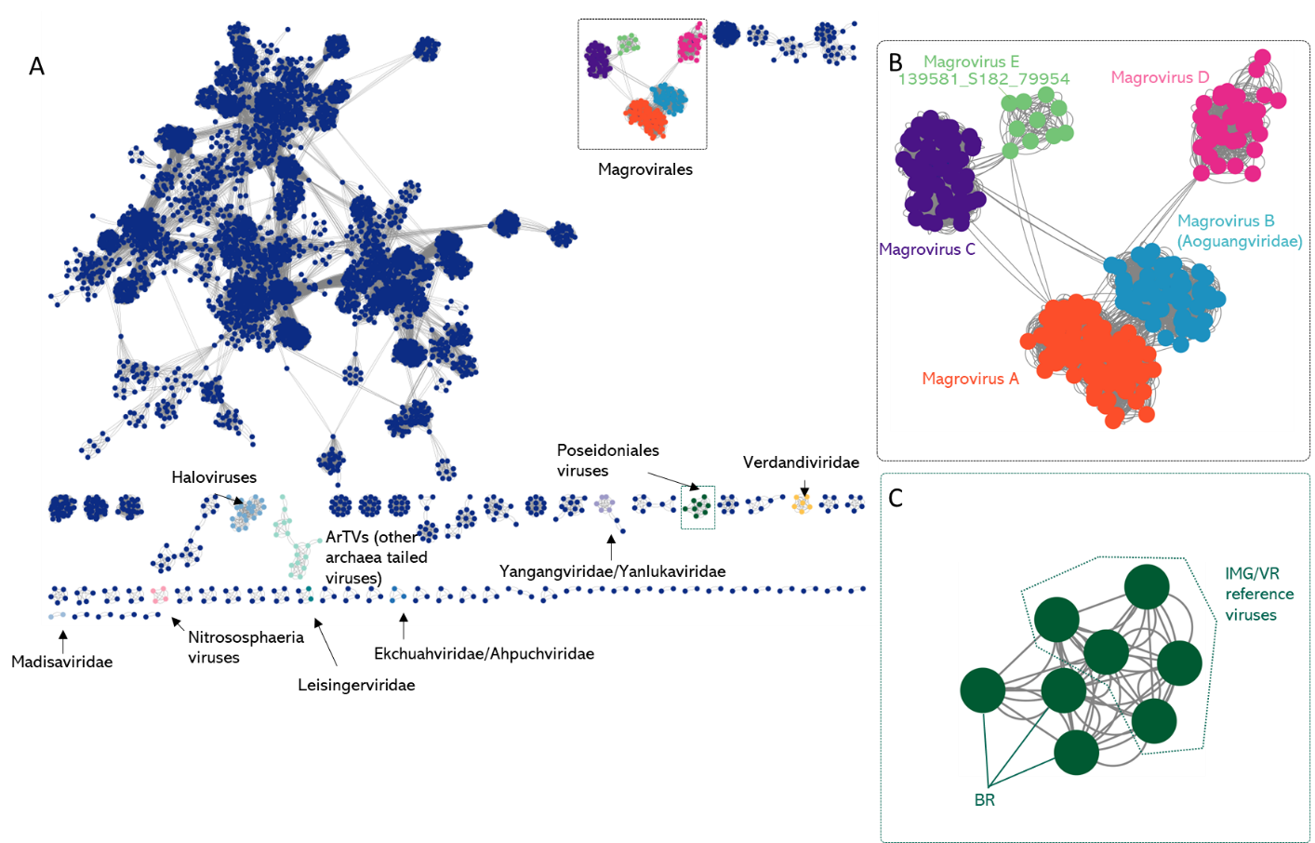

**Figure 1: Network analyses for Brisbane River Estuary viruses (BR) and reference prokaryotic DNA viruses constructed by vConTACT2 using RefSeq211 database. (A)** Each node represents a viral genome, and the edges indicate statistically significant relationship between the genomes based on shared protein profiles. Nodes for bacteriophages are shown in blue, and classified reference archaeal viruses are denoted by arrows. The enlarged panel (inset) indicates a *Magrovirales* cluster **(B)**, consisting of the groups A (orange), B (teal), C (purple), D (pink) and E (light green), identified based on similarities with reference magrovirus genomes. A second cluster **(C)** includes novel BR and related IMG/VR viruses associated with Poseidoniales. The BR viruses within the cluster are highlighted in dark green and denoted by lines.

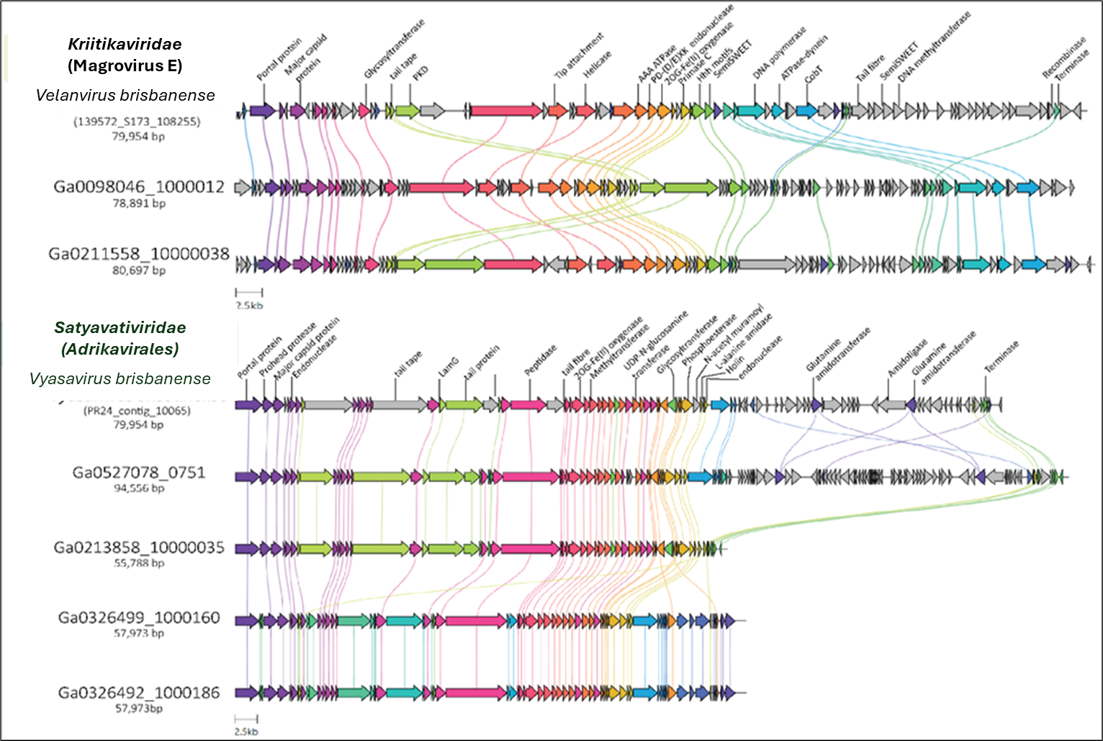

**Figure 2: Gene neighbourhood of representative Magrovirus A and the Brisbane River estuary (BR) viruses. Top box:** Genome map of the Velanvirus brisbanensis (Magrovirus E;139581_S182_79954) and closely related high-quality/complete sequences obtained from IMG/VR (Ga0098046_1000012 and Ga0211558_10000038). The genomes were re-oriented to aid visualisation. **Bottom box**: Genome map of Vyasavirus brisbanense (PR24_contig_10065_pilon) and closely related high-quality/complete sequences obtained from IMG/VR (Ga0527078_0751, Ga0213858_10000035, Ga0326499_1000160, Ga0326492_1000186). Related genes are linked by respective colour shading, indicating the percentage identity between genes. A selection of related genes, which have significant similarity (Blastp 1e-05, Bitscore >70 and % similarity > 40), were annotated by Gennomenet-aar and blast searches, and the annotations are shown in the figure.

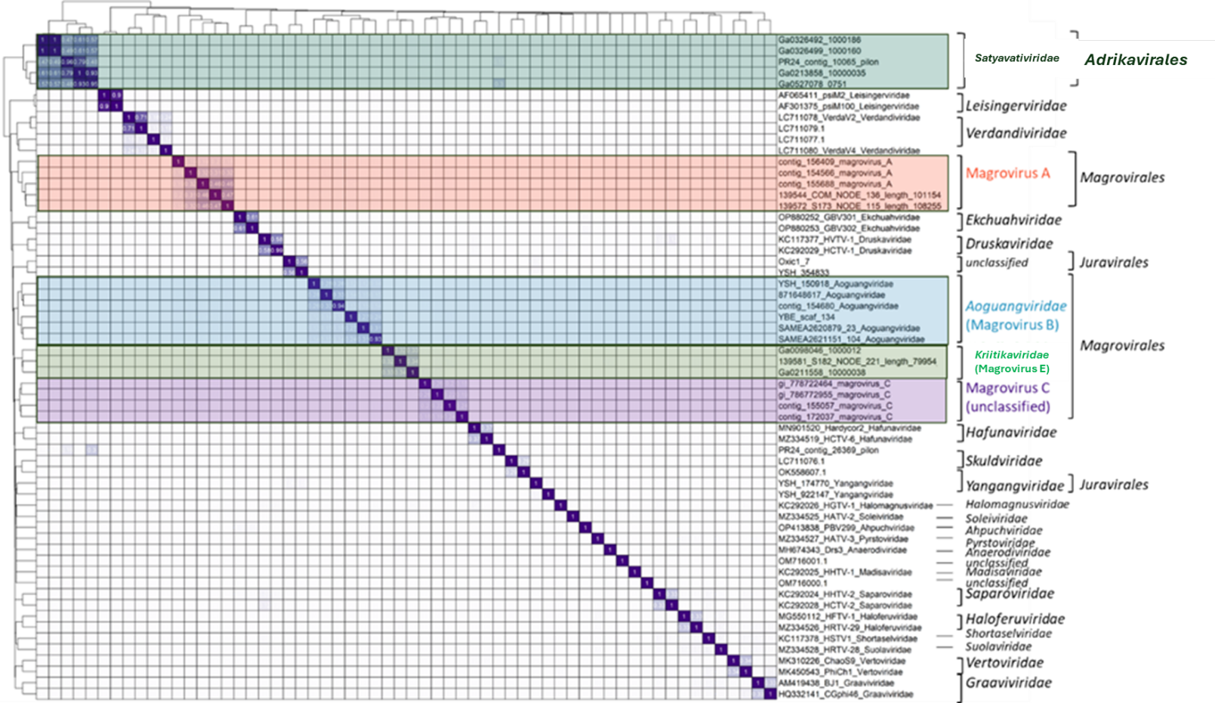

**Figure 3: Heatmap of orthologous proteins shared between Poseidoniales associated viruses.** Genes belonging to the same group are shown in clusters, with values > 0.08 shown in boxes. The proportion for family level demarcation is 0.1. Viral groups are highlighted and labelled as magrovirus group A (orange), B (teal), C (purple) and as the newly proposed ‘*Krittikaviridae*’ (group E)(light green) and as new order ‘*Adrikavirales*’ (dark green).

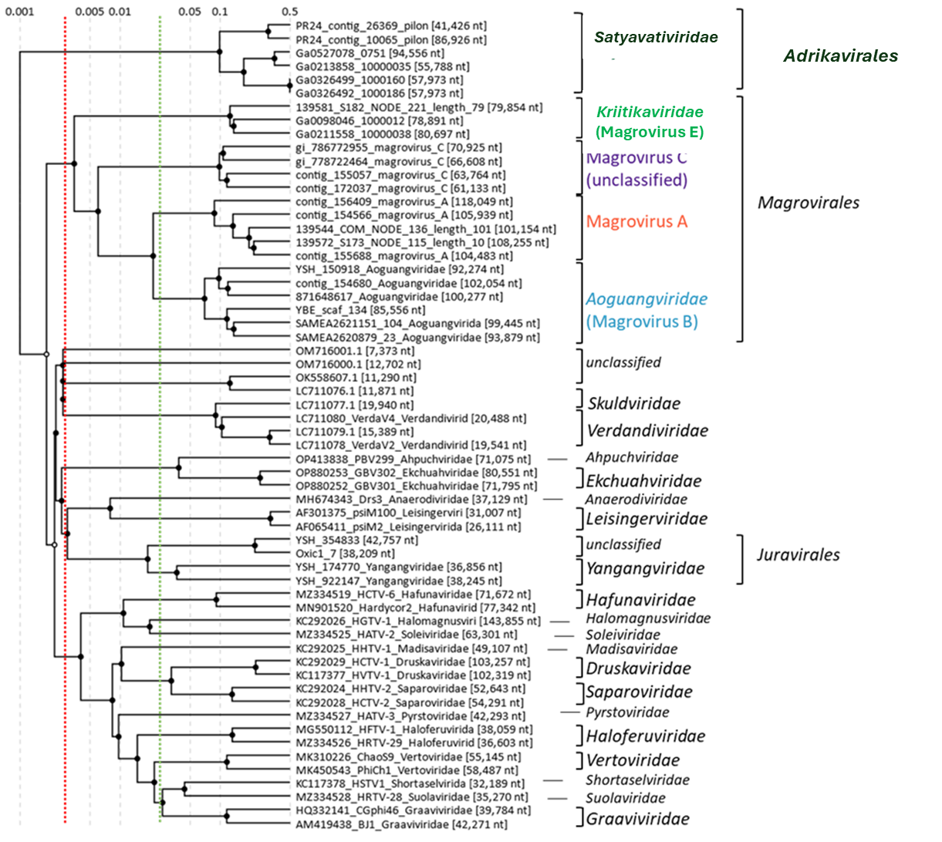

**Figure 4: Current classification for the using ViPTree analysis.** The newly proposed viruses are indicated by bold green text. The ViPTree is a web-based tool that constructs trees using BIONJ using all-versus-all genomic similarity matrix. The branch length, for family level demarcation, is highlighted in green dashed line and for order level in orange.

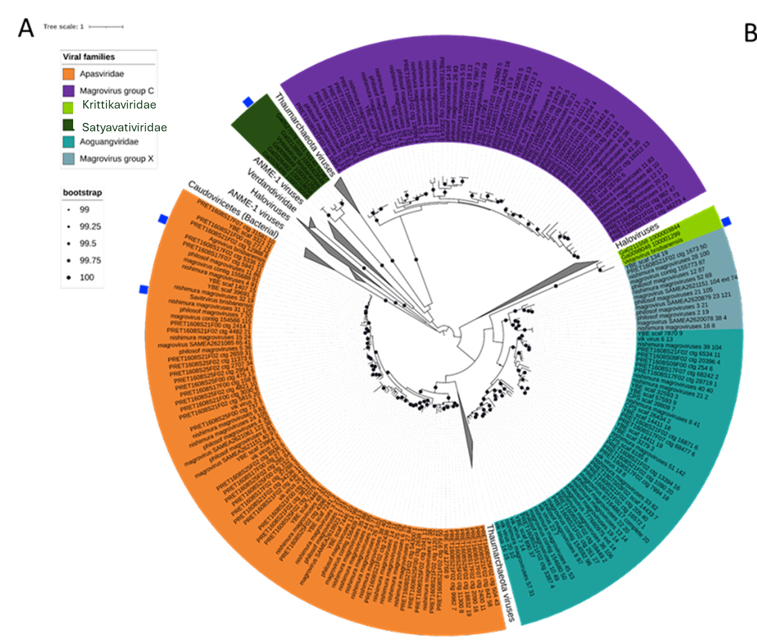

**Figure 5: MCP phylogeny of newly named and reference archaeaviruses.** A bootstrapped phylogenetic tree was built using protein alignments of major capsid protein (MCP) sequences of newly named, reference archaeal viruses and bacterial MCP (*Caudoviricetes*) as an outgroup. Colors are shaded for each viral family and provided in the legend. Viral contigs/genomes with newly proposed names are marked with a blue square. Bootstrap support values between 99% and 100% are indicated by black dots.

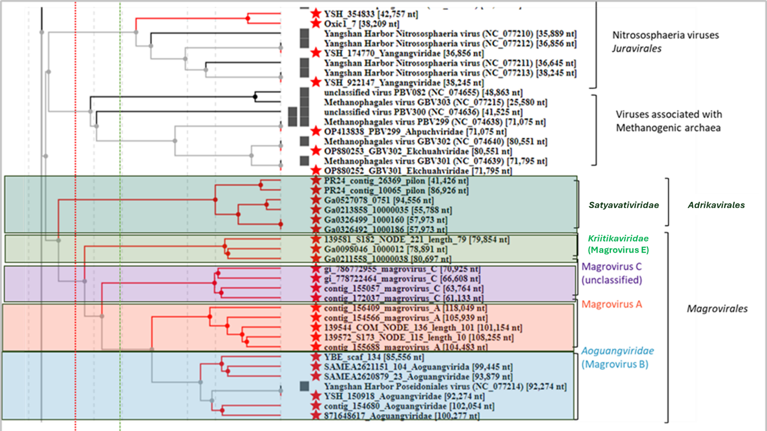

**Figure 6: Classification against prokaryotic dsDNA viruses in VIPTree analyses.** The ViPTree is a web-based tool that constructs trees using BIONJ using all-versus-all genomic similarity matrix.The magroviruses and the novel Poseidoniales virus are indicated in shading next to the colored text. The newly proposed viruses are indicated by bold green text. The branch length, for family level demarcation, is highlighted in green dashed line and for order level in orange.