

The International Committee on Taxonomy of Viruses

Taxonomy Proposal Form, 2024

**Part 1a: Details of taxonomy proposals**

|  |  |  |
| --- | --- | --- |
| **Title:** | Create one new family in the order *Magrovirales* (class *Caudoviricetes*) | |
| **Code assigned:** | 2024.001A.N.v1.Apasviridae_newfam |

|  |  |  |  |
| --- | --- | --- | --- |
| **Author(s), affiliation and email address(es):** | | | |
| **Name** | **Affiliation** | **Email address** | **Corresponding author(s)** X |
| Prabhu A | Australian Centre for Ecogenomics, the University of Queensland, Brisbane, Australia | apoorva.prabhu@uq.edu.au | **X** |
| Rinke C | University of Innsbruck, 6020 Innsbruck, Austria | christian.rinke@uibk.ac.at |  |

**Part 1b: Taxonomy Proposal Submission**

|  |  |  |  |
| --- | --- | --- | --- |
| **ICTV Subcommittee:** | | | |
| Animal DNA Viruses and Retroviruses |  | Bacterial viruses |  |
| Animal minus-strand and dsRNA viruses |  | Fungal and protist viruses |  |
| Animal positive-strand RNA viruses |  | Plant viruses |  |
| Archaeal viruses | **X** | General - |  |

|  |
| --- |
| **List the ICTV Study Group(s) that have seen or have been involved in creating this proposal:** |
|  |

|  |  |  |  |
| --- | --- | --- | --- |
| **Optional – complete only if formally voted on by an ICTV Study Group:** | | | |
| **Study Group** | **Number of members** | | |
| **Votes in support** | **Votes against** | **No vote** |
|  |  |  |  |
|  |  |  |  |

|  |  |
| --- | --- |
| **Submission date:** | 24/07/2023 |

**Part 1c: Feedback from ICTV Executive Committee (EC) meeting**

|  |  |
| --- | --- |
| **Executive Committee Meeting Decision code:** | **X** |
| A – Accept |  |
| Ac – Accept subject to revision by relevant subcommittee chair. No further vote required |  |
| U – Accept without revision but with re-evaluation and email vote by the EC |  |
| Uc – Accept subject to revision and re-evaluation and email vote by the EC | **X** |
| Ud – Deferred to the next EC meeting, with an invitation to revise based on EC comments |  |
| J - Reject |  |
| W - Withdrawn |  |

|  |
| --- |
| **Comments from the Executive Committee:** |
| The EC voted Uc (see the table above for explanation) for this proposal. The conditions for the acceptance of this proposal are twofold. First, given that the genome of Magrovirus_A_02 is incomplete, please remove from the proposal the creation of genus *Savitrvirus*. Second, please update the GenBank record for Magrovirus_A_01 with annotations. The GenBank record should minimally contain the coordinates of predicted genes, but additional useful information, such as functional annotations, are desirable. Following these changes, the proposal will be voted upon by the EC via an email vote in the fall and, if accepted, proceed to the ratification stage. |

**Part 1d: Revised Taxonomy Proposal Submission**

|  |
| --- |
| **Response of proposer:** |
| We have now indicated that the recovered genomes assigned to the genus *Savitrvirus and the species Savitrvirus brisbanense* are incomplete, and we have therefore removed the proposal of these two names.  We have also updated the Genbank records. |

|  |  |
| --- | --- |
| **Revision date:** | 07/10/2024 |

**Part 3:** **TAXONOMIC PROPOSAL**

|  |
| --- |
| **Name of accompanying Excel module:** |
| 2024.001A.N.v1.Apasviridae_newfam.xlsx |

|  |  |  |  |
| --- | --- | --- | --- |
| **Taxonomic changes proposed:** | | | |
| Establish new taxon | **X** | Split taxon |  |
| Abolish taxon |  | Merge taxon |  |
| Move taxon |  | Promote taxon |  |
| Rename taxon |  | Demote taxon |  |
| Move and rename |  |

|  |  |  |
| --- | --- | --- |
| **Is any taxon name used here derived from that of a living person:** | | **N** |
| **Taxon name** | **Person from whom the name is derived** | **Attached X** |
|  |  |  |
|  |  |  |
|  |  |  |

|  |
| --- |
| **Abstract of Taxonomy Proposal:** |
| *Taxonomic rank(s) affected*: Magrovirus group A (order *Magrovirales*; class *Caudoviricetes*)  *Description of current taxonomy*: Recently, the order *Magrovirales* has been created for viruses associated with Marine Group II Archaea (order *Poseidoniales*), belonging to the class *Caudoviricetes*. Within *Magrovirales*, the family *Aoguangviridae*, representing the group “Magrovirus B” has been created.  *Proposed* *taxonomic change(s):* Here we propose creating the new family ‘*Apasviridae*’, representing the group “Magrovirus A”, with one new genus ‘*Agnivirus*’, which includes the species ‘*Agnivirus brisbanense*’. Please note, that the genus Savitrvirus and the species ‘Savitrvirus brisbanense’, which are included in the text and the figures of this proposal, are not officially proposed at this point because complete genomes are currently not available for this virus group.  *Justification*: Most of the recovered magroviruses belonging to group A have not been deposited into public databases, i.e. GenBank. Hence, we propose the classification of viruses based on the demarcation criteria previously established for classification of archaeal tailed viruses (arTVs) infecting halophilic and methanogenic archaea [1]. |

|  |
| --- |
| * **Text of Taxonomy proposal:** |
| Viruses belonging to the class *Caudoviricetes* have gained considerable attention, since they represent an abundant and diverse group of viruses known to infect both bacterial and archaeal hosts. These viruses represent tailed viruses among archaeal viruses, and very few have been classified to date [1]. Recent studies [2,3] identified and described viruses associated with possible halophilic and methanogenic hosts, as well as with the ecologically important ammonia-oxidizing class Nitrososphaeria and the globally distributed marine order Poseidoniales [4-7]. Recently, a new order has been created for viruses infecting the order Poseidoniales, named *Magrovirales* with genomic representation for one of the main subgroups, Magrovirus B (now named *Aoguangviridae*). In this study we propose a new family “*Apasviridae*” for another Magrovirales subgroup, Magrovirus A.  The metagenomic analyses of surface water samples collected in the Brisbane River Estuary (Queensland, Australia) over a one-year period, yielded non-redundant viral genomes that clustered with the previously described Magrovirus groups A, B and C (Fig. 1). These genomes encode hallmark proteins of the class *Caudoviricetes*, including the major capsid protein, large subunit of the terminase, portal protein, DNA polymerase family B, and various tail proteins (Fig. 2), and therefore are genuine members of *Caudoviricetes*. We recovered one complete circular genome (100% completeness estimated by checkV [8]) and one near-complete genome (in reference to the 100% complete magrovirus sequence contig_155688 [4] as estimated by checkV) named 139572_S173_108255 and 139544_COM_101154, respectively. Both viral genomes are ~100kb in size, and therefore in the size range expected for Magroviruses [4]. Both viral genomes are closely related to the previously recovered viral sequences contig_155688, contig_154566 and contig_156409, which have been unofficially assigned to Magrovirus group A [4], but have not been deposited into public databases, i.e. GenBank. Here, we propose the classification of viruses from the Brisbane River Estuary dataset based on the demarcation criteria previously established for classification of archaeal tailed viruses (arTVs) infecting halophilic and methanogenic archaea [1]:  **Species demarcation**: members of the same species are defined by an Average Nucleotide Identity (ANI) of equal or greater than 95%.  **Genus demarcation**: members of the same genus share more than 60% of their proteins.  **Family demarcation**: viruses from different families share less than 10% of their proteins, and members from the same family share 20-50% of their proteins.  To estimate the proportion of shared genes, the EzAAI tool was used (http://leb.snu.ac.kr/ezaai) with default settings, which was 40% identity and 50% coverage. The output table was spread into a longer format (pivot) using the spread function in tidyr package in Rstudio(v4.2) and used to construct a heatmap with the pheatmap package. This analysis confirmed that Poseidoniales viruses 139572_S173_108255 and 139544_COM_101154 show similarities to magroviruses of group A. The closest viral sequence to these genomes, contig_155688, shares 46.5% of the proteins. Both viral genomes have an ANI <95% and can be proposed as different species. Hence, we propose new genus, ‘*Agnivirus*’ and species ‘*Agnivirus brisbanense*’ for the classification of the complete genome 139572_S173_108255. A similar approach was used to evaluate the near-complete genomes of the phages Lötschberg virus, Oberland virus and Kander virus [11], which has been approved by ICTV. The viral genome (*Savitrviiirus brisbanense)* which share 46.5% of the proteins by pairwise comparison (Fig. 3) to the closest viral reference genome contig_155688 (Table 2) and is therefore considered to be coding complete.  The viruses associated with the order Poseidoniales consistently formed three family level groups in our ViPTree analysis, in concordance with previous studies [9]. Magrovirus group A currently lacks genome sequence representatives with GenBank entries. Therefore, we propose creating a new family ‘*Apasviridae*’. In summary, we propose the following taxon names and provide their etymology:  Family  *Apasviridae* – (pronounced Ap-as) after the ancient water goddesses in Indian mythology.  Genus  *Agnivirus* – (pronounced Ag-nee) After the Hindu God Agni, as the fire of life on earth was born out of Apas, from ancient Indian mythology.  Species  *Agnivirus brisbanense* –After the Hindu God Agni, as the fire of life on earth was born out of Apas, from ancient Indian mythology, and after the isolation source in the Brisbane River.  **Names not officially proposed since complete genomes are currently not available for this virus group:**  *Savitrvirus* – (pronounced Sa-vi-tra) After the Hindu God Savitr, who is the fire of the sun and the child of the waters from ancient Indian mythology.  *Savitrvirus brisbanense* - After the Hindu God Savitr, who is the fire of the sun and the child of the waters from ancient Indian mythology, and after the isolation source in the Brisbane River**.** |

|  |
| --- |
| **References:** |
| 1. Liu Y, Demina TA, Roux S, Aiewsakun P, Kazlauskas D, Simmonds P, Prangishvili D, Oksanen HM, Krupovic M (2021) Diversity, taxonomy, and evolution of archaeal viruses of the class Caudoviricetes. PLOS Biology 19:e3001442. PMID: 34752450. doi: 10.1371/journal.pbio.3001442.  2. Ahlgren NA, Fuchsman CA, Rocap G, Fuhrman JA (2019) Discovery of several novel, widespread, and ecologically distinct marine Thaumarchaeota viruses that encode amoC nitrification genes. ISME J 13(3):618-631. PMID: 30315316. doi: 10.1038/s41396-018-0289-4.  3. López-Pérez M, Haro-Moreno JM, de la Torre JR, Rodriguez-Valera F (2019) Novel Caudovirales associated with Marine Group I Thaumarchaeota assembled from metagenomes. Environ Microbiol 21(6):1980-1988. PMID: 30370610. doi: 10.1111/1462-2920.14462.  4. Philosof A, Yutin N, Flores-Uribe J, Sharon I, Koonin EV, Béjà O (2017) Novel Abundant Oceanic Viruses of Uncultured Marine Group II Euryarchaeota. Curr Biol 27(9):1362-1368. doi: 10.1016/j.cub.2017.03.052. PMID: 28457865  5. Nishimura Y, Watai H, Honda T, Mihara T, Omae K, Roux S, Blanc-Mathieu R, Yamamoto K, Hingamp P, Sako Y, Sullivan MB, Goto S, Ogata H, Yoshida T (2017). Environmental viral genomes shed new light on virus-host interactions in the ocean. Msphere, 2(2), 10-1128.  6. Zhou, Y., Zhou, L., Yan, S., Chen, L., Krupovic, M., & Wang, Y. (2023). Diverse viruses of marine archaea discovered using metagenomics. Environmental Microbiology, 25(2), 367-382.  7. Xu, B., Fan, L., Wang, W., Zhu, Y., & Zhang, C. (2023). Diversity, distribution, and functional potentials of magroviruses from marine and brackish waters. Frontiers in Microbiology, 14, 1151034.  8. Nayfach, S., Camargo, A. P., Schulz, F., Eloe-Fadrosh, E., Roux, S., & Kyrpides, N. C. (2021). CheckV assesses the quality and completeness of metagenome-assembled viral genomes. Nature biotechnology, 39(5), 578-585.  9. Nishimura Y, Yoshida T, Kuronishi M, Uehara H, Ogata H, Goto S (2017) ViPTree: the viral proteomic tree server. Bioinformatics 33:2379-2380. PMID: 28379287. doi: 10.1093/bioinformatics/btx157.  10. Bin Jang H, Bolduc B, Zablocki O, Kuhn JH, Roux S, Adriaenssens EM, Brister JR, Kropinski AM, Krupovic M, Lavigne R, Turner D, Sullivan MB (2019) Taxonomic assignment of uncultivated prokaryotic virus genomes is enabled by gene-sharing networks. Nature Biotechnology 37:632-639. PMID: 31061483. doi: 10.1038/s41587-019-0100-8.  11.Seuberlich T, Kuhn JH, Schmidt-Posthaus H.2023.Near-Complete Genome Sequence of Lötschberg Virus (Mononegavirales: Filoviridae) Identified in European Perch (Perca fluviatilis Linnaeus, 1758). Microbiol Resour Announc12:e00028-23.https://doi.org/10.1128/mra.00028-23 |

|  |
| --- |
| **Tables, Figures:** |

**Supporting evidence**

|  |  |  |  |  |  |  |  |  |  |
| --- | --- | --- | --- | --- | --- | --- | --- | --- | --- |
| **Table1: Proposed taxonomy for viruses associated with Poseidoniales** | | | | | | | | | |
| **Virus ID** | **Contig length** | **Topology** | **Completeness** | **Total genes** | **Order** | **Family** | **Genus** | **Species** | **Accession number** |
| 139572_S173_ 108255 | 108,255 | Circular | 100 | 99 | *Magrovirales* | *Apasviridae* | *Agnivirus* | *Agnivirus brisbanense* | OR863078 |

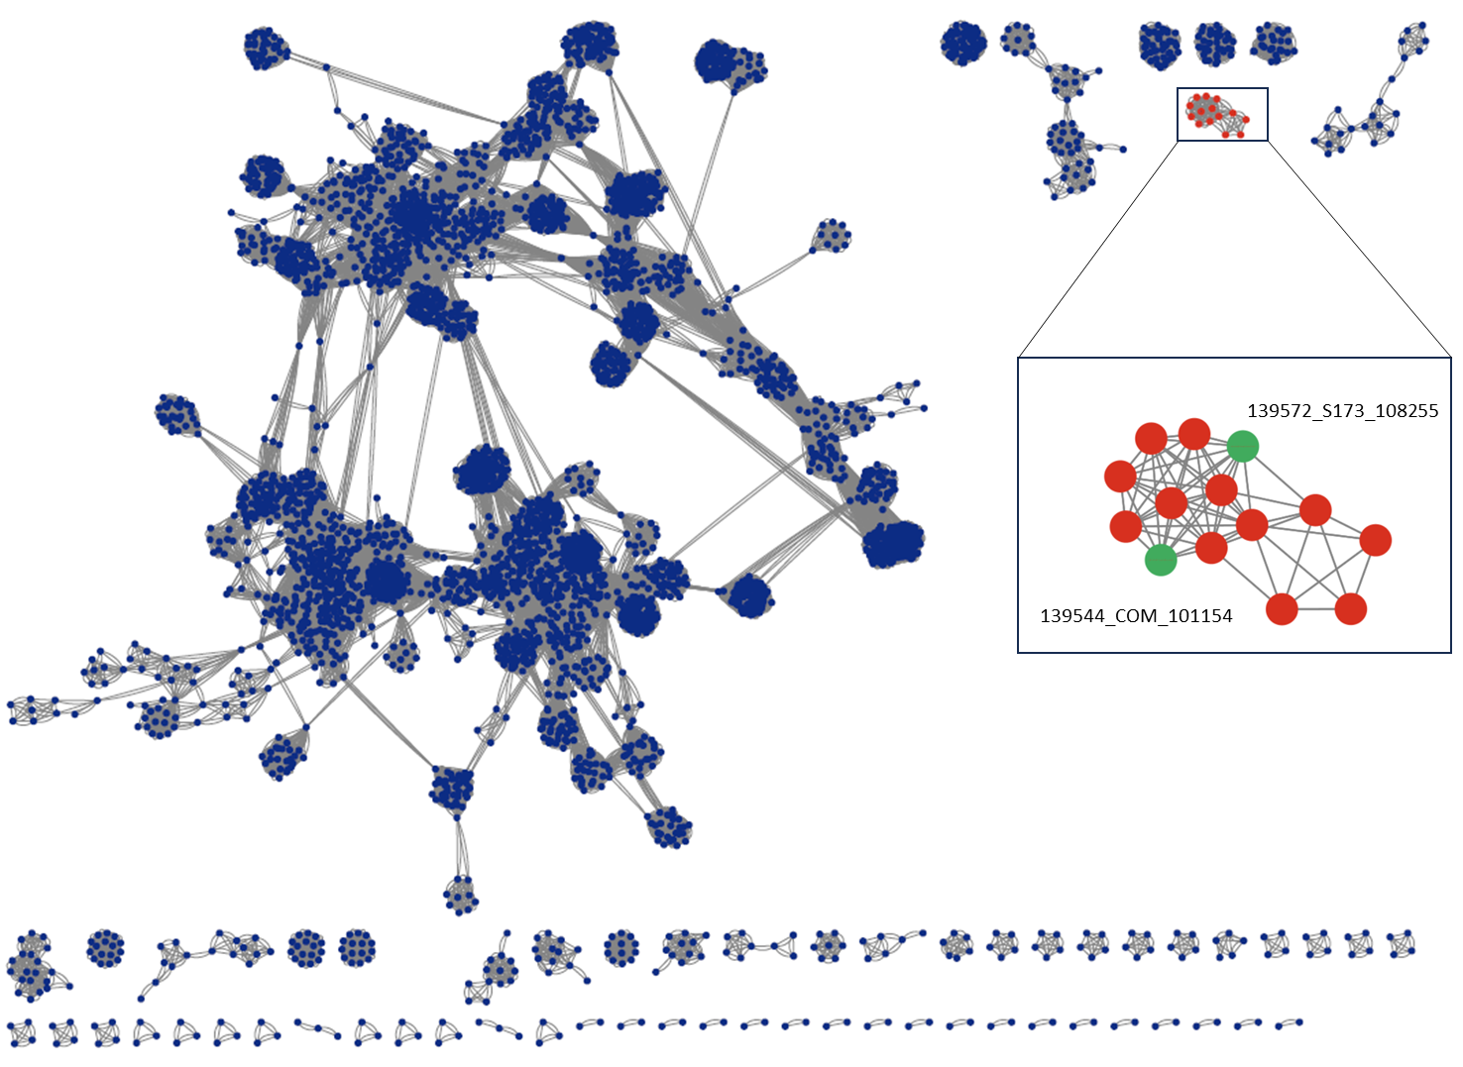

**Figure 1: Network analyses for Brisbane River Estuary viruses (BR) and reference prokaryotic DNA viruses constructed by vConTACT2 using RefSeq211 database.** Each node represents a viral genome, and the edges indicating statistically significant relationship between the genomes based on shared protein profiles. Nodes for bacteriophages are shown in blue, and for classified archaea viruses in red. The enlarged panel (inset) indicates the *Magrovirales* cluster shown in red, based on the similarities with the reference magrovirus genomes. BR viruses within the cluster are marked in green.

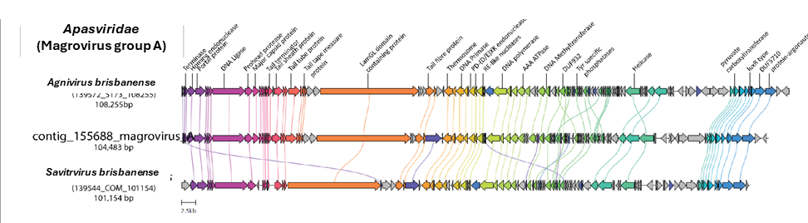

**Figure 2: Gene neighbourhood of representative Magrovirus A and the Brisbane River estuary (BR) viruses.** Genome map of the Magrovirus A contig_155688, and the complete genome 139572_S173_108255 and the near-complete genome 139544_COM_101154 from the Brisbane River Estuary dataset. The genomes were re-oriented to aid visualisation. Related genes are linked by respective colour lines indicating the percentage identity >= 30% between genes. A selection of related genes, which have significant similarity (Blastp 1e-05, bitscore > 70 and similarity % > 40), were annotated by Genomenet-aar and by BLASTp search against NCBI NR database are shown in the figure.

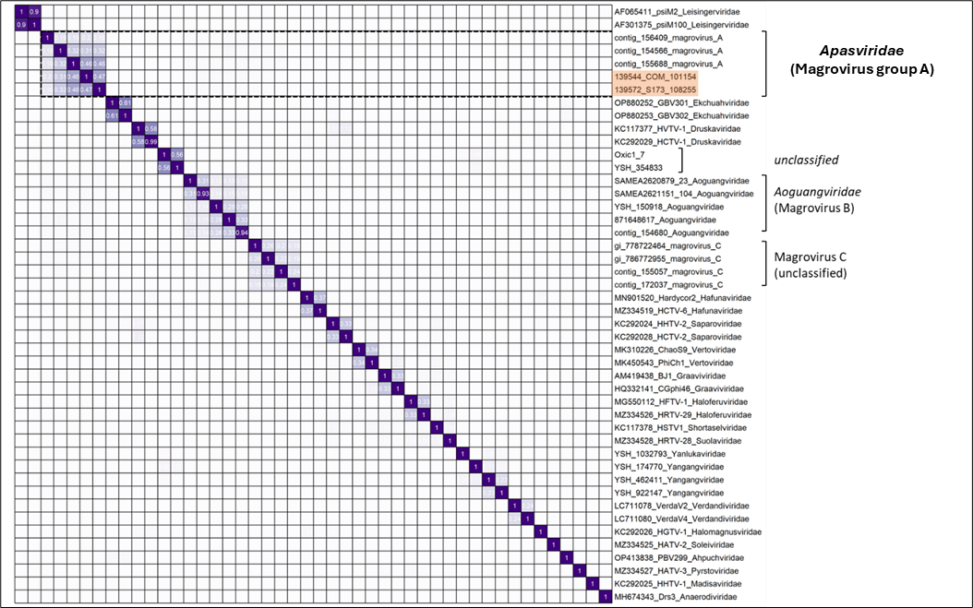

**Figure 3: Heatmap of orthologous proteins shared between *Magrovirales* viruses.** Genes belonging to the same group are shown in clusters, with values > 0.08 shown in boxes. The proportion for family level demarcation is 0.1. The Brisbane River viruses are highlighted in light orange in the figure.

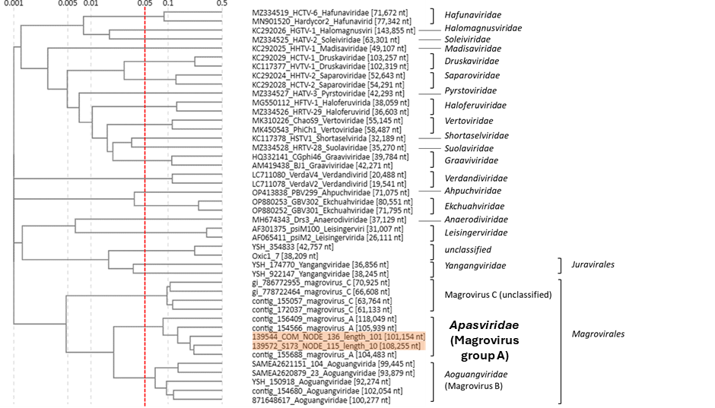

**Figure 4: Current classification for the *Magrovirales* using ViPTree analysis.** The newly proposed viral family (‘*Apasviridae*’) is indicated in bold font. The ViPTree is a web-based tool that constructs trees using BIONJ using all-versus-all genomic similarity matrix. The branch length for family level demarcation, is around 0.05. The Brisbane River viruses are highlighted with a shaded orange background.

Table 2: Annotations for accessory, morphogenetic and replication modules for the viral hallmark genes of *Savitrvirus brisbanense* genome that had complete coding sequences (CDS).

