

The International Committee on Taxonomy of Viruses

Taxonomy Proposal Form, 2024

**Part 1a: Details of taxonomy proposals**

|  |  |  |
| --- | --- | --- |
| **Title:** | Create four new species and abolish one current species in family *Baculoviridae* | |
| **Code assigned:** | 2024.005D.N.v1.Baculoviridae_4nsp_1absp |

|  |  |  |  |
| --- | --- | --- | --- |
| **Author(s), affiliation and email address(es):** | | | |
| **Name** | **Affiliation** | **Email address** | **Corresponding author(s)** X |
| van Oers MM | Laboratory of Virology, Wageningen University and  Research, Wageningen, the Netherlands | monique.vanoers@wur.nl |  |
| Abd-Alla AMM | Joint FAO/IAEA Programme of Nuclear Techniques in Food  and Agriculture, Vienna International Centre, Vienna, Austria | A.M.M.Abd-Alla@iaea.org |  |
| Bateman KS | European Community Reference Laboratory for Crustacean Diseases, Center for Environment, Fisheries and Aquaculture Science (CEFAS), Dorset. UK | kelly.bateman@cefas.co.uk |  |
| Bojko J | School of Health and Life Sciences, Teesside University, Middlesbrough, UK | j.bojko@tees.ac.uk |  |
| Harrison RL | Invasive Insect Biocontrol and Behavior Laboratory, USDAARS,  10300 Baltimore Avenue,  Beltsville, MD, USA | robert.l.harrison@usda.gov | **X** |
| Herniou EA | Institut de Recherche sur la Biologie de l’Insecte,  CNRS - University of Tours, Tours, France | elisabeth.herniou@univ-tours.fr |  |
| Sun XL | State Key Laboratory of Virology, Wuhan Institute of  Virology, Chinese Academy of Sciences, Wuhan,  P. R. China | sunxl@wh.iov.cn |  |
| Jehle JA | Institute for Biological Control, Julius Kühn-Institut, Dossenheim, Germany | Johannes.Jehle@julius-kuehn.de |  |
| Krell PJ | Department of Molecular and Cellular Biology, University of  Guelph, Guelph, Canada | pkrell@uoguelph.ca |  |
| Ribeiro BM | Laboratory of Baculovirus, Cell Biology Department,  University of Brasília, Brasília, Brazil | bergmann@unb.br |  |

**Part 1b: Taxonomy Proposal Submission**

|  |  |  |  |
| --- | --- | --- | --- |
| **ICTV Subcommittee:** | | | |
| Animal DNA Viruses and Retroviruses | **X** | Bacterial viruses |  |
| Animal minus-strand and dsRNA viruses |  | Fungal and protist viruses |  |
| Animal positive-strand RNA viruses |  | Plant viruses |  |
| Archaeal viruses |  | General - |  |

|  |
| --- |
| **List the ICTV Study Group(s) that have seen or have been involved in creating this proposal:** |
| *Baculoviridae* and *Nudiviridae* Study Group |

|  |  |  |  |
| --- | --- | --- | --- |
| **Optional – complete only if formally voted on by an ICTV Study Group:** | | | |
| **Study Group** | **Number of members** | | |
| **Votes in support** | **Votes against** | **No vote** |
| Baculovirdae and Nudivirdae | 7 | 0 | 1 |
|  |  |  |  |

|  |  |
| --- | --- |
| **Submission date:** | 30/04/2024 |

**Part 1c: Feedback from ICTV Executive Committee (EC) meeting**

|  |  |
| --- | --- |
| **Executive Committee Meeting Decision code:** | **X** |
| A – Accept |  |
| Ac – Accept subject to revision by relevant subcommittee chair. No further vote required |  |
| U – Accept without revision but with re-evaluation and email vote by the EC |  |
| Uc – Accept subject to revision and re-evaluation and email vote by the EC |  |
| Ud – Deferred to the next EC meeting, with an invitation to revise based on EC comments |  |
| J - Reject |  |
| W - Withdrawn |  |

|  |
| --- |
| **Comments from the Executive Committee:** |
|  |

**Part 1d: Revised Taxonomy Proposal Submission**

|  |
| --- |
| **Response of proposer:** |
|  |

|  |  |
| --- | --- |
| **Revision date:** | DD/MM/YYYY |

**Part 3:** **TAXONOMIC PROPOSAL**

|  |
| --- |
| **Name of accompanying Excel module:** |
| 2024.005D.N.v1.Baculoviridae_4nsp_1absp.xlsx |

|  |  |  |  |
| --- | --- | --- | --- |
| **Taxonomic changes proposed:** | | | |
| Establish new taxon | **X** | Split taxon |  |
| Abolish taxon | **X** | Merge taxon |  |
| Move taxon |  | Promote taxon |  |
| Rename taxon |  | Demote taxon |  |
| Move and rename |  |

|  |  |  |
| --- | --- | --- |
| **Is any taxon name used here derived from that of a living person:** | | **N** |
| **Taxon name** | **Person from whom the name is derived** | **Attached X** |
|  |  |  |
|  |  |  |
|  |  |  |

|  |
| --- |
| **Abstract of Taxonomy Proposal:** |
| *Taxonomic rank(s) affected*: Species  *Description of current taxonomy*: There are currently 65 species in genus *Alphabaculovirus* and 28 species in genus *Betabaculovirus* of the family *Baculoviridae*.  *Proposed* *taxonomic change(s):* We propose to create three new species in the genus *Alphabaculovirus*, one new species in the genus *Betabaculovirus*, and abolish one current species, *Alphabaculovirus altermaconfiguratae*.  *Justification for the abolisment* : Analysis of recently sequenced baculovirus genomes have identified four viruses that represent a previously undescribed baculovirus species, in accordance with the species demarcation criteria defined for the family *Baculoviridae*. An analysis of the genomes of viruses from the species *Alphabaculovirus mabrassicae*, *Alphabaculovirus maconfiguratae* and *Alphabaculovirus altermaconfiguratae* indicates that *Alphabaculovirus altermaconfiguratae* is redundant and should be abolished. The creation of *A. mabrassicae* precedes that of both *A. maconfiguratae* and *A. altermaconfiguratae*, and the exemplar isolate of *A. mabrassicae* falls in the same clade as the exemplar isolate of *A. altermaconfiguratae,* so we propose to abolish *A. altermaconfiguratae*. |

|  |
| --- |
| * **Text of Taxonomy proposal:** |
| *Taxonomic rank(s) affected*: Species  *Description of current taxonomy*: The family *Baculoviridae* currently contains 97 species in 4 genera [1]. Most of the species are classified into genera *Alphabaculovirus* and *Betabaculovirus*, which contain 65 and 28 species, respectively. Isolates are classified into these genera if they conform to the following criteria:   * Host species of the insect order Lepidoptera * Circular double-stranded DNA genome ranging in size from 80 to 180 kbp with a gene content characteristic of other alphabaculoviruses or betabaculoviruses; * Relationships to other alpha- or betabaculoviruses as inferred by molecular phylogeny; * Occlusion bodies formed within the nucleus (*Alphabaculovirus*) or the nucleocytoplasmic mileu formed after degradation of the nuclear envelope (*Betabaculovirus*), with a shape and size characteristic for the genus; * Rod-shaped virions consisting of enveloped nucleocapsids, with single (*Betabaculovirus*) or multiple (*Alphabaculovirus*) virions contained in each occlusion body.   Specific epithets for member species of *Baculoviridae* are Latinized words formed by merging the first two to four letters of the host genus name with the genitive form of the host specific epithet [2]. For example, the species for alphabaculovirus Autographa californica multiple nucleopolyhedrovirus is *Alphabaculovirus aucalifornicae*.  *Proposed* *taxonomic change(s)*:  We propose to create the following species for classification in *Alphabaculovirus* or *Betabaculovirus*:  **1) *Alphabaculovirus pastagnalis***  **Exemplar isolate:** Parapoynx stagnalis nucleopolyhedrovirus 473 (PastNPV-473) [3]  **Etymology:** The host specific epithet *stagnalis* comes from *stāgnum* (“standing water”) and the suffix‎ -*ālis*, consistent with the presence of semi-aquatic larvae of the host in rice paddies. The genitive of the suffix -*alis* is -*alis*, so we have selected *pastagnalis* for the virus specific epithet.  **2) *Alphabaculovirus pavitrealis***  **Exemplar isolate:** Palpita vitrealis nucleopolyhedrovirus Gz05 (PaviNPV-Gz05) [4]  **Etymology:** Moths of *Palpita vitrealis* possess translucent wings, and its scientific name presumably derived from *vitrus*, the Latin adjective for glassy or translucent, and the suffix *-alis*. The genitive for the suffix -*alis* is -*alis*, so we have selected *pavitrealis* for the virus specific epithet.  **3) *Alphabaculovirus spocosmioidis***  **Exemplar isolate:** Spodoptera cosmioides nucleopolyhedrovirus VPN72 (SpcoNPV-VPN72) [5]  **Etymology:** San Blas et al. [6] suggest that the host epithet *cosmoides* comes from the Greek *kosmas* (beautiful and orderly) and the suffix *–(o)ides* (similar to, shaped like, looking like). We have adopted the genitive *spocosmoidis* for the virus specific epithet.  **4) *Betabaculovirus psincretae***  **Exemplar isolate:** Psilogramma increta granulovirus GZ (PsinGV-GZ) [7]  **Etymology:** In the absence of information on the host epithet, we followed the general rule for making a genitive in singular and adopted the epithet *psincretae* for the viral species epithet.  In addition, we propose to abolish the current species *Alphabaculovirus altermaconfiguratae*.  *Demarcation criteria:*  Species demarcation criteria for baculoviruses are based on pairwise nucleotide distances estimated with the Kimura-2-parameter (K2P) substitution model. Initially, this criterion employed pairwise alignments of three conserved genes, with a cutoff value of >0.050 substitutions/site indicating that the viruses being compared belonged to different species, while distances <0.015 indicated that they belonged to the same species [8]. For K2P distances between these two cutoff points, additional evidence is required to support the classification of the isolates being compared into different species. Later, a modified version of the criteria based on a larger group of complete baculovirus genome sequences was developed using concatenated pairwise nucleotide alignments of all 38 core genes of the family *Baculoviridae* [9]. The core gene-based criterion largely confirmed the species assignments based on the three-loci criterion, with cutoff points for species demarcation determined to be <0.021 (same species) and >0.072 (different species) substitutions/site, with additional evidence required for species assignments when pairwise distances fall between these two cutoff points.  *Justification*:  Phylogenetic inference based on core gene amino acid alignments placed exemplar isolates of the proposed new species in clades with other alphabaculoviruses (Figures 1, 2) or betabaculoviruses (Figure 3). Analysis of their nucleotide sequences yielded K2P distances above the cut-off point for new species in pairwise alignments, indicating that these viruses represented previously undescribed species in their respective genera.  Three species of alphabaculoviruses isolated from larvae of the host genus *Mamestra* are currently listed for the family *Baculoviridae*. These species consist of *Alphabaculovirus mabrassicae* (exemplar isolate: Mamestra brassica nucleopolyhedrovirus K1), *Alphabaculovirus maconfiguratae* (exemplar isolate: Mamestra configurata nucleopolyhedrovirus A 90/2), and *Alphabaculovirus alterconfiguratae* (exemplar isolate: Mamestra configurata nucleopolyhedrovirus B 96B). The recent sequencing and analysis of several alphabaculovirus isolates from *Mamestra brassica* revealed that these isolates do not form a distinct monophyletic clade, but instead occur in the clades corresponding to isolates of species *A. maconfiguratae* or *A. altermaconfiguratae* [10 – 12]. K2P pairwise distances between *A. mabrassicae* isolates and isolates of either *A. maconfiguratae* or *A. altermaconfiguratae* confirm that one of these three species is redundant. *A. mabrassicae* appeared first in the list of baculovirus species in the ICTV 5th Report (MSL #12, 1991), followed later by *A. maconfiguratae* (MSL #20, 2002) and *A. altermaconfiguratae* (MSL #23, 2005).A majority of the sequenced *A. mabrassicae* isolates, including the exemplar isolate Mamestra brassica nucleopolyhedrovirus K1, occur in the *A. altermaconfiguratae* clade [10]. We therefore propose that *A. altermaconfiguratae* should be abolished. |
|  |

|  |
| --- |
| **References:** |
| 1. Harrison RL, Herniou EA, Jehle JA, Theilmann DA, Burand JP, Becnel JJ, Krell PJ, van Oers MM, Mowery JD, Bauchan GR (2018) ICTV Virus Taxonomy Profile: *Baculoviridae*. Journal of General Virology 99:1185-1186. PMID: 29947603 DOI 10.1099/jgv.0.001107 2. van Oers MM, Herniou EA, Jehle JA, Krell PJ, Abd-Alla AMM, Ribeiro BM, Theilmann DA, Hu Z, Harrison RL (2023) Developments in the classification and nomenclature of arthropod-infecting large DNA viruses that contain *pif* genes. Archives of Virology 168:182. PMID: 37322175 DOI 10.1007/s00705-023-05793-8. 3. Harrison RL, Rowley DL (2022) The Parapoynx stagnalis nucleopolyhedrovirus (PastNPV), a divergent member of the alphabaculovirus group I clade, encodes a homolog of Ran GTPase. Viruses 14:2289. PMID: 36298845 DOI 10.3390/v14102289. 4. El-Salamouny S, Wennmann JT, Kleespies RG, Richert-Pöggeler KR, Mansour A, Awad M, Agamy E, Salama R, Jehle JA (2022) Identification of a new nucleopolyhedrovirus isolated from the olive leaf moth, *Palpita vitrealis*, from two locations in Egypt. Journal of Invertebrate Pathology 192:107770. PMID: 35597278 DOI 10.1016/j.jip.2022.107770. 5. Resmin C, Santos ER, Sosa-Gómez DR, Ribeiro BM, Ardisson-Araújo DMP (2022) Characterization and genomic analyses of a novel alphabaculovirus isolated from the black armyworm, *Spodoptera cosmioides* (Lepidoptera: Noctuidae). Virus Research 316: 198797. PMID: 35537574 DOI 10.1016/j.virusres.2022.198797. 6. San Blas G, Ficheti P, Barrionuevo MJ, Murúa G (2022) Amendment of a typo: *Spodoptera cosmioides* vs. *Spodoptera cosmiodes* (Lepidoptera: Noctuidae). Biotaxa 81: 52-53. DOI 10.25085/rsea.810305. 7. Zhang H, Li L, Chen B, Zuo Y, Wu W, Yuan M, Yang K (2022) Genome analysis of Psilogramma increta granulovirus and its intrapopulation diversity. Virus Research 322:198946. PMID: 36179968 DOI 10.1016/j.virusres.2022.198946. 8. Jehle JA, Lange M, Wang H, Hu Z, Wang Y, Hauschild R (2006) Molecular identification and phylogenetic analysis of baculoviruses from Lepidoptera. Virology 346:180-193. PMID: 15215679 DOI: 10.1023/B:VIRU.0000032784.03761.e2 9. Wennmann JT, Keilwagen J, Jehle JA (2018) Baculovirus Kimura two-parameter species demarcation criterion is confirmed by the distances of 38 core gene nucleotide sequences. J Gen Virol 99:1307-1320. PMID: 30045782 DOI: 10.1099/jgv.0.001100 10. Erlandson M, Baldwin D, Vlak JM, Theilmann D (2024) Genomics of alphabaculovirus isolates infecting Mamestra species from North America and Eurasia. Journal of Invertebrate Pathology 203:108163. PMID: 38286330 DOI: 10.1016/j.jip.2024.108063 11. Dou T, Gao F, Zhu J, Wang Z, Yang X, Hao Y, Song N, An S, Ying X, Liu X (2024) Evolutionary analysis and biological characterization of a novel alphabaculovirus isolated from *Mythimna separata*. Journal of General Virology 105. PMID: 38376497 DOI: 10.1099/jgv.0.001958 12. Yang X, Peng X, Lei C, Min Y, Hu J, Sun X (2024) Virus-host coevolutionary analyses of an Alphabaculovirus with a wide host range. Journal of General Virology 105. PMID: 38314674 DOI: 10.1099/jgv.0.001959 13. Silvestro D, MIchalak I (2012) raxmlGUI: a graphical front-end for RAxML. Organisms Diversity & Evolution 12:335-337. DOI: 10.1007/s13127-011-0056-0 14. Le SQ, Gascuel O (2008) An improved general amino acid replacement matrix. Mol Biol Evol 25:1307-1320. PMID: 18367465 DOI: 10.1093/molbev/msn067 15. Théze J, Lopez-Vaamonde C, Cory JS, Herniou EA (2018) Biodiversity, evolution and ecological specialization of baculoviruses: A treasure trove for future applied research. Viruses 10(7):366. PMID: 29997344 PMCID: PMC6071083 DOI: 10.3390/v10070366 |
|  |

|  |
| --- |
| **Tables, Figures:** |

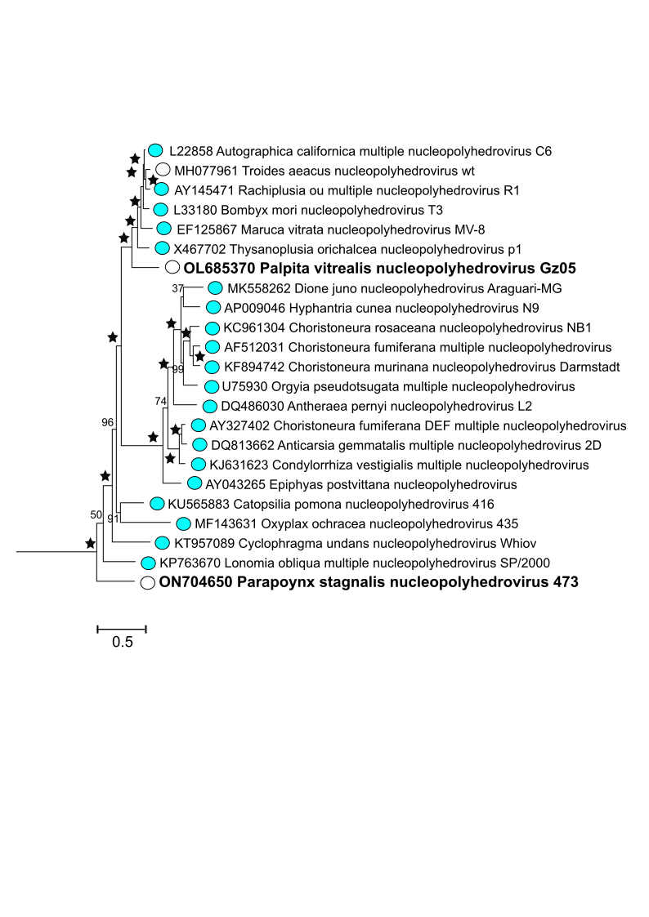

**Figure 1.** Phylogeny showing the relationships of baculoviruses of the Group I clade of genus *Alphabaculovirus* (*Lefavirales*: *Baculoviridae*). Shown is a maximum likelihood tree inferred from the concatenated alignments of 38 baculovirus core gene amino acid sequences with RAxML [13] using the Le and Gascuel (LG) substitution model [14]. Reliability of the tree was assessed with 100 rapid bootstrap replicates, with bootstrap support shown for each node. Stars indicate 100% bootstrap support. Colored circles indicate exemplar viruses classified in genus *Alphabaculovirus* and are listed in the ICTV Virus Metadata Resource. Unclassified viruses are indicated by open circles. The exemplar viruses for proposed species *Alphabaculovirus pastagnalis* and *Alphabaculovirus pavitrealis* are in bold type.

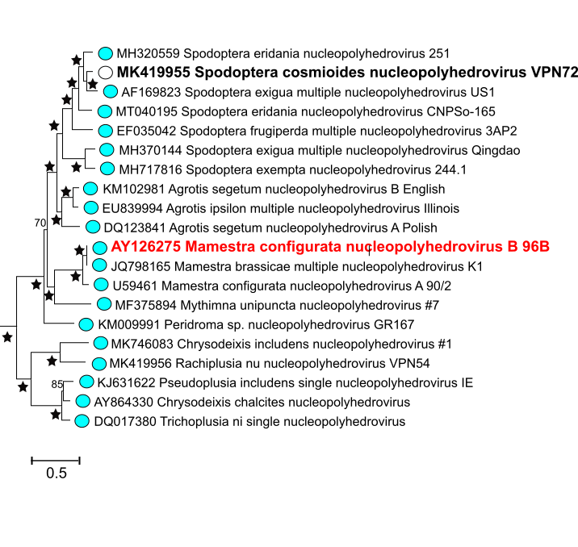

**Figure 2.** Phylogeny showing the relationships of baculoviruses in clade II.A of genus *Alphabaculovirus* (*Lefavirales*: *Baculoviridae*)[15]. Shown is a maximum likelihood tree inferred as described for Figure 1, with bootstrap support shown for each node. Colored circles indicate exemplar viruses classified in genus *Alphabaculovirus* and unclassified viruses are indicated by open circles. The exemplar virus for proposed species *Alphabaculovirus spocosmioidis* is in bold black type, and the exemplar virus for the species *Alphabaculovirus altermaconfiguratae* which we propose to abolish is in bold red type.

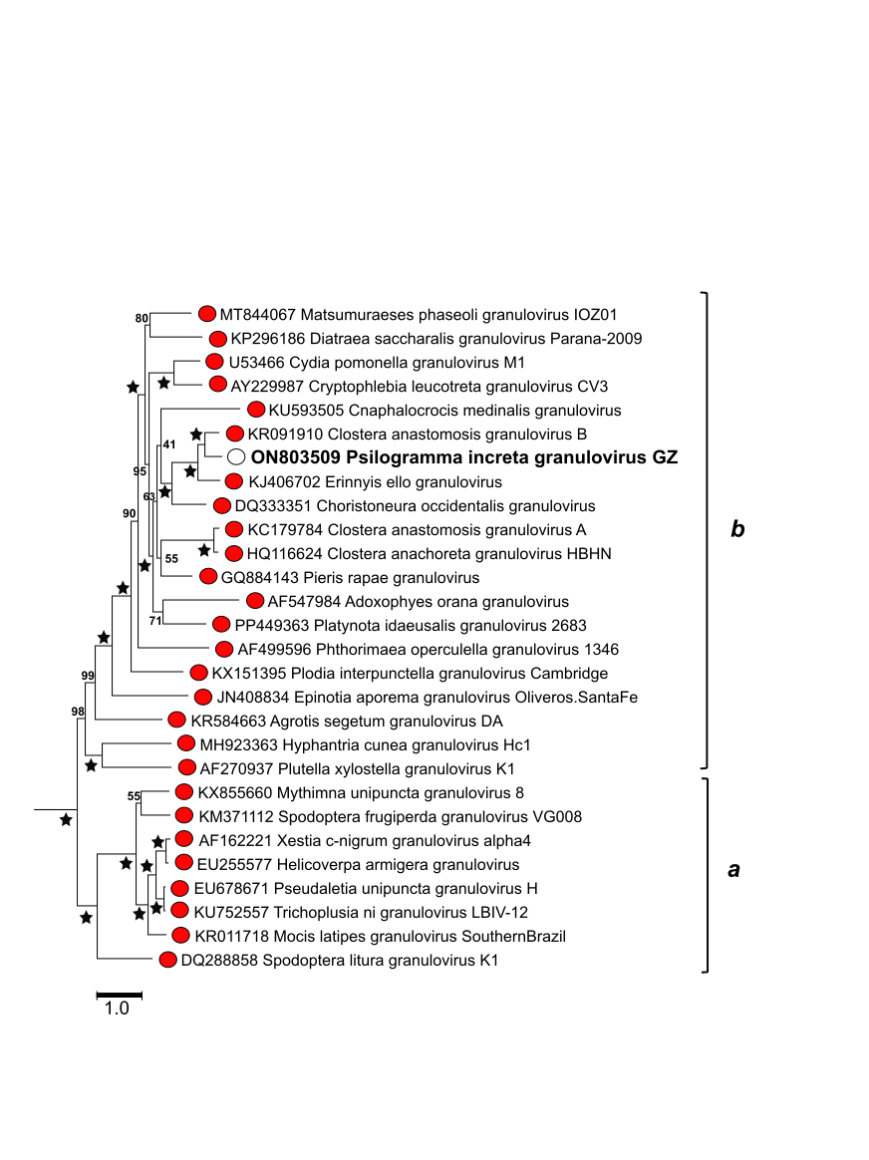

**Figure 3.** Phylogeny showing the relationships of baculoviruses of genus *Betabaculovirus* (*Lefavirales*: *Baculoviridae*). Shown is a maximum likelihood tree inferred as described for Figure 1, with bootstrap support shown for each node and the two base clades of the genus (*a* and *b*) indicated by brackets. Colored circles indicate exemplar viruses classified in genus *Betabaculovirus* and unclassified viruses are indicated by open circles. The exemplar virus for proposed species *Betabaculovirus psincretae* is in bold type.