

The International Committee on Taxonomy of Viruses

Taxonomy Proposal Form, 2024

**Part 1a: Details of taxonomy proposals**

|  |  |  |
| --- | --- | --- |
| **Title:** | Create five new species in the genus *Circovirus* (*Cirlivirales: Circoviridae*) | |
| **Code assigned:** | 2024.002D.N.v1.1.Circoviridae_5ns |

|  |  |  |  |
| --- | --- | --- | --- |
| **Author(s), affiliation and email address(es):** | | | |
| **Name** | **Affiliation** | **Email address** | **Corresponding author(s)** X |
| Tarján ZL | HUN-REN Veterinary Medical Research Institute, Budapest, Hungary | [tarjan.zoltan@vmri.hun-ren.](mailto:tarjan.zoltan@vmri.hun-ren.)hu | X |
| Benkő M | HUN-REN Veterinary Medical Research Institute, Budapest, Hungary | [maribenko@gmail.com](mailto:maribenko@gmail.com) |  |
| Egyed L | HUN-REN Veterinary Medical Research Institute, Budapest, Hungary | egyed.laszlo@vmri.hu |  |
| Harrach B | HUN-REN Veterinary Medical Research Institute, Budapest, Hungary | [balazs.harrach@gmail.com](mailto:balazs.harrach@gmail.com) |  |
|  |  |  |  |
|  |  |  |  |
|  |  |  |  |

**Part 1b: Taxonomy Proposal Submission**

|  |  |  |  |
| --- | --- | --- | --- |
| **ICTV Subcommittee:** | | | |
| Animal DNA Viruses and Retroviruses | **X** | Bacterial viruses |  |
| Animal minus-strand and dsRNA viruses |  | Fungal and protist viruses |  |
| Animal positive-strand RNA viruses |  | Plant viruses |  |
| Archaeal viruses |  | General - |  |

|  |
| --- |
| **List the ICTV Study Group(s) that have seen or have been involved in creating this proposal:** |
| Circoviridae SG |

|  |  |  |  |
| --- | --- | --- | --- |
| **Optional – complete only if formally voted on by an ICTV Study Group:** | | | |
| **Study Group** | **Number of members** | | |
| **Votes in support** | **Votes against** | **No vote** |
|  |  |  |  |
|  |  |  |  |

|  |  |
| --- | --- |
| **Submission date:** | 21/06/2024 |

**Part 1c: Feedback from ICTV Executive Committee (EC) meeting**

|  |  |
| --- | --- |
| **Executive Committee Meeting Decision code:** | **X** |
| A – Accept |  |
| Ac – Accept subject to revision by relevant subcommittee chair. No further vote required |  |
| U – Accept without revision but with re-evaluation and email vote by the EC |  |
| Uc – Accept subject to revision and re-evaluation and email vote by the EC |  |
| Ud – Deferred to the next EC meeting, with an invitation to revise based on EC comments |  |
| J - Reject |  |
| W - Withdrawn |  |

|  |
| --- |
| **Comments from the Executive Committee:** |
|  |

**Part 1d: Revised Taxonomy Proposal Submission**

|  |
| --- |
| **Response of proposer:** |
|  |

|  |  |
| --- | --- |
| **Revision date:** | DD/MM/YYYY |

**Part 3:** **TAXONOMIC PROPOSAL**

|  |
| --- |
| **Name of accompanying Excel module:** |
| 2024.002D.N.v1.1.Circoviridae_5ns.xlsx |

|  |  |  |  |
| --- | --- | --- | --- |
| **Taxonomic changes proposed:** | | | |
| Establish new taxon | **X** | Split taxon |  |
| Abolish taxon |  | Merge taxon |  |
| Move taxon |  | Promote taxon |  |
| Rename taxon |  | Demote taxon |  |
| Move and rename |  |

|  |  |  |
| --- | --- | --- |
| **Is any taxon name used here derived from that of a living person:** | | **N** |
| **Taxon name** | **Person from whom the name is derived** | **Attached X** |
|  |  |  |
|  |  |  |
|  |  |  |

|  |
| --- |
| **Abstract of Taxonomy Proposal:** |
| *Taxonomic rank(s) affected*:  species  *Description of current taxonomy*:  155 species (65 circoviruses /CVs/ and 90 cycloviruses /CyVs/) in 2 genera within the family *Circoviridae*.  *Proposed* *taxonomic change(s):*  Adding 5 novel species to genus *Circovirus*.  *Justification*:  Based on genome organization and phylogenetic analyses, we propose the establishment of 5 new species in genus *Circovirus*. The species demarcation was based on the genome-wide pairwise identity between circovirids (less than 80 percent identity as established species demarcation criterion [2, 9]). |

|  |
| --- |
| * **Text of Taxonomy proposal:** |
| *Taxonomic rank(s) affected*:  species  *Description of current taxonomy*:  155 species (65 CVs and 90 CyVs/ in 2 genera within the family *Circoviridae*.  *Proposed* *taxonomic change(s)*:  Adding 5 novel species to genus *Circovirus;*  2 circovirus genomes from fish, 1 from snake, 1 from bird, 1 from a mammal.  *Demarcation criteria:*  The genome-wide identity between exemplars of different species must be less than 80 percent [2, 9].  *Justification*:  Various novel complete genome sequences of circoviruses and cycloviruses from different host species have been submitted to GenBank (many from metagenomic data), reflecting the increasing number of circovirids being discovered within this ssDNA virus family. We propose the establishment of new species for 5 circovirids belonging to genus *Circovirus* based on phylogenetic analysis and the genome organization (direction of the *rep* and *cp* genes compared to the replication origin).  The proposed classification of the viruses that seem to merit the establishment of new species for them is based on genome organizations (Fig. 1), phylogenetic analyses of the derived amino acid sequences of replication-associated protein (Fig 2) and the genome-wide pairwise nucleotide sequence identity analysis based on sequence identity matrix analyses (Table 1).  The naming of the proposed species is based on the host name on the language of the country where the circovirids have been described (in Chinese, English, and Hungarian) as customary for the family *Circoviridae*.  Bioinformatics  Deduced amino acid (aa) sequences were generated with the JavaScript DNA Translator 1.1 program [8]. From the Rep sequences of the representatives of genus *Circovirus*, multiple aa sequence alignments were generated online using the Mafft v7 server [7]. Sequence alignments were edited manually using BioEdit v7.0.5.3. [6]. Selection of best fit evolutionary models according to Bayesian Information Criterion (BIC) was performed by the ProtTest v3.4.2 package [3]. For the phylogenetic tree reconstructions, we performed maximum likelihood analysis by PhyML 3.0 on the ATGC server [5]. The topologies of the phylogenetic trees were tested by Shimodaira–Hasegawa-like approximate likelihood-ratio test. Phylogenetic trees were visualised in FigTree v1.4.3. and edited in Inkscape. |

|  |
| --- |
| **References:** |
| 1. Altan E, Kubiski SV, Burchell J, Bicknese E, Deng X, Delwart E. (2019) The first reptilian circovirus identified infects gut and liver tissues of black-headed pythons. Vet. Res. 50(1), 35. <https://doi.org/10.1186/s13567-019-0653-z> 2. Breitbart M, Delwart E, Rosario K, Segalés J, Varsani A and ICTV Report Consortium (2017) ICTV Virus Taxonomy Profile: *Circoviridae*. J. Gen. Virol. 98(8), 1997–1998. <https://doi.org/10.1099/jgv.0.000871> 3. Darriba D, Taboada GL, Doallo R, Posada D. (2011) ProtTest 3: fast selection of best-fit models of protein evolution. Bioinformatics 27(8), 1164–1165. <https://doi.org/10.1093/bioinformatics/btr088> 4. Carver T, Harris SR, Berriman M, Parkhill J, McQuillan JA. (2012) Artemis: an integrated platform for visualization and analysis of high-throughput sequence-based experimental data. Bioinformatics 28(4), 464–469. <https://doi.org/10.1093/bioinformatics/btr703> 5. Guindon S, Dufayard JF, Lefort V, Anisimova M, Hordijk W, Gascuel O. (2010) New algorithms and methods to estimate maximum-likelihood phylogenies: assessing the performance of PhyML 3.0. Syst. Biol. 59(3), 307–321. <https://doi.org/10.1093/sysbio/syq010> 6. Hall TA. (1999) BioEdit: a user-friendly biological sequence alignment editor and analysis program for Windows 95/98/NT. Nucl. Acids. Symp. Ser. 41, 95–98. 7. Katoh K, Rozewicki J, Yamada KD (2019) MAFFT online service: multiple sequence alignment, interactive sequence choice and visualization. Brief Bioinform. 20, 1160–1166. <https://doi.org/10.1093/bib/bbx108> 8. Perry WL. (2002) JavaScript DNA Translator: DNA-Aligned Protein Translations. BioTechniques 33(6), 1318–1320. <https://doi.org/10.2144/02336bc01> 9. Rosario K, Breitbart M, Harrach B, Segales J, Delwart E, Biagini P, Varsani A. (2017) Revisiting the taxonomy of the family *Circoviridae*: establishment of the genus *Cyclovirus* and removal of the genus *Gyrovirus*. Arch. Virol. 162(5), 1447–1463. <https://doi.org/10.1007/s00705-017-3247-y> 10. Tarján ZL, Pénzes JJ, Tóth RP, Benkő M. (2014) First detection of circovirus-like sequences in amphibians and novel putative circoviruses in fishes. Acta Vet. Hung. 62(1), 134–144. <https://doi.org/10.1556/AVet.2013.061> 11. Tarján ZL, Szekeres S, Vidovszky MZ, Egyed, L. (2024) Detection of circovirus in free-ranging brown rats (*Rattus norvegicus*). Infect. Genet. Evol. 118, 105548. <https://doi.org/10.1016/j.meegid.2023.105548> |

|  |
| --- |
| **Tables, Figures:** |

<Start here>

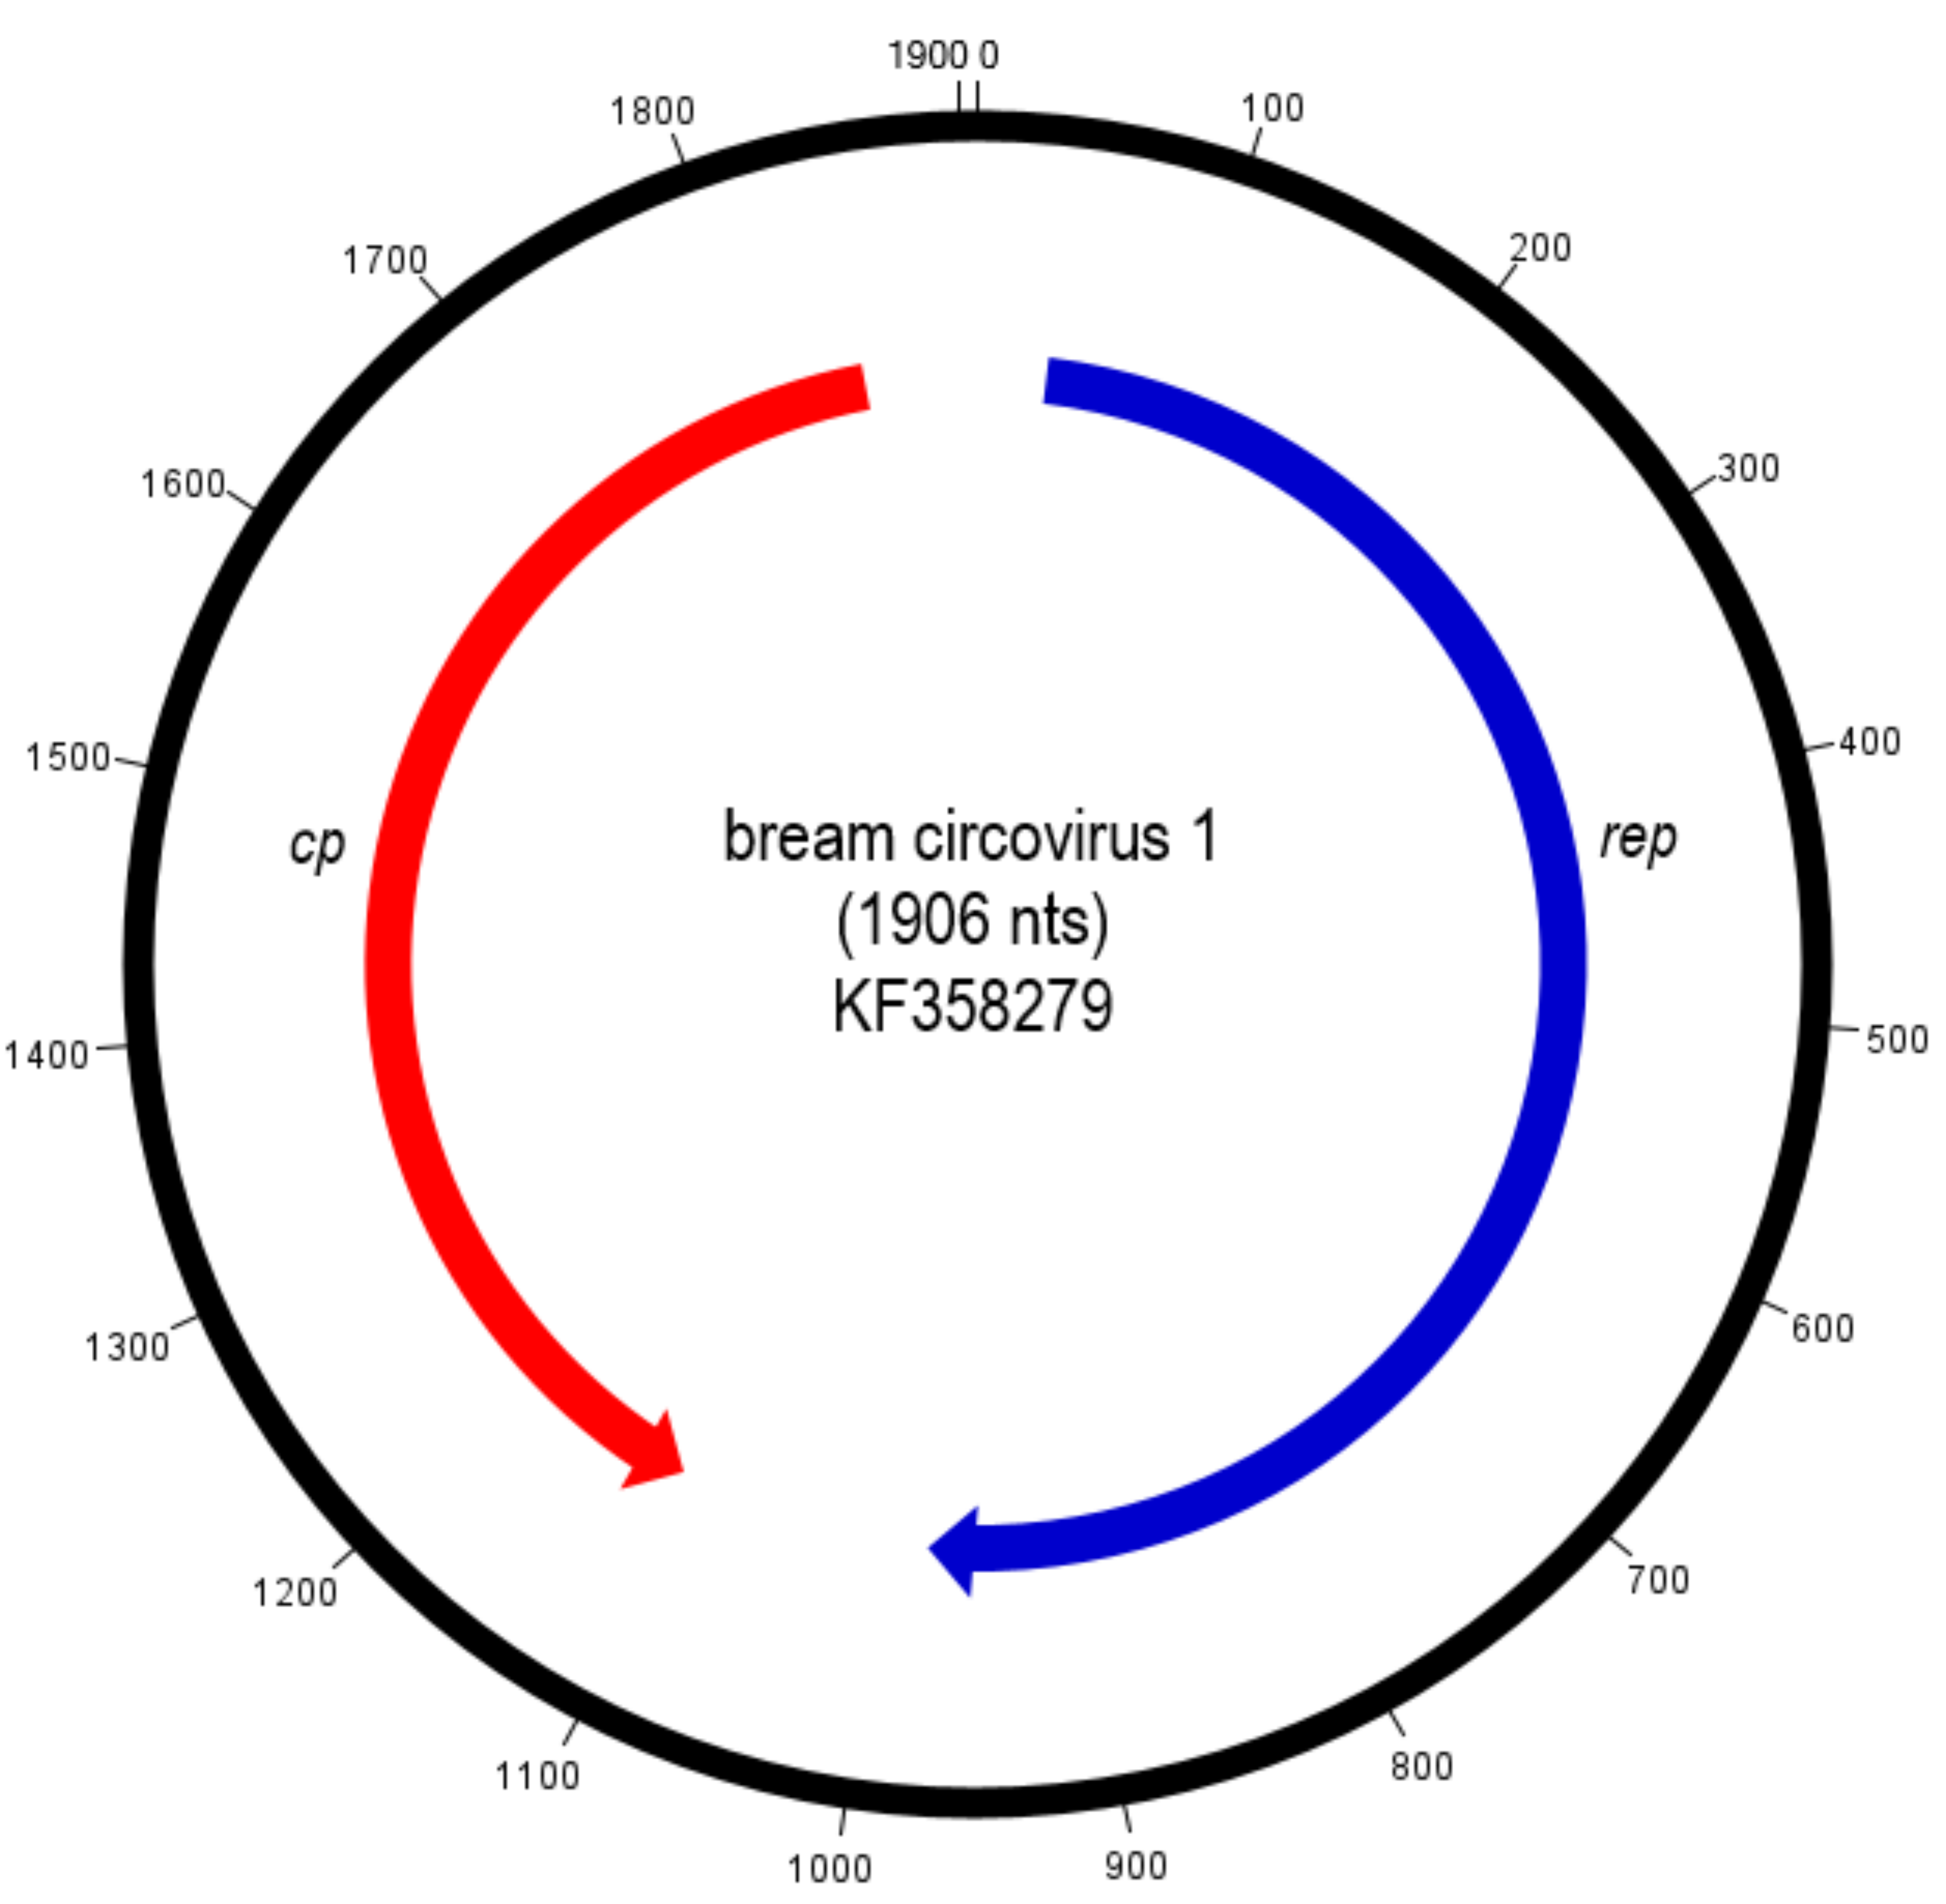 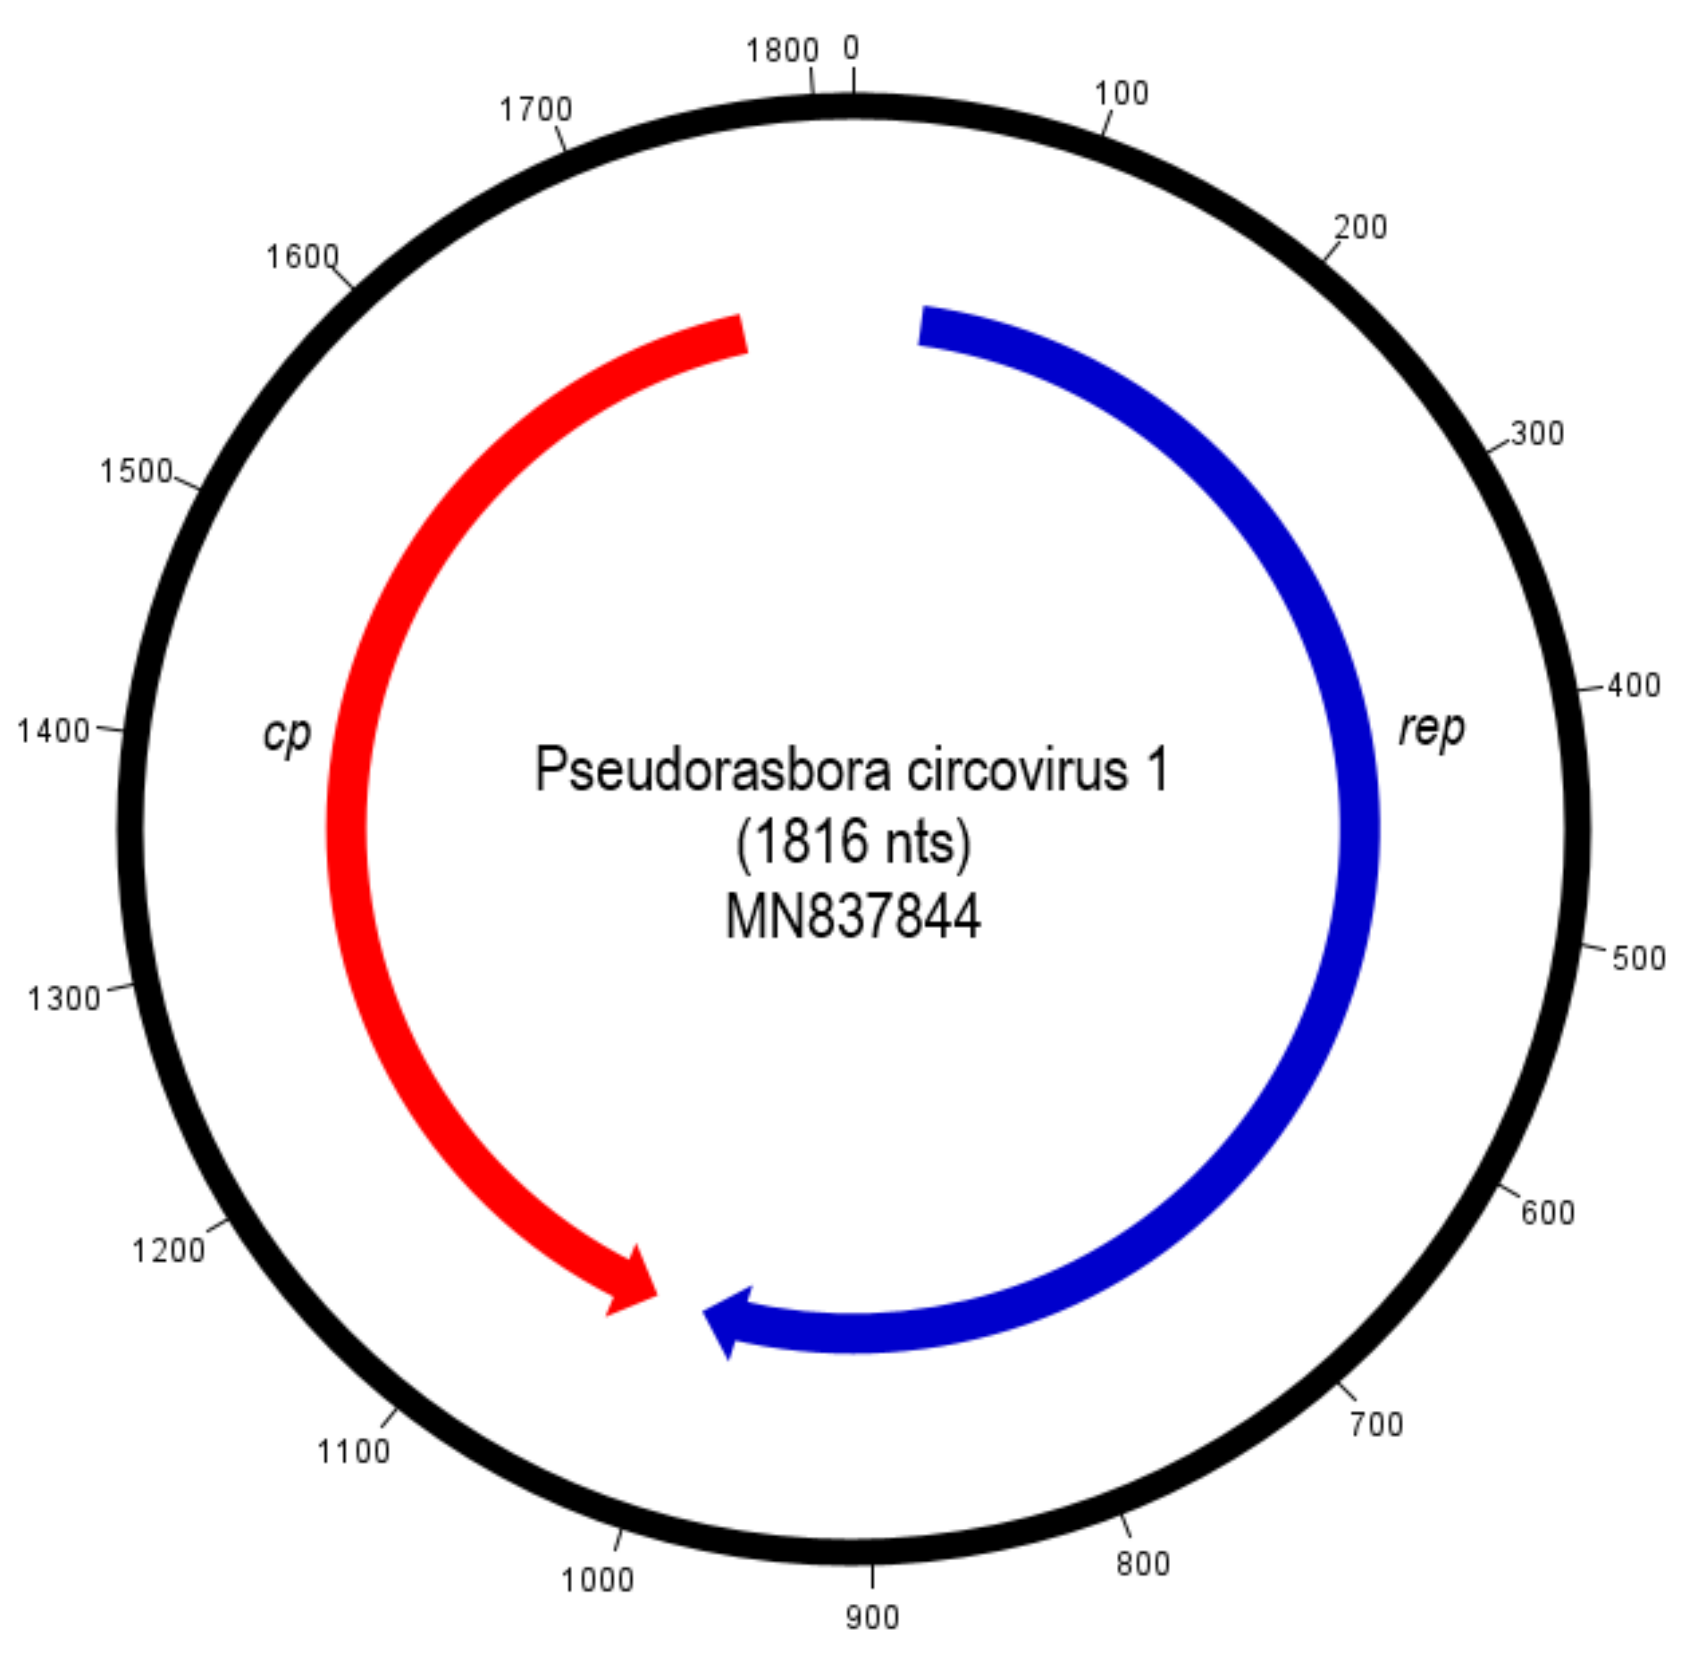

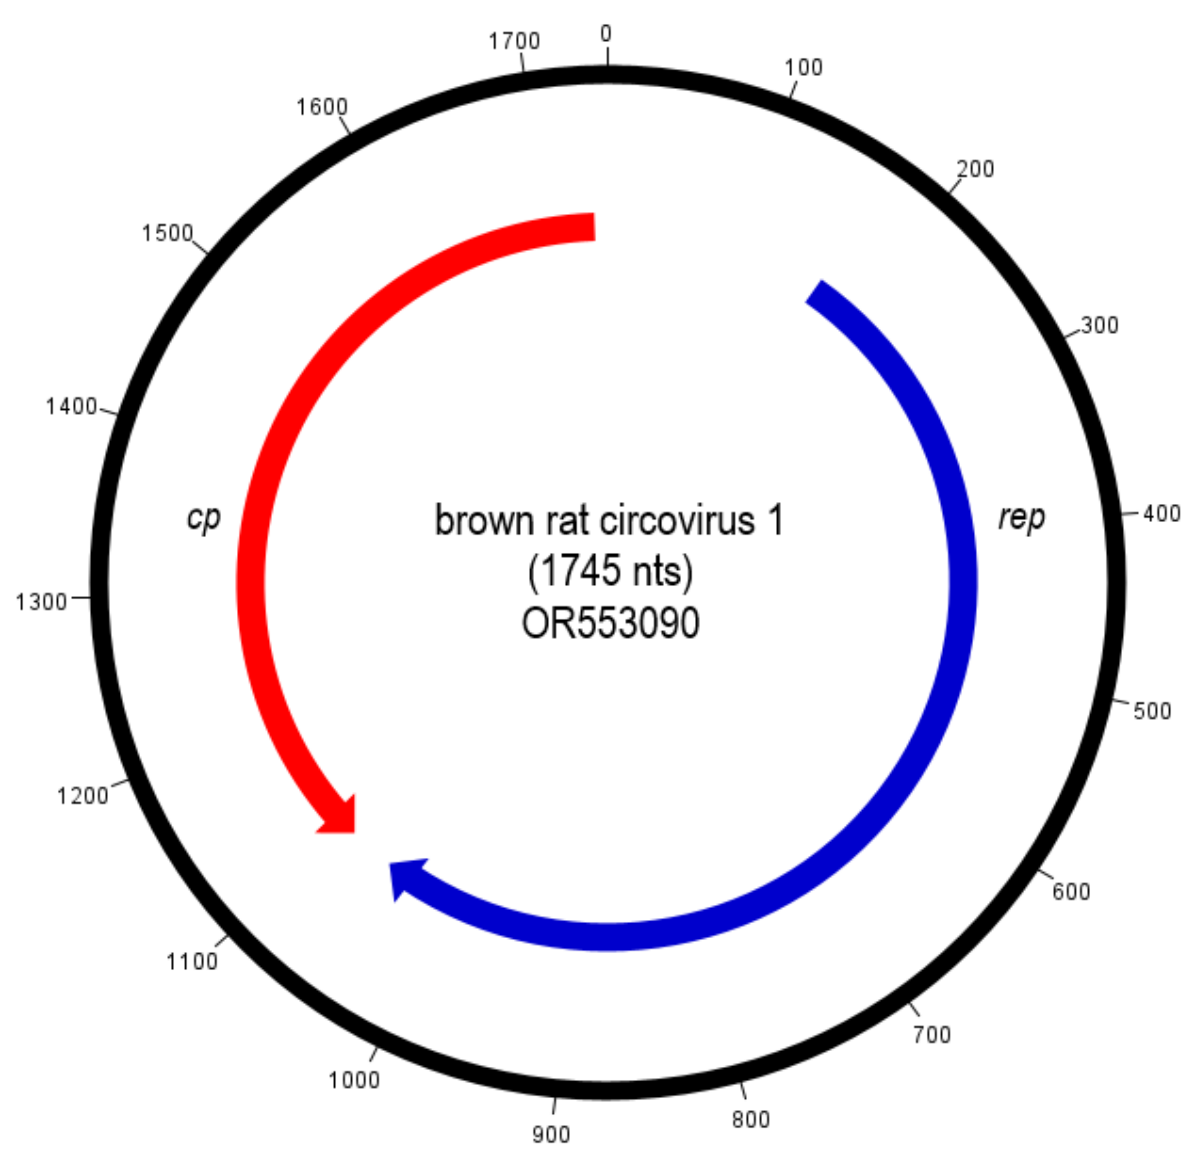 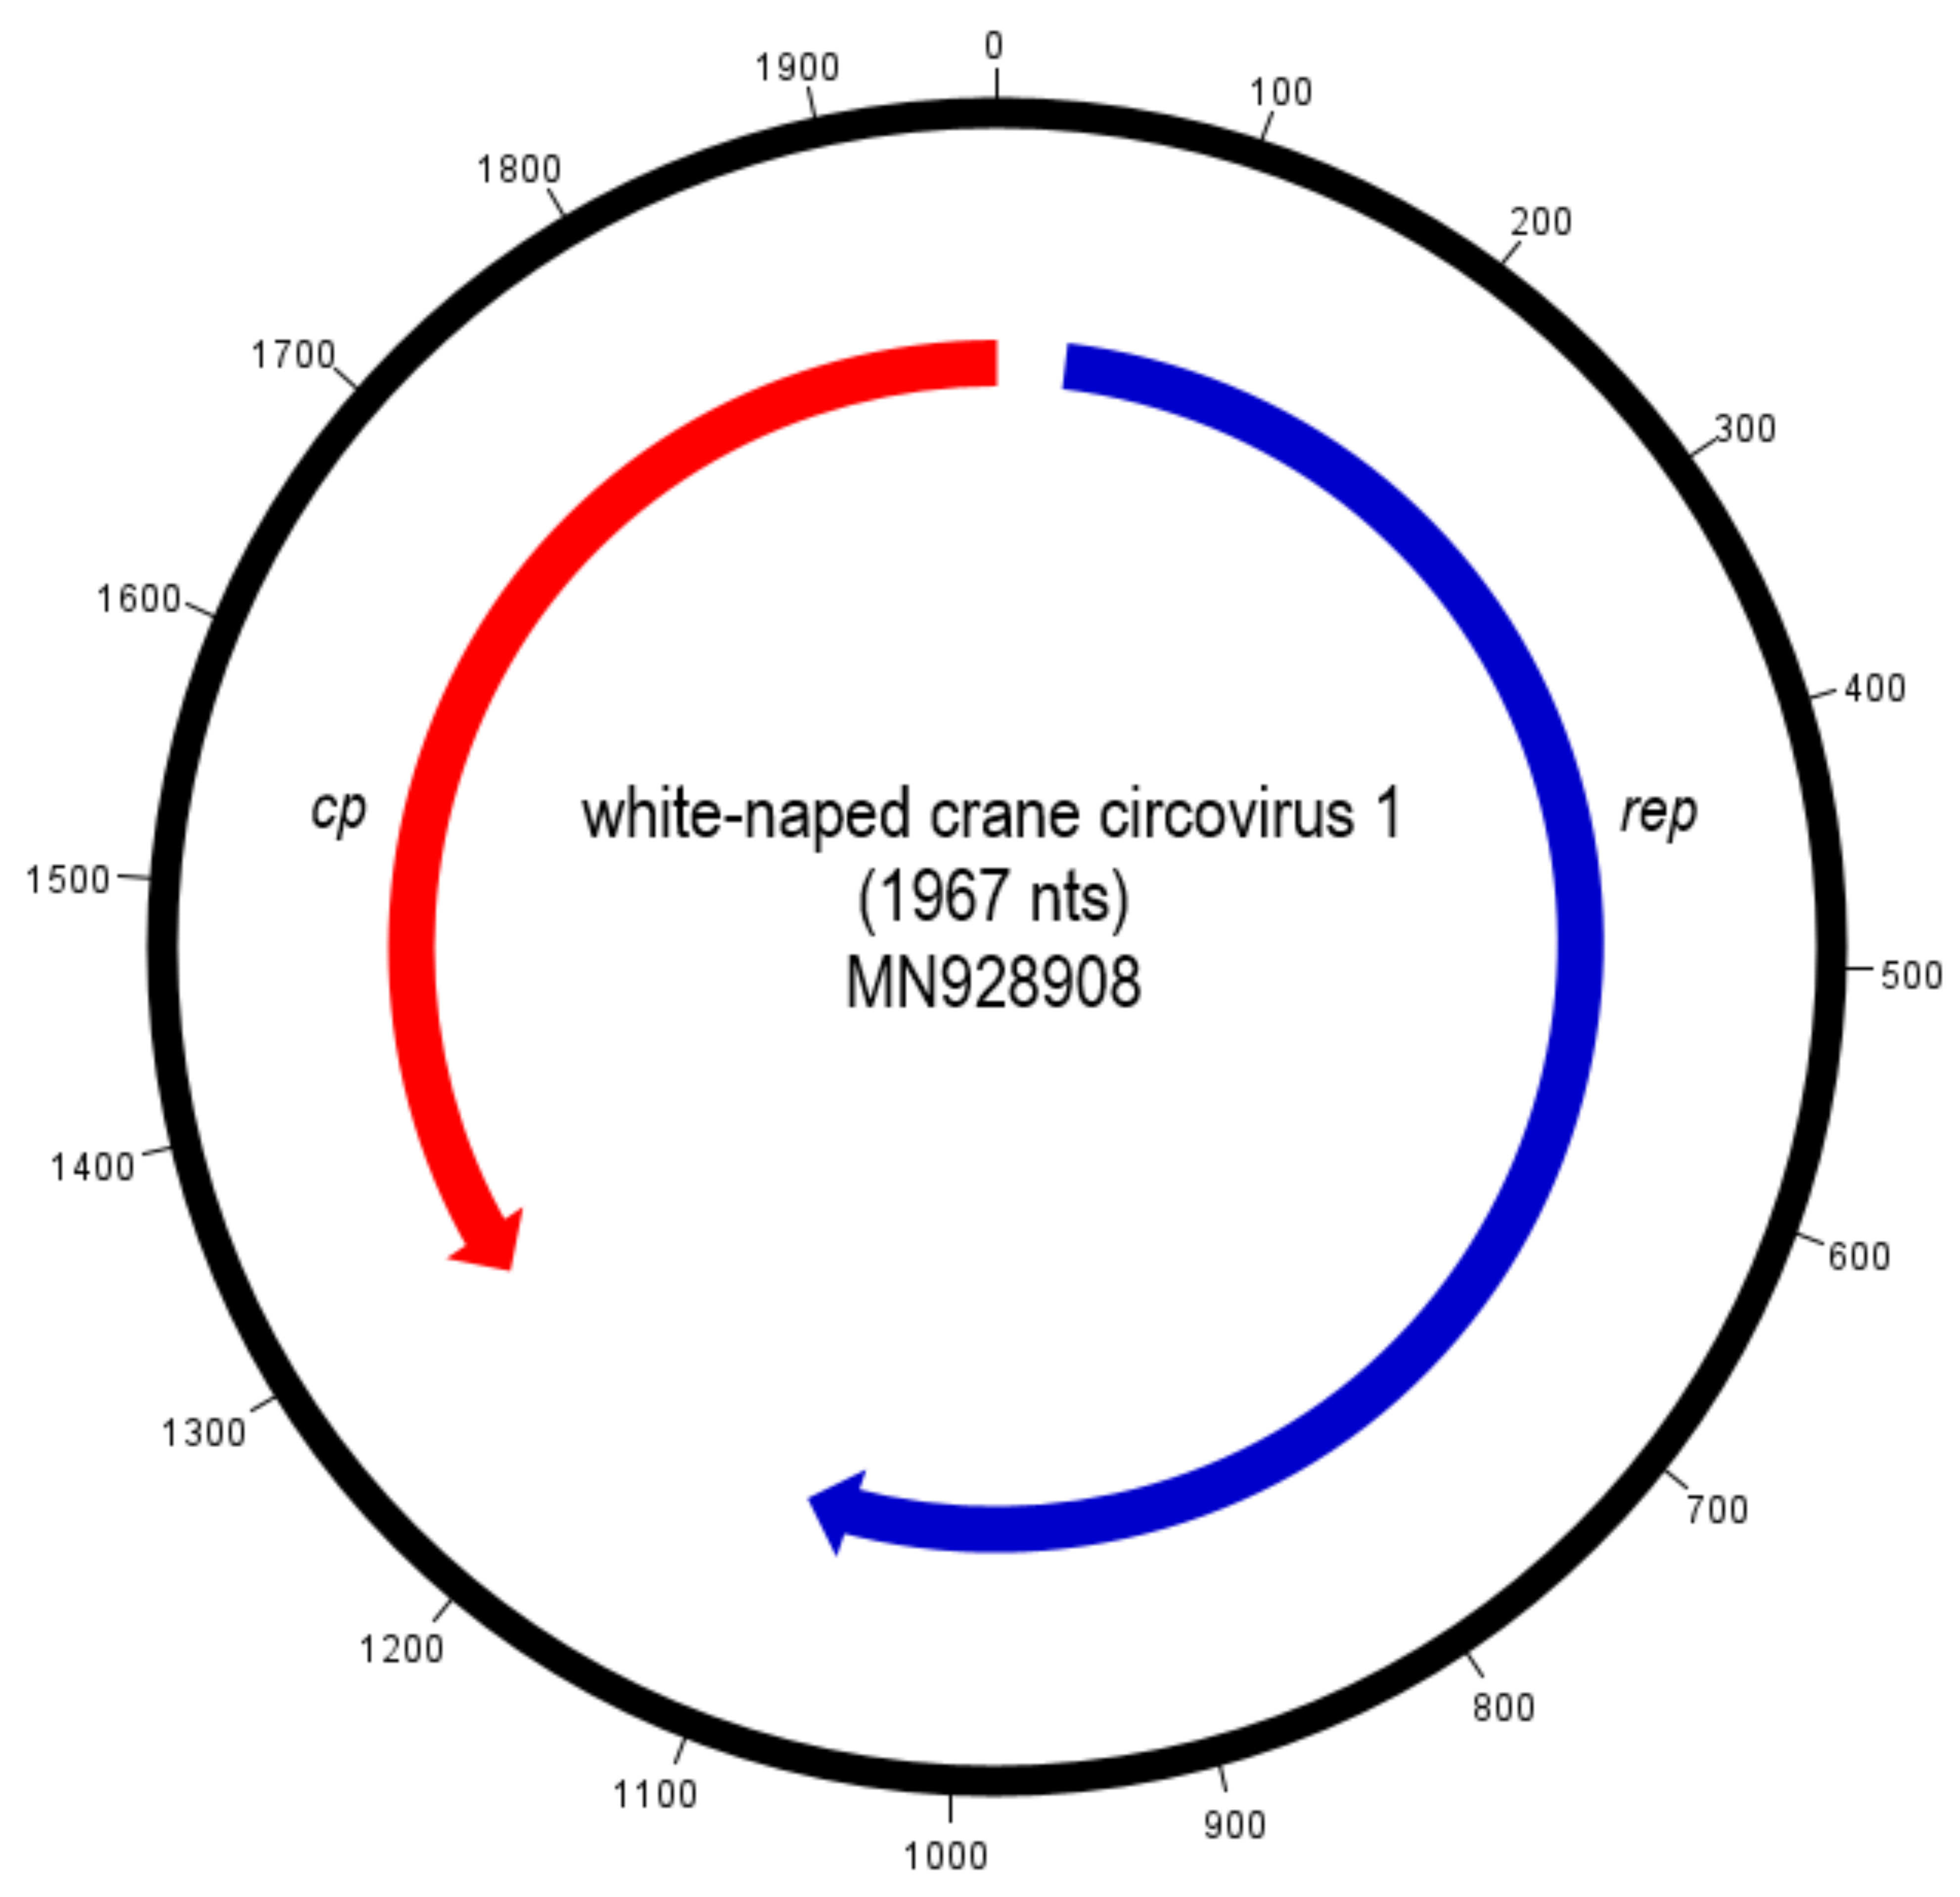

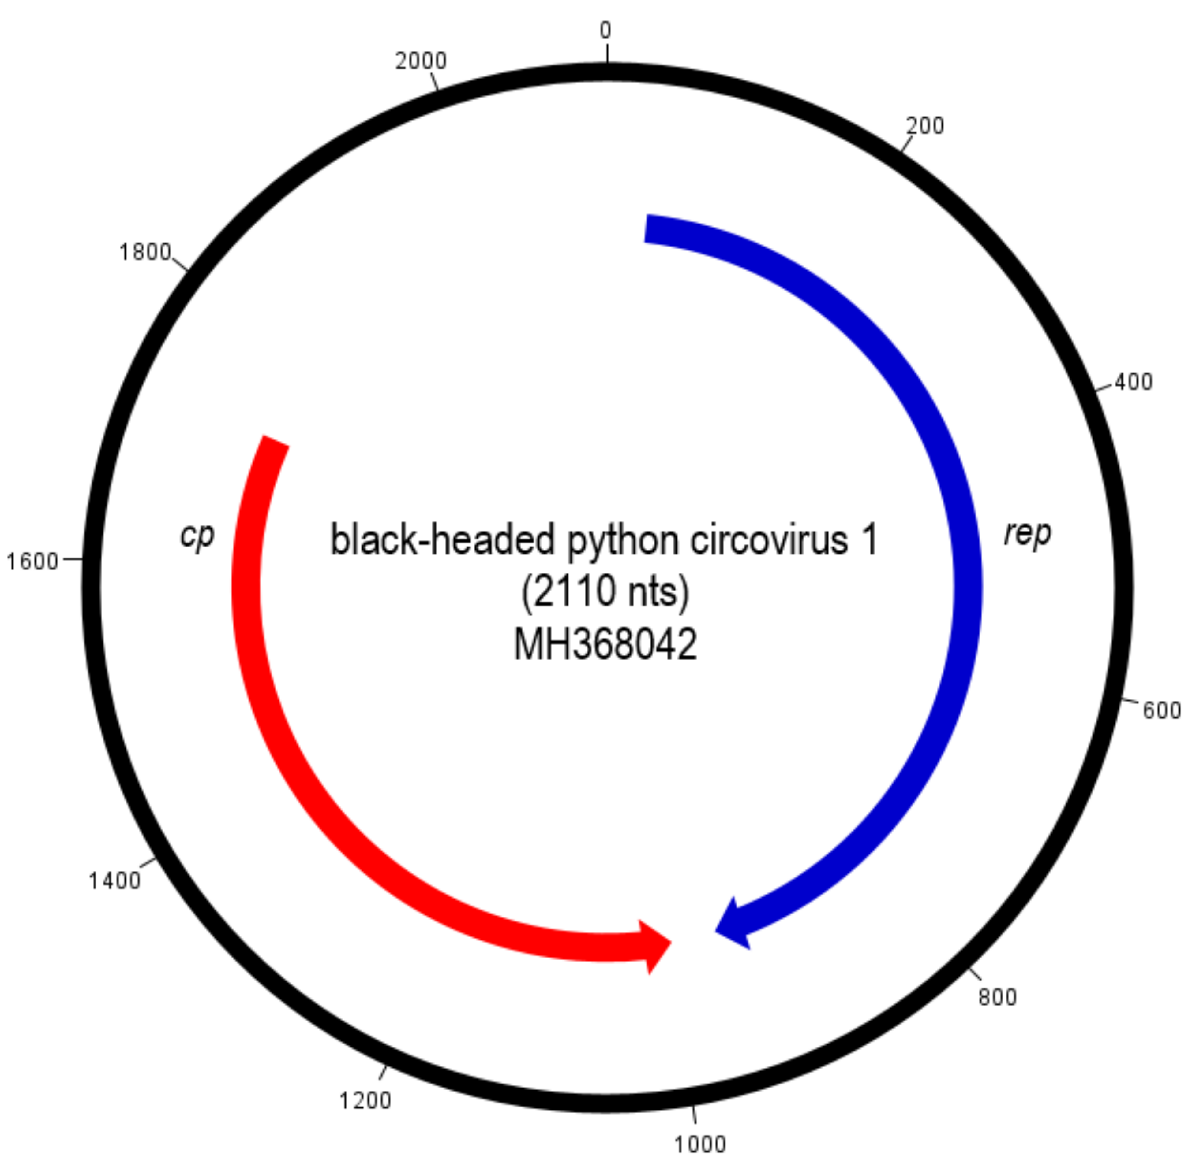

Fig. 1. Genome organisation of the candidate viruses (figures was made using Artemis v18.2.0 software [4]).



Fig. 2. Maximum likelihood phylogenetic tree (rooted with dragonfly cyclovirus 1 (*Cyclovirus kisikisi*) sequence) of representative Rep amino acid sequences of exemplars of each accepted circovirus species (aligned with MAFFT v7 [7]) inferred using PHYML 3.0 [5] with LG+I+G as the best fit model according to BIC (α=0.991, p-inv=0.083).

**Table 1. Pairwise sequence identity analysis of the exemplar strains of proposed new circovirid species based on complete genomes**

|  |  |  |  |
| --- | --- | --- | --- |
| **Proposed new species** | | **Most similar CVs of the proposed species based on Rep phylogeny** | **Pairwise nucleic acid sequence identity (%; <80), based of BioEdit v7.0.5.3. [5] sequence identity matrix analysis** |
| **Type name, GenBank accession number, host species** | **Proposed species name** |
| bream CV-1, KF358279 (*Abramis brama*) [10] | *Circovirus dever* | *Circovirus razbora* (Pseudorasbora CV-1, MN837844) | 58.3 |
| Pseudorasbora CV-1, MN837844 (*Pseudorasbora parva*) | *Circovirus razbora* | *Circovirus dever* (bream CV-1, KF358279) | 58.3 |
| white-naped crane CV-1, MN928908  (*Antigone vipio*) | *Circovirus baizhenhe* | *Circovirus dever* (bream CV-1, KF358279) | 56.7 |
| brown rat CV-1, OR553090 (*Rattus norvegicus*) [11] | *Circovirus patkany* | *Circovirus kukwuria* (banfec CV-1, OQ599922) | 60.7 |
| black-headed python CV-1, MH368042 (*Aspidites melanocephalus*) [1] | *Circovirus python* | *Circovirus naaleeli* (WigFec CV-1, MZ604582) | 42.3 |