This form should be used for all taxonomic proposals. Please complete all those modules that are applicable.
For guidance, see the notes written in blue and the separate document “Help with completing a taxonomic proposal”

Please try to keep related proposals within a single document.

Part 1: TITLE, AUTHORS, etc

Code assigned: | 2018.021P |  |  |  | (to be completed by ICTV officers)
Short title: One (1) new species in the genus Idaeovirus

Modules attached  (Modules 1, 4 and either 2 or 3 are required. |  | 1 2 3 4
Author(s):
Beatriz Navarro, Francesco Di Serio, Nina Aboughanem-Sabanadzovic
Corresponding author with e-mail address:
Beatriz Navarro, beatriz.navarro@ipsp.cnr.it
List the ICTV study group(s) that have seen this proposal:
A list of study groups and contacts is provided at http://www.ictvonline.org/subcommittees.asp . If in doubt, contact the appropriate subcommittee chair (there are six virus subcommittees: animal DNA and retroviruses, animal ssRNA-, animal ssRNA+, fungal and protist, plant, bacterial and archaeal) |  |  | ICTV Bromoviridae Study Group
ICTV Study Group comments (if any) and response of the proposer:
Date first submitted to ICTV:
Date of this revision (if different to above):

ICTV-EC comments and response of the proposer:

Part 2: PROPOSED TAXONOMY
Present the proposed new taxonomy on accompanying spreadsheet
Name of accompanying spreadsheet: 2018.021P.N.v1.Idaeovirus_1nsp.xlsx

Please display the taxonomic changes you are proposing on the accompanying spreadsheet module 2017_TP_Template_Excel_module. Submit both this and the spreadsheet to the appropriate ICTV Subcommittee Chair.

Part 3: NON-STANDARD
Template for any proposal regarding ICTV procedures, rules or policy, not involving the creation of new taxonomy.
Text of proposal:

Part 4: APPENDIX: supporting material
additional material in support of this proposal
Proposal for the new species Privet idaeovirus in the genus Idaeovirus
A new virus has been recently identified in privet (Ligustrum japonicum L) showing leaf blotch symptoms resembling infectious variegation, a virus-like privet disease known since long. The novel virus, named privet leaf blotch-associated virus (PrLBaV), was identified by high-throughput sequencing of small RNA library. The complete nucleotide sequence of the viral genome was determined by sequencing overlapping cDNA clones generated by RT-PCR using specific primers.
PrLBaV is a positive sense RNA virus with a genome composed of two RNAs. The 5’ and 3’ ends of PrLBaV RNA1 and RNA2 share conserved untranslated regions (UTRs), consisting of an identical hexanucleotide fragment at the 5’ end, and a stretch of nucleotides assuming a stem-loop conformation and terminating with a tetracytidine at the 3’ end (Figure 1). PrLBaV RNA1 (5277 nucleotides, nt) encodes the RNA-dependent RNA polymerase (RdRp, p198) and RNA2 (2348 nt) contains two ORFs (ORF2a and ORF2b) separated by an unusual intergenic spacer composed of only one nucleotide. ORF2b is very likely expressed through a subgenomic RNA (RNA3). ORF 2a and ORF 2b encode putative movement (p38, MP) and coat (p30, CP) proteins, respectively (Figure 2).
The closest related virus to PrLBaV is raspberry bushy dwarf virus (RBDV), classified as the sole species (Raspberry bushy dwarf virus) of the genus Idaeovirus (MacFarlane, 2012).
PrLBaV and RBDV RNAs show nt identities ranging from 55% to 61%, while the respective encoded proteins have only 25-48% pairwise amino acid (aa) identity (Table 1). Although the species demarcation criteria in the genus Idaeovirus have not been established yet, the nt and aa sequence identity between PrLBaV and RBDV is significantly below the limit established as species demarcation criteria in several genera of the family Bromoviridae, thus further supporting its classification as a new species.
As reported below, PrLBaV and RBDV share genomic organization, gene expression strategy and structural elements at both RNA and protein levels that support the inclusion of PrLBaV in the genus Idaeovirus:
i) PrLBaV and RBDV have the same genome organization and expression strategy, with a monocistronic RNA1 (coding for the RdRP) and a bicistronic RNA2 (encoding the CP and MP) that expresses one protein (CP) through a subgenomic RNA (sgRNA3) (Figure 2).
ii) Genomic RNAs of PrLBaV and RBDV share similar sizes and UTRs with an almost identical hexanucleotide fragment at the 5’ terminus and similar structural features at the 3’ terminus (Figure 1).
iii) Phylogenetic analyses show that PrLBaV and RBDV cluster always together in a clade significantly separated from those containing members of different genera in the family Bromoviridae and Japanese holly fern mottle virus (JHFMoV) - not classified yet (Valverde and Sabanadzovic, 2009). The same result was obtained when phylogenetic trees were inferred using multiple alignments of the RdRp methyltransferase (MTR), helicase (HEL) and polymerase signatures, and of the MP and CP (Figure 3).

Therefore, pairwise sequence comparisons, phylogenetic analyses, and genome organization support the classification of PrLBaV as a new species of the genus Idaeovirus. The name Privet idaeovirus is proposed for this new species, which would be the second one in the genus.

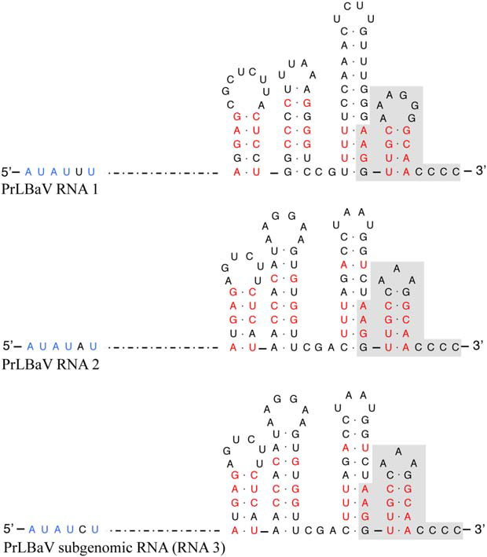
Figure 1. Primary and secondary structures of 5’ and 3’ termini of privet leaf blotch-associated virus (PrLBaV) RNAs. The genomic RNA1 and RNA2 and the subgenomic RNA3 are presented. Identical nucleotides at the 5’ end are shown in blue; identical sequences at the 3’ termini are shown on a grey background; identical base-paired nucleotides at several positions within each stem-loop atthe 3’ terminus are denoted in red (from Navarro et al., 2017).
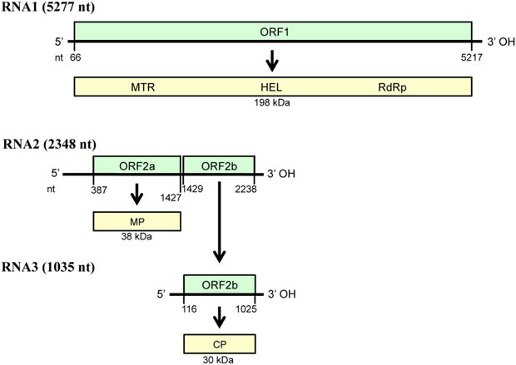
Figure 2. Diagrammatic representation of the genome organization and expression of privet leaf blotch-associated virus. Horizontal black lines depict RNAs; green boxes show the positions of the open reading frames (ORFs, with nucleotide positions of start and stop codons indicated below); yellow boxes represent the corresponding putative protein products with the molecular mass (kDa) indicated below. RNA3 is a subgenomic RNA generated from the genomic RNA2. CP, coat protein; HEL, helicase; MTR, methyltransferase; MP, movement protein; nt, nucleotide; RdRp, RNA-dependent RNA polymerase. (from Navarro et al., 2017)
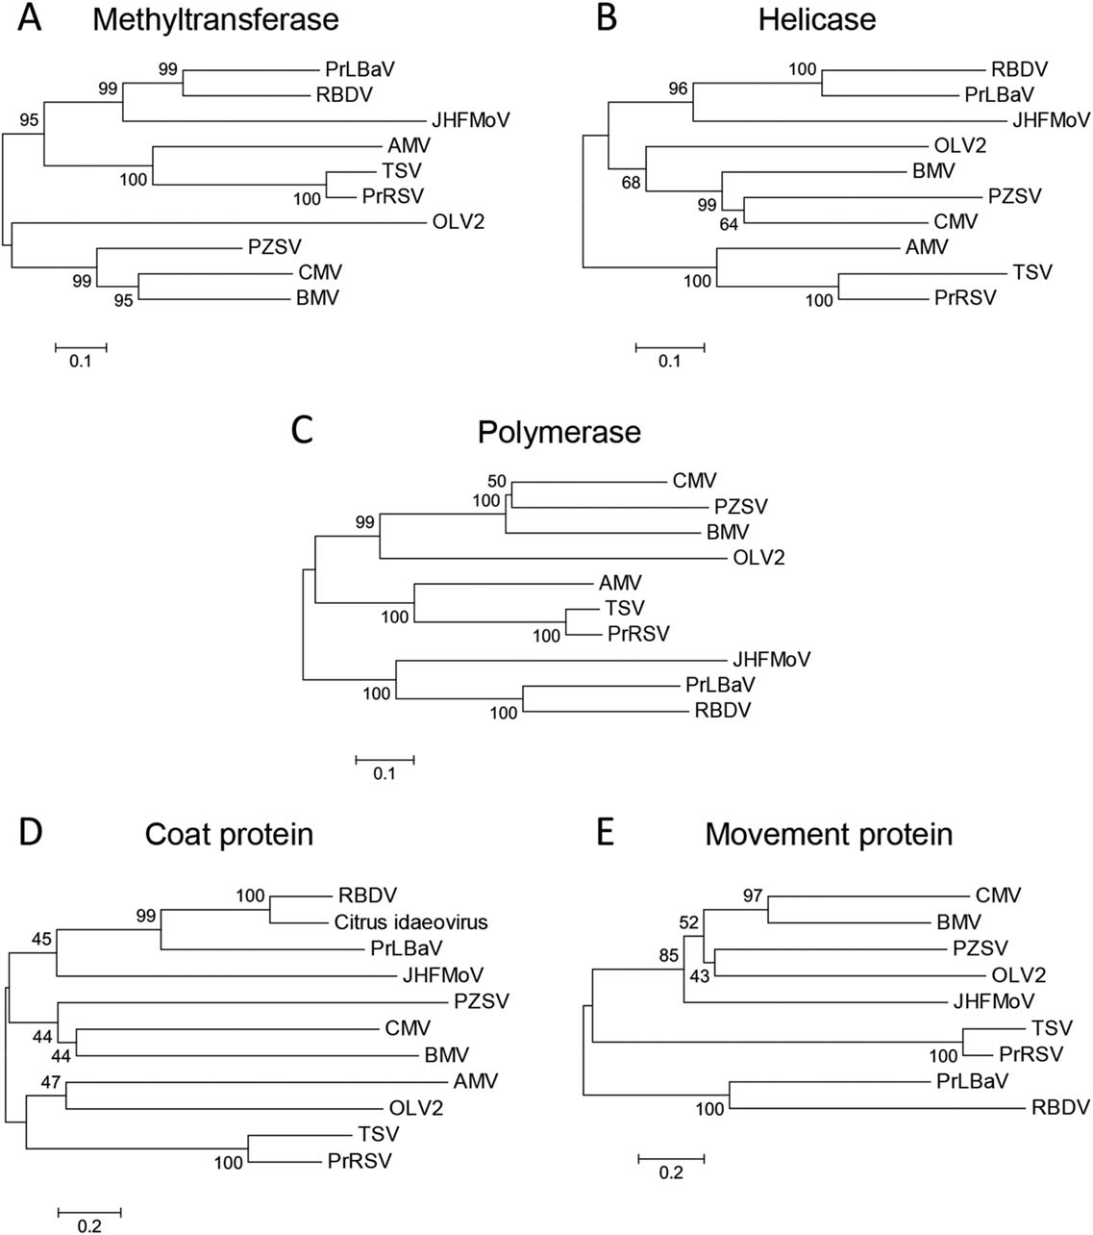
Figure 3. Phylogenetic trees inferred by neighbour-joining analysis of the methyltransferase (A), helicase (B) and RNA-dependent RNA polymerase (C) signatures, and of the coat proteins (D) and movement proteins (E) of privet leaf blotch-associated virus (PrLBaV), RBDV (genus Idaeovirus), JHFMoV and representative viruses in the family Bromoviridae. The number on each branch is the result of bootstrap analysis (1000 replicates). Extended names of the viruses included in the phylogenetic trees are reported below, with the accession numbers of the respective methyltransferase (MTR), helicase (HEL), RNA-dependent RNA polymerase (RdRp) signatures, and of the coat protein (CP) and movement protein (MP) reported in parentheses. AMV (alfalfa mosaic virus; MTR and HEL, NP_041192; RdRp, YP_053235; CP, NP_041195; MP, NP_041194), BMV (brome mosaic virus; MTR and HEL, NP_041196; RdRp, NP_041197; CP, AAA46334; MP, NP_041198), CMV (cucumber mosaic virus; MTR and HEL, NP_049323; RdRp, NP_049324; CP, NP_040777; MP, NP_040776), JHFMoV (Japanese holly fern mottle virus; MTR, HEL and RdRp, YP_003126903; CP, ACT67468; MP, YP_003126905), OLV2 (olive latent virus 2; MTR and HEL, NP_620042; RdRp, NP_620043; CP, NP_620039; MP, NP_620038), PrLBaV (privet leaf blotch–associated virus; MTR, HEL and RdRp, YP_009305430; CP, YP_009305432; MP, YP_009305431; PrRSV (privet ringspot virus; MTR and HEL, YP_009165996; RdRp, YP_009165997; CP, YP_009166000; MP, YP_009165999), PZSV (Pelargonium zonate spot virus; MTR and HEL, NP_619770; RdRp, NP_619771; CP, NP_619773; MP, NP_619772), RBDV (raspberry bushy dwarf virus; MTR, HEL and RdRp, NP_620465; CP, NP_620467; MP, NP_620466), TSV (tobacco streak virus; MTR and HEL, NP_620772; RdRp, NP_620768; CP, NP_620774; MP, NP_620773), citrus idaeovirus (CP; DQ100358). (modified from Navarro et al., 2017).
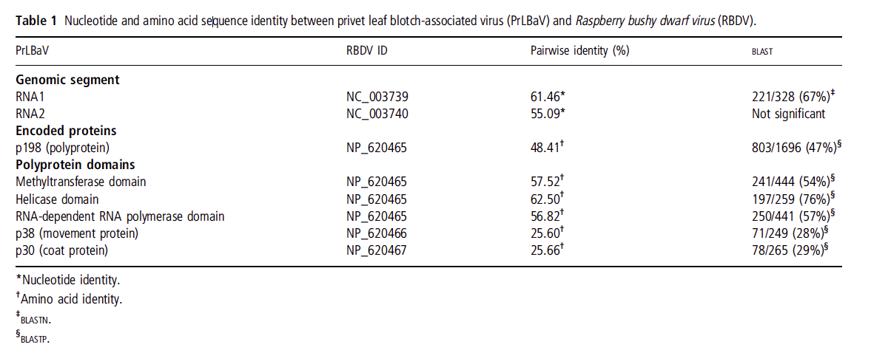

References
MacFarlane, S.A. 2012. Genus Idaeovirus. In: Virus Taxonomy, Ninth Report of the International Committee on Taxonomy of Viruses (King, A.M.Q., Adams, M.J., Carstens, E.B., and Lefkowitz, E.J., eds), pp. 1173–1175. London: Elsevier/Academic Press.
Navarro B., Loconsole G., Giampetruzzi A., Aboughanem-Sabanadzovic N., Ragozzino A., Ragozzino E. and Di Serio F. (2017) Identification and characterization of privet leaf blotch-associated virus, a novel idaeovirus. Molecular Plant Pathology 18, 925-936.
Valverde, R.A. and Sabanadzovic, S. (2009) A new plant virus with unique properties infecting Japanese holly fern. Journal of General Virology 90, 2542–2549.

