This Word module should be used for all taxonomic proposals.
Please complete Part 1 and:
either Part 3 for proposals to create new taxa or change existing taxa
or Part 2 for proposals of a general nature.
Submit the completed Word module, together with the accompanying Excel module named in Part 3, to the appropriate ICTV Subcommittee Chair.
For guidance, see the notes written in blue, below, and the help notes in file Taxonomic_Proposals_Help_2018.
Part 1: TITLE, AUTHORS, etc

Code assigned: | 2018.019P |  | (to be completed by ICTV officers)
Short title: Rename the species Pepper vein yellows virus and create 5 new species in the genus Polerovirus
Author(s):
Jesús Navas-Castillo, Elvira Fiallo-Olivé, F. Murilo Zerbini
Corresponding author with e-mail address:
J.N.C. (jnavas@eelm.csic.es)
List the ICTV study group(s) that have seen this proposal:
A list of study groups and contacts is provided at http://www.ictvonline.org/subcommittees.asp . If in doubt, contact the appropriate subcommittee chair (there are six virus subcommittees: animal DNA and retroviruses, animal ssRNA-, animal ssRNA+, fungal and protist, plant, bacterial and archaeal)
ICTV Study Group comments (if any) and response of the proposer:
Date first submitted to ICTV: |  |  | 8 June 2018
Date of this revision (if different to above):

ICTV-EC comments and response of the proposer:

Part 2: NON-STANDARD
Template for any proposal regarding ICTV procedures, rules or policy, not involving the creation of new taxonomy.
Text of proposal:

Part 3: PROPOSED TAXONOMY

Name of accompanying Excel module: 2018.019P.N.v1.Polerovirus_5sp1ren.xlsx

Supporting material:
additional material in support of this proposal
In 1981, symptoms of vein yellowing and leaf roll were observed in pepper plants grown in greenhouses in Japan, although the disease was not reported until more than ten years later. A similar disease was observed both in greenhouses and open field in Israel during 1998. In addition to the symptoms observed in Japan, the Israeli group reported symptoms in fruit, which were smaller than normal and discolored, resulting in reduced commercial value. An aphid-transmissible luteo-like virus was shown to be the causal agent of the disease in both countries, which was named pepper vein yellows virus (PeVYV) in Japan and pepper yellow leaf curl virus (PYLCV) in Israel.

Nucleotide sequencing of the complete genome of two virus isolates causing the yellowing disease of pepper in Japan (Murakami et al., 2011) and Israel (Dombrovsky et al., 2013) confirmed that their linear positive-sense ssRNA genomes presented the typical organization of polerovirus genomes, with seven genes encoding proteins P0 to P5 and P3a. Recently, four additional pepper polerovirus genomes have been completely sequenced from China (Liu et al., 2016), Australia (Maina et al., 2016), Spain (Fiallo-Olivé et al., 2018) and Greece (Lotos et al., 2017).

To date, only one pepper polerovirus (genus Polerovirus, family Luteoviridae) species is recognized by the ICTV, Pepper vein yellows virus, represented by the pepper vein yellows virus isolate from Japan (AB594828).

Species demarcation criterion in the family Luteoviridae is a >10% difference in amino acid sequence identity of any gene product from its closest relative. Following a re-analysis of the available nucleotide sequences of pepper poleroviruses from Japan, Israel, China, Australia, Spain and Greece, and application of the mentioned species demarcation criterion, six distinct species are proposed. Figure 1 shows the percent aminoacid identities calculated for the proteins P0-P5 and P3a. The sequence of P0 would differentiate the pepper poleroviruses in four species (Australia, Japan, China/Israel/Greece and Spain). Additionally, isolates from China, Israel and Greece would be separated at the species level according to differences in the sequence of P5. Given that the symptoms caused by all pepper poleroviruses are similar, if not identical, we propose to rename the species Pepper vein yellows virus to Pepper vein yellows virus 1 and to create the species Pepper vein yellows virus 2 to Pepper vein yellows virus 6 according to date of genome publication (Table 1). Phylogenetic position of the proposed species within the genus Polerovirus is shown in Figure 2.

Table 1. Details of the renamed (Pepper vein yellows virus 1) and five proposed new polerovirus species.

Species name | Isolate name | GenBank  Acc. No. | Reference
Pepper vein yellows virus 1 | PeVYV-1-[JP-Oki-09] | AB594828 | Murakami et al., 2011
Pepper vein yellows virus 2 | PeVYV-2-[IL-02] | HM439608 | Dombrovsky et al., 2013
Pepper vein yellows virus 3 | PeVYV-3-[CN-HN-13] | KP326573 | Liu et al. 2016
Pepper vein yellows virus 4 | PeVYV-4-[AU-12KNX1-15] | KU999109 | Maina et al., 2016
Pepper vein yellows virus 5 | PeVYV-5-[ES-Alm2-13] | KY523072 | Fiallo-Olivé et al., 2018
Pepper vein yellows virus 6 | PeVYV-6-[GR-PX3-14] | LT559483 | Lotos et al., 2017

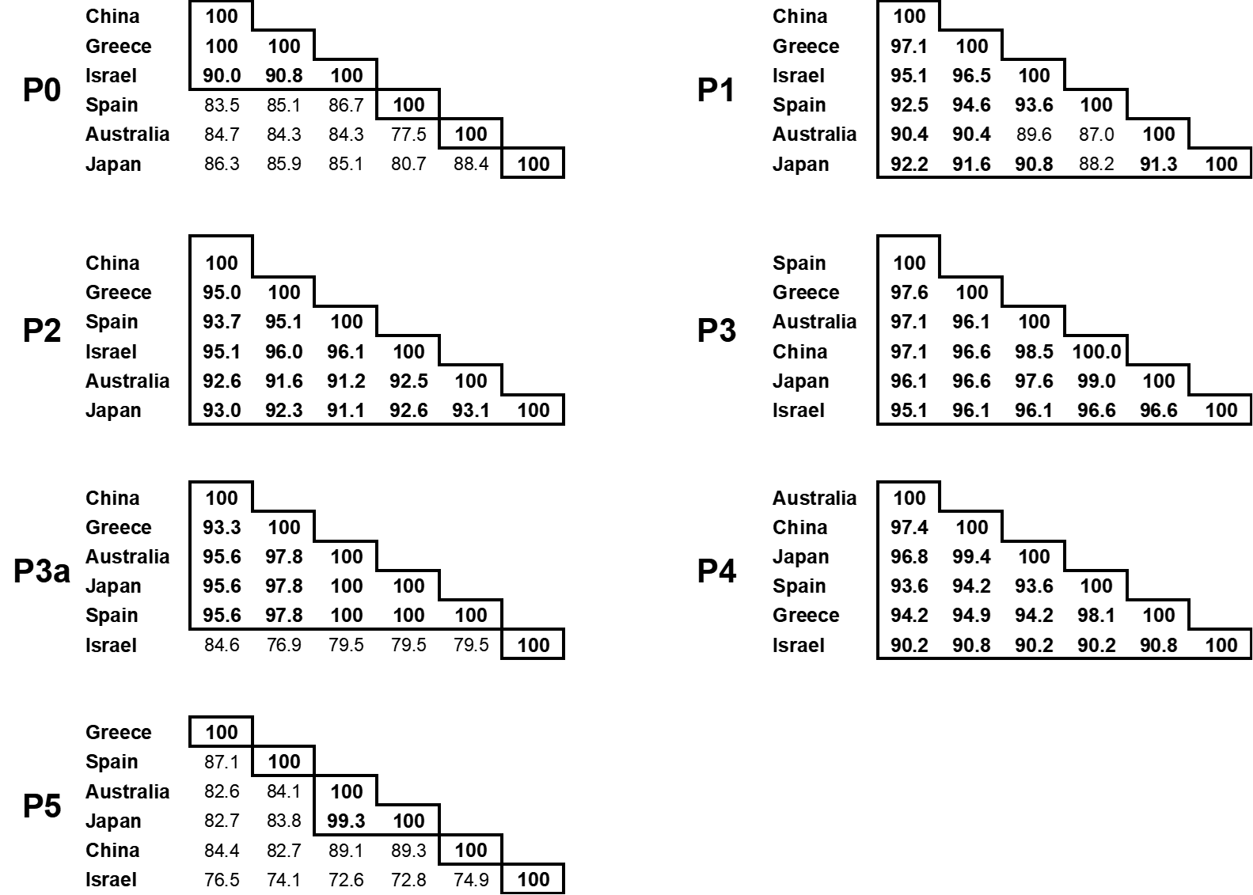

Figure 1. Pairwise amino acid sequence identites calculated with Sequence Demarcation Tool (SDT) (Muhire et al., 2014) between the proteins (P0-P5 and P3a) coded by the pepper polerovirus genomes from Australia (AU, KU999109), China (CN, KP326573), Greece (GR, LT559483), Israel (IL, HM439608), Japan (JP, AB594828) and Spain (ES, KY523072). Values higher than 90% (criterion used for polerovirus species demarcation) are in bold and the values that define species-level units are grouped by boxes.

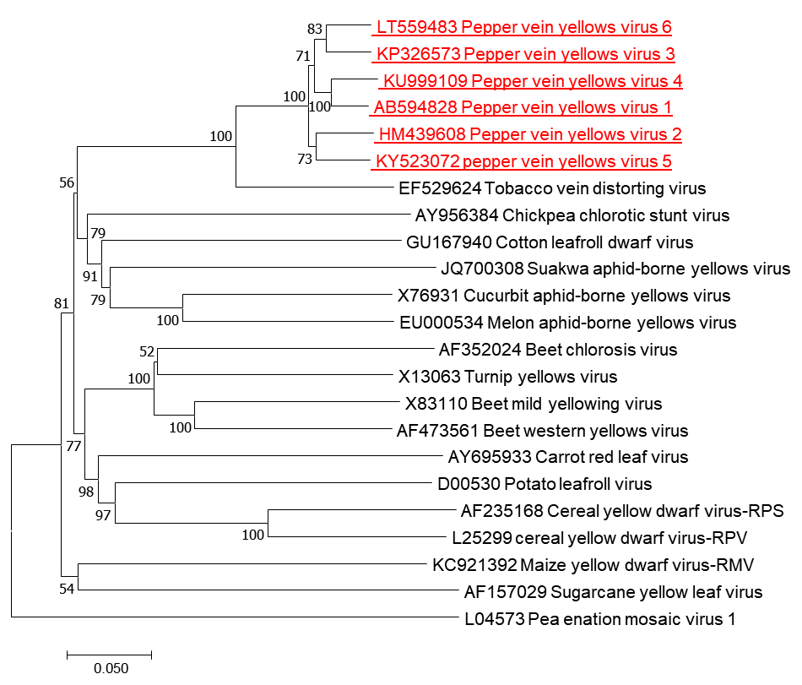

Figure 2. Phylogenetic tree illustrating the relationships of the complete genome sequences of the pepper poleroviruses Pepper vein yellows virus 1 to Pepper vein yellows virus 6 (highlighted in red) to isolates of all accepted polerovirus species. The tree was constructed using the neighbour-joining method available in the MEGA7 package (Kumar et al., 2016) and bootstrap values (1000 replicates) are shown at the nodes. Branch length is related to genetic distance (p-distance method). The enamovirus Pea enation mosaic virus 1 was used as an outgroup. The bar below the tree indicates 0.05 nucleotide substitutions per site.

References:
Dombrovsky A, Glanz E, Lachman O, Sela N, Doron-Faigenboim A, Antignus Y (2013) The complete genomic sequence of Pepper yellow leaf curl virus (PYLCV) and its implications for our understanding of evolution dynamics in the genus Polerovirus. PLoS ONE 8: e70722.
Fiallo-Olivé E, Navas-Hermosilla E, Ferro CG, Zerbini FM, Navas-Castillo J (2018) Evidence for a complex of emergent poleroviruses affecting pepper worldwide. Archives of Virology 163: 1171-1178.
Kumar S, Stecher G, Tamura K (2016) MEGA7: Molecular Evolutionary Genetics Analysis version 7.0 for bigger datasets. Molecular Biology and Evolution 33: 1870-1874.
Liu M, Liu X, Li X, Zhang D, Dai L, Tang Q (2016) Complete genome sequence of a Chinese isolate of pepper vein yellows virus and evolutionary analysis based on the CP, MP and RdRp coding regions. Archives of Virology 161: 677-683.
Lotos L, Olmos A, Orfanidou C, Efthimiou K, Avgelis A, Katis NI, Maliogka VI (2017) Insights into the etiology of polerovirus-induced pepper yellows disease. Phytopathology 107: 1567-1576.
Maina S, Edwards OR, Jones RAC (2016) First complete genome sequence of Pepper vein yellows virus from Australia. Genome Announcements 4: e00450-16.
Muhire BM, Varsani A, Martin DP (2014) SDT: A virus classification tool based on pairwise sequence alignment and identity calculation. PLoS One 9: e108277.
Murakami R, Nakashima N, Hinomoto N, Kawano S, Toyosato T (2011) The genome sequence of pepper vein yellows virus (family Luteoviridae, genus Polerovirus). Archives of Virology 156: 921-923.

