This Word module should be used for all taxonomic proposals.
Please complete Part 1 and:
either Part 3 for proposals to create new taxa or change existing taxa
or Part 2 for proposals of a general nature.
Submit the completed Word module, together with the accompanying Excel module named in Part 3, to the appropriate ICTV Subcommittee Chair.
For guidance, see the notes written in blue, below, and the help notes in file Taxonomic_Proposals_Help_2018.
Part 1: TITLE, AUTHORS, etc

Code assigned: | 2018.029P |  | (to be completed by ICTV officers)
Short title: Create 28 species and abolish 5 species in the genus Begomovirus

Author(s):
E. Fiallo-Olivé, J. Navas-Castillo and F.M. Zerbini, on behalf of the Geminiviridae and Tolecusatellitidae Study Group
Corresponding author with e-mail address:
E. Fiallo-Olivé, efiallo@eelm.csic.es
List the ICTV study group(s) that have seen this proposal:
A list of study groups and contacts is provided at http://www.ictvonline.org/subcommittees.asp . If in doubt, contact the appropriate subcommittee chair (there are six virus subcommittees: animal DNA and retroviruses, animal ssRNA-, animal ssRNA+, fungal and protist, plant, bacterial and archaeal) |  | Geminiviridae and Tolecusatellitidae SG
ICTV Study Group comments (if any) and response of the proposer:
Date first submitted to ICTV: |  |  | June 6th 2018
Date of this revision (if different to above):

ICTV-EC comments and response of the proposer:

Part 2: NON-STANDARD
Template for any proposal regarding ICTV procedures, rules or policy, not involving the creation of new taxonomy.
Text of proposal:

Part 3: PROPOSED TAXONOMY

Name of accompanying Excel module: 2018.029P.N.v1.Begomovirus_28sp_5sprem.xlsx

Supporting material:

The remarkably high number of currently known begomoviruses (genus Begomovirus, family Geminiviridae) is in part a reflection of the easiness with which their genomes can be currently cloned and completely sequenced. Begomoviruses have one or two small (2.6 kb) circular ssDNA genome components which replicate using a dsDNA intermediate. Both forms (ss and ds) can be readily amplified using rolling-circle amplification (RCA), a sequence-unbiased method which has been widely embraced by the geminivirus community since it was shown to be applicable to these viruses (Inoue-Nagata et al., 2004). Most, if not all (information is not available for some of the unpublished sequences), genomes of viruses we propose to represent new species were obtained after RCA, full-length cloning and Sanger sequencing.

Current species demarcation criteria for the genus Begomovirus are those established by Brown et al. (2015). Pairwise sequence comparison is used as the main criterion, although phylogenetic support is highly desirable due to frequent occurrence of recombination among begomovirus genomes. Using these criteria, 28 new species are being proposed in the genus (see Table 1 and accompanying Excel module). Members of these 28 species have <91% nucleotide sequence identity for the complete genome (or the complete DNA-A in the case of bipartite viruses) with members of existing species, which is the cut off value established. The proposed begomoviruses species contain 1 to 4 isolates completely sequenced. Also, phylogenetic support is shown for all 28 cases (Figures 1 and 2).

The new begomoviruses have been isolated from cultivated (n=20, including food, fiber and ornamental crops) and non-cultivated (n=8) plants. Phylogenetically, they belong to the New World (n=5), Old World (n=22) and sweepovirus (n=1) clusters (Briddon et al., 2010).

Following the species demarcation criteria in the genus Begomovirus (Brown et al., 2015), we propose to abolish five currently recognized species (Table 2). These species contain isolates with ≥91% nt identity (monopartite genome or DNA-A of bipartite genome) with isolates of previously established species, with which they should be merged.

Table 1. Details of the 28 proposed begomovirus species.

Species name | Isolate names | GenBankAcc. No.* | Highest nt sequence identity with (%) | Reference
African cassava mosaic Burkina Faso virus | ACMBFV-[BF-Oua-127-08]  ACMBFV-[BF-Oua-128A-08]  ACMBFV-BF-Oua-128B-08  ACMBFV-[BF-Oua-128C-08] | HE616777  HE616779  HE616780  HE616781 | HE979759 (88)  HE979759 (88)  HE979759 (88)  HE979759 (88) | Tiendrébéogo et al. (2012)
Bean leaf crumple virus | BLCrV-[CO-HA-15] | KX857725 | AY927277 (84) | Carvajal-Yepes et al. (2017)
Bhendi yellow vein mosaic Delhi virus | BYVMDV-[IN-OY131-04] | FJ515747 | GU112076 (89) | Venkataravanappa et al. (2012)
Bhendi yellow vein Haryana virus | BYVHV-[IN-OY76-03] | FJ561298 | GU112082 (90) | Unpublished
Blechum yellow vein virus | BleYVV-[TW-W1-12]  BleYVV-[TW-W4-12] | KF446659  KF446660 | FJ869907 (90)  FJ869907 (90) | Tsai et al. (2014)
Chilli leaf curl Ahmedabad virus | ChiLCAV-[IN-Ahm-14] | KM880103 | HM007100 (90) | Unpublished
Chilli leaf curl Bhavanisagar virus | ChiLCBV-[IN-Bha-10]  ChiLCBV-[IN-Sal-08]  ChiLCBV-[LK-Noc-09] | HM992939  HM007119  JN555600 | JN604491 (79)  JN663870 (80)  JQ654463 (79) | Krishnan et al. (2015)
Chilli leaf curl Gonda virus | ChiLCGV-[IN-Gon-13] | KJ957157 | JN663853 (89) | Khan & Khan (2017)
Chilli leaf curl Sri Lanka virus | ChiLCSLV-[LK-CL14-09] | JN555601 | HM140366 (79) | Senanayake et al. (2013)
Datura leaf curl virus | DaLCV-[SD- Kha435-16]  DaLCV-[SD- Kha436-16] | MF402918  MF402919 | HG969260 (87)  HG969260 (87) | Mohammed et al. (2018)
Eclipta yellow vein virus | EYVV-[IN-WOK44-14] | KT390456 | KC476655 (90) | Unpublished
Emilia yellow vein Thailand virus | EYVTHV-[TH-4872_6-15] | KY373213 | JN809811 (86) | Zhao et al. (2018)
Hollyhock yellow vein mosaic virus | HoYVMV-[IN-Luc-11] | JQ911766 | FR772081 (90) | Srivastava et al. (2014)
Jacquemontia yellow vein virus | JacYVV-[VE-Zu 1915_1-10]  JacYVV-[VE-Zu 1915_2-10] | KY617094  KY624376 | AF130415 (81)  AF130415 (81) | Fiallo-Olivé et al. (2017)
Pepper leafroll virus | PepLRV-[PE-P107-pep-09] | KC769819 | EF417915 (77) | Martínez-Ayala et al. (2014)
Pepper yellow leaf curl Indonesia virus 2 | PepYLCV2-[ID-PSSWS14-09] | KT809345 | AB267834 (87) | Unpublished
Pouzolzia yellow mosaic virus | PouYMV-[TW-ML13W1-13]  PouYMV-[TW-HC14W1-14]  PouYMV-[TW-PT14W1-14]  PouYMV-[TW-Yu14W1-14] | KF927128  KU358527  KU358528  KU358529 | JX183732 (90)  JX183732 (90)  JX183732 (89)  JX183732 (90) | Unpublished
Sweet potato leaf curl Shandong virus | SPLCSdV-[CN-SD-14] | KU323597 | KU992910 (90) | Unpublished
Tomato leaf curl Japan virus | ToLCJV-[JP-Miy-01]  ToLCJV-[JP-KG5TOB] | AB236323  AB178949 | AB079765 (90) AB079765 (90) | Ueda et al. (2008)
Tomato leaf curl purple vein virus | ToLCPVV-[BR-P793-15]  ToLCPVV-[BR-P795-15]  ToLCPVV-[BR-PD6-15] | KY196216  KY196217  KY196221 | KJ939886 (80)  KJ939886 (80)  KJ939886 (80) | Macedo et al. (2018)
Tomato leaf curl New Delhi virus 5 | ToLCNDV5-[BD-cuc-06] | EF450316 | DQ116885 (90) | Unpublished
Tomato leaf curl Tanzania virus | ToLCTZV-[TZ-Ten-05] | DQ519575 | EF194760 (90) | Shih et al. (2006)
Tomato leaf curl Karnataka virus 2 | ToLCKV2-[IN-TC289-10] | KF551578 | HM803118 (87) | Unpublished
Tomato leaf curl Karnataka virus 3 | ToLCKV3-[IN-TC235-09] | KF551585 | AY754812 (87) | Unpublished
Tomato severe leaf curl Kalakada virus | ToSLCKV-[IN-TC101-07] | KP195267 | JN663864 (88) | Unpublished
Tomato wrinkled mosaic virus | ToWMV-[VE-Tru427-06] | KY449275 | DQ875868 (89) | Romay et al. (2018)
Vernonia yellow vein Fujian virus | VeYVFjV-[CN-Fj-09] | JF265670 | AM182232 (79) | Zulfiqar et al. (2012)
West African Asystasia virus 3 | WAAV3-[BJ-58-14] | KT444609 | KT444601 (90) | Unpublished
*GenBank Acc. No. correspond to complete genomes (monopartite begomoviruses) or DNA-A (bipartite begomoviruses).

Table 2. Details of the 5 begomovirus species to be abolished.

Abolished species | GenBank Acc. No.* | Merges with | GenBank Acc. No.* | % nt identity
Honeysuckle yellow vein mosaic virus | AB020781  and others | Honeysuckle yellow vein virus | AJ542540 and many others | ≥91
Rhynchosia golden mosaic Yucatan virus | EU021216  KP641347  KP641349  KT192632  KT381193 | Cabbage leaf curl virus | U65529  DQ178612  DQ406672  GQ352453 | 89-93
Sweet potato leaf curl Uganda virus | FR751068 | Sweet potato leaf curl South Carolina virus | HQ333144 | 91
Tobacco leaf curl Japan virus | AB028604  and others | Honeysuckle yellow vein virus | AJ542540 and many others | ≥91
Tomato leaf curl Oman virus | FJ956700 and others | Tomato yellow leaf curl virus | AJ489258 and many others | ≥91
*GenBank Acc. No. correspond to complete genomes (monopartite begomoviruses) or DNA-A (bipartite begomoviruses).

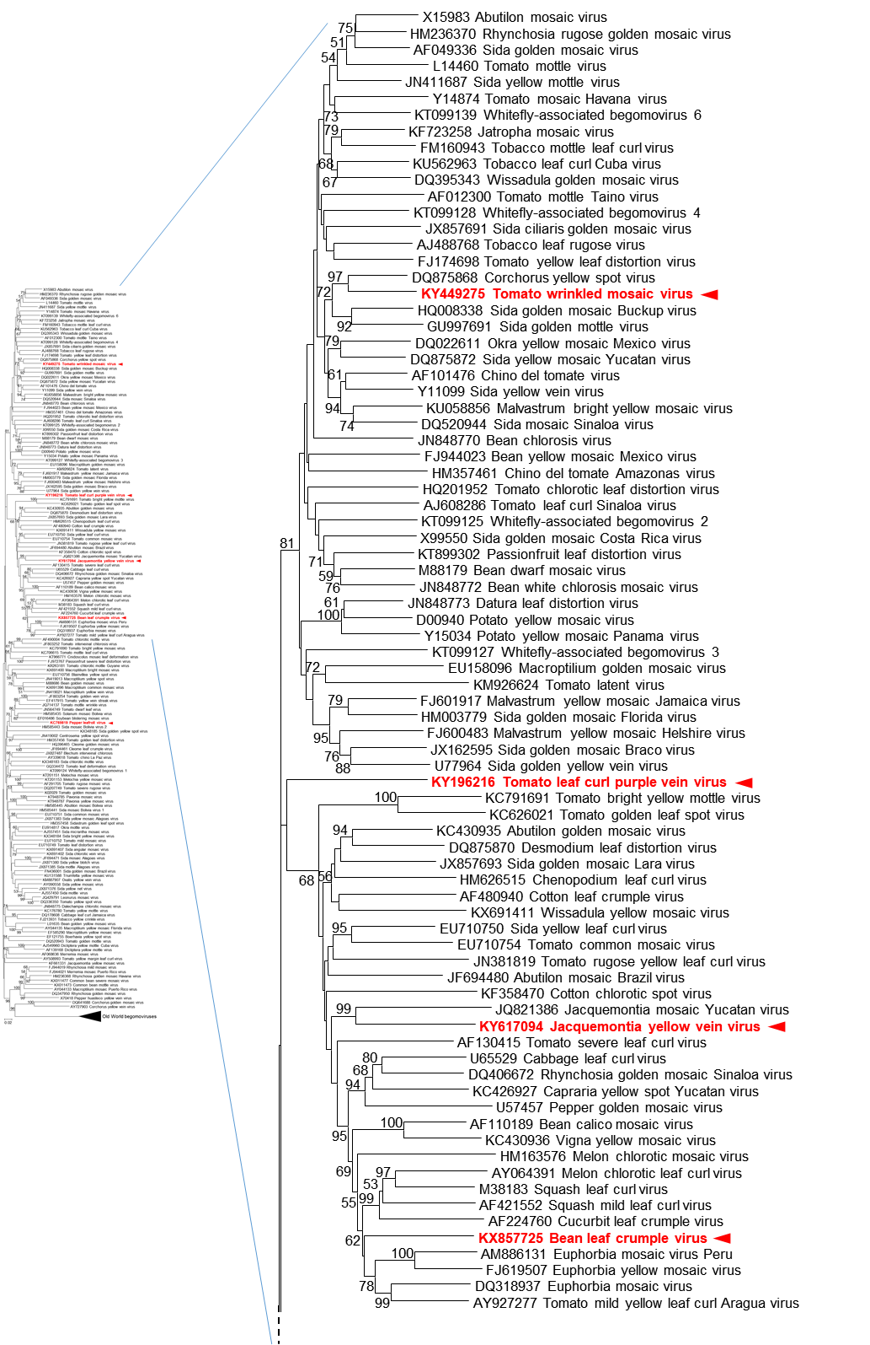
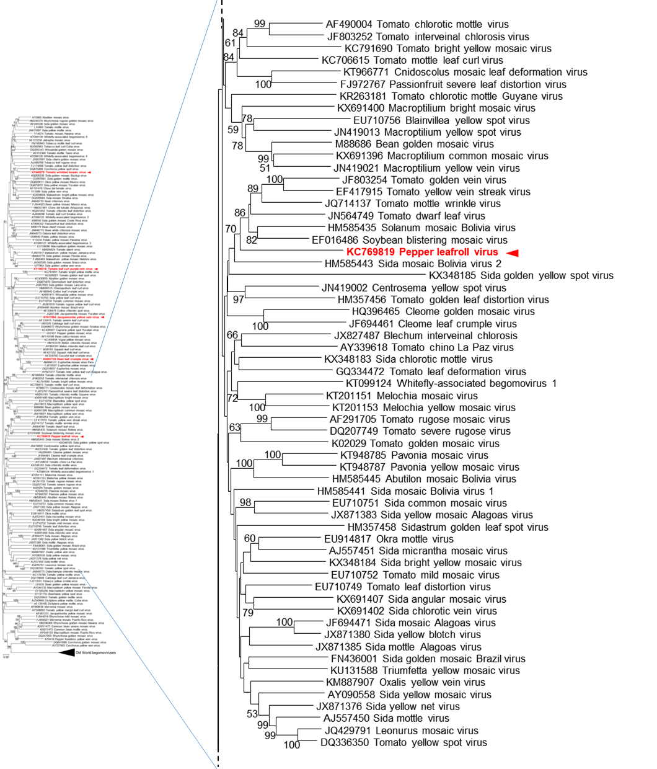
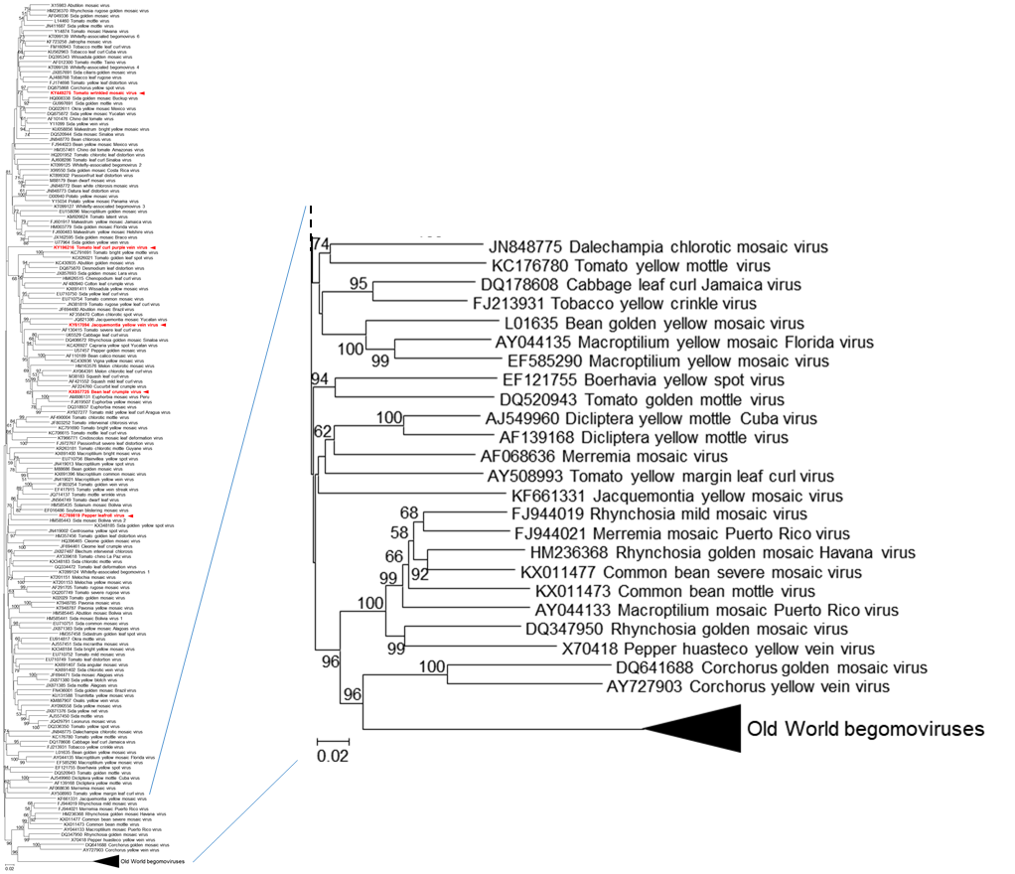

Figure 1. Neighbour-joining phylogenetic tree based on the complete nucleotide sequences (genomic DNA for monopartite viruses, DNA-A component for bipartite viruses) of New World begomoviruses. Branch length is related to genetic distance (p-distance method by using MEGA7 [Kumar et al., 2016]). Numbers at the nodes indicate bootstrap values (1000 replications) and only values >50% are shown. A set of Old World begomoviruses was used as outgroup. The new species listed in this proposal are highlighted in red and marked with arrowheads.

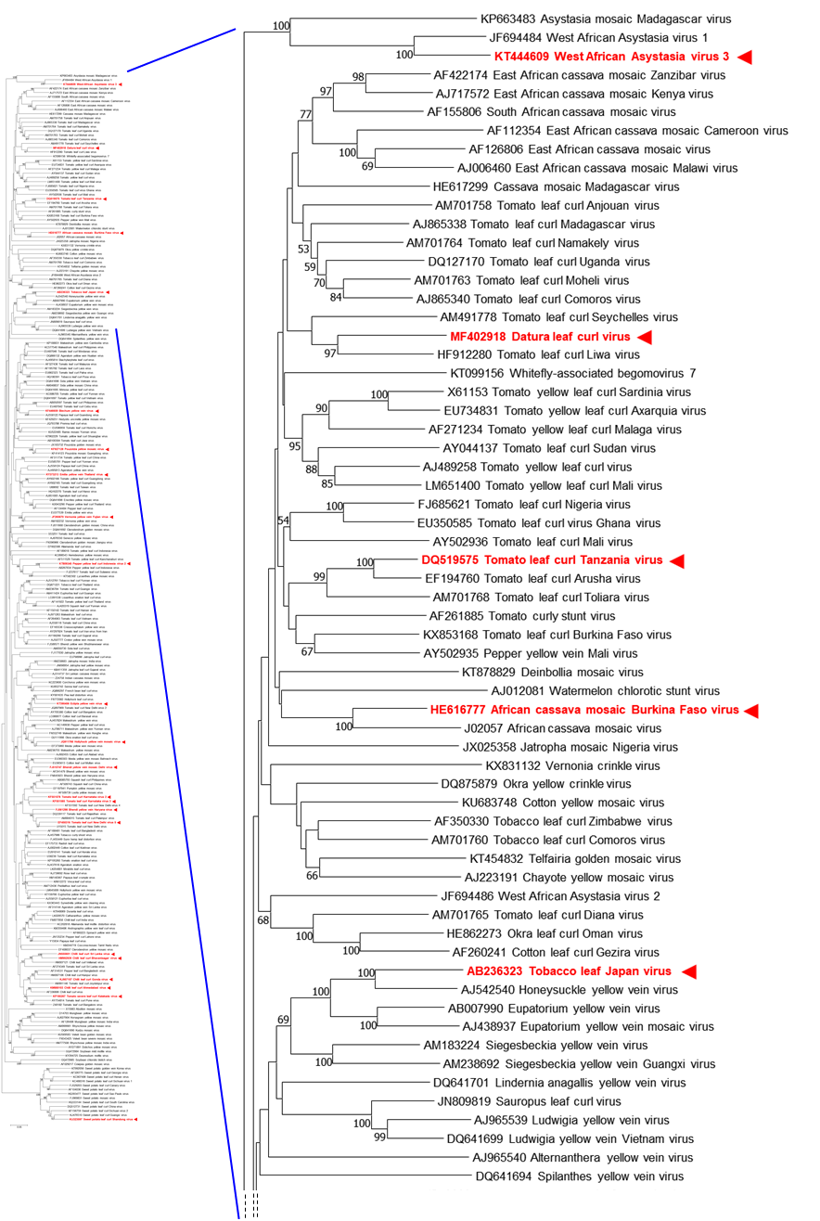
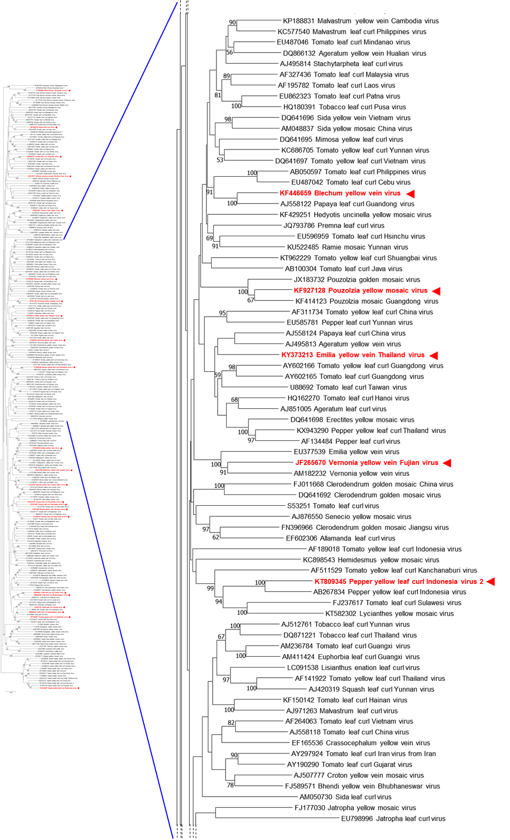
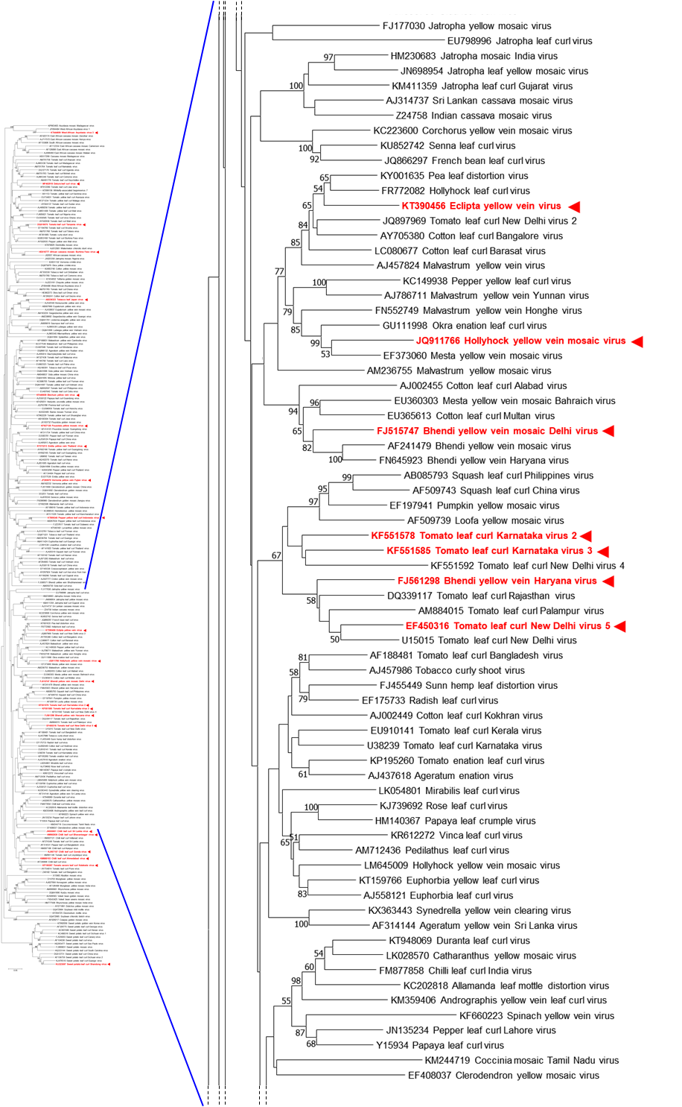

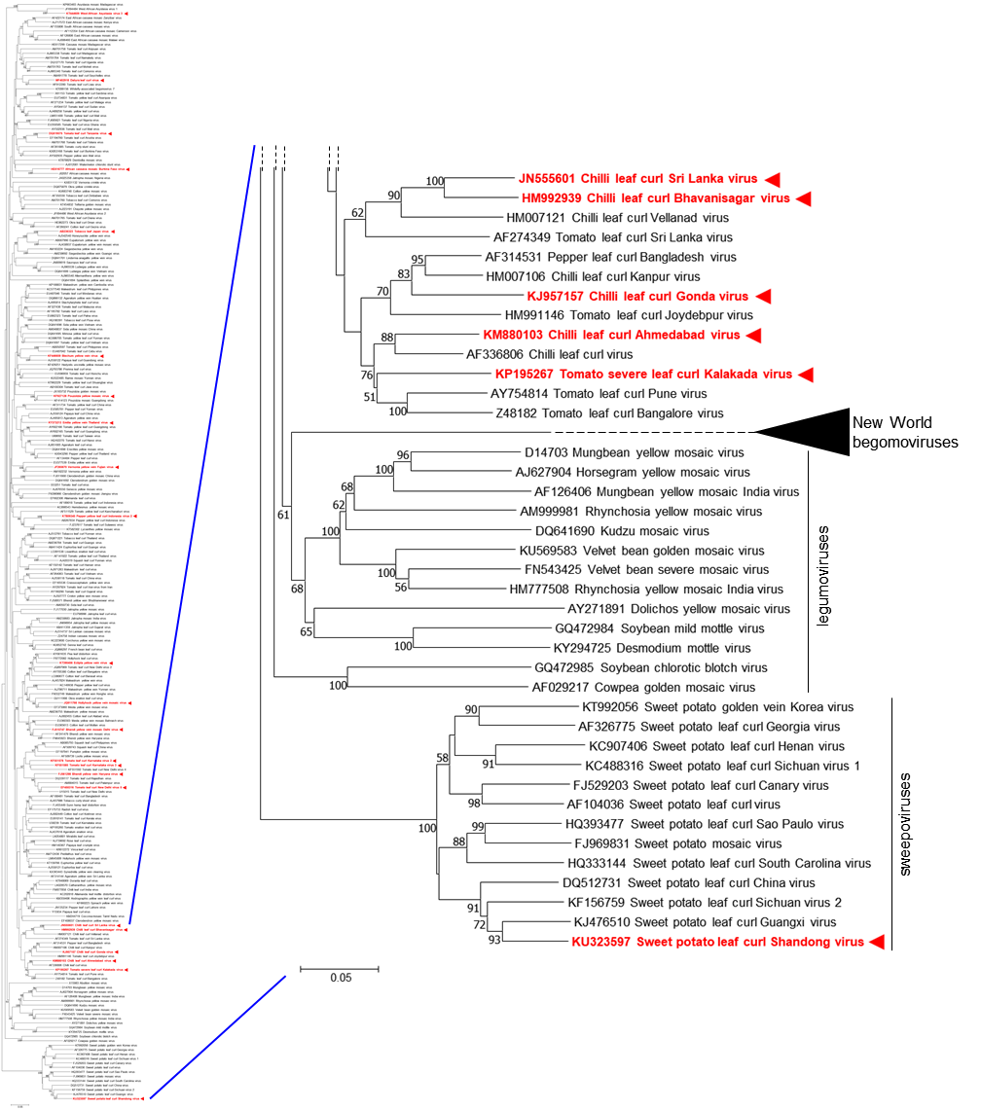

Figure 2. Neighbour-joining phylogenetic tree based on the complete nucleotide sequences (genomic DNA for monopartite viruses, DNA-A component for bipartite viruses) of Old World begomoviruses (including "sweepoviruses" and "legumoviruses"). Branch length is related to genetic distance (p-distance method by using MEGA7 [Kumar et al., 2016]). Numbers at the nodes indicate bootstrap values (1000 replications) and only values >50% are shown. A set of New World begomoviruses was used as outgroup. The new species listed in this proposal are highlighted in red and marked with arrowheads.
References:
Briddon RW, Patil BL, Bagewadi B, Nawaz-ul-Rehman MS (2010) Distinct evolutionary histories of the DNA-A and DNA-B components of bipartite begomoviruses. BMC Evolutionary Biology 10: 97.
Brown JK, Zerbini FM, Navas-Castillo J, Moriones E, Ramos-Sobrinho R, Silva JC, Fiallo-Olivé E, Briddon RW, Hernández-Zepeda C, Idris A, Malathi VG, Martin DP, Rivera-Bustamante R, Ueda S, Varsani A (2015) Revision of Begomovirus taxonomy based on pairwise sequence comparisons. Archives of Virology 160: 1593-1619
Carvajal-Yepes M, Zambrano L, Bueno JM, Raatz B, Cuellar, WJ (2017) Complete genome sequence of bean leaf crumple virus, a novel begomovirus infecting common bean in Colombia. Archives of Virology 162: 1773.
Fiallo-Olivé E, Chirinos DT, Geraud-Pouey F, Navas-Castillo J (2017) Complete genome sequence of jacquemontia yellow vein virus, a novel begomovirus infecting Jacquemontia tamnifolia in Venezuela. Archives of Virology 162: 2463-2466.
Inoue-Nagata AK, Albuquerque LC, Rocha WB, Nagata T (2004) A simple method for cloning the complete begomovirus genome using the bacteriophage phi 29 DNA polymerase. Journal of Virological Methods 116: 209-211.
Khan ZA, Khan JA (2017) Characterization of a new begomovirus and betasatellite associated with chilli leaf curl disease in India. Archives of Virology 162: 561-565.
Krishnan P, Angappan K, Malathi VG, Sukla R, Jyothsna P, Jeevalatha A, Kumar RN (2015) Molecular characterization of a leaf curl virus infecting chillies (Capsicum annum L.) in Tamil Nadu. Indian J. Virol. 21 (Suppl. 1): A76 (Abstract).
Kumar S, Stecher G, Tamura K (2016) MEGA7: Molecular Evolutionary Genetics Analysis version 7.0 for bigger datasets. Molecular Biology and Evolution 33: 1870-1874.
Macedo MA, Albuquerque LC, Maliano MR, Souza JO, Rojas MR, Inoue-Nagata AK, Gilbertson RL (2018) Characterization of tomato leaf curl purple vein virus, a new monopartite New World begomovirus infecting tomato in Northeast Brazil. Archives of Virology 163: 737-743.
Martínez-Ayala A, Sánchez-Campos S, Cáceres F, Aragón-Caballero L, Navas-Castillo J, Moriones E (2014) Characterisation and genetic diversity of pepper leafroll virus, a new bipartite begomovirus infecting pepper, bean and tomato in Peru. Annals of Applied Biology 164: 62-72.
Mohammed HS, El Siddig MA, El Hussein AA, Navas-Castillo J, Fiallo-Olivé E (2018) Complete genome sequence of datura leaf curl virus, a novel begomovirus infecting Datura innoxia in Sudan, related to begomoviruses causing tomato yellow leaf curl disease. Archives of Virology 163: 273-275.
Romay G, Chirinos DT, Geraud-Pouey F, Gilis A, Mahillon J, Bragard C (2018) Complete genome sequence of two tomato-infecting begomoviruses in Venezuela: evidence of a putative novel species and a novel recombinant strain. Archives of Virology 163: 555-558.
Senanayake DMJB, Jayasinghe, JEARM, Shilpi S, Wasala SK, Mandal B (2013). A new begomovirus-betasatellite complex is associated with chilli leaf curl disease in Sri Lanka. Virus Genes 46: 128-139.
Shih SL, Tsai WS, Green SK, Lee LM (2006) Molecular characterization of a distinct begomovirus associated with tomato leaf curl disease in Arusha of Tanzania. Plant Disease 90: 1550.
Srivastava A, Kumar, Raj SK, Pande SS (2014). Association of a distinct strain of hollyhock yellow vein mosaic virus and Ludwigia leaf distortion betasatellite with yellow vein mosaic disease of hollyhock (Alcea rosea) in India. Archives of Virology 159: 2711-2715.
Tiendrébéogo F, Lefeuvre P, Hoareau M, Harimalala MA, de Bruyn A, Villemot J, Traoré VSE, Konaté G, Traoré AS, Barro N, Reynaud B, Traoré O, Lett JM (2012) Evolution of African cassava mosaic virus by recombination between bipartite and monopartite begomoviruses. Virology Journal 9: 67.
Tsai WS, Shih SL, Lee LM, Dolores LM, Kenyon L (2014) First report of a novel begomovirus associated with yellow vein disease of Browne's blechum (Blechum pyramidatum). Plant Disease 98: 701.
Ueda S, Onuki M, Hanada K, Takanami Y (2008). Unique grouping of the Far East Asian begomovirus complex based on sequence analyses of the DNA-A genome and associated DNAβ satellite molecules isolated from tomato, honeysuckle and Eupatorium plants in Japan. Archives of Virology 153: 417-426.
Venkataravanappa V, Lakshminarayana Reddy C, Jalali S, Krishna Reddy M (2012) Molecular characterization of distinct bipartite begomovirus infecting bhendi (Abelmoschus esculentus L.) in India. Virus Genes 44: 522-535.
Zhao L, Zhong J, Zhang X, Yin Y, Li T, Ding M (2018) Two distinct begomoviruses associated with an alphasatellite coinfecting Emilia sonchifolia in Thailand. Archives of Virology 163: 1695-1699.
Zulfiqar A, Zhang J, Cui X, Qian Y, Zhou X, Xie Y (2012) A new begomovirus associated with alpha- and betasatellite molecules isolated from Vernonia cinerea in China. Archives of Virology 157:189-191.

