This Word module should be used for all taxonomic proposals.
Please complete Part 1 and:
either Part 3 for proposals to create new taxa or change existing taxa
or Part 2 for proposals of a general nature.
Submit the completed Word module, together with the accompanying Excel module named in Part 3, to the appropriate ICTV Subcommittee Chair.
For guidance, see the notes written in blue, below, and the help notes in file Taxonomic_Proposals_Help_2018.
Part 1: TITLE, AUTHORS, etc

Code assigned: | 2018.018P |  | (to be completed by ICTV officers)
Short title: Cherry associated luteovirus, a new species in genus Luteovirus
Author(s):
S. Kanakala, O.I. Olawole and W. Allen Miller
Corresponding author with e-mail address:
W. Allen Miller wamiller@iastate.edu
List the ICTV study group(s) that have seen this proposal: \
A list of study groups and contacts is provided at http://www.ictvonline.org/subcommittees.asp . If in doubt, contact the appropriate subcommittee chair (there are six virus subcommittees: animal DNA and retroviruses, animal ssRNA-, animal ssRNA+, fungal and protist, plant, bacterial and archaeal) |  | Luteoviridae Study Group (Chair: W. Allen Miller, wamiller@iastate.edu)
ICTV Study Group comments (if any) and response of the proposer:
“I agree to accept it as a new species.”
Date first submitted to ICTV: |  |  | 2017
Date of this revision (if different to above): |  |  | 6/6/2018

ICTV-EC comments and response of the proposer:
First submission had figures directly from the published MS, by Lenz et al. (2017), which would have violated copyright rules. Here we drew our own version of the genome, calculated our own amino acid sequence similarities and made our own phylogenetic trees.

Part 2: NON-STANDARD
Template for any proposal regarding ICTV procedures, rules or policy, not involving the creation of new taxonomy.
Text of proposal:

Part 3: PROPOSED TAXONOMY

Name of accompanying Excel module: 2018.018P.N.v1.Luteovirus_spb.xlsx
The taxonomic changes you are proposing should be presented on an accompanying Excel module, 2017_TP_Template_Excel_module. Please enter the file name of the completed module in this box.
Supporting material:
additional material in support of this proposal

Please explain the reasons for the taxonomic changes you are proposing and provide evidence to support them. The following information should be provided, where relevant:
- Species demarcation criteria: Explain how new species differ from others in the genus and demonstrate that these differences meet the criteria previously established for demarcating between species. If no criteria have previously been established, and if there will now be more than one species in the genus, please state the demarcation criteria you are proposing.
- Higher taxa:
  - There is no formal requirement to state demarcation criteria when proposing new genera or other higher taxa. However, a similar concept should apply in pursuit of a rational and consistent virus taxonomy.
  - Please indicate the origin of names assigned to new taxa at genus level and above.
  - For each new genus a type species must be designated to represent it. Please explain your choice.

The complete genomic sequence of a new virus from cherry trees was determined. Libraries of dsRNA were sequenced using an Illumina HiSeq 2500 system and processed using CLC Genomic WorkBench 7.5. Its genome is 5857 nt long (accession no. KX159470) and resembles that of members of the genus Luteovirus in its genomic organization (Figure 1) and nucleotide sequence. Based on the species demarcation criteria for luteoviruses (at least one ORF differs by >10% from homologous ORF in the most closely related virus) the virus represents a new luteovirus species. Furthermore, a 47 nt-long inverted repeat was found at the 3’ end of its genome, unlike in other luteoviruses. Phylogenetic analysis clearly indicates that ChaLV clusters with members of the genus Luteovirus (Figure 2). The new virus has been provisionally named cherry-associated luteovirus (ChaLV) based on the plant (cherry trees) from which the virus was isolated, and we propose Cherry associated luteovirus as the name for the new species.

Species demarcation criteria
The species demarcation criteria for luteoviruses indicates that there must be >10% difference in amino acid sequence of any gene, which is the case for most of the comparisons between ChaLV proteins and those of luteovirids (Table 1). The genome organization of ChaLV also differs from other luteoviruses by the position of ORF3a and its sequence.

- Supporting evidence: The use of Figures and Tables is strongly recommended (note that copying from publications will require permission from the copyright holder). For phylogenetic analysis, try to provide a tree where branch length is related to genetic distance.

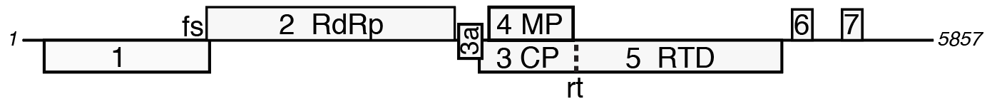

Figure 1. Genome organization of ChaLV (KX159470). Open reading frames are numbered according to luteovirus convention, with some functions indicated. RdRp, RNA-dependent RNA polymerase; MP, movement protein, CP, coat protein, RTD, readthrough domain of coat protein; fs, -1 ribosomal frameshift site; rt, site of stop codon readthrough (dashed line).

Table 1. Percent amino acid sequence identities between ChaLV proteins and those of other luteoviruses and a polerovirus (ScYLV). BLRV, bean leaf roll virus; RSDaV, rose spring dwarf associated virus; SbDV, soybean dwarf virus; NSPaV, nectarine stem pitting associated virus; BYDV, bean yellow dwarf virus; ScYLV, sugarcane yellow leaf virus. n.a., not applicable. Modified from Lenz et al. (2017).

Virus | P1 (364aa) | P2 (527aa) | P3a (48aa) | P3 (198aa) | P4 (175aa) | P5 (448 aa) | P6 (79aa) | P7 (79aa)
BLRV | 32% | 74% | 17% | 33% | 31% | 23% | n.a. | n.a.
RSDaV | 38% | 69% | 25% | 41% | 22% | 29% | 4% | 15%
SbDV | 33% | 69% | 36% | 33% | 30% | 24% | n.a. | n.a.
NSPaV | 25% | 68% | n.a. | 35% | n.a. | 19% | 15% | 10%
BYDV | 31% | 66% | 23% | 42% | 38% | 25% | 9% | 13%
ScYLV | 11% | 9% | n.a. | 43% | 37% | 19% | n.a. | n.a.

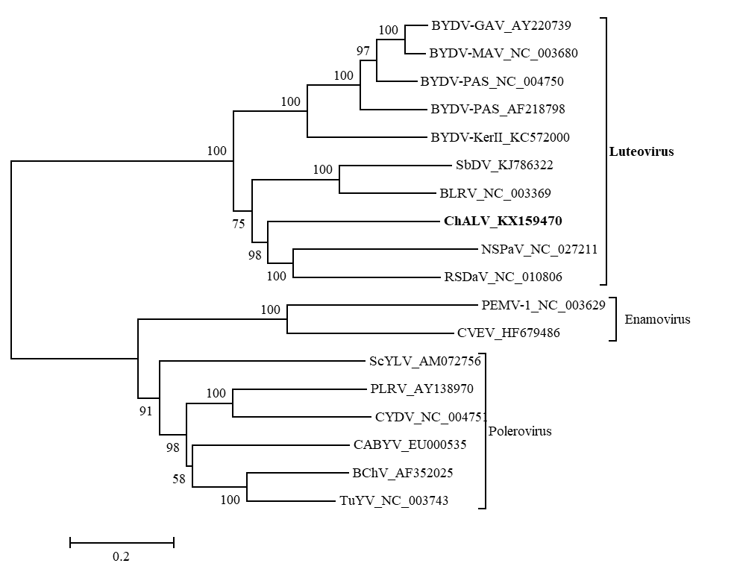
Figure 2. Phylogeny based on complete genome nucleotide sequences of ChaLV and representative members of the family Luteoviridae. Dendograms were constructed in MEGA6 using the neighbour-joining method with 1000 bootstrap replications. Alignments were produced with Clustal W 1.6. Virus abbreviations: BYDV, barley yellow dwarf virus; SbDV, soybean dwarf virus; BLRV, bean leaf roll virus; NSPaV, nectarine stem pitting associated virus; RSDaV, rose spring dwarf- associated virus; PEMV1, pea enation mosaic virus 1; CVEV, citrus vein enation virus; ScYLV, sugarcane yellow leaf virus; PLRV, potato leaf roll virus; CYDV, cereal yellow dwarf virus; CABYV, cucurbit aphid-borne yellows virus; BChV, beet chlorosis virus and TuYV, turnip yellows virus.

References:
Lenz O, Pribylova J, Franova J, Koloniuk I, Spak J (2017) Arch Virol 162:587-590.

