This Word module should be used for all taxonomic proposals.

Please complete **Part 1** and:

either **Part 3** for proposals to create new taxa or change existing taxa

or **Part 2** for proposals of a general nature.

Submit the completed Word module, together with the accompanying Excel module named in Part 3, to the appropriate ICTV Subcommittee Chair.

For guidance, see the notes written in blue, below, and the help notes in file Taxonomic_Proposals_Help_2018.

**Part 1:** **TITLE, AUTHORS, etc**

|  |  |  |  |
| --- | --- | --- | --- |
| **Code assigned:** | ***2018.003P*** | | (to be completed by ICTV officers) |
| **Short title: 1 new species in genus *Pelarspovirus*** | | | |
|  | | | |
| **Author(s):** | | | |
| Kay Scheets for *Tombusviridae* SG | | | |
| **Corresponding author with e-mail address:** | | | |
| kay.scheets@okstate.edu | | | |
| **List the ICTV study group(s) that have seen this proposal:** | | | |
| A list of study groups and contacts is provided at <http://www.ictvonline.org/subcommittees.asp> . If in doubt, contact the appropriate subcommittee chair (there are six virus subcommittees: animal DNA and retroviruses, animal ssRNA-, animal ssRNA+, fungal and protist, plant, bacterial and archaeal) | | *Tombusviridae* SG | |
| **ICTV Study Group comments (if any) and response of the proposer:** | | | |
|  | | | |
|  | | | |
| Date first submitted to ICTV: | | | June 2nd, 2018 |
| Date of this revision (if different to above): | | |  |

|  |
| --- |
| **ICTV-EC comments and response of the proposer:** |
|  |

**Part 2:** **NON-STANDARD**

Template for any proposal regarding ICTV procedures, rules or policy, not involving the creation of new taxonomy.

| **Text of proposal:** |
| --- |
|  |

**Part 3:** **PROPOSED TAXONOMY**

|  |
| --- |
| **Name of accompanying Excel module: 2018.003P.N.v1.Pelarspovirus_sp.xlsx** |

The taxonomic changes you are proposing should be presented on an accompanying Excel module, 2017_TP_Template_Excel_module. Please enter the file name of the completed module in this box.

**Supporting material:**

| additional material in support of this proposal |
| --- |
| Please explain the reasons for the taxonomic changes you are proposing and provide evidence to support them. The following information should be provided, where relevant:   * **Species demarcation criteria**: Explain how new species differ from others in the genus and demonstrate that these differences meet the criteria previously established for demarcating between species. If no criteriahave previously been established, and if there will now be more than one species in the genus, please state the demarcation criteria you are proposing. * **Higher taxa**:   + There is no formal requirement to state demarcation criteria when proposing new genera or other higher taxa. However, a similar concept should apply in pursuit of a rational and consistent virus taxonomy.   + Please indicate the **origin of names** assigned to new taxa at genus level and above.   + For each new genus a **type species** must be designated to represent it. Please explain your choice. * **Supporting evidence**: The use of Figures and Tables is strongly recommended (note that copying from publications will require permission from the copyright holder). For phylogenetic analysis, try to provide a tree where branch length is related to genetic distance. |

A new virus named clematis chlorotic mottle virus (CICMV) was found in many samples of clematis from mid-western USA and the UK [McLaughlin et al, 2017, Mollov et al, 2014]. It produces 28-30 nm virions, and the sequence shows the 3,880 nt ssRNA genome encodes 5 genes for equivalent proteins encoded by viruses belonging to recognized pelarspovirus species. This includes a noncanonical start codon for the movement protein 2 (MP2) ORF, allowing the use of the same template sgRNA to express downstream ORFs. Phylogenetic analyses show that the RNA dependent RNA polymerase (RdRp) and coat protein (CP) each reside on a branch with the relevant proteins for current members of the genus (Fig. 1 and [McLaughlin et al, 2017]). One species demarcation criterion is the natural host range [Scheets et al, 2015]. ClCMV was found only in clematis species (order Ranunculales) which is different than the hosts for the three pelarspoviruses found in pelargoniums (order Geraniales), rosa rugosa leaf distortion virus (order Rosales) and elderberry latent virus (order Dipsacales). Therefore, CICMV it is unlikely to have hosts that overlap current genus members.

Species demarcation criteria in genus *Pelarspovirus* are:

- <75% amino acid sequence identity in RdRps and

- <75% amino acid sequence identity in CPs

- Natural host range

The % identities for ClCMV’s RdRp and CP are 51-54% and 43-48% for the five current pelarspoviruses, and 39-42% and 29-35% for alphacarmoviruses and trailing lespedeza virus 1, respectively, which are the next most similar viruses in the family (Table 1). Therefore, ClCMV is proposed to represent a new species in genus *Pelarspovirus*. Like other viruses in the family *Tombusviridae* the RNA in the 5’ and 3’ UTRs are predicted to fold into the structures necessary for cap independent translation (data not shown), indicating that the sequence is complete and correct.

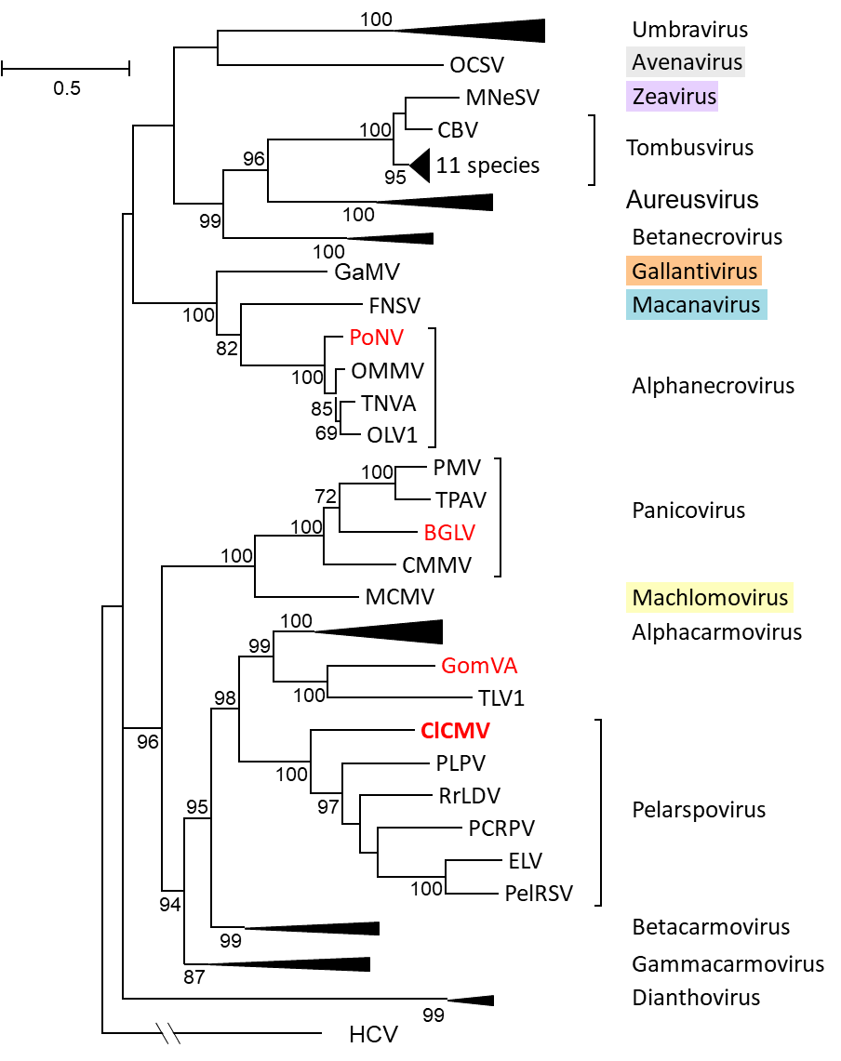

**Figure 1.** Phylogenetic (distance) analysis of the RdRps of tombusvirids with four possible new members (red font). The alignment was made using MUSCLE while trees were generated with the Maximum Likelihood (ML) algorithm in MEGA7 (Kumar et al. 2016) using 1000 bootstrap replicates (showing values >50%). All positions with less than 50% site coverage were eliminated. That is, fewer than 50% alignment gaps, missing data, and ambiguous bases were allowed at any position. There were 797 positions in the final dataset. Hepatitis C virus (HCV) RdRp (GQ870618.1) was used as the outgroup. Brackets mark uncollapsed genera. Monotypic genera names are in colored boxes. Sequence sources and virus names are in Table 2.

**Table 1. Percent Identities of Polymerase and Coat Protein from ClCMV to Closely Related Tombusvirids**



**Table 2. Sequence IDs used for phylogenetic analyses of RdRps and CPs**

|  |  |  |  |  |  |
| --- | --- | --- | --- | --- | --- |
| **Virus Abbreviation(s)** | **Species** | | **Exemplar RefSeq #** | **Exemplar Virus GB #** | |
|  | **genus *Alphacarmovirus*** | |  |  | |
| CarMV-B | **Carnation mottle virus** | | **X02986** | NC_001265 | |
| AFBV-FL | Angelonia flower break virus | | **DQ219415** | NC_007733 | |
| CbMV-CA | Calibrachoa mottle virus | | **GQ244431** | NC_021926 | |
| HoRSV-CA | Honeysuckle ringspot virus | | **HQ677625** | NC_014967 | |
| NLVCV-AK | Nootka lupine vein clearing virus | | **\*EF207438** | **NC_009017** | |
| PFBV-MZ10 | Pelargonium flower break virus | | **AJ514833** | NC_005286 | |
| SgCV-MRN | Saguaro cactus virus | | **U72332** | NC_001780 | |
|  | **genus *Alphanecrovirus*** | |  |  | |
| TNVA-FM1B | **Tobacco necrosis virus A** | | **M33002** | NC_001777 | |
| OLV1-citrus | Olive latent virus 1 | | **X85989** | NC_001721 | |
| OMMV-GP | Olive mild mosaic virus | | **AY616760** | NC_006939 | |
|  | **genus *Aureusvirus*** | |  |  | |
| PoLV | **Pothos latent virus** | | **X87115** | NC_000939 | |
| CLSV | Cucumber leaf spot virus | | **EU127904** | NC_007816 | |
| JCSMV-Iran | Johnsongrass chlorotic stripe mosaic virus | | **AJ557804** | NC_005287 | |
| MWLMV-OH | Maize white line mosaic virus | | **EF589670** | NC_009533 | |
| YSV-DMSZ:PV0517 | Yam spherical virus | | **KF482072** | NC_022895 | |
|  | **genus *Avenavirus*** | |  |  | |
| OCSV-Llanwern | **Oat chlorotic stunt virus** | | **X83964** | NC_003633 | |
|  | **genus *Betacarmovirus*** | |  |  | |
| TCV-B | **Turnip crinkle virus** | | **M22445** | NC_003821 | |
| CCFV-CL | Cardamine chlorotic fleck virus | | **L16015** | NC_001600 | |
| HCRSV-Singapore | Hibiscus chlorotic ringspot virus | | **X86448** | NC_003608 | |
| JINRV | Japanese iris necrotic ring virus | | **D86123** | NC_002187 | |
|  | **genus *Betanecrovirus*** | |  |  | |
| TNVD-Hungary | **Tobacco necrosis virus D** | | **U62546** | NC_003487 | |
| BBSV-Ningxia | Beet black scorch virus | | **AF452884** | NC_004452 | |
| LWSV | Leek white stripe virus | | **X94560** | NC_001822 | |
|  | **genus *Dianthovirus*** | |  |  | |
| CRSV | **Carnation ringspot virus** | | **L18870** | NC_003530 | |
| RCNMV-Australia | Red clover necrotic mosaic virus | | **J04357** | NC_003756 | |
| SCNMV-59 | Sweet clover necrotic mosaic virus | | L07884 | **NC_003806** | |
|  | **genus *Gallantivirus*** | |  |  | |
| GaMV | **Galinsoga mosaic virus** | | **Y13463** | NC_001818 | |
|  | **genus *Gammacarmovirus*** | |  |  | |
| MNSV-Dutch | **Melon necrotic spot virus** | | **M29671** | NC_001504 | |
| CPMV-ATCC:PV955 | Cowpea mottle virus | | **U20976** | NC_003535 | |
| PSNV-Wakayama | Pea stem necrosis virus | | **AB086951** | NC_004995 | |
| SYMMV-Gunwi | Soybean yellow mottle mosaic virus | | **FJ457015** | NC_011643 | |
|  | **genus *Macanavirus*** | |  |  | |
| FNSV-Cauca | **Furcraea necrotic streak virus** | | **FJ768020** | NC_020469 | |
|  | **genus *Machlomovirus*** | |  |  | |
| MCMV-KS1 | **Maize chlorotic mottle virus** | | **X14736** | NC_003627 | |
|  | **genus *Panicovirus*** | |  |  | |
| PMV-109S | **Panicum mosaic virus** | | **U55002** | NC_002598 | |
| CMMV-Scotland | Cocksfoot mild mosaic virus | | **EU081018** | NC_011108 | |
| TPAV-05TGP00369 | Thin paspalum asymptomatic virus | | **JX848617** | NC_021705 | |
|  | **genus *Pelarspovirus*** | |  |  | |
| PelRSV-DMSZ:PV0304 | **Pelargonium ringspot virus** | | **AY038068** | NC_026240 | |
| ELV-ATCC:PV522 | Elderberry latent virus | | **AY038066** | NC_026239 | |
| PCRPV-GR57 | Pelargonium chlorotic ring pattern virus | | **AY038069** | NC_005985 | |
| PLPV-DMSZ:PV0193 | Pelargonium line pattern virus | | **AY613852** | NC_007017 | |
| RrLDV-MN-3 | Rosa rugosa leaf distortion virus | | **KC166238** | NC_020415 | |
|  | Clematis chlorotic mottle virus (proposed) | | **KX712140** | NC_033777 | |
|  | **genus *Tombusvirus*** | |  |  | |
| TBSV-cherry | **Tomato bushy stunt virus** | | **M21958** | NC_001554 | |
| AMCV-Bari | Artichoke mottled crinkle virus | | **X62493** | NC_001339 | |
| CIRV | Carnation Italian ringspot virus | | **X85215** | NC_003500 | |
| CBV-Bulgaria | Cucumber Bulgarian virus | | **AY163842** | NC_004725 | |
| CNV | Cucumber necrosis virus | | **M25270** | NC_001469 | |
| CyRV | Cymbidium ringspot virus | | **X15511** | NC_003532 | |
| EMCV-Israel | Eggplant mottled crinkle virus | | **JQ864181** | NC_023339 | |
| GALV-nipplefruit | Grapevine Algerian latent virus | | **AY830918** | NC_011535 | |
| MPV-PM75 | Moroccan pepper virus | | **\*\*JX197071** | **NC_020073** | |
| PLCV-T46 | Pelargonium leaf curl virus | | **KU187189** | NC_030452 | |
| PNSV-UPEV | Pelargonium necrotic spot virus | | **AJ607402** | NC_005285 | |
|  | **genus *Umbravirus*** | |  |  | |
| CMoV-Weddel | **Carrot mottle virus** | | **FJ188473** | NC_011515 | |
| CMoMV-Australia | Carrot mottle mimic virus | | **U57305** | NC_001726 | |
| ETBTV-18-2 | Ethiopian tobacco bushy top virus | | **KJ918748** | NC_024808 | |
| GRV-MC1 | Groundnut rosette virus | | **Z69910** | NC_003603 | |
| OPMV-PHEL 5235 | Opium poppy mosaic virus | | **EU151723** | NC_027710 | |
| PEMV2-WSG | Pea enation mosaic virus 2 | | U03563 | **NC_003853** | |
| TBTV-Ch | Tobacco bushy top virus | | **AF402620** | NC_004366 | |
|  | **genus *Zeavirus*** | |  |  | |
| MNeSV-AZ | **Maize necrotic streak virus** | | **AF266518** | NC_007729 | |
|  | **unassigned tombusvirid** | |  |  | |
| TLV1-06TGP01091 | Trailing lespedeza virus 1 | | **HM640935** | NC_015227 | |
|  | **genus *Hepacivirus*** | |  |  | |
| HCV-H77 | Hepacivirus C | | GQ870618 |  | |
|  | **unassigned viruses** | |  |  | |
| BGLV | Bermudagrass latent virus | | **KX758441** | NC_032405.1 | |
| GomVA | Gompholobium virus A | | **\*\*\*KX184304** | **NC_030742** | |
| PoNV | Potato necrosis virus | | **KP901095** | NC_029900 | |
| **Blue font has correct RdRp annotation & was used** | |  |  |  | |
| **Red font has same incorrect RdRp annotation** | |  | **\* join RAP & RT with "X"** | |  |
| **Asterisks indicate modifications to GenBank entries** | |  | **\*\* insert "X" at RT site** | |  |
| **Type species are bold** |  | | **\*\*\* use "X" at RT site** | |  |

| **References:** |
| --- |
| McLaughlin, M., Lockhart, B., Jordan, R., Denton, G., Mollov, D., 2017. Complete nucleotide sequence of clematis chlorotic mottle virus, a new member of the family Tombusviridae. Archives of Virology 162, 1373-1379.  Mollov, D, Lockhart, B, Phibbs, A, Creswell, T, Ruhl, G, Dorman, E, Kinard, G, Jordan R  Clematis chlorotic mottle virus, a novel virus occurring in clematis in the USA (2014)  (Abstr.) Phytopathology 104(Suppl. 3):S3.1.<http://dx.doi.org/10.1094/PHYTO-104-11-S3.81>  Scheets, K, Jordan, R, White, A, and Hernandez, C, (2015) ICTV taxonomic proposal 2014.006bfP.A.v3.Pelarspovirus. In the family *Tombusviridae* assign 5 previously unassigned species to a new genus, *Pelarspovirus*  https://talk.ictvonline.org/files/ictv_official_taxonomy_updates_since_the_8th_report/m/plant-official/5847 |