This Word module should be used for all taxonomic proposals.
Please complete Part 1 and:
either Part 3 for proposals to create new taxa or change existing taxa
or Part 2 for proposals of a general nature.
Submit the completed Word module, together with the accompanying Excel module named in Part 3, to the appropriate ICTV Subcommittee Chair.
For guidance, see the notes written in blue, below, and the help notes in file Taxonomic_Proposals_Help_2018.
Part 1: TITLE, AUTHORS, etc

Code assigned: | 2018.011P |  | (to be completed by ICTV officers)
Short title: Grapevine virus G, a new species in the genus Vitivirus

Author(s):
Arnaud G Blouin, Kar Mun Chooi, Ben Warren, Kathryn R. Napier, Roberto A. Barrero, Robin M. MacDiarmid
Corresponding author with e-mail address:
Arnaud.blouin@plantandfood.co.nz
List the ICTV study group(s) that have seen this proposal:
A list of study groups and contacts is provided at http://www.ictvonline.org/subcommittees.asp . If in doubt, contact the appropriate subcommittee chair (there are six virus subcommittees: animal DNA and retroviruses, animal ssRNA-, animal ssRNA+, fungal and protist, plant, bacterial and archaeal) |  | Beta-, Gamma-, and Deltaflexiviridae Study Group (Chair: Ioannis Tzanetakis)
ICTV Study Group comments (if any) and response of the proposer:
Date first submitted to ICTV: |  |  | May 4th 2018
Date of this revision (if different to above):

ICTV-EC comments and response of the proposer:

Part 2: NON-STANDARD
Template for any proposal regarding ICTV procedures, rules or policy, not involving the creation of new taxonomy.
Text of proposal:

Part 3: PROPOSED TAXONOMY

Name of accompanying Excel module: 2018.011P.N.v1.Vitivirus_spb.xlsx
The taxonomic changes you are proposing should be presented on an accompanying Excel module, 2017_TP_Template_Excel_module. Please enter the file name of the completed module in this box.
Supporting material:
additional material in support of this proposal
Please explain the reasons for the taxonomic changes you are proposing and provide evidence to support them. The following information should be provided, where relevant:
- Species demarcation criteria: Explain how new species differ from others in the genus and demonstrate that these differences meet the criteria previously established for demarcating between species. If no criteria have previously been established, and if there will now be more than one species in the genus, please state the demarcation criteria you are proposing.

Species of the genus Vitivirus have filamentous virions of about 725-825 nm by 12 nm containing a positive sense RNA genome of 7400 to 7600 nucleotides (nt).
A novel virus from Vitis vinifera was identified by high throughput sequencing (HTS) of small RNAs and confirmed by HTS of total RNA and Sanger sequencing (Blouin et al., 2017). The new virus (isolate VID561) genome is 7496 nt long (GenBank accession No. MF405923) and its structure is similar to the one reported for other vitiviruses (Figure 1), with five open reading frames (ORFs) coding for the conserved domains described for genus Vitivirus (Minafra et al., 2017; Adams et al., 2004). ORF1 (nt positions 65:5176) encodes a polyprotein of 1710 amino acids (aa) that contains four recognized domains (from the N terminus): metyltransferase (MTR); helicase (HEL); 2OG-Fe(II) oxygenase superfamily (AlkB); and RNA-dependent RNA-polymerase (RdRp). The second ORF starts 14 nt after the stop codon of ORF1 (nt positions 5191-5655) and encodes a 154 aa protein with no recognised domains and no known function, as observed for the other vitiviruses. The third ORF starts 20 nt after ORF2 (nt positions 5676-6536) and encodes a 286 aa protein with a movement protein domain. ORF4 overlaps ORF3 by 89 nt (nt positions 6448:7053) and encodes a 201 aa protein with the recognised tricho coat superfamily domain. ORF5 starts 36 nt after the stop codon of ORF4 (nt positions 7090:7443) and is the shortest ORF, coding for a product of 117 aa with a nucleic acid binding domain. The 5´ and 3´ untranslated regions (UTRs) are 64 and 53 nt long, respectively (excluding the 3´ poly A tail).

Within the genus Vitivirus, the closest sequences available in GenBank are those of grapevine virus E (GVE) and agave tequilana leaf virus (ATLV) (Figure 2). In the full sequence pairwise comparison, the new virus shares 52 and 53% nt identity with ATLV and GVE, respectively. The replicase gene shares 51% nt (41% aa) and 56% nt (51% aa) identity to ATLV and GVE, respectively. The highest identity is found in the coat protein encoded by ORF4, i.e. 65% nt (67% aa) and 59% nt (55% aa) identity with ATLV and GVE, respectively.

The species demarcating criteria in the genus Vitivirus are:
- The natural host range: Grapevine
- Serological specificity using discriminatory polyclonal and monoclonal antibodies: N/A
- Epidemiology: individual species or groups of species are transmitted by different types and species of vectors, N/A
- Differences in dsRNA pattern: N/A
- Less than about 72% nt identity (or 80% aa identity) between their CP or polymerase genes: GVG shares only 51% amino acid identity with GVE and 41% aa identity with ATLV in the replicase protein, and 66.8 % aa identity with ATLV and 55% aa identity with GVE in the coat protein.

- Supporting evidence: The use of Figures and Tables is strongly recommended (note that copying from publications will require permission from the copyright holder). For phylogenetic analysis, try to provide a tree where branch length is related to genetic distance.

Figure 1. Schematic representation of the genome organisation of grapevine virus G (GVG). Open reading frames are represented by boxes with the conserved domains indicated. Acronyms used are for the methyl transferase domain (MTR), the helicase domain (HEL), the 2OG-Fe(II) oxygenase domain (AlkB), the RNA-dependent RNA polymerase domain (RdRp), the movement protein (MP), the coat protein (CP), and the nucleic-acid-binding protein (NABP).

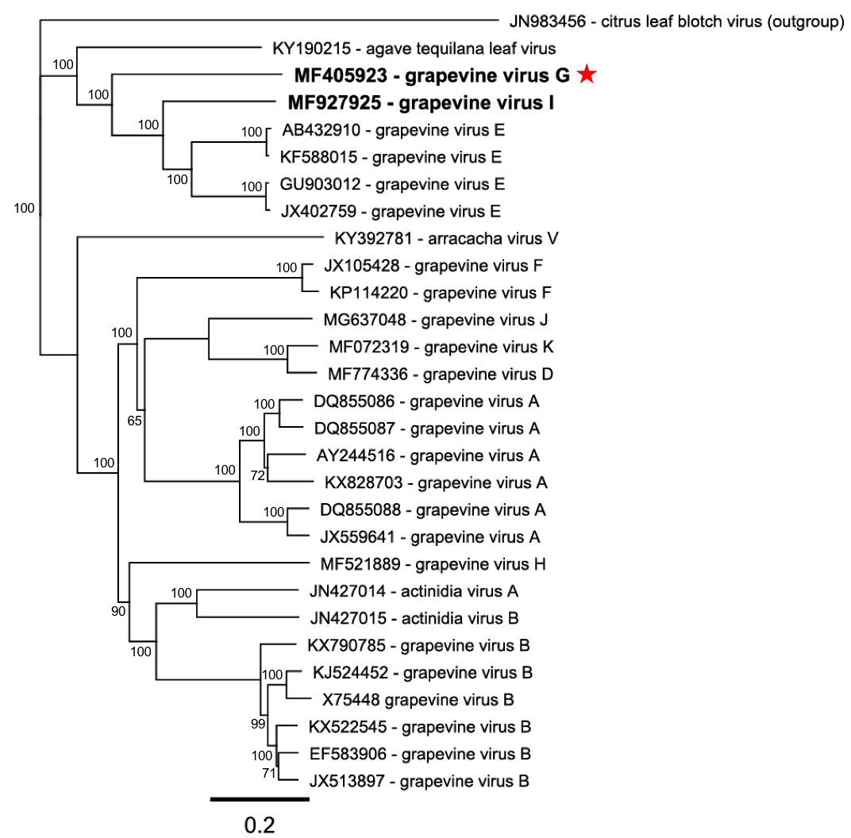

Figure 2. Neighbor-Joining tree (1000 bootstrap replicates using the Jukes-Cantor distance model) based on the replicase polyprotein of representative members of the genus Vitivirus. Protein alignments (translated from the accession number indicated) were performed with ClustalW (BLOSUM cost matrix with a gap opening cost set at 10, and a gap extension cost at 0.1). Consensus support is shown as a percentage on the branch. Citrus leaf blotch virus was used as outgroup. The position of grapevine virus G is indicated in bold and with a red star.

References:
Blouin AG, Keenan S, Napier K, Barrero R, MacDiarmid R (2017) Identification of a novel vitivirus from grapevines in New Zealand. Arch Virol 163:281-284
Adams MJ, Antoniw JF, Bar-Joseph M, Brunt AA, Candresse T, Foster GD, Martelli GP, Milne RG, Zavriev SK, Fauquet CM (2004) The new plant virus family Flexiviridae and assessment of molecular criteria for species demarcation. Arch Virol 149:1045-1060
Minafra A, Mawassi M, Goszczynski D, Saldarelli P (2017) Grapevine vitiviruses. In: Meng B, Martelli G, Golino D, Fuchs M (eds) Grapevine Viruses: Molecular Biology, Diagnostics and Management. Springer, pp 229-256

