This Word module should be used for all taxonomic proposals.

Please complete **Part 1** and:

either **Part 3** for proposals to create new taxa or change existing taxa

or **Part 2** for proposals of a general nature.

Submit the completed Word module, together with the accompanying Excel module named in Part 3, to the appropriate ICTV Subcommittee Chair.

For guidance, see the notes written in blue, below, and the help notes in file Taxonomic_Proposals_Help_2018.

**Part 1:** **TITLE, AUTHORS, etc**

|  |  |  |  |
| --- | --- | --- | --- |
| **Code assigned:** | ***2018.013P*** | | (to be completed by ICTV officers) |
| **Short title:** Grapevine virus I, a new species in the genus *Vitivirus* | | | |
|  | | | |
| **Author(s):** | | | |
| Arnaud G Blouin, Kar Mun Chooi, Ben Warren, Kathryn R. Napier, Roberto A. Barrero, Robin M. MacDiarmid | | | |
| **Corresponding author with e-mail address:** | | | |
| Arnaud G Blouin, Arnaud.blouin@plantandfood.co.nz | | | |
| **List the ICTV study group(s) that have seen this proposal:** | | | |
| A list of study groups and contacts is provided at <http://www.ictvonline.org/subcommittees.asp> . If in doubt, contact the appropriate subcommittee chair (there are six virus subcommittees: animal DNA and retroviruses, animal ssRNA-, animal ssRNA+, fungal and protist, plant, bacterial and archaeal) | | *Beta*-, *Gamma*-, and *Deltaflexiviridae* Study Group (Chair: Ioannis Tzanetakis) | |
| **ICTV Study Group comments (if any) and response of the proposer:** | | | |
|  | | | |
|  | | | |
| Date first submitted to ICTV: | | | May 4th 2018 |
| Date of this revision (if different to above): | | |  |

|  |
| --- |
| **ICTV-EC comments and response of the proposer:** |
|  |

**Part 2:** **NON-STANDARD**

Template for any proposal regarding ICTV procedures, rules or policy, not involving the creation of new taxonomy.

| **Text of proposal:** |
| --- |
|  |

**Part 3:** **PROPOSED TAXONOMY**

|  |
| --- |
| **Name of accompanying Excel module: 2018.013P.N.v1.Vitivirus_spd.xlsx** |

The taxonomic changes you are proposing should be presented on an accompanying Excel module, 2017_TP_Template_Excel_module. Please enter the file name of the completed module in this box.

**Supporting material:**

| additional material in support of this proposal |
| --- |
| Please explain the reasons for the taxonomic changes you are proposing and provide evidence to support them. The following information should be provided, where relevant:   * **Species demarcation criteria**: Explain how new species differ from others in the genus and demonstrate that these differences meet the criteria previously established for demarcating between species. If no criteriahave previously been established, and if there will now be more than one species in the genus, please state the demarcation criteria you are proposing.   Members of the genus *Vitivirus* have filamentous virions of about 725-825 nm by 12 nm containing a positive sense RNA genome of 7400 to 7600 nucleotides (nt).  A novel virus, denoted grapevine virus I, with characteristics of the genus *Vitivirus* was identified from a sample of *Vitis vinifera* cv. Chardonnay in New Zealand (Blouin et al, 2018). The virus was detected with high throughput sequencing (small RNA and total RNA) and its sequence was confirmed by Sanger sequencing. Its genome is 7507 nt long excluding the poly-A tail (GenBank accession No. MF927925, isolate VID499) with the organization similar to that described for the other members of the genus *Vitivirus* (Minafra et al., 2017; Adams et al., 2004) (Figure 1).  ORF1 encodes a 1696 aa polyprotein (nt positions 69-5159) that contains the recognized domains of methyltransferase (MTR); helicase (HEL); 2OG-Fe(II) oxygenase superfamily (AlkB); and RNA-dependent RNA-polymerase (RdRp). The closest relative in GenBank is grapevine virus E (GVE, isolate SA94, GU903012) with 65% aa and nt identity for the entire ORF1. The second ORF (ORF2) overlaps with ORF1 by 11 nt (nt positions 5149-5652) and codes for a 167 aa putative protein with poor homology to known proteins and no recognized domains, as observed in previously characterised viruses from genus *Vitivirus*. The third ORF (ORF3) starts 32 nt downstream of ORF2 and codes for a 264 aa protein (nt positions 5685-6479) containing a movement protein domain. The movement protein of GVE is its closest relative with 63% aa identity (65% nt). The next ORF (ORF4) overlaps with ORF3 by 70 nt and codes for a 199 aa protein (nt positions 6409-7008) containing the tricho coat superfamily domain. This protein shares 65% aa identity with the coat protein of agave tequilina leaf virus (ATLV) (68% nt); 63% aa identity with GVE (66% nt) and 62% aa with grapevine virus G (GVG) (61% nt). ORF5 starts 29 nt downstream of ORF4 and codes for a 121 aa protein (nt positions 7038-7403) with a recognized viral nucleic acid binding protein (NABP). This protein shows the closest match with GVE in GenBank (72% aa and 70% nt identity).  Phylogenetic analysis shows that the new virus groups together with GVE, ATLV and GVG (Figure 2). A limited survey revealed the presence of this virus in multiple plants, often detected in co-infection with GVG. The characteristics of this virus suggest it is a representative of a new species in the genus *Vitivirus* for which we propose the name *Grapevine virus I*.  The criteria demarcating species in the genus *Vitivirus* are:   * The natural host range: Grapevine * Serological specificity using discriminatory polyclonal and monoclonal antibodies: N/A * Epidemiology: individual species or groups of species are transmitted by different types and species of vectors, N/A * Differences in dsRNA pattern: N/A * Less than 72% nt identity (or 80% aa identity) between their CP or polymerase genes: GVI shares the highest aa identities (65% aa identity in the ORF1 and 63% aa identity of the coat protein) with its closest relative grapevine virus E (GVE). Both values are clearly below the species demarcation criteria. * **Supporting evidence**: The use of Figures and Tables is strongly recommended (note that copying from publications will require permission from the copyright holder). For phylogenetic analysis, try to provide a tree where branch length is related to genetic distance. |



**Figure 1.** Schematic representation of the genome organization for grapevine virus I (GVI). Open reading frames are represented by boxes. Acronyms used are for the methyl transferase domain (MTR); the helicase domain (HEL), the 2OG-Fe(II) oxygenase domain (AlkB), the RNA-dependent RNA-polymerase domain (RdRp), the movement protein (MP), the coat protein (CP) and the nucleic acid binding protein (NABP).

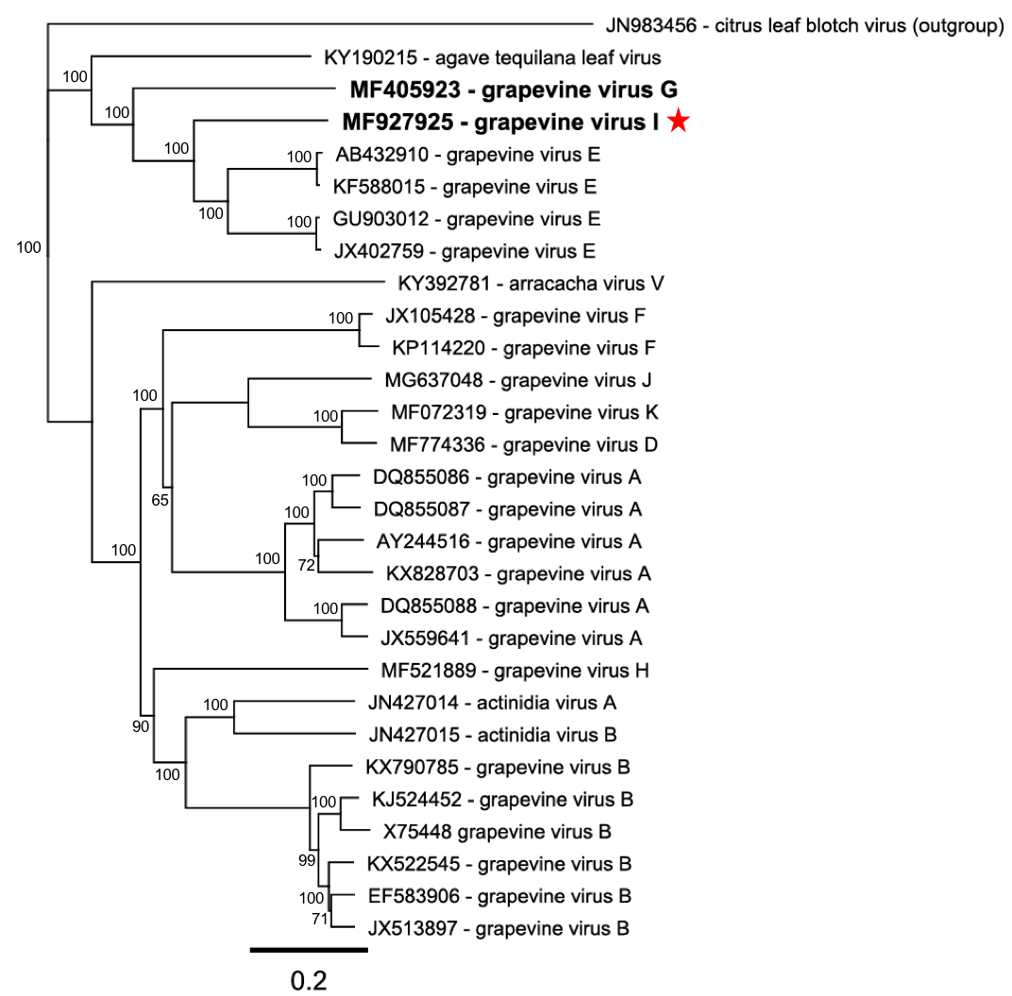

**Figure 2.** Neighbor-Joining tree (1000 bootstrap replicates using the Jukes-Cantor distance model) of the replicase polyprotein (ORF1) of representative members of the genus *Vitivirus*. Protein alignments (translated from the accession number indicated) were performed with ClustalW (BLOSUM cost matrix with a gap opening cost set at 10, and a gap extension cost at 0.1). Consensus support is shown as a percentage on the branch. Citrus leaf blotch virus was used as outgroup. The position of grapevine virus I is indicated in bold and with a red star.

| **References:** |
| --- |
| Adams MJ, Antoniw JF, Bar-Joseph M, Brunt AA, Candresse T, Foster GD, Martelli GP, Milne RG, Zavriev SK, Fauquet CM (2004) The new plant virus family *Flexiviridae* and assessment of molecular criteria for species demarcation. Arch Virol 149:1045-1060  Blouin AG, Chooi KM, Warren B, Napier KR, Barrero RA, MacDiarmid RM (2018) Grapevine virus I, a putative new vitivirus detected in co-infection with grapevine virus G in New Zealand. Arch Virol 163: 1371-1374  Minafra A, Mawassi M, Goszczynski D, Saldarelli P (2017) Grapevine vitiviruses. In: Meng B, Martelli G, Golino D, Fuchs M (Eds) Grapevine Viruses: Molecular Biology, Diagnostics and Management. Springer, pp 229-256 |