This Word module should be used for all taxonomic proposals.
Please complete Part 1 and:
either Part 3 for proposals to create new taxa or change existing taxa
or Part 2 for proposals of a general nature.
Submit the completed Word module, together with the accompanying Excel module named in Part 3, to the appropriate ICTV Subcommittee Chair.
For guidance, see the notes written in blue, below, and the help notes in file Taxonomic_Proposals_Help_2018.
Part 1: TITLE, AUTHORS, etc

Code assigned: | 2018.007P |  | (to be completed by ICTV officers)
Short title: A new species in the genus Foveavirus
Author(s):
Yeonhwa Jo, Myung-Kyu Song, Hoseong Choi, Jae-Seong Park, Jae-Wung Lee, Sen Lian, Bong Choon Lee, Won Kyong Cho
Corresponding author with e-mail address:
Won Kyong Cho (wonkyong@gmail.com)
List the ICTV study group(s) that have seen this proposal:
A list of study groups and contacts is provided at http://www.ictvonline.org/subcommittees.asp . If in doubt, contact the appropriate subcommittee chair (there are six virus subcommittees: animal DNA and retroviruses, animal ssRNA-, animal ssRNA+, fungal and protist, plant, bacterial and archaeal) |  | Beta-, Gamma-, and Deltaflexiviridae Study Group (SG Chair: Ioannis Tzanetakis)
ICTV Study Group comments (if any) and response of the proposer:
Date first submitted to ICTV: |  |  | May 12th 2018
Date of this revision (if different to above):

ICTV-EC comments and response of the proposer:

Part 2: NON-STANDARD
Template for any proposal regarding ICTV procedures, rules or policy, not involving the creation of new taxonomy.
Text of proposal:

Part 3: PROPOSED TAXONOMY

Name of accompanying Excel module: 2018.007P.N.v1.Foveavirus_sp.xlsx
The taxonomic changes you are proposing should be presented on an accompanying Excel module, 2017_TP_Template_Excel_module. Please enter the file name of the completed module in this box.

Grapevine virus T (GVT) is a novel single-stranded RNA virus identified from the transcriptome of grapevine cv. Teroldego. The genome of GVT isolate Cho (GVT-Cho) is 8,701 nucleotides in length and encodes five open reading frames, the replicase (ORF1), three triple-gene block (TGB1, TGB2 and TGB3) and coat protein (ORF5), as observed with members of the genus Foveavirus (Figure 1). Nevertheless, identities in nucleotide sequences of the ORFs 1 and 5, as well as in amino acid content of their translated products with known foveaviruses are below the currently valid species demarcation threshold in the genus (see below). Phylogenetic analysis based on both the replicase (Figure 2) and coat protein (Figure 3) supports the inclusion of GVT in the genus Foveavirus. Therefore, we propose that GVT-Cho represents a new species in the genus Foveavirus in the family Betaflexiviridae, named Grapevine virus T.

Supporting material:

additional material in support of this proposal
Please explain the reasons for the taxonomic changes you are proposing and provide evidence to support them. The following information should be provided, where relevant:
- Species demarcation criteria: Explain how new species differ from others in the genus and demonstrate that these differences meet the criteria previously established for demarcating between species. If no criteria have previously been established, and if there will now be more than one species in the genus, please state the demarcation criteria you are proposing.

The criteria demarcating species in the genus are:
- Natural host range: Grapevine
- Serological specificity: N/A
- CP size: 28KDa
- Less than about 72% nt identity (or 80% aa identity) between their CP or polymerase genes: GVT shares the following sequence identities with grapevine rupestris stem pitting-associated virus (GRSPaV): 52% identity for the replicase, 62% identity for TGB1, 53% identity for TGB2, 48% identity for TGB3 and 53% identity for the coat protein.

- Supporting evidence: The use of Figures and Tables is strongly recommended (note that copying from publications will require permission from the copyright holder). For phylogenetic analysis, try to provide a tree where branch length is related to genetic distance.

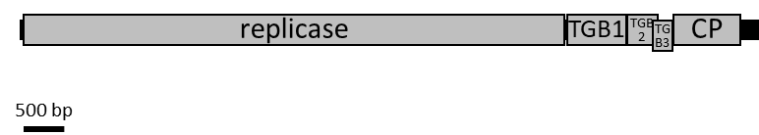

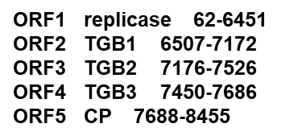

Figure 1. Schematic representation of the genome organization for Grapevine virus T (8,701 nt).

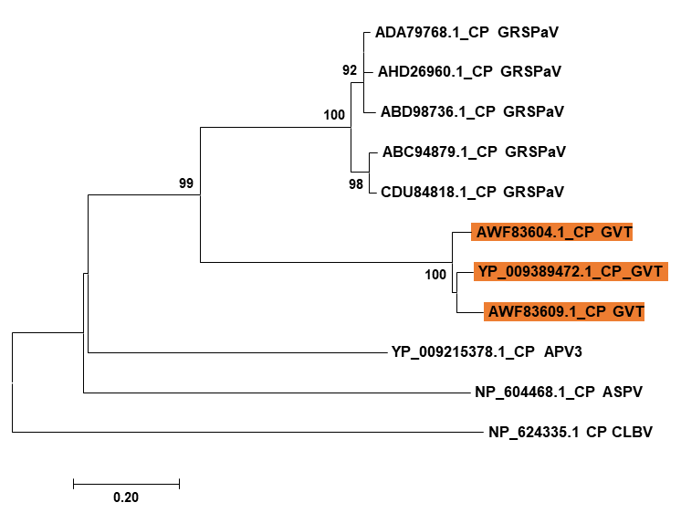

Figure 2. Phylogenetic tree based on the amino acid sequences of the coat proteins (CP) of GVT and other members in the genus Foveavirus. Amino acid sequences of CP were aligned by the ClustalW program with default parameters. The phylogenetic tree was constructed via the neighbor-joining method with 1,000 bootstrap replicates and Poisson model using the MEGA7 program. Citrus leaf blotch virus (CLBV) in the genus Citrivirus in the family Betaflexiviridae, was used as an outgroup virus. Abbreviations of virus names are as follows: grapevine rupestris stem pitting-associated virus (GRSPaV), Asian prunus virus 3 (APV3), apple stem pitting virus (ASPV).

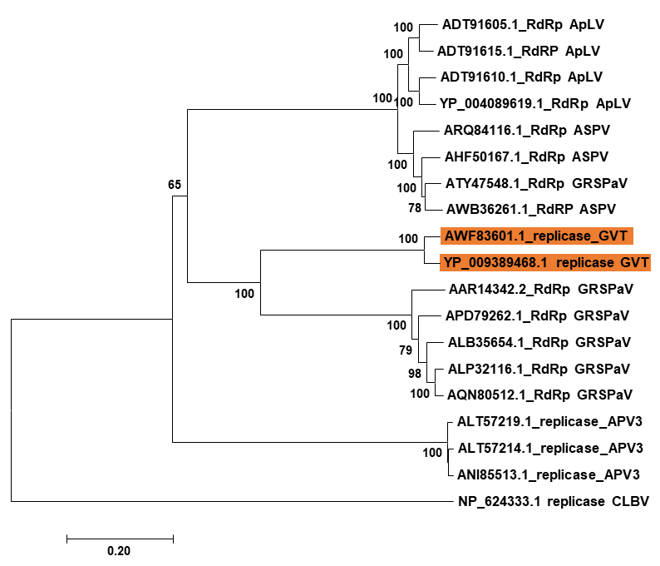

Figure 3. Phylogenetic tree based on the amino acid sequences of replicases (RdRp) from GVT and other members in the genus Foveavirus. Amino acid sequences of RdRp were aligned by the ClustalW program with default parameters. The phylogenetic tree was constructed via the neighbor-joining method with 1,000 bootstrap replicates and Poisson model using the MEGA7 program. Citrus leaf blotch virus (CLBV) in the genus Citrivirus in the family Betaflexiviridae was used as an outgroup virus. Abbreviations of virus names are as follows: apricot latent virus (ApLV), grapevine rupestris stem pitting-associated virus (GRSPaV), Asian prunus virus 3 (APV3), apple stem pitting virus (ASPV).

References:
Yeonhwa Jo, Myung-Kyu Song, Hoseong Choi, Jae-Seong Park, Jae-Wung Lee, Sen Lian, Bong Choon Lee, Won Kyong Cho (2017) Genome sequence of Grapevine virus T, a novel foveavirus infecting grapevine. Genome Announcements 5:e00995-17.

