This Word module should be used for all taxonomic proposals.

Please complete **Part 1** and:

either **Part 3** for proposals to create new taxa or change existing taxa

or **Part 2** for proposals of a general nature.

Submit the completed Word module, together with the accompanying Excel module named in Part 3, to the appropriate ICTV Subcommittee Chair.

For guidance, see the notes written in blue, below, and the help notes in file Taxonomic_Proposals_Help_2018.

**Part 1:** **TITLE, AUTHORS, etc**

|  |  |  |  |
| --- | --- | --- | --- |
| **Code assigned:** | ***2018.022P*** | | (to be completed by ICTV officers) |
| **Short title: One new species in genus *Alphanecrovirus*** | | | |
|  | | | |
| **Author(s):** | | | |
| Kay Scheets for *Tombusviridae* SG | | | |
| **Corresponding author with e-mail address:** | | | |
| kay.scheets@okstate.edu | | | |
| **List the ICTV study group(s) that have seen this proposal:** | | | |
| A list of study groups and contacts is provided at <http://www.ictvonline.org/subcommittees.asp> . If in doubt, contact the appropriate subcommittee chair (there are six virus subcommittees: animal DNA and retroviruses, animal ssRNA-, animal ssRNA+, fungal and protist, plant, bacterial and archaeal) | | *Tombusviridae* SG | |
| **ICTV Study Group comments (if any) and response of the proposer:** | | | |
|  | | | |
|  | | | |
| Date first submitted to ICTV: | | | June 2nd, 2018 |
| Date of this revision (if different to above): | | |  |

|  |
| --- |
| **ICTV-EC comments and response of the proposer:** |
|  |

**Part 2:** **NON-STANDARD**

Template for any proposal regarding ICTV procedures, rules or policy, not involving the creation of new taxonomy.

| **Text of proposal:** |
| --- |
|  |

**Part 3:** **PROPOSED TAXONOMY**

|  |
| --- |
| **Name of accompanying Excel module: 2018.022P.N.v1.Alphanecrovirus_sp.xlsx** |

The taxonomic changes you are proposing should be presented on an accompanying Excel module, 2017_TP_Template_Excel_module. Please enter the file name of the completed module in this box.

**Supporting material:**

| additional material in support of this proposal |
| --- |
| Please explain the reasons for the taxonomic changes you are proposing and provide evidence to support them. The following information should be provided, where relevant:   * **Species demarcation criteria**: Explain how new species differ from others in the genus and demonstrate that these differences meet the criteria previously established for demarcating between species. If no criteriahave previously been established, and if there will now be more than one species in the genus, please state the demarcation criteria you are proposing. * **Higher taxa**:   + There is no formal requirement to state demarcation criteria when proposing new genera or other higher taxa. However, a similar concept should apply in pursuit of a rational and consistent virus taxonomy.   + Please indicate the **origin of names** assigned to new taxa at genus level and above.   + For each new genus a **type species** must be designated to represent it. Please explain your choice. * **Supporting evidence**: The use of Figures and Tables is strongly recommended (note that copying from publications will require permission from the copyright holder). For phylogenetic analysis, try to provide a tree where branch length is related to genetic distance. |

In 2005 a new virus infecting potatoes was identified in a locally grown potato crop by Science and Advice for Scottish Agriculture (SASA) staff [Monger & Jeffries, 2018]. Potato necrosis virus (PoNV) produced delayed, milder symptoms on indicator plants of *Nicotiana debneyi*, *Chenopodium amaranticolor* and *C. quinoa* compared to olive mild mosaic virus (OMMV), tobacco necrosis virus A (TNVA), and tobacco necrosis virus D (TNVD). The 3,674 nt genome is slightly smaller than the 3,684-3,699 nt genomes of the viruses belonging to three currently recognized alphanecrovirus species, and its RNA dependent RNA polymerase (RdRp) is clearly most closely related to the RdRps of alphanecroviruses (Table 1 and Fig. 1). Like OMMV, PoNV’s CP ORF was derived from the betanecrovirus TNVD (Table 1 and Fig. 2), likely in a separate recombination event since its RdRp is equally distant from OMMV, olive latent virus 1 (OLV1), and TNVA (Fig. 1). Both movement proteins are more closely related to those of alphanecroviruses [Monger and Jeffries, 2018, and data not shown].

When genus *Necrovirus* was split into the genera *Alphanecrovirus* and *Betanecrovirus* identical species demarcation criteria were proposed:

1) Less than 93% aa sequence identity in the polymerase **and**

2) Less than 55% aa sequence identity in the coat protein

These criteria would indicate PoNV is not a member of a new species, but it’s RdRp is well below the 93% cutoff. Since there is evidence that recombination between species in the two genera can occur more than once, we propose to amend the demarcation criteria for both *Alphanecrovirus* and *Betanecrovirus* as follows:

1) Less than 93% aa sequence identity in the polymerase **or**

2) Less than 55% aa sequence identity in the coat protein

Therefore, according to the newly proposed criteria, PoNV represents a new species in genus *Alphanecrovirus*.



**Table 1.** Percent identity of CPs (yellow background) and RdRps (clear background) of all tombusvirids with closely related ORFs. MNeSV, maize necrotic streak virus; FNSV, furcraea necrotic streak virus. Boxes outline alphanecroviruses and betanecroviruses. Sequence sources and virus names are in Table 2.

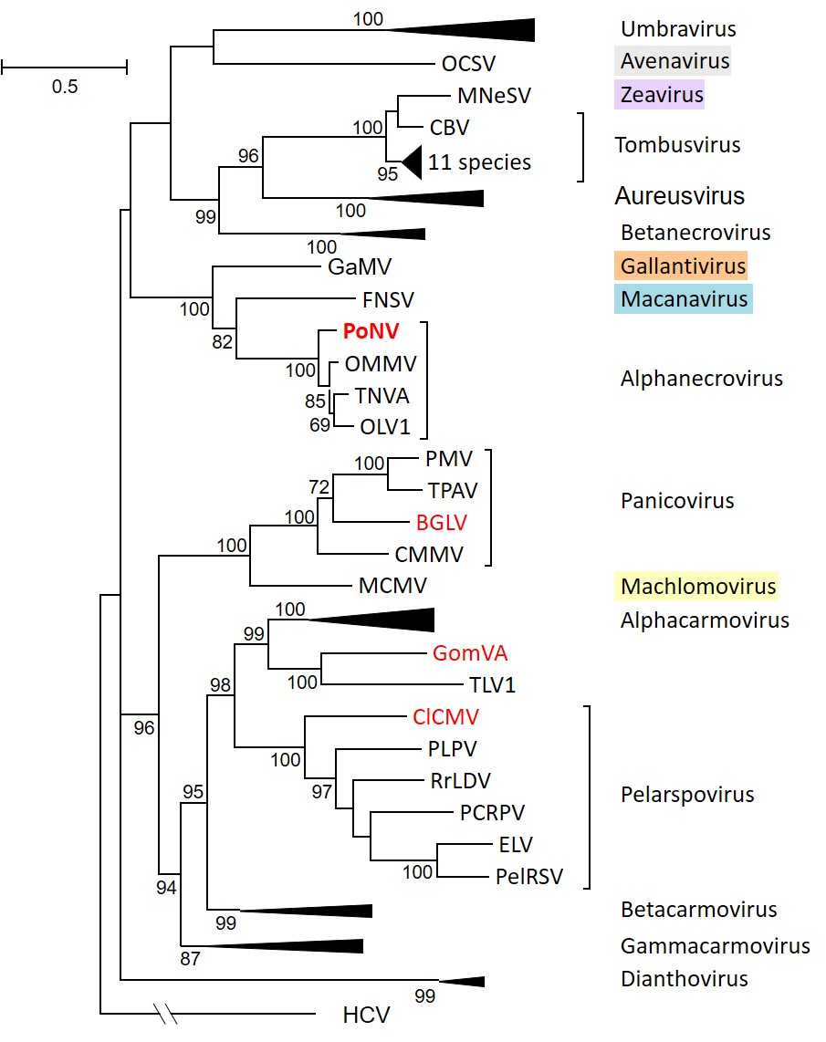

**Figure 1.** Phylogenetic (distance) analysis of the RdRps of tombusvirids with four possible new members (red font). The alignment was made using MUSCLE while trees were generated with the Maximum Likelihood (ML) algorithm in MEGA7 (Kumar et al. 2016) using 1000 bootstrap replicates (showing values >50%). All positions with less than 50% site coverage were eliminated. That is, fewer than 50% alignment gaps, missing data, and ambiguous bases were allowed at any position. There were 797 positions in the final dataset. Hepatitis C virus (HCV) RdRp (GQ870618.1) was used as the outgroup. Brackets mark uncollapsed genera. Monotypic genera names are in colored boxes. Sequence sources and virus names are in Table 2.

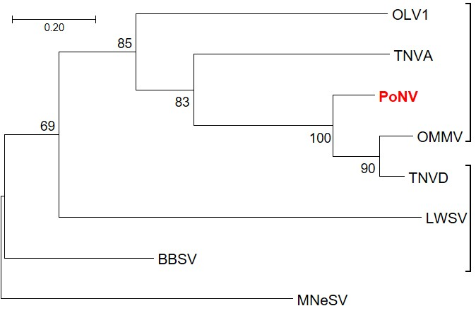

**Figure 2.** Phylogenetic (distance) analysis of the CPs of alphanecroviruses and betanecroviruses with MNeSV CP as outgroup. The same methods described in Fig. 1 were used. There were 8 sequences and 270 positions in the final dataset. Brackets mark genera. Sequence sources and virus names are in Table 2.

|  |  |  |  |
| --- | --- | --- | --- |
|  |  |  |  |
|  |  |  |  |
|  |  |  |  |
|  |  |  |  |
|  |  |  |  |

**Table 2.** Sequence IDs used for phylogenetic analyses of RdRps and CPs

|  |  |  |  |
| --- | --- | --- | --- |
| **Virus abbreviation(s)** | **Species** | **Exemplar RefSeq #** | **Exemplar Virus GB #** |
|  | **genus *Alphacarmovirus*** |  |  |
| CarMV-B | **Carnation mottle virus** | **X02986** | NC_001265 |
| AFBV-FL | Angelonia flower break virus | **DQ219415** | NC_007733 |
| CbMV-CA | Calibrachoa mottle virus | **GQ244431** | NC_021926 |
| HoRSV-CA | Honeysuckle ringspot virus | **HQ677625** | NC_014967 |
| NLVCV-AK | Nootka lupine vein clearing virus | **\*EF207438** | **NC_009017** |
| PFBV-MZ10 | Pelargonium flower break virus | **AJ514833** | NC_005286 |
| SgCV-MRN | Saguaro cactus virus | **U72332** | NC_001780 |
|  | **genus *Alphanecrovirus*** |  |  |
| TNVA-FM1B | **Tobacco necrosis virus A** | **M33002** | NC_001777 |
| OLV1-citrus | Olive latent virus 1 | **X85989** | NC_001721 |
| OMMV-GP | Olive mild mosaic virus | **AY616760** | NC_006939 |
| PoNV-QV323 | Potato necrosis virus | **KP901095** | NC_029900 |
|  | **genus *Aureusvirus*** |  |  |
| PoLV | **Pothos latent virus** | **X87115** | NC_000939 |
| CLSV | Cucumber leaf spot virus | **EU127904** | NC_007816 |
| JCSMV-Iran | Johnsongrass chlorotic stripe mosaic virus | **AJ557804** | NC_005287 |
| MWLMV-OH | Maize white line mosaic virus | **EF589670** | NC_009533 |
| YSV-DMSZ:PV0517 | Yam spherical virus | **KF482072** | NC_022895 |
|  | **genus *Avenavirus*** |  |  |
| OCSV-Llanwern | **Oat chlorotic stunt virus** | **X83964** | NC_003633 |

|  |  |  |  |
| --- | --- | --- | --- |
|  |  |  |  |
|  | **genus *Betacarmovirus*** |  |  |
| TCV-B | **Turnip crinkle virus** | **M22445** | NC_003821 |
| CCFV-CL | Cardamine chlorotic fleck virus | **L16015** | NC_001600 |
| HCRSV-Singapore | Hibiscus chlorotic ringspot virus | **X86448** | NC_003608 |
| JINRV | Japanese iris necrotic ring virus | **D86123** | NC_002187 |
|  | **genus *Betanecrovirus*** |  |  |
| TNVD-Hungary | **Tobacco necrosis virus D** | **U62546** | NC_003487 |
| BBSV-Ningxia | Beet black scorch virus | **AF452884** | NC_004452 |
| LWSV | Leek white stripe virus | **X94560** | NC_001822 |
|  | **genus *Dianthovirus*** |  |  |
| CRSV | **Carnation ringspot virus** | **L18870** | NC_003530 |
| RCNMV-Australia | Red clover necrotic mosaic virus | **J04357** | NC_003756 |
| SCNMV-59 | Sweet clover necrotic mosaic virus | L07884 | **NC_003806** |
|  | **genus *Gallantivirus*** |  |  |
| GaMV | **Galinsoga mosaic virus** | **Y13463** | NC_001818 |
|  | **genus *Gammacarmovirus*** |  |  |
| MNSV-Dutch | **Melon necrotic spot virus** | **M29671** | NC_001504 |
| CPMV-ATCC:PV955 | Cowpea mottle virus | **U20976** | NC_003535 |
| PSNV-Wakayama | Pea stem necrosis virus | **AB086951** | NC_004995 |
| SYMMV-Gunwi | Soybean yellow mottle mosaic virus | **FJ457015** | NC_011643 |
|  | **genus *Macanavirus*** |  |  |
| FNSV-Cauca | **Furcraea necrotic streak virus** | **FJ768020** | NC_020469 |
|  | **genus *Machlomovirus*** |  |  |
| MCMV-KS1 | **Maize chlorotic mottle virus** | **X14736** | NC_003627 |
|  | **genus *Panicovirus*** |  |  |
| PMV-109S | **Panicum mosaic virus** | **U55002** | NC_002598 |
| CMMV-Scotland | Cocksfoot mild mosaic virus | **EU081018** | NC_011108 |
| TPAV-05TGP00369 | Thin paspalum asymptomatic virus | **JX848617** | NC_021705 |
|  | **genus *Pelarspovirus*** |  |  |
| PelRSV-DMSZ:PV0304 | **Pelargonium ringspot virus** | **AY038068** | NC_026240 |
| ELV-ATCC:PV522 | Elderberry latent virus | **AY038066** | NC_026239 |
| PCRPV-GR57 | Pelargonium chlorotic ring pattern virus | **AY038069** | NC_005985 |
| PLPV-DMSZ:PV0193 | Pelargonium line pattern virus | **AY613852** | NC_007017 |
| RrLDV-MN-3 | Rosa rugosa leaf distortion virus | **KC166238** | NC_020415 |
|  | **genus *Tombusvirus*** |  |  |
| TBSV-cherry | **Tomato bushy stunt virus** | **M21958** | NC_001554 |
| AMCV-Bari | Artichoke mottled crinkle virus | **X62493** | NC_001339 |
| CIRV | Carnation Italian ringspot virus | **X85215** | NC_003500 |
| CBV-Bulgaria | Cucumber Bulgarian virus | **AY163842** | NC_004725 |
| CNV | Cucumber necrosis virus | **M25270** | NC_001469 |
| CyRV | Cymbidium ringspot virus | **X15511** | NC_003532 |
| EMCV-Israel | Eggplant mottled crinkle virus | **JQ864181** | NC_023339 |
| GALV-nipplefruit | Grapevine Algerian latent virus | **AY830918** | NC_011535 |
| MPV-PM75 | Moroccan pepper virus | **\*\*JX197071** | **NC_020073** |
| PLCV-T46 | Pelargonium leaf curl virus | **KU187189** | NC_030452 |
| PNSV-UPEV | Pelargonium necrotic spot virus | **AJ607402** | NC_005285 |

|  |  |  |  |
| --- | --- | --- | --- |
|  | **genus *Umbravirus*** |  |  |
| CMoV-Weddel | **Carrot mottle virus** | **FJ188473** | NC_011515 |
| CMoMV-Australia | Carrot mottle mimic virus | **U57305** | NC_001726 |
| ETBTV-18-2 | Ethiopian tobacco bushy top virus | **KJ918748** | NC_024808 |
| GRV-MC1 | Groundnut rosette virus | **Z69910** | NC_003603 |
| OPMV-PHEL 5235 | Opium poppy mosaic virus | **EU151723** | NC_027710 |
| PEMV2-WSG | Pea enation mosaic virus 2 | U03563 | **NC_003853** |
| TBTV-Ch | Tobacco bushy top virus | **AF402620** | NC_004366 |
|  | **genus *Zeavirus*** |  |  |
| MNeSV-AZ | **Maize necrotic streak virus** | **AF266518** | NC_007729 |
|  | **unassigned tombusvirid** |  |  |
| TLV1-06TGP01091 | Trailing lespedeza virus 1 | **HM640935** | NC_015227 |
|  | **genus *Hepacivirus*** |  |  |
| HCV-H77 | Hepacivirus C | GQ870618 |  |
|  | **unassigned viruses** |  |  |
| BGLV | Bermudagrass latent virus | **KX758441** | NC_032405.1 |
| GomVA-Monadnocks | Gompholobium virus A | **\*\*\*KX184304** | **NC_030742** |
| ClCMV | Clematis chlorotic mottle virus | **KX712140** | NC_033777 |
| **Blue font has correct RdRp annotation & was used** | | **\* join RAP & RT with "X"** | |
| **Red font has more correct RdRp annotation & was modified for use** | | **\*\* insert "X" at RT site** | |
| **Asterisks indicate further modifications** | | **\*\*\* use "X" at RT site** | |

| **References:** |
| --- |
| Monger W, Jeffries. 2018. A new virus, classifiable in the family *Tombusviridae*, found infecting *Solanum tuberosum* in the UK. Archives of Virology 163:1585-1594.  Rochon D’A. 2011.009a-mP.A.v3.split_necrovirus. Divide the genus *Necrovirus* into 2 new genera, *Alphanecrovirus* and *Betanecrovirus*.  <https://talk.ictvonline.org/ICTV/proposals/2011.009a-mP.A.v3.split_Necrovirus.pdf>. |