This Word module should be used for all taxonomic proposals.
Please complete Part 1 and:
either Part 3 for proposals to create new taxa or change existing taxa
or Part 2 for proposals of a general nature.
Submit the completed Word module, together with the accompanying Excel module named in Part 3, to the appropriate ICTV Subcommittee Chair.
For guidance, see the notes written in blue, below, and the help notes in file Taxonomic_Proposals_Help_2018.
Part 1: TITLE, AUTHORS, etc

Code assigned: | 2018.028P |  | (to be completed by ICTV officers)
Short title: Three new species in the genus Mastrevirus, one new species in the genus Becurtovirus, two new species in the genus Grablovirus

Author(s):
Arvind Varsani, Philippe Roumagnac, Jean-Michel Lett, Darren P. Martin on behalf of the Geminiviridae and Tolecusatellitidae SG
Corresponding author with e-mail address:
Arvind Varsani, Arvind.varsani@asu.edu
List the ICTV study group(s) that have seen this proposal:
A list of study groups and contacts is provided at http://www.ictvonline.org/subcommittees.asp . If in doubt, contact the appropriate subcommittee chair (there are six virus subcommittees: animal DNA and retroviruses, animal ssRNA-, animal ssRNA+, fungal and protist, plant, bacterial and archaeal) |  | Geminiviridae and Tolecusatellitidae SG
ICTV Study Group comments (if any) and response of the proposer:
Date first submitted to ICTV: |  |  | June 4th, 2018
Date of this revision (if different to above):

ICTV-EC comments and response of the proposer:

Part 2: NON-STANDARD
Template for any proposal regarding ICTV procedures, rules or policy, not involving the creation of new taxonomy.
Text of proposal:

Part 3: PROPOSED TAXONOMY

Name of accompanying Excel module: 2018.028P.N.v1.Geminiviridae_6sp.xlsx

Supporting material:

Three new species in the genus Mastrevirus

There are currently 37 species in the genus Mastrevirus in the family Geminiviridae. Of these, members of six infect dicots and the rest (n=31) infect monocots. Most of the viruses in this latter group have been identified infecting various grasses in Africa and Australia (Muhire et al., 2013).

A framework for classification of mastreviruses was established by Muhire et al. (2013) where a 78% genome-wide pairwise identity (PI) threshold coupled with phylogenetic support were proposed, and accepted, as species demarcation criteria. Based on this framework, three new species need to be established to allow the classification of new mastrevirus isolates that have been recently characterized from Australia and Brazil.

New species to be created and isolates that should be assigned to these species

1. Maize striate mosaic virus
Eleven isolates of maize striate mosaic virus (table 1) have been identified from Zea mays (n=10) and the leafhopper Dalbulus maidis (n=1) (Fontenele et al., 2018). The 11 isolates share >99% genome-wide pairwise identity with each other and <63% with all other known mastreviruses within currently established species (Figure 1).

2. Rice latent virus 1
Twenty two isolates of rice latent virus 1 have been identified in Oryza sp. ‘Taxon A’ (n=16) and Oryza sp. ‘Taxon B’ (n=6) from Australia (Kraberger et al., 2017). Rice latent virus 1 isolates share >98% genome-wide pairwise identity with each other and <62% with all other known mastreviruses within currently established species.

3. Rice latent virus 2
One isolate of rice latent virus 2 has been identified in Oryza sp. ‘Taxon B’ from Australia (Kraberger et al., 2017). This isolate shares <70% genome-wide pairwise with all other known mastreviruses within currently established species.
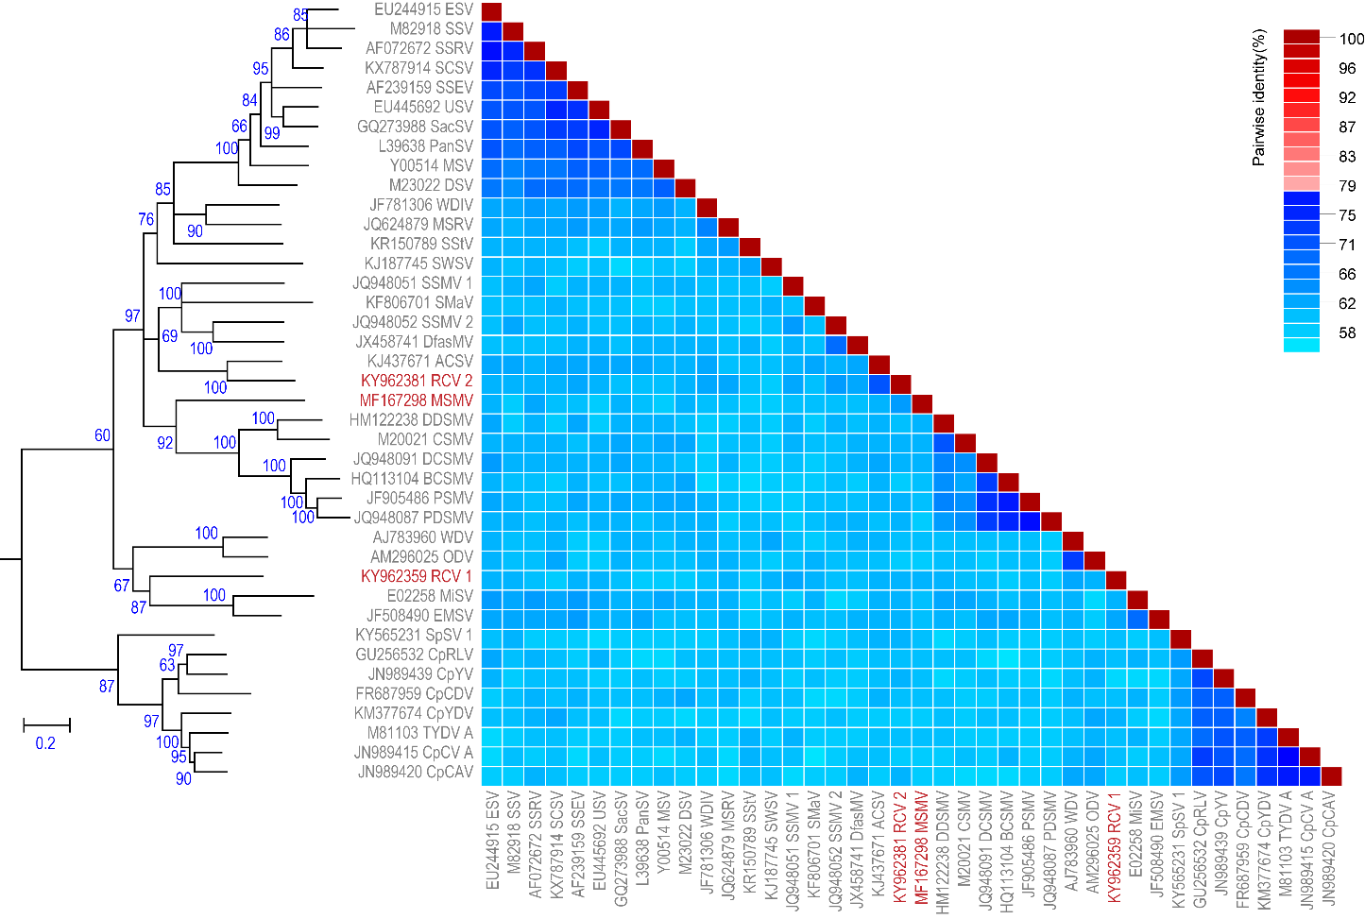
Figure 1. Maximum likelihood phylogenetic tree (rooted with becurtovirus sequences) of representative genomes from each mastrevirus species inferred using PHYML (Guindon et al., 2010) with GTR+I+G4 chosen as the best fit model and a two-colour pairwise identity matrix inferred using SDT v1.2 (Muhire et al., 2014). Sequences of representative isolates for each new species are in red font.

Table 1. Details of new isolates and species being proposed in the genus Mastrevirus
Species name | GenBank accession | Virus acronym | Isolate ID | Country of isolate | Host
Maize striate mosaic virus | MF167297 | MSMV | BR_974_Pla_2016 | Brazil | Zea mays
 | MF167298 |  | BR_975_Pla_2016 | Brazil | Zea mays
 | MF167299 |  | BR_976_Pla_2016 | Brazil | Zea mays
 | MF167300 |  | BR_981_Pla_2016 | Brazil | Zea mays
 | MF167301 |  | BR_982_Pla_2016 | Brazil | Zea mays
 | MF167302 |  | BR_984_Pla_2016 | Brazil | Zea mays
 | MF167303 |  | BR_985_Pla_2016 | Brazil | Zea mays
 | MF167304 |  | BR_987_Pla_2016 | Brazil | Zea mays
 | MF167305 |  | BR_988_Pla_2016 | Brazil | Zea mays
 | MF167306 |  | BR_989_Pla_2016 | Brazil | Zea mays
 | MF167307 |  | BR_J455_Pla_2016 | Brazil | Dalbulus maidis*
Rice latent virus 1 | KY962377 | RLV 1 | NA67 | Australia | Oryza sp. ‘Taxon A’
 | KY962378 |  | NA68 | Australia | Oryza sp. ‘Taxon A’
 | KY962379 |  | NA69 | Australia | Oryza sp. ‘Taxon A’
 | KY962380 |  | NA70 | Australia | Oryza sp. ‘Taxon A’
 | KY962359 |  | NA15 | Australia | Oryza sp. ‘Taxon B’
 | KY962360 |  | NA16 | Australia | Oryza sp. ‘Taxon B’
 | KY962361 |  | NA18 | Australia | Oryza sp. ‘Taxon B’
 | KY962362 |  | NA22 | Australia | Oryza sp. ‘Taxon B’
 | KY962364 |  | NA30 | Australia | Oryza sp. ‘Taxon B’
 | KY962363 |  | NA26 | Australia | Oryza sp. ‘Taxon B’
 | KY962365 |  | NA49 | Australia | Oryza sp. ‘Taxon A’
 | KY962366 |  | NA52 | Australia | Oryza sp. ‘Taxon A’
 | KY962367 |  | NA53 | Australia | Oryza sp. ‘Taxon A’
 | KY962368 |  | NA55 | Australia | Oryza sp. ‘Taxon A’
 | KY962369 |  | NA56 | Australia | Oryza sp. ‘Taxon A’
 | KY962370 |  | NA57 | Australia | Oryza sp. ‘Taxon A’
 | KY962371 |  | NA59 | Australia | Oryza sp. ‘Taxon A’
 | KY962372 |  | NA60 | Australia | Oryza sp. ‘Taxon A’
 | KY962373 |  | NA62 | Australia | Oryza sp. ‘Taxon A’
 | KY962374 |  | NA63 | Australia | Oryza sp. ‘Taxon A’
 | KY962375 |  | NA64 | Australia | Oryza sp. ‘Taxon A’
 | KY962376 |  | NA65 | Australia | Oryza sp. ‘Taxon A’
Rice latent virus 2 | KY962381 | RLV 2 | NA24 | Australia | Oryza sp. ‘Taxon B’
*Leafhopper (Hemiptera:Cicadellidae)
One new species in the genus Becurtovirus

There are currently two species in the genus Becurtovirus (Varsani et al., 2014) (Figure 2). Varsani et al., 2014 proposed a species demarcation threshold of 80% genome-wide identity for becurtoviruses.

1. Exomis microphylla latent virus
Recently a new becurtovirus was identified in Exomis microphylla from South Africa (Claverie et al., 2018) (Figure 2, Table 2). The genome of Exomis microphylla latent virus shares <72% genome-wide identity with other known becurtoviruses within currently established species.

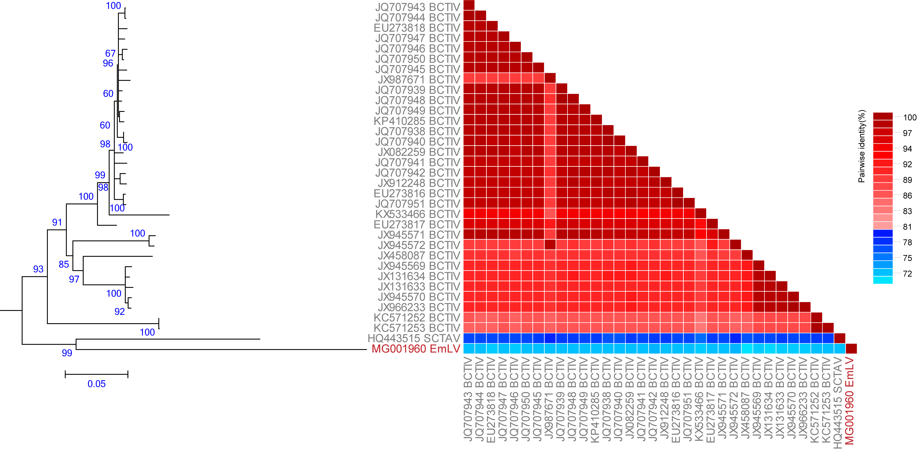

Figure 2. Maximum likelihood phylogenetic tree (rooted with turncurtovirus sequences) of genomes of viruses in the genus Becurtovirus inferred using PHYML (Guindon et al., 2010) with GTR+I+G4 chosen as the best fit model and a ‘two colour’ pairwise identity matrix inferred using SDT v1.2 (Muhire et al., 2014). Sequences of the isolate for the new species is in red font.

Table 2. Details of new isolate and species being proposed in the genus Becurtovirus

Species name | GenBank accession | Virus acronym | Isolate ID | Country of isolate | Host
Exomis microphylla latent virus | MG001960 | EmLV | 2-90-C1 | South Africa | Exomis microphylla

Two new species in the genus Grablovirus

There is currently one species in the genus Grablovirus (Varsani et al., 2014) (Figure 3) and thus no species demarcation has been seen. Grapevine red blotch virus isolate sequences (n=28) share >91% genome-wide pairwise identities.

1. Wild Vitis latent virus

1. Wild Vitis viruses (n=9) were recently identified in non-cultivated (wild) grapevine (Perry et al., 2017). They share >95% identity. They are most closely related to grapevine red blotch virus (67-68% genome-wide identity; Figure 3) and have a similar genome organisation. Thus, we propose that the nine wild Vitis viruses isolates be assigned to a new species – Wild Vitis latent virus.

2. Prunus latent virus
Prunus geminivirus A isolates (n=9) were identified in various Prunus species (Al Rwahnib et al., in press). They share >99% identity. They share ~74% genome-wide identity with grapevine red blotch viruses. We propose that the nine Prunus geminiviruses be assigned to a new species – Prunus latent virus.

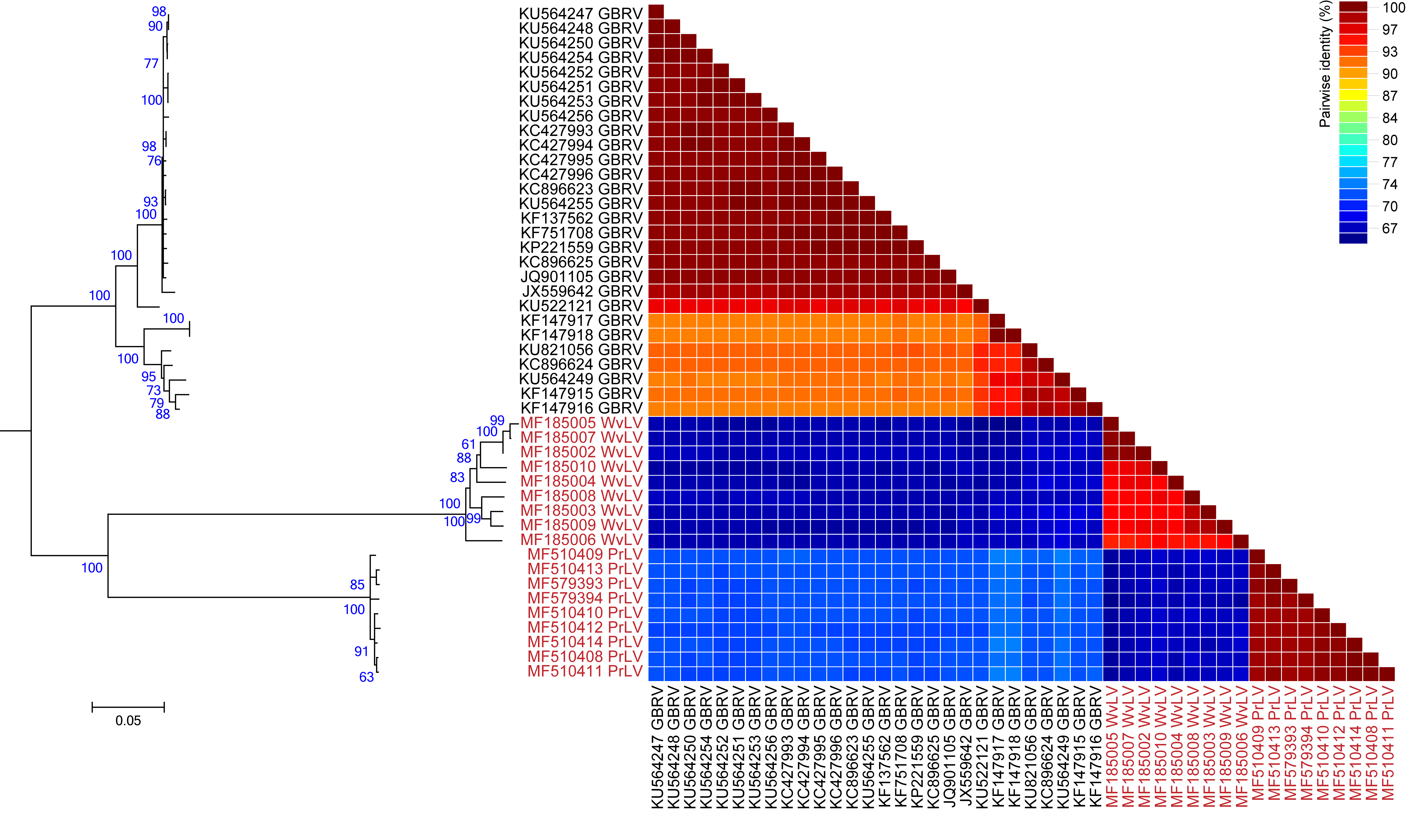

Figure 3. Maximum likelihood phylogenetic tree (rooted with grapevine geminivirus A sequences) of genomes of grabloviruses inferred using PHYML (Guindon et al., 2010) with GTR+G4 chosen as the best fit model pairwise identity matrix inferred using SDT v1.2 (Muhire et al., 2014). Sequences of isolates for the new species are in red font.

Table 3. Details of new isolates and the species being proposed in the genus Grablovirus
Species name | GenBank accession | Virus acronym | Isolate ID | Country of isolate | Host
Wild vitis latent virus | MF185002 | WvLV | WVV1-NY1298 | USA | Vitis sp.
 | MF185003 |  | WVV1-NY1308 | USA | Vitis sp.
 | MF185004 |  | WVV1-NY1325 | USA | Vitis sp.
 | MF185005 |  | WVV1-NY1358 | USA | Vitis sp.
 | MF185006 |  | WVV1-NY1424 | USA | Vitis sp.
 | MF185007 |  | WVV1-NY1466 | USA | Vitis sp.
 | MF185008 |  | WVV1-NY1467 | USA | Vitis sp.
 | MF185009 |  | WVV1-NY1468 | USA | Vitis sp.
 | MF185010 |  | WVV1-NY1616 | USA | Vitis sp.
Prunus latent virus | MF510408 | PrLV | PL4 | USA | Prunus salicina cv. Formosa
 | MF510409 |  | PL6 |  | Prunus domestica cv. Reine Claude De Bravay
 | MF510410 |  | PL8 |  | Prunus domestica cv. Pervenec 36Neg23
 | MF510411 |  | PL9 |  | Prunus domestica cv. Purple Gage
 | MF510412 |  | PL10 |  | Prunus salicina cv. Wickson
 | MF510413 |  | PL11 | China | Prunus salicina cv. NA 67714
 | MF510414 |  | PL13 | USA | Prunus salicina cv. Abundance
 | MF579393 |  | GF305 | USA | Prunus persica cv. GF 305
 | MF579394 |  | HTS | USA | Prunus sp.

References:
Al Rwahnib, M., Alabi, I, J., Westrick, N.M., Golino, D., (in press) Prunus geminivirus A: a novel grablovirus infecting Prunus spp. https://doi.org/10.1094/PDIS-09-17-1486-RE
Claverie, S., Bernardo, P., Kraberger, S., Hartnady, P., Lefeuvre, P., Lett, J-M., Galzi, S., Filloux, D., Harkins, G.W., Varsani, A., Martin, D.P., Roumagnac, P. (2018) From spatial metagenomics to molecular characterization of plant viruses: a geminivirus case study. Advances in Virus Research DOI: oi.org/10.1016/bs.aivir.2018.02.003
Fontenele, R.S., Alves-Freitas, D.M.T., Silva, P.I.T., Foresti, J., Silva, P.R., Godinho, M.T., Varsani, A., Ribeiro, S.G. (2018) Discovery of the first maize-infecting mastrevirus in the Americas using a vector-enabled metagenomics approach. Archives of Virology 163:263-267
Guindon, S., Dufayard, J. F., Lefort, V., Anisimova, M., Hordijk, W. & Gascuel, O. (2010). New algorithms and methods to estimate maximum-likelihood phylogenies: assessing the performance of PhyML 3.0. Systematic biology 59, 307-321.
Kraberger, S., Geering, A.D.W., Walters, M., Martin, D.P., Varsani, A. (2017) Novel mastreviruses identified in Australian wild rice. Virus Research. 238: 193-197
Muhire, B., Martin, D.P., Brown, J.K., Navas-Castillo, J., Moriones, E., Zerbini, F.M., Rivera-Bustamante, R., Malathi, V.G., Briddon, R.W., Varsani, A., 2013. A genome-wide pairwise-identity-based proposal for the classification of viruses in the genus Mastrevirus (family Geminiviridae). Arch Virol 158(6), 1411-1424.
Muhire, B.M., Varsani, A., Martin, D.P., 2014. SDT: a virus classification tool based on pairwise sequence alignment and identity calculation. PLoS One 9(9), e108277.
Perry, K.l., McLane, H., Thompson, J.R., Fuchs, M. (2017) A novel grablovirus from non-cultivated grapevine (Vitis sp.) in North America. Arch Virol 163:259-262
Varsani, A., Navas-Castillo, J., Moriones, E., Hernández-Zepeda, C., Idris, A., Brown, J.K., Zerbini, F.M., Martin, D.P. (2014) Establishment of three new genera in the family Geminiviridae: Becurtovirus, Eragrovirus and Turncurtovirus. Arch Virol 159:2193-2203

