This form should be used for all taxonomic proposals. Please complete all those modules that are applicable.
For guidance, see the notes written in blue and the separate document “Help with completing a taxonomic proposal”

Please try to keep related proposals within a single document.

Part 1: TITLE, AUTHORS, etc

Code assigned: | 2018.015P |  |  | (to be completed by ICTV officers)
Short title: Grapevine enamovirus 1, a new species in the genus Enamovirus
Author(s):
João Marcos Fagundes Silva, Maher Al Rwahnih, Rosana Blawid, Tatsuya Nagata, Thor Vinícius Martins Fajardo

Corresponding author with e-mail address:
Thor Vinícius Martins Fajardo (thor.fajardo@embrapa.br)
List the ICTV study group(s) that have seen this proposal:
A list of study groups and contacts is provided at http://www.ictvonline.org/subcommittees.asp . If in doubt, contact the appropriate subcommittee chair (there are six virus subcommittees: animal DNA and retroviruses, animal ssRNA-, animal ssRNA+, fungal and protist, plant, bacterial and archaeal) |  | Luteoviridae Study Group (Chair: W. Allen Miller, wamiller@iastate.edu)
ICTV Study Group comments (if any) and response of the proposer:
Date first submitted to ICTV: |  |  | June 30th, 2017
Date of this revision (if different to above):

ICTV-EC comments and response of the proposer:

Part 2: PROPOSED TAXONOMY
Present the proposed new taxonomy on accompanying spreadsheet
Name of accompanying spreadsheet: 2018.015P.N.v1.Enamovirus_sp.xlsx
Please display the taxonomic changes you are proposing on the accompanying spreadsheet module 2017_TP_Template_Excel_module. Submit both this and the spreadsheet to the appropriate ICTV Subcommittee Chair.

Part 3: NON-STANDARD
Template for any proposal regarding ICTV procedures, rules or policy, not involving the creation of new taxonomy.

non-standard proposal
Title of proposal:
Text of proposal:

Part 4: APPENDIX: supporting material
additional material in support of this proposal
Annex:
Please explain the reasons for the taxonomic changes you are proposing and provide evidence to support them. The following information should be provided, where relevant:
- Species demarcation criteria: Explain how new species differ from others in the genus and demonstrate that these differences meet the criteria previously established for demarcating between species. If no criteria have previously been established, and if there will now be more than one species in the genus, please state the demarcation criteria you are proposing.
- Higher taxa:
  - There is no formal requirement to state demarcation criteria when proposing new genera or other higher taxa. However, a similar concept should apply in pursuit of a rational and consistent virus taxonomy.
  - Please indicate the origin of names assigned to new taxa at genus level and above.
  - For each new genus a type species must be designated to represent it. Please explain your choice.
- Supporting evidence: The use of Figures and Tables is strongly recommended (note that copying from publications will require permission from the copyright holder). For phylogenetic analysis, try to provide a tree where branch length is related to genetic distance.

Following a typical metagenomic pipeline using high-throughput sequencing (HTS) we identified a new putative Enamovirus member, tentatively named Grapevine enamovirus 1 (GEV1), infecting distinct grapevine cultivars in Brazil. The family Luteoviridae comprises three genera, Luteovirus, Polerovirus and Enamovirus. These viruses have a positive-sense RNA genome of around 5.2 to 6.3 kb. The genus Enamovirus has only two viral species recognized by the ICTV, Pea enation mosaic virus 1 (PEMV1) and Alfalfa enamovirus 1 (AEV1). Citrus vein enation virus (CVEV) is a putative enamovirus. The systemic movement of PEMV1, type species of the genus Enamovirus, is provided by a co-infecting umbravirus, PEMV2, although co-infecting umbraviruses have not been reported for AEV1 or CVEV. Viruses in the family Luteoviridae are transmitted by aphids in a circulative persistent manner.
The near complete genome of GEV1 isolate CS-BR (6227 bp), lacking only part of the 3’ untranslated region, was deposited in GenBank under accession number KX645875. The near complete sequence (6176 bp) of isolate SE-BR, obtained by de novo assembly, was deposited in GenBank under accession KY820716 (NC_034836).
Luteovirids are known to harbor seven open reading frames (ORFs) usually displayed as two gene blocks separated by a noncoding intergenic region. The 5’-proximal block contains two partially overlapping ORFs 1 and 2, plus an additional ORF encoding a silencing suppressor protein (ORF 0) in the genera Enamovirus and Polerovirus. The 3’-proximal gene block contains the ORFs corresponding to the coat protein (ORF 3), an extension of the coat protein translated by an in-frame stop codon readthrough (ORF 5) and a movement protein (ORF 4) located within ORF 3 in the genera Luteovirus and Polerovirus that is absent in the genus Enamovirus. Also luteo- and poleroviruses, but not enamoviruses, encode a short (<50 codon) ORF 3a, upstream of ORFs 3 and 4 that starts with a non-AUG codon and terminates between the start codons of ORFs 3 and 4, in the third reading frame. ORFs 3, 4 and 5 are translated from a subgenomic RNA (sgRNA). GEV1 genomic features (Figure 1a) are discussed below.
GEV1 ORF 0 (nt 335-1279) overlaps ORF 1 and potentially encodes a 34.9 kDa protein (P0), presumably a suppressor of host RNAi machinery. The F-box-like domain [LPXXI/L(X₁₀₋₁₃)P] found in the P0 of polero- and enamoviruses is necessary for its silencing suppressor activity. Interestingly, only the first leucine is conserved where the F-box-like domain of GEV1 is predicted. ORF 1 (nt 471-2912) encodes an 89.8 kDa protein (P1) containing a conserved 3C-like serine peptidase followed by the genome-linked viral protein (VPg). The conserved domain H(X₂₅)D(X₇₀₋₈₀)GXSG of the serine protease is positioned between nt 1350 and 1841. Alignments with PEMV1 suggests that the first VPg cleavage site (E/S) at the GEV1 genome is positioned at nt 1938, but we were unable to deduce the second proteolysis site. The W(A, G)D motif followed by a DE-rich region is located between nt 2079 and 2111. ORF 2 (nt 2168-4165) is translated by a -1 frameshift from ORF 1, originating a fusion protein (P1-P2) containing the RNA-dependent RNA polymerase (RdRp) with a predicted molecular mass of 136.55 kDa. The highly conserved GDD motif is located between nt 3869 and 3877. ORF 3 (nt 4281-4871) encodes a 21.4 kDa protein which corresponds to the coat protein (CP). ORF 5 (nt 4872-5915) encodes the readthrough domain (RTD) of the CP-RTD fusion protein, predicted to have a total molecular mass of 59.7 kDa. This protein is needed for efficient aphid transmission. GEV1 lacks the C-terminal portion of the CP-RTD protein that is responsible for limiting the infection of luteo- and poleroviruses to the phloem. The amino acid sequence identity between GEV1 and others enamoviruses is below 44% for all ORFs.
Viruses in the family Luteoviridae employ a wide range of translational mechanisms which are regulated by cis-acting RNA elements (CRE) embedded in the virus genome. GEV1 ORF 0 possesses a putative leaky start codon UAUAUGU, allowing the translation of ORF 1. Two signals are required for the -1 ribosomal frameshift at ORF 1, the heptanucleotide sequence XXXYYYZ and a downstream pseudoknot or very stable RNA secondary structure located six to eight nucleotides from the frameshift site. The heptanucleotide sequence UUUAAAC is located at nt 2168 and a pseudoknot is present seven nt downstream of this site, as predicted with the RNAPKplex program. Remarkably, the sequence flanking the GEV1 stop codon readthrough site at ORF 3 (UUGUGAUAU) is not similar to any previously reported Luteoviridae, but like other luteovirids GEV1 does contain the CCNNNN tandem repeat motif required for ORF 3 stop codon readthrough at nt 4887 and 4935, 15 nucleotides downstream from the termination site. It contains sequence adjacent to the leaky stop codon capable of base pairing to a putative downstream readthrough element as in other luteovirids.
Maximum likelihood trees for the family Luteoviridae were estimated based on the P2 and CP translated sequences (Figure 1b). ORF 2 is separated from ORF 3 by an intergenic region which is a probable hot spot for recombination among luteovirids, so incongruences in the trees when considering these two distinct regions are expected. In both trees, GEV1 clusters together with PEMV1 and AEV1, indicating that GEV1 is more closely related to members of the genus Enamovirus.
The distinguishing feature of the genus Enamovirus is the lack of a movement protein (ORF 4 in polero- and luteoviruses). No ORF corresponding to this protein could be identified on GEV1. Based on its genomic properties and phylogenetic analyses, GEV1 should be classified as a new species of the genus Enamovirus.

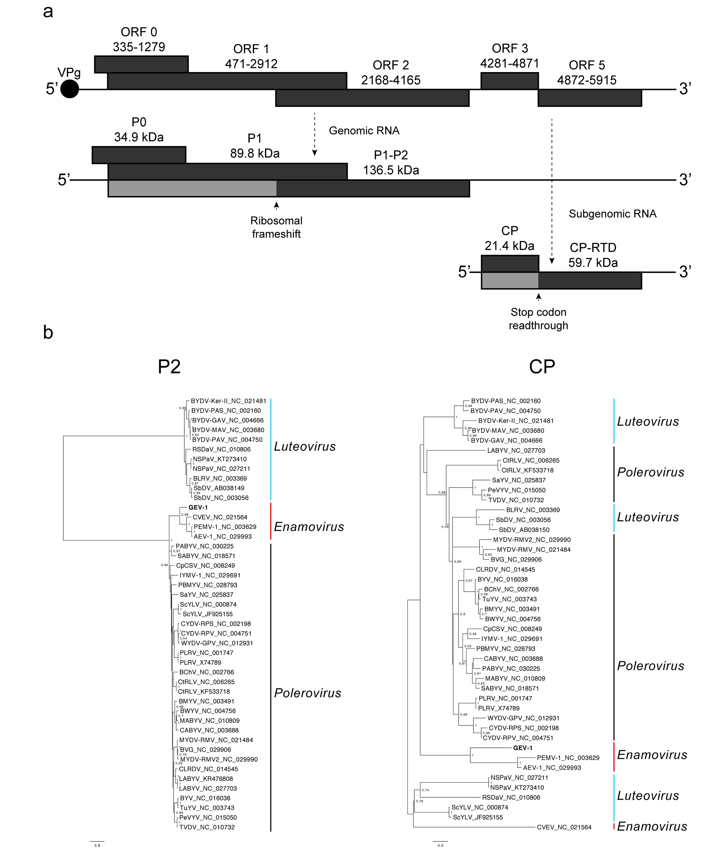
Figure 1. (a) Grapevine enamovirus 1 (GEV1) genome organization and (b) maximum likelihood trees [JTT + G(4) + I; Bootstrap = 1000 replications] for the family Luteoviridae using the P2 and CP amino acid sequences. Trees were inferred with MEGA 7. Alignments were performed with MUSCLE. Trees were midpoint rooted.

References:
Silva, J.M.F., Al Rwahnih, M., Blawid, R., Nagata, N., Fajardo, T.V.M. Discovery and molecular characterization of a novel enamovirus, Grapevine enamovirus-1. Virus Genes 53:667-671, 2017.

