This Word module should be used for all taxonomic proposals.
Please complete Part 1 and:
either Part 3 for proposals to create new taxa or change existing taxa
or Part 2 for proposals of a general nature.
Submit the completed Word module, together with the accompanying Excel module named in Part 3, to the appropriate ICTV Subcommittee Chair.
For guidance, see the notes written in blue, below, and the help notes in file Taxonomic_Proposals_Help_2018.
Part 1: TITLE, AUTHORS, etc

Code assigned: | 2018.006P |  | (to be completed by ICTV officers)
Short title: A new capillovirus species from red currant
Author(s):
Karel Petrzik, Jaroslava Pribylova, Igor Koloniuk, Josef Spak
Corresponding author with e-mail address: petrzik@umbr.cas.cz
List the ICTV study group(s) that have seen this proposal:
A list of study groups and contacts is provided at http://www.ictvonline.org/subcommittees.asp . If in doubt, contact the appropriate subcommittee chair (there are six virus subcommittees: animal DNA and retroviruses, animal ssRNA-, animal ssRNA+, fungal and protist, plant, bacterial and archaeal) |  | Beta-, Gamma-, and Deltaflexiviridae Study Group (SG Chair: Ioannis Tzanetakis)
ICTV Study Group comments (if any) and response of the proposer:
Date first submitted to ICTV: |  |  | April 27th 2018
Date of this revision (if different to above):

ICTV-EC comments and response of the proposer:
Part 2: NON-STANDARD
Template for any proposal regarding ICTV procedures, rules or policy, not involving the creation of new taxonomy.
Text of proposal:

Part 3: PROPOSED TAXONOMY

Name of accompanying Excel module: 2018.006P.N.v1.Capillovirus_sp_b
The taxonomic changes you are proposing should be presented on an accompanying Excel module, 2017_TP_Template_Excel_module. Please enter the file name of the completed module in this box.
Supporting material:
additional material in support of this proposal
.Please explain the reasons for the taxonomic changes you are proposing and provide evidence to support them. The following information should be provided, where relevant:
- Species demarcation criteria: Explain how new species differ from others in the genus and demonstrate that these differences meet the criteria previously established for demarcating between species. If no criteria have previously been established, and if there will now be more than one species in the genus, please state the demarcation criteria you are proposing.

The complete nucleotide sequence of a novel virus from red currant, provisionally named currant virus A (CuVA), was determined. The virus was present in cultivar Holandsky cerveny. Double-stranded RNA isolated from leaf tissue was used for sequencing library preparation and processed using the Illumina HiSeq2500 platform. The complete genome of the virus is 7925 nt long and has a 3'-poly(A) tail. The genome organization with two overlapping open reading frames (ORFs) is similar to that of capilloviruses. The first ORF begins at AUG initiation codon at nt position 94-96 and terminates at nt position 7668-7670. The ORF codes for a 2524 aa long polyprotein with domains of methyltransferase, 2-oxoglutarate-Fe(II) oxygenase, papain-like protease, RNA helicase, RdRp and the virus CP. The polyprotein shows 50.8% and 22.2% aa identities to cherry virus A (CVA) and apple stem grooving virus (ASGV), respectively (Table 1). ORF2 encodes a protein of 461 aa and shows similarities to the capillovirus 30K-like movement proteins. The exact mechanism of ORF2 expression is not known. The movement protein shows 57.1% and 21.6% aa identities to CVA and ASGV homologs respectively (Table 2).

The genus Capillovirus currently includes only two distantly related species, ASGV and CVA, and phylogenetic analysis of the replicase and movement protein amino acid sequences place CuVA closer to CVA (Figures 1 and 2). We propose to accept CuVA as a new and distinct member of the genus Capillovirus with the species name proposed as Currant virus A.

The species demarcation criteria in the Capillovirus genus are: (Adams et al., 2012)
- Natural host range: currant - different than the other members of the genus
- Serological specificity (all known species are serologically unrelated): N/A
- Less than about 72% nt identity (or 80% aa identity) between their CP or polymerase genes <51%

- Supporting evidence: The use of Figures and Tables is strongly recommended (note that copying from publications will require permission from the copyright holder). For phylogenetic analysis, try to provide a tree where branch length is related to genetic distance.

Table 1. Pairwise amino acid sequence comparisons of the replication-associated polyprotein. Pairwise identities (%) based on CLUSTALW alignment, BLOSUM cost matrix and gap open cost 10.

 | Divavirus |  |  | Capillovirus
 | DiVB | DiVA | HarVA | CVA | CuVA | ASGV
 | AFV57240 | AFV57238 | AEB00587 | CAA57896 | ALT08067 | BAA03639
DiVB |  | 58,5 | 53,3 | 22,7 | 20,7 | 22,4
DiVA |  |  | 55,7 | 21,9 | 21,2 | 21,4
HarVA |  |  |  | 21,9 | 21,6 | 22,3
CVA |  |  |  |  | 50,8 | 20,6
CuVA |  |  |  |  |  | 22,2
ASGV

Table 2. Pairwise amino acid sequence comparisons for the movement protein. Pairwise identity (%) based on CLUSTALW alignment, BLOSUM cost matrix and gap open cost 10.

 | Divavirus |  |  | Capillovirus |  |  | Tepovirus
 | DivA | DivB | HarVA | CVA | CuVA | ASGV | PVT | PrVT
 | AFV57239 | AFV57241 | AEB00588 | CAA57897 | KT763043 | BAA03640 | ACF39933 | AHM92767
DivA |  | 52,3 | 55,8 | 17,4 | 16,0 | 14,9 | 14,1 | 12,9
DivB |  |  | 47,4 | 13,7 | 13,3 | 13,6 | 12,4 | 11,9
HarVA |  |  |  | 17,4 | 17,9 | 16,5 | 15,4 | 13,4
CVA |  |  |  |  | 57,1 | 15,8 | 12,1 | 10,2
CuVA |  |  |  |  |  | 15,6 | 11,9 | 12,8
ASGV |  |  |  |  |  |  | 15,4 | 12,7
PVT |  |  |  |  |  |  |  | 18,2
PrVT

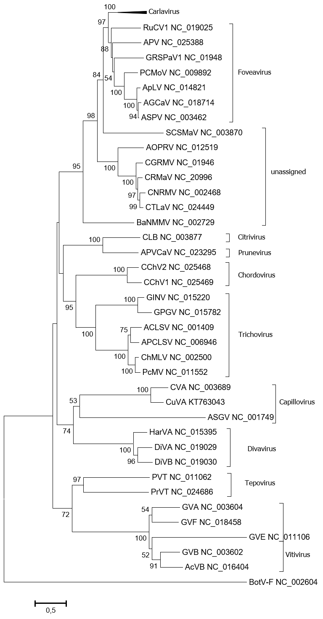

Figure 1. Phylogenetic tree based on replication-associated protein amino acid sequences, rooted with botrytis virus F. Neighbor-Joining tree (JTT substitution model) with 1000 bootstrap replicates.

APsCLSV YP_224131
ACLSV AAA42588
ChMLV AAF86667
PcMoV ABA18637
GINV BAB47272
Trichovirus
CChV1 AHA85535
CChV2 AHA85532
Chordovirus
PrVT AHM92767
PVT ACF39933
Tepovirus
ASGV BAA03640
CVA CAA57897
CuVA KT763043
Capillovirus
HarVA AEB00588
DiVA AFV57239
DiVB AFV57241
Divavirus
Prunevirus
AVCaV CDF66417
CPrV AKN08995
Citrivirus
CLBV CAC39423
84
100
63
100
100
100
73
97

99

100
95
29
33
16
56
0.5

Figure 2. Unrooted phylogenetic tree based on movement protein amino acid sequences of capilloviruses and members of related genera. Neighbor-Joining tree (JTT substitution model) with 1000 bootstrap replicates.

References:
Adams et al. (2012) Family Betaflexiviridae. In: Virus Taxonomy-Ninth Report on the International Committee on Taxonomy of Viruses. King et al. eds. Elsevier Academic Press: Cambridge, MA, USA, pp. 920–941
Petrzik K et al. (2016) Molecular characterization of a novel capillovirus from red currant. Arch. Virol. 161: 1083-1086

