This Word module should be used for all taxonomic proposals.
Please complete Part 1 and:
either Part 3 for proposals to create new taxa or change existing taxa
or Part 2 for proposals of a general nature.
Submit the completed Word module, together with the accompanying Excel module named in Part 3, to the appropriate ICTV Subcommittee Chair.
For guidance, see the notes written in blue, below, and the help notes in file Taxonomic_Proposals_Help_2018.
Part 1: TITLE, AUTHORS, etc

Code assigned: | 2018.005P |  | (to be completed by ICTV officers)
Short title: (e.g. “6 new species in the genus Zetavirus”)
One new species in the genus Capillovirus
Author(s):
Armelle Marais
Thierry Candresse
Corresponding author with e-mail address:
Armelle Marais: armelle.marais-colombel@inra.fr
List the ICTV study group(s) that have seen this proposal:
A list of study groups and contacts is provided at http://www.ictvonline.org/subcommittees.asp . If in doubt, contact the appropriate subcommittee chair (there are six virus subcommittees: animal DNA and retroviruses, animal ssRNA-, animal ssRNA+, fungal and protist, plant, bacterial and archaeal) |  | Beta-, Gamma-, and Deltaflexiviridae Study Group (SG Chair: Ioannis Tzanetakis)
ICTV Study Group comments (if any) and response of the proposer:
Date first submitted to ICTV: |  |  | June 8th, 2018
Date of this revision (if different to above):

ICTV-EC comments and response of the proposer:

Part 2: NON-STANDARD
Template for any proposal regarding ICTV procedures, rules or policy, not involving the creation of new taxonomy.
Text of proposal:

Part 3: PROPOSED TAXONOMY

Name of accompanying Excel module: 2018.005P.N.v1.Capillovirus_spa
The taxonomic changes you are proposing should be presented on an accompanying Excel module, 2017_TP_Template_Excel_module. Please enter the file name of the completed module in this box.
Supporting material:
additional material in support of this proposal
Please explain the reasons for the taxonomic changes you are proposing and provide evidence to support them. The following information should be provided, where relevant:
- Species demarcation criteria: Explain how new species differ from others in the genus and demonstrate that these differences meet the criteria previously established for demarcating between species. If no criteria have previously been established, and if there will now be more than one species in the genus, please state the demarcation criteria you are proposing.

Illumina sequencing of double stranded RNAs purified from leaves showing diffuse chlorotic spots from a Japanese apricot tree collected in Japan has provided information about the presence of a novel capillovirus (Marais et al., 2018). The authors have determined the complete genome sequence of an isolate (PM14) and discussed its phylogenetic relationships with other Capillovirus members. The genome organization (Figure 1) as well as the phylogeny based on full genome (Figure 2) place the PM14 isolate in the Capillovirus genus: two open reading frames (ORFs) are encoded, ORF1 contains conserved motifs for viral methyltransferase, viral helicase, RNA-dependent RNA polymerase, and coat protein (CP); ORF2 is nested within ORF1 and encodes the movement protein (MP).
The unrooted tree reconstructed using complete genome sequences of representative members of the Betaflexiviridae family shows that the PM14 isolate clusters with Capillovirus members (Figure 2). The phylogenetic analyses of the replicase, CP and MP sequences of Capillovirus members also support that the PM14 isolate belongs to this genus, close to cherry virus A (CVA) and currant virus A (CuVA) (Figure 3). Comparison of the PM14 isolate with other sequenced Capillovirus members shows that at the best, 62.3% and 60% of nucleotide sequence identity were observed in the replicase and CP genes of CuVA and CVA, respectively, corresponding to 65.4-62.7% and 54.4-53.7% of amino acid sequence identity in the deduced proteins (Table 1). These values are clearly outside the species demarcation criteria.
In conclusion, the PM14 isolate has a capillovirus genome organization but its divergence from all other sequences of Capillovirus members falls clearly outside of the species demarcation criteria. Its sequence affinities position it as a new Capillovirus species, for which the name Mume virus A is proposed.
The species demarcation criteria in the Capillovirus genus are: (Adams et al., 2012)
- Natural host range: Prunus mume - different than the other members of the genus
- Serological specificity: N/A
- Less than about 72% nucleotide or 80% amino acid sequence identity between their coat protein (CP) or polymerase genes

- Supporting evidence: The use of Figures and Tables is strongly recommended (note that copying from publications will require permission from the copyright holder). For phylogenetic analysis, try to provide a tree where branch length is related to genetic distance.

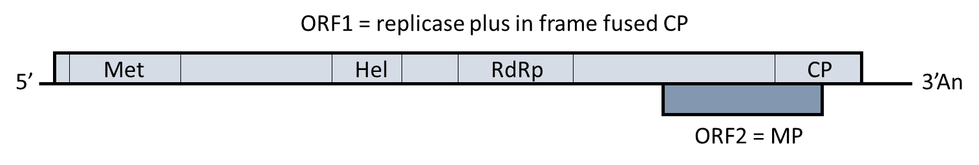

Figure 1. Genome organization of the PM14 isolate. The two predicted open reading frames (ORFs) are represented by boxes. Conserved motifs for viral methyltransferase (Met), viral helicase (Hel) and RNA-dependent RNA polymerase (RdRp) domains are shown within ORF1, as well as the coat protein (CP) domain. MP, movement protein. An: poly-A tail.

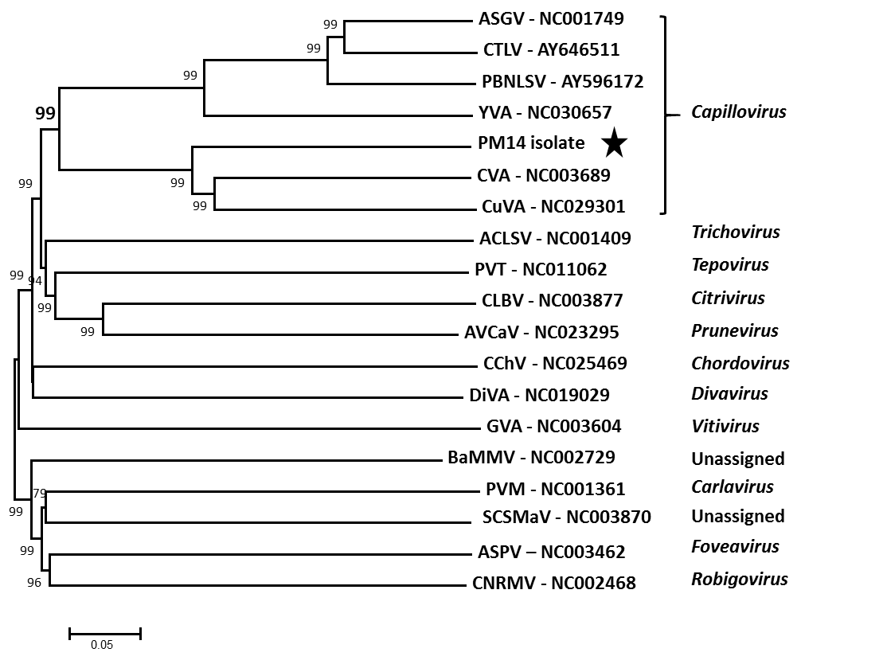

Figure 2. Unrooted phylogenetic tree reconstructed using the complete genome sequences of representative members of the Betaflexiviridae family. The tree was constructed using the neighbor-joining method. The statistical significance of branches was evaluated by bootstrap analysis (1000 replicates). Bootstrap values above 70% are shown. The scale bar represents 5% nucleotide divergence between sequences. The abbreviations followed by the accession numbers are: ASGV, apple stem grooving virus; CTLV, citrus tatter leaf virus; PBNLSV, pear black necrotic leaf spot virus; YVA, yacon virus A; CVA, cherry virus A; CuVA, currant virus A; ACLSV, apple chlorotic leaf spot virus; PVT, potato virus T; CLBV, citrus leaf blotch virus; AVCaV, apricot vein clearing-associated virus; CChV1, carrot chordovirus 1; DiVA, diuris virus A; GVA, grapevine virus A; BaMMV, banana mild mosaic virus; PVM, potato virus M; SCSMaV, sugarcane striate mosaic-associated virus; ASPV, apple stem pitting virus, and CNRMV, cherry necrotic rusty mottle virus. The genus to which each virus belongs is indicated at the right. The PM14 isolate of Mume virus A is indicated by a black star.

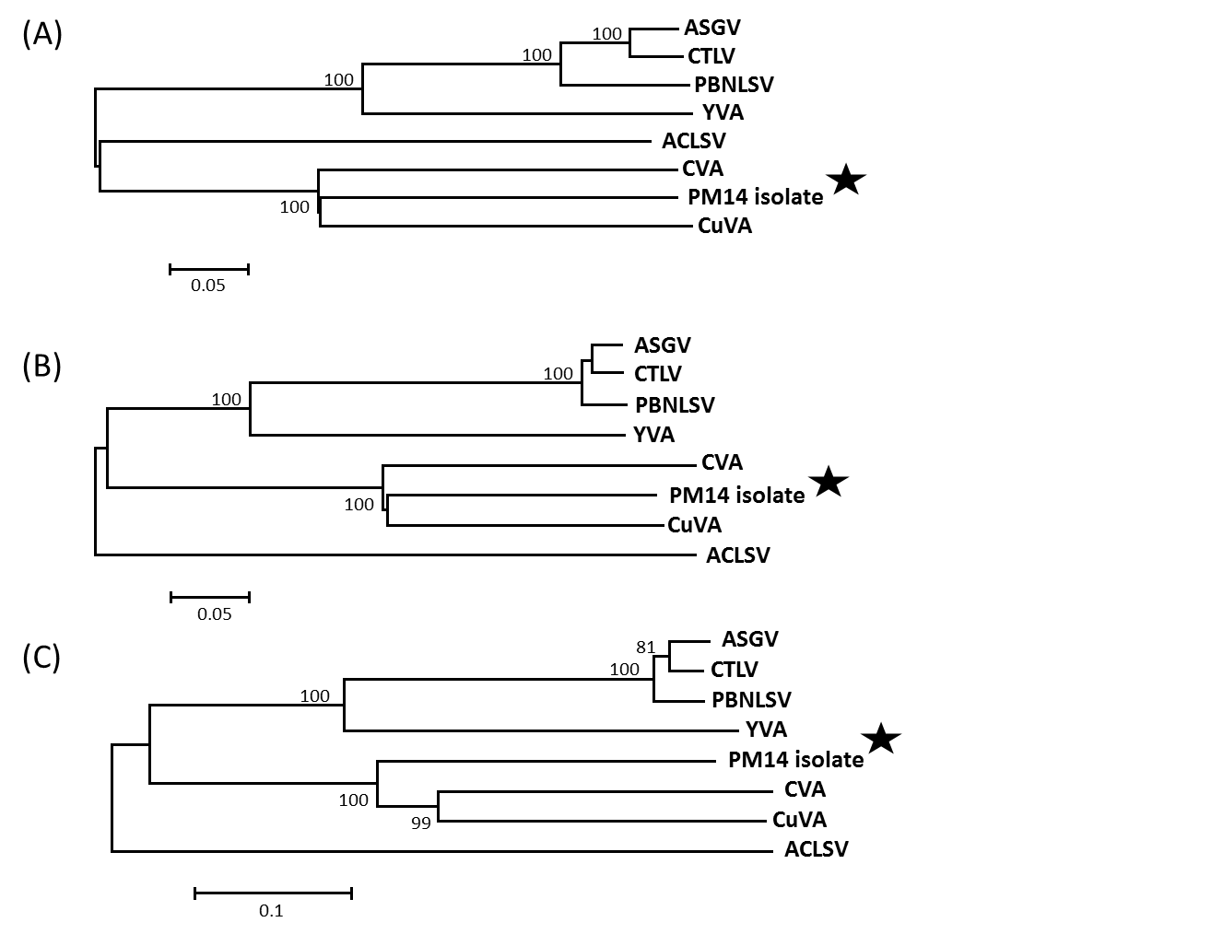
Figure 3. Neighbor joining phylogenetic trees reconstructed using the amino acid sequences of the replicase (A), coat protein (B) or movement protein (C) from Capillovirus members. Apple chlorotic leaf spot virus (NC_001409, genus Trichovirus) was included as an outgroup. The trees were constructed in Mega 6.0 using a strict amino acid identity distance. Bootstrap values above 70% (1000 replicates) are shown. The scale bars represent 5% (A, B) or 10% (C) amino acid divergence. Sequences retrieved from GenBank are the same as in Figure 2. The PM14 isolate is indicated by a black star.

Table 1. Percent sequence identity between genes and deduced proteins of the PM14 isolate and Capillovirus members.
 | Replicase |  | Coat protein |  | Movement protein
 | Nucleotide | Protein | Nucleotide | Protein | Nucleotide | Protein
Cherry virus A | 60% | 54.4% | 62.3% | 62.7% | 61.2% | 53.7%
Currant virus A | 60% | 53.7% | 62.3% | 65.4% | 63.8% | 53.3%
Apple stem grooving virus | 41% | 25.7% | 44.9% | 32.1% | 42.6% | 29.1%
Yacon virus A | 40% | 24.6% | 43.5% | 30.2% | 43% | 26.2%

References:
Marais et al. (2018) Molecular characterization of a novel species of Capillovirus from Japanese Apricot (Prunus mume). Viruses, 10:144-152 doi:10.3390/v10040144
Adams et al. (2012) Family Betaflexiviridae. In: Virus Taxonomy-Ninth Report on the International Committee on Taxonomy of Viruses. King et al. eds. Elsevier Academic Press: Cambridge, MA, USA, pp. 920–941

