This Word module should be used for all taxonomic proposals.
Please complete Part 1 and:
either Part 3 for proposals to create new taxa or change existing taxa
or Part 2 for proposals of a general nature.
Submit the completed Word module, together with the accompanying Excel module named in Part 3, to the appropriate ICTV Subcommittee Chair.
For guidance, see the notes written in blue, below, and the help notes in file Taxonomic_Proposals_Help_2018.
Part 1: TITLE, AUTHORS, etc

Code assigned: | 2018.003F |  | (to be completed by ICTV officers)
Short title: Establishment of one new family (Botourmiaviridae) including one existing (Ourmiavirus) and three new genera (Botoulivirus, Magoulivirus and Scleroulivirus)
Author(s):
María A. Ayllón, mariaangeles.ayllon@upm.es
Livia Donaire, ldonaire@cebas.csic.es
Shin-Yi Marzano, ShinYi.Marzano@sdstate.edu
Karel Petrzik, petrzik@umbr.cas.cz
Alejandro Sánchez-Gracia, elsanchez@ub.edu
Julio Rozas, jrozas@ub.edu
Massimo Turina, massimo.turina@ipsp.cnr.it
Corresponding author with e-mail address:
María A. Ayllón, mariaangeles.ayllon@upm.es
List the ICTV study group(s) that have seen this proposal:
A list of study groups and contacts is provided at http://www.ictvonline.org/subcommittees.asp . If in doubt, contact the appropriate subcommittee chair (there are six virus subcommittees: animal DNA and retroviruses, animal ssRNA-, animal ssRNA+, fungal and protist, plant, bacterial and archaeal) |  | ICTV Fungal and Protist Viruses Subcommittee. Chair: Peter Simmonds,  peter.simmonds@ndm.ox.ac.uk ICTV Narnaviridae study group:  Hillman, Bradley I.  hillman@AESOP.Rutgers.edu  Sead Sabanadzovic, ICTV Fungal and Protist Viruses SC member and Deputy Chair ssabanadzovic@entomology.msstate.edu
ICTV Study Group comments (if any) and response of the proposer:
Date first submitted to ICTV: |  |  | June 2018
Date of this revision (if different to above):

ICTV-EC comments and response of the proposer:
Members of the Botourmiaviridae have an RNA genome and use cognate RNA-dependent RNA polymerases (RdRps) for replication. Thus, they should be assigned to the realm Riboviria.

Part 2: NON-STANDARD
Template for any proposal regarding ICTV procedures, rules or policy, not involving the creation of new taxonomy.
Text of proposal:

Part 3: PROPOSED TAXONOMY

Name of accompanying Excel module: 2018.003F.N.v1.Botourmiaviridae

The genus of plant viruses, Ourmiavirus, is a floating genus, currently unassigned to any family by the ICTV Virus Taxonomy since it does not fit in the established Narnaviridae and Leviviridae families (5) even if it bears some homology in the RdRp with them. Therefore, based upon close evolutionary relationships between members of genera Ourmiavirus and members of the ourmia-like viruses infecting fungi, presented in several published papers and in this document, we propose the creation of a new family named Botourmiaviridae, to embrace the genus Ourmiavirus and the three new genera described in this proposal (Botoulivirus, Magoulivirus and Scleroulivirus).

Genus Botoulivirus
Name of the type species: Botrytis botoulivirus
Representative isolate: Botrytis ourmia-like virus (BOLV) HAZ2-3
GenBank sequence accession number: LN827955

Botrytis ourmia-like virus (BOLV) infects strain V446 of the plant pathogenic fungus Botrytis paeoniae. BOLV genome is a (+) ssRNA molecule of 2903 nucleotides in size with a 45.9% GC content. The complete genome sequence has a 5’ non coding region (NCR) of 41 nts and a 3’ NCR of 693 nts. The viral full-length genome contains a unique open reading frame (ORF) from position 42 to 2210 (Fig. 1A). The in silico translation of this ORF of 2169 nt yields a polypeptide of 722 amino acids in length, with a theoretical molecular weight of 81.88 kDa that has similarity to the RNA dependent RNA polymerase of the ourmiaviruses, Ourmia mosaic virus, Epirus cherry virus and Cassava virus C, and is also similar to several other ourmia-like mycoviruses. The conceptual protein encoded by BOLV contains the conserved domains of the viral RdRps of (+) ssRNA viruses (motifs I-VIII), including the highly conserved core domain GDD (motif VI) (Fig. 1B).
In addition, another recently described virus (1, 3) is proposed to be included in this genus. This assignment is supported by it grouping in a phylogenetic tree constructed using the alignment of conserved amino acid sequences of 42 RdRps (Fig. 4):
- Sclerotinia sclerotiorum ourmia-like virus 2 isolate 291 (GenBank Acc No KP900929) to represent the species Sclerotinia botoulivirus 2
Genus Magoulivirus
Name of the type species: Magnaporthe magoulivirus 1
Representative isolate: Magnaporthe oryzae ourmia-like virus 1 (MOLV1) isolate Guy11
GenBank sequence accession number: LT593139
Magnaporthe oryzae ourmia-like virus 1 (MOLV1) infects the rice field isolate Guy11 of Magnaporthe oryzae. MOLV1 genome is a positive and polyadenylated ssRNA molecule of 2364 nt, excluding the poly (A) tail. The 5’ and 3’ UTRs of MOLV1 are 116 nt and 430 nt in length, respectively. The MOLV1 genome has a unique open reading frame (ORF) from position 117 to 1931 (Fig.2A). The in silico translation of this 1818 nt ORF generates a polypeptide of 605 aa with a theoretical molecular weight of 67.12 kDa. This protein has higher identity with the RdRp of Rhizoctonia solani ourmia-like virus 1 (RsOLV1; 40 %), although it is also similar to other ourmia-like mycoviruses and plant ourmiaviruses. The MOLV1 viral protein contains the conserved domains of the RdRp present in (+) ssRNA viruses, including the highly conserved core domain GDD in motif VI (Fig.2B).
In addition, another virus is proposed to be included in this genus according the recently published data (2, 3). This assignment is supported by it bootstrap supported grouping in the phylogenetic tree constructed using the alignment of conserved amino acid sequences of 42 RdRps (Fig. 4):
- Rhizoctonia solani ourmia-like virus 1 isolate RsAG2 (GenBank Acc No KP900921) to represent a species Rhizoctonia magoulivirus 1

Genus Scleroulivirus
Name of new species: Sclerotinia scleroulivirus 1
Representative isolate: Sclerotinia sclerotiorum ourmia-like virus 1 isolate 334
GenBank sequence accession number: KP900928
Sclerotinia sclerotiorum ourmia-like virus 1 (SsOLV1) infects the isolate 334 of the plant pathogenic fungus Sclerotinia sclerotiorum. SsOLV1 genome is a (+) ssRNA molecule of 3180 nt. The SsOLV1 genome has a unique open reading frame (ORF) from position 281 to 2341 (Fig.3A). The in silico translation of this 2058 nt ORF generates a polypeptide of 686 aa. This protein has highest identity with the RdRp of Soybean leaf-associated ourmiavirus 1 (49 %), although it is also similar to other ourmia-like mycoviruses and plant ourmiaviruses. The SsOLV1 viral protein contains the conserved domains of the RdRp present in (+) ssRNA viruses, including the highly conserved core domain GDD in motif VI (Fig.3B).
Other viruses are proposed to be included in this genus according the recently published data (3, 4). These assignments are supported by their bootstrap supported grouping in the phylogenetic tree constructed using the alignment of conserved amino acid sequences of 42 RdRps (Fig. 4):
- Soybean leaf-associated ourmiavirus 1 isolate SlaOurV1-1 (GenBank Acc No KT598235) as a type isolate of the species Soybean scleroulivirus 1
- Soybean leaf-associated ourmiavirus 2 isolate SlaOurV2-1 (GenBank Acc No KT598247) to represent the species Soybean scleroulivirus 2

The tree in Fig. 4 was used to infer broader relationships of the proposed new family and its component genera, this places the proposed Botourmiaviridae more closely related to members of the genus Narnavirus than to members of the genus Mitovirus. Moreover, the analysis indicates that fungal ourmia-like viruses are more closely related to plant viruses of the Ourmiavirus genus than to mycoviruses of the Narnaviridae family. Altogether, the analysis indicates that BOLV, MOLV1, SsOLV1 and other ourmia-like mycoviruses are related with members of the genus Ourmiavirus.
However, BOLV, MOLV1 and SsOLV1 differ significantly from all members of the established genus Ourmiavirus. Currently recognized ourmiaviruses infect plants, and contain a tripartite genome, each one of the three segments contains a single ORF that codes for an RdRp, a coat protein or a movement protein (5). Members of the proposed Scleroulivirus, Magoulivirus, Botoulivirus genera differ significantly from all members of Ourmiavirus genus by possessing a monopartite genome that does not encode a movement protein or a coat protein, hence viral RNA is not encapsidated. Viruses belonging to these proposed genera all infect fungi, instead of plants, which is a further distinct feature that separates these mycoviruses from the genus Ourmiavirus.
Moreover, the creation of three new genera Botouivirus, Magoulivirus and Scleroulivirus is supported since the phylogenetic tree places the mycoviruses proposed to be included in each of this genus in different groups with bootstrap support higher that 70 %.
For species demarcation criteria, we propose that amino acid sequences identities of putative RdRp proteins between viruses belonging to different species in each of the genera Botoulivirus, Magoulivirus and Scleroulivirus should be less than 90%. However, the species inside each genus described thus far leave little doubt about species demarcation since within the RdRp isolates of different species have less than 55% amino acid sequence identity, apart from SlaOurV1-1 and SlaOurV1-2 (71% identity).

The taxonomic changes you are proposing should be presented on an accompanying Excel module, 2017_TP_Template_Excel_module. Please enter the file name of the completed module in this box.
Supporting material:
additional material in support of this proposal
Please explain the reasons for the taxonomic changes you are proposing and provide evidence to support them. The following information should be provided, where relevant:
- Species demarcation criteria: Explain how new species differ from others in the genus and demonstrate that these differences meet the criteria previously established for demarcating between species. If no criteria have previously been established, and if there will now be more than one species in the genus, please state the demarcation criteria you are proposing.
- Higher taxa:
  - There is no formal requirement to state demarcation criteria when proposing new genera or other higher taxa. However, a similar concept should apply in pursuit of a rational and consistent virus taxonomy.
  - Please indicate the origin of names assigned to new taxa at genus level and above.
  - For each new genus a type species must be designated to represent it. Please explain your choice.
- Supporting evidence: The use of Figures and Tables is strongly recommended (note that copying from publications will require permission from the copyright holder). For phylogenetic analysis, try to provide a tree where branch length is related to genetic distance.

A
ORF (722 aa)
BOLV
42
2210
2903 nts

B
I II III
BOLV KGKIRVVTMQGANTKKVLRPVHSALYDYLAGFGWLVRGDVTAADFEAIIEDKQ

IV
BOLV GDEKFISGDYEQATNHINIDSVQAIISVIAEEPLLSDEEREVLIRSFRDVTVYK

V
BOLV NNGSFLCKVRNGSMMGNLVSFPLLCILNKCCYDMSREIESEENGVPYCPR

VI VII VIII
BOLV VGRFNGDDCAFCGTDRFFEIWRETTSIFGLVVQEKKTGISSRWIELNSESFDSLKHRFVQ

Figure 1. Sequence properties of BOLV (A) Schematic representation of BOLV-HAZ2-3 genome showing location of ORF. (B) Sequence of the conserved motifs I to VIII of the viral RdRps of (+) ssRNA viruses in BOLV RdRp (LN827955), in bold is highlighted the highly conserved core domain GDD (motif VI).

A
ORF (605 aa)
MOLV1
117
1931
2364 nt
(A)n

B
I II III
MOLV1 DGKSRRVTQSPAESVVLSPLHTLIYNHLSRKDWLLRGEATPDKFADFCQKDGEV

IV
MOLV1 FVSGDYESASDNLSIEAAETVLSAIFAKARYIPQAIRRVAMDSLRCVLVSEGAVG

V VI
MOLV1 IQARGQLMGNFLCFPLLCLQNYAAFRYLAGNYPVRINGDDIVFRAPEHVRARWAA

VII VIII
MOLV1 GVQALGLTLSVGKTFVHKRFFSLNSTYFRARTKNGVK

Figure 2. Sequence properties of MOLV1 (A) Schematic representation of MOLV1 Guy11 genome showing location of ORF. (B) Sequence of the conserved motifs I to VIII of the viral RdRps of (+) ssRNA viruses in MOLV1 RdRp (LT593139), in bold is highlighted the highly conserved core domain GDD (motif VI).

A
ORF (686 aa)
SsOLV1
281
1931
3180 nts

B
I II III
SsOLV1 SGKPRPLTRFESDSSYLRPLHGLIYDQISKNPWLLRGDVTAEKLKNAGFSGSSE

IV
SsOLV1 TSLISGDYVSASDNLPIEIAELILDVIWSSSRHIPASILRFAIAAQRPELTFE

V VI
SsOLV1 RQDHTIDSFVPSIGQMMGSYLCFPLLCIQNYLAFRWATKDMVTVPPALINGDDILVE

VII VIII
SsOLV1 ENDKFFNRWSRTISDVGFVVEETKTSVSTEWGTINSTLLRRRGGNLV

Figure 3. Sequence properties of SsOLV1 (A) Schematic representation of SsOLV1 isolate 334 genome showing location of ORF. (B) Sequence of the conserved motifs I to VIII of the viral RdRps of (+) ssRNA viruses in SsOLV1 RdRp (KP900928), in bold is highlighted the highly conserved core domain GDD (motif VI).

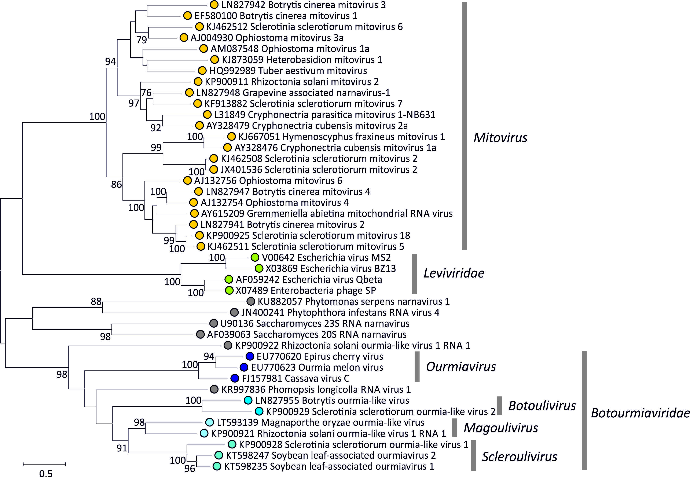
Figure 4. Maximum likelihood phylogenetic tree of translated RdRp amino acid sequences of members of the proposed family, Botourmiaviridae, and including representative sequences from the family Leviviridae and of the Mitovirus genus. Sequences between amino acid positions 323 – 599 of the RdRp gene (numbered using the Cassava virus sequence, FJ157981) were aligned by MUSCLE and analysed using the optimal WAG+I+G+F protein evolution model. Bootstrap resampling was performed using 1000 replicates, with values of >= 70% shown. Branch lengths were proportional to evolutionary distances as indicated by the scale bar. Unassigned viruses are indicated by grey symbols.

References:
- Donaire L, Rozas J, Ayllón MA. 2016. Molecular characterization of Botrytis ourmia-like virus, a mycovirus close to the plant pathogenic genus Ourmiavirus. Virology 489, 158–164.

- Illana A, Marconi M, Rodríguez-Romero J, Xu P, Dalmay T, Wilkinson MD, Ayllón MA, Sesma A. 2017. Molecular characterization of a novel ssRNA ourmia-like virus from the rice blast fungus Magnaporthe oryzae. Archives of Virology 162, 891-895

Marzano SY, Nelson BD, Ajayi-Oyetunde O, Bradley CA, Hughes TJ, Hartman GL, Eastburn DM, Domier LL. 2016. Identification of Diverse Mycoviruses through Metatranscriptomics Characterization of the Viromes of Five Major Fungal Plant Pathogens. Journal of Virology 90, 6846-6863
- Marzano S-YL, Domier L. 2015. Novel mycoviruses discovered form metatranscriptomics survey of soybean phyllosphere phytobiomes. Virus Research 213, 332-342

- Turina, M., Hillman, B.I., Izadpanah, K., Rastgou, M., Rosa, C. and ICTV Report Consortium. 2017, ICTV Virus Taxonomy Profile: Ourmiavirus, Journal of General Virology, 98:129-130.

