This Word module should be used for all taxonomic proposals.

Please complete **Part 1** and:

either **Part 3** for proposals to create new taxa or change existing taxa

or **Part 2** for proposals of a general nature.

Submit the completed Word module, together with the accompanying Excel module named in Part 3, to the appropriate ICTV Subcommittee Chair.

For guidance, see the notes written in blue, below, and the help notes in file Taxonomic_Proposals_Help_2018.

**Part 1:** **TITLE, AUTHORS, etc**

|  |  |  |  |
| --- | --- | --- | --- |
| **Code assigned:** | ***2018.004F*** | | (to be completed by ICTV officers) |
| **Short title:** (e.g. “6 new species in the genus *Zetavirus”*)  **Renaming 1 genus, adding 1 new genus and 16 new species in the family *Chrysoviridae*** | | | |
|  | | | |
| **Author(s):** | | | |
| Ioly Kotta-Loizou  E-mail: [i.kotta-loizou13@imperial.ac.uk](mailto:i.kotta-loizou13@imperial.ac.uk)  Said A. Ghabrial  E-mail: [saghab00@uky.edu](mailto:saghab00@uky.edu)  José R. Castón  E-mail: [jrcaston@cnb.csic.es](mailto:jrcaston@cnb.csic.es)  Robert H. A. Coutts  E-mail: [r.coutts@herts.ac.uk](mailto:r.coutts@herts.ac.uk)  Bradley I. Hillman  E-mail: [bradley.hillman@rutgers.edu](mailto:bradley.hillman@rutgers.edu)  Daohong Jiang  E-mail [daohongjiang@mail.hzau.edu.cn](mailto:daohongjiang@mail.hzau.edu.cn)  Dae-Hyuk Kim  E-mail: [dhkim@chonbuk.ac.kr](mailto:dhkim@chonbuk.ac.kr)  Hiromitsu Moriyama  E-mail: [hmori714@cc.tuat.ac.jp](mailto:hmori714@cc.tuat.ac.jp)  Nobuhiro Suzuki  E-mail: [nsuzuki@okayama-u.ac.jp](mailto:nsuzuki@okayama-u.ac.jp) | | | |
| **Corresponding author with e-mail address:** | | | |
| Ioly Kotta-Loizou; i.kotta-loizou13@imperial.ac.uk | | | |
| **List the ICTV study group(s) that have seen this proposal:** | | | |
| A list of study groups and contacts is provided at <http://www.ictvonline.org/subcommittees.asp> . If in doubt, contact the appropriate subcommittee chair (there are six virus subcommittees: animal DNA and retroviruses, animal ssRNA-, animal ssRNA+, fungal and protist, plant, bacterial and archaeal) | | ***Chrysoviridae* SG** | |
| **ICTV Study Group comments (if any) and response of the proposer:** | | | |
|  | | | |
|  | | | |
| Date first submitted to ICTV: | | | June 2018 |
| Date of this revision (if different to above): | | |  |

|  |
| --- |
| **ICTV-EC comments and response of the proposer:** |
|  |

**Part 2:** **NON-STANDARD**

Template for any proposal regarding ICTV procedures, rules or policy, not involving the creation of new taxonomy.

| **Text of proposal:** |
| --- |
| N/A |

**Part 3:** **PROPOSED TAXONOMY**

|  |
| --- |
| **Name of accompanying Excel module: 2018.004F.N.v1.Betachrysovirus** |

The taxonomic changes you are proposing should be presented on an accompanying Excel module, 2017_TP_Template_Excel_module. Please enter the file name of the completed module in this box.

**Supporting material:**

| additional material in support of this proposal  Currently there are nine species in the family *Chrysoviridae*, all belonging to genus *Chrysovirus* (Ghabrial *et al*., 2018). The recent discoveries of new viruses related to chrysoviruses have led to a proposed revision of the family organization as follows (Table 1):   1. Renaming of the sole genus *Chrysovirus* to *Alphachrysovirus* (from the first letter of the Greek alphabet *alpha*, as the first genus of the family *Chrysoviridae*). 2. Introduction of a second genus *Betachrysovirus* (from the second letter of the Greek alphabet *beta*, as the second genus of the family *Chrysoviridae*). 3. Assignment of eight additional species to the proposed genus *Alphachrysovirus*. 4. Assignment of eight new species to the proposed genus *Betachrysovirus*.   Members of the family *Chrysoviridae* have 3-7 dsRNA genomic segments and are therefore informally designated as trichrysoviruses (3 genomic segments), cinquechrysoviruses (5 genomic segments) and settechrysoviruses (7 genomic segments), in addition to the ‘traditional’ chrysoviruses with 4 genomic segments. Each dsRNA segment is individually encapsidated in a separate particle; dsRNA 1 encodes the RNA-dependent RNA polymerase (RdRP), another dsRNA (usually dsRNA 2) encodes the capsid protein and the rest encode proteins of unknown function. The overall size of the genome ranges from 8.9 to 16.0 kbp. Chrysoviruses mostly infect fungi, ascomycetes and basidiomycetes, but also plants and insects.  As evident by the phylogenetic analysis (Fig. 1), putative members of the family *Chrysoviridae* form two distinct clades designated in this proposal as genera *Alphachrysovirus* and *Betachrysovirus*. The proposed classification is also supported by the pairwise distance matrix (Fig. 2), illustrating that each virus has an evolutionary distance smaller than 0.8 compared to all putative members of the same genus.  Members of the genus *Alphachrysovirus* have 3-4 dsRNA genomic segments ranging from 2.5 to 3.7 kbp. The genomic organization of Penicillium chrysogenum virus (PcV), a member of the type species of the genus *Alphachrysovirus* is depicted in Fig. 3, left panel. Information on the exemplars representing the eight proposed species in the genus *Alphachrysovirus* can be found in Table 2.  Members of the genus *Betachrysovirus* have 4-5 and, in one virus, 7 dsRNA genomic segments ranging from 0.8 to 3.7 kbp. The genomic organization of Botryosphaeria dothidea chrysovirus 1 (BdCV1), the proposed representative of the type species of the genus *Betachrysovirus* is depicted in Fig. 3, right panel. BdCV1 is the most well characterized member of the genus *Betachrysovirus* and has been associated with hypovirulence (Wang *et al.*, 2014). Information on the exemplars representing the eight proposed species in the genus *Betachrysovirus* can be found in Table 3.  As described in previous ICTV reports, the criteria to differentiate species within the family *Chrysoviridae* are:   * host of isolation * amino acid sequence data (≤ 70% aa sequence identity in the RdRP) * size of dsRNA segments * length of 5′-UTR * serological relationships   All proposed species of the family *Chrysoviridae* are represented by fully sequenced viruses with publically available accession numbers and with an evolutionary distance larger than 0.3 from each other and exemplars of officially recognized species. |
| --- |

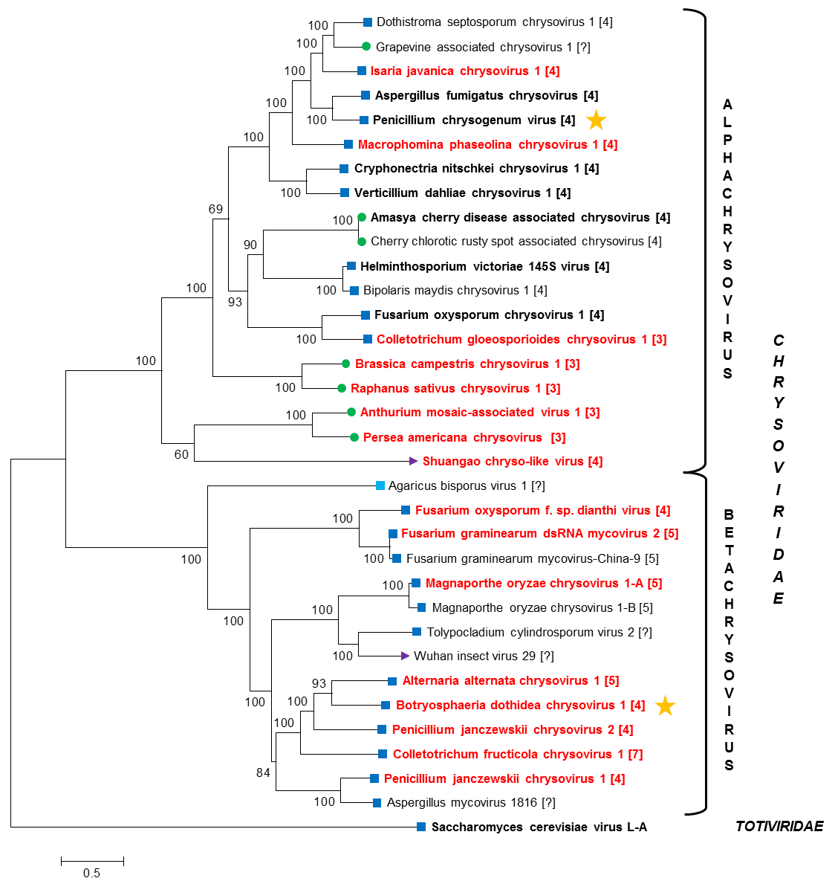

**Figure 1:** Maximum likelihood phylogenetic tree created based on the RdRP sequences of chrysoviruses and related viruses. The sequences were aligned with MUSCLE as implemented by MEGA 6 (Tamura *et al*., 2013), all positions with less than 30% site coverage were eliminated and the LG+G+I+F substitution model was used. Members of the family *Chrysoviridae* are in bold black font; proposed members are in bold red font. The number in brackets after the virus name indicates the number of dsRNA genomic segments if known. At the end of the branches, dark blue and light blue squares indicate that the virus infects fungi, ascomycetes and basidiomycetes respectively; green circles indicate that the virus infects or is associated with plants; purple triangles indicate that the virus infects or is associated with insects. The orange star indicates the representative of type species for each genus. GenBank accession numbers of viruses used to construct the tree are presented in the legend of figure 2.



**Figure 2:** Pairwise distance matrix created based on the RdRP sequences of chrysoviruses and related viruses. The sequences were aligned with MUSCLE as implemented by MEGA 6 (Tamura *et al*., 2013), all positions with less than 30% site coverage were eliminated and the p-distance substitution model/method was used. Red background indicates high conservation while green background indicates low conservation.

Agaricus bisporus virus 1, X94361; Alternaria alternata chrysovirus 1, LC350277; Amasya cherry disease associated chrysovirus, AJ781166; Anthurium mosaic-associated virus, FJ899675; Aspergillus fumigatus chrysovirus, FN178512; Aspergillus mycovirus 1816, EU289896; Bipolaris maydis chrysovirus 1, KY489954; Botryosphaeria dothidea chrysovirus 1, KF688736; Brassica campestris chrysovirus 1, KP782031; Cherry chlorotic rusty spot associated chrysovirus, AJ781397; Colletotrichum gloeosporioides chrysovirus 1, KT581957; Colletotrichum fructicola chrysovirus 1, MG425969; Cryphonectria nitschkei chrysovirus 1, GQ290649; Dothistroma septosporum chrysovirus 1, no accession number; Fusarium graminearum dsRNA mycovirus 2, HQ343295; Fusarium graminearum mycovirus-China-9, HQ228213; Fusarium oxysporum f. sp. dianthi virus, KP876629; Fusarium oxysporum chrysovirus 1, EF152346; Grapevine associated chrysovirus 1, GU108588; Helminthosporium victoriae 145S virus, AF297176; Isaria javanica chrysovirus 1, KX898416; Macrophomina phaseolina chrysovirus 1, KP900886; Magnaporthe oryzae chrysovirus 1-A, AB560761; Magnaporthe oryzae chrysovirus 1-B, AB824667; Penicillium chrysogenum virus, AF296439; Penicillium janczewskii chrysovirus 1, KT601115; Penicillium janczewskii chrysovirus 2, KT950836; Persea americana chrysovirus, KJ418374; Raphanus sativus chrysovirus 1, JQ045335; Saccharomyces cerevisiae virus L-A, AAA50508; Shuangao chryso-like virus, MF176340; Tolypocladium cylindrosporum virus 2, FR750563; Verticillium dahliae chrysovirus 1, HM004067; Wuhan insect virus 29, KX882987.

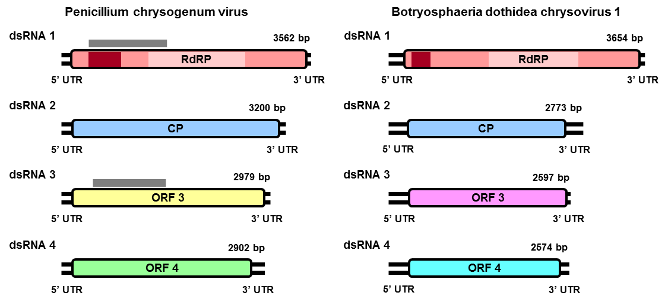

**Figure 3:** Schematic representation of the genomic organization of Penicillium chrysogenum virus, exemplar virus for the type species of genus *Alphachrysovirus* (left panel), and Botryosphaeria dothidea chrysovirus 1, a representative of the proposed type species of the genus *Betachrysovirus* (right panel). Each genome consists of four dsRNAs, each containing one ORF (coloured boxes) flanked by 5’- and 3’-UTRs (black double lines). The light coloured box in dsRNA 1 represents the RdRP_4 motif (PF00680; Finn *et al.*, 2014); the dark coloured box in dsRNA 1 represents an independent P-loop NTPase domain predicted by HHpred (Zimmermann *et al*., 2017); the grey coloured thick lines represent a region of homology between the proteins encoded by dsRNAs 1 and 3 as detected by PSI-BLAST (Altschul *et al*., 1997).

|  |  |  |  |  |  |  |  |  |  |  |  |  |  |  |  |  |  |  |  |  |  |  |  |  |  |  |  |  |  |  |  |  |  |  |  |  |  |  |  |  |  |  |  |  |  |  |  |  |  |  |  |  |  |  |  |  |  |  |  |  |  |  |  |  |  |  |  |  |  |  |  |  |  |  |  |  |  |  |  |  |  |  |  |  |  |  |  |  |  |  |  |  |  |  |  |  |  |  |  |  |  |  |  |  |  |  |  |  |  |  |  |  |  |  |  |  |  |  |  |  |  |  |  |  |  |  |  |  |  |  |  |  |  |  |  |  |  |  |  |  |  |  |  |  |  |  |  |  |  |  |  |  |  |  |  |  |  |  |  |  |  |  |  |  |  |  |  |  |  |  |  |  |  |  |  |  |  |  |  |  |  |  |  |  |  |  |  |  |  |  |  |  |  |  |  |  |  |  |  |  |  |  |  |  |  |  |  |  |  |  |  |  |  |  |  |  |  |  |  |  |  |  |  |  |  |  |  |  |  |  |  |  |  |  |  |  |  |  |  |  |  |  |  |  |  |  |  |  |  |  |  |  |  |  |  |  |  |  |  |  |  |  |  |
| --- | --- | --- | --- | --- | --- | --- | --- | --- | --- | --- | --- | --- | --- | --- | --- | --- | --- | --- | --- | --- | --- | --- | --- | --- | --- | --- | --- | --- | --- | --- | --- | --- | --- | --- | --- | --- | --- | --- | --- | --- | --- | --- | --- | --- | --- | --- | --- | --- | --- | --- | --- | --- | --- | --- | --- | --- | --- | --- | --- | --- | --- | --- | --- | --- | --- | --- | --- | --- | --- | --- | --- | --- | --- | --- | --- | --- | --- | --- | --- | --- | --- | --- | --- | --- | --- | --- | --- | --- | --- | --- | --- | --- | --- | --- | --- | --- | --- | --- | --- | --- | --- | --- | --- | --- | --- | --- | --- | --- | --- | --- | --- | --- | --- | --- | --- | --- | --- | --- | --- | --- | --- | --- | --- | --- | --- | --- | --- | --- | --- | --- | --- | --- | --- | --- | --- | --- | --- | --- | --- | --- | --- | --- | --- | --- | --- | --- | --- | --- | --- | --- | --- | --- | --- | --- | --- | --- | --- | --- | --- | --- | --- | --- | --- | --- | --- | --- | --- | --- | --- | --- | --- | --- | --- | --- | --- | --- | --- | --- | --- | --- | --- | --- | --- | --- | --- | --- | --- | --- | --- | --- | --- | --- | --- | --- | --- | --- | --- | --- | --- | --- | --- | --- | --- | --- | --- | --- | --- | --- | --- | --- | --- | --- | --- | --- | --- | --- | --- | --- | --- | --- | --- | --- | --- | --- | --- | --- | --- | --- | --- | --- | --- | --- | --- | --- | --- | --- | --- | --- | --- | --- | --- | --- | --- | --- | --- | --- | --- | --- | --- | --- | --- | --- | --- | --- | --- | --- | --- | --- | --- | --- | --- | --- | --- |
| |  |  |  |  |  |  |  |  |  |  |  |  |  |  |  |  |  |  |  |  |  |  |  |  |  |  |  |  |  |  |  |  |  |  |  |  |  |  |  |  |  |  |  |  |  |  |  |  |  |  |  |  |  |  |  |  |  |  |  |  |  |  |  |  |  |  |  |  |  |  |  | | --- | --- | --- | --- | --- | --- | --- | --- | --- | --- | --- | --- | --- | --- | --- | --- | --- | --- | --- | --- | --- | --- | --- | --- | --- | --- | --- | --- | --- | --- | --- | --- | --- | --- | --- | --- | --- | --- | --- | --- | --- | --- | --- | --- | --- | --- | --- | --- | --- | --- | --- | --- | --- | --- | --- | --- | --- | --- | --- | --- | --- | --- | --- | --- | --- | --- | --- | --- | --- | --- | --- | | |  |  | | --- | --- | | **Table 1:** Current and proposed organization of the family *Chrysoviridae* | | | **current organization** | **proposed organization** | | **Genus: *Chrysovirus*** | **Genus: *Alphachrysovirus* (previously *Chrysovirus*)** | | *Amasya cherry disease associated chrysovirus* | *Amasya cherry disease associated chrysovirus* | |  | *Anthurium mosaic-associated virus* | | *Aspergillus fumigatus chrysovirus* | *Aspergillus fumigatus chrysovirus* | |  | *Brassica campestris chrysovirus* | |  | *Colletotrichum gloeosporioides chrysovirus* | | *Cryphonectria nitschkei chrysovirus 1* | *Cryphonectria nitschkei chrysovirus 1* | | *Fusarium oxysporum chrysovirus 1* | *Fusarium oxysporum chrysovirus 1* | | *Helminthosporium victoriae 145S virus* | *Helminthosporium victoriae 145S virus* | |  | *Isaria javanica chrysovirus* | |  | *Macrophomina phaseolina chrysovirus* | | *Penicillium brevicompactum virus* | *Penicillium brevicompactum virus* | | *Penicillium chrysogenum virus* (type species) | *Penicillium chrysogenum virus* (type species) | | *Penicillium cyaneofulvum virus* | *Penicillium cyaneofulvum virus* | |  | *Persea americana chrysovirus* | |  | *Raphanus sativus chrysovirus* | |  | *Shuangao insect-associated chrysovirus* | | *Verticillium dahliae chrysovirus* | *Verticillium dahliae chrysovirus* | |  |  | |  | **Genus: *Betachrysovirus*** | |  | *Alternaria alternata chrysovirus* | |  | *Botryosphaeria dothidea chrysovirus (type species)* | |  | *Colletotrichum fructicola chrysovirus* | |  | *Fusarium graminearum chrysovirus* |  | |  | *Fusarium oxysporum chrysovirus 2* |  | |  | *Magnaporthe oryzae chrysovirus* |  | |  | *Penicillium janczewskii chrysovirus 1* |  | |  | *Penicillium janczewskii chrysovirus 2* |  | |  |  |  |   **Table 2:** Exemplars of the proposed species in genus *Alphachrysovirus* | | | | **virus name & abbreviation** | **accession number & size** | **Reference** | | Anthurium mosaic-associated virus | dsRNA 1: FJ899675 (3550 bp) | unpublished | | (AMAV) | dsRNA 2: FJ899676 (3448 bp) |  | |  | dsRNA 3: FJ899677 (3244 bp) |  | | Brassica campestris chrysovirus 1 | dsRNA 1: KP782031 (3639 bp) | Zhang *et al*., 2017 | | (BcCV1) | dsRNA 2: KP782030 (3567 bp) |  | |  | dsRNA 3: KP782029 (3337 bp) |  | | Colletotrichum gloeosporioides chrysovirus 1 | dsRNA 1: KT581957 (3397 bp) | Zhong *et al.*, 2016 | | (CgCV1) | dsRNA 2: KT581958 (2869 bp) |  | |  | dsRNA 3: KT581959 (2630 bp) |  | | Isaria javanica chrysovirus 1 | dsRNA 1: KX898416 (3593 bp) | Herrero, 2016 | | (IjCV1) | dsRNA 2: KX898417 (3175 bp) |  | |  | dsRNA 3: KX898418 (3165 bp) |  | |  | dsRNA 4: KX898419 (2874 bp) |  | | Macrophomina phaseolina chrysovirus 1 | dsRNA 1: KP900886 (3712 bp) | Marzano *et al*., 2016 | | (MpCV1) | dsRNA 2: KP900887 (3462 bp) |  | |  | dsRNA 3: KP900888 (2927 bp) |  | |  | dsRNA 4: KP900889 (2985 bp) |  | | Persea americana chrysovirus | dsRNA 1: KJ418374 (3421 bp) | unpublished | | (PaCV) | dsRNA 2: KJ418375 (3335 bp) |  | |  | dsRNA 3: KJ418376 (2857 bp) |  | | Raphanus sativus chrysovirus 1 | dsRNA 1: JQ045335 (3638 bp) | Li *et al*., 2013 | | (RsCV1) | dsRNA 2: JQ045336 (3517 bp) |  | |  | dsRNA 3: JQ045337 (3299 bp) |  | | Shuangao chryso-like virus | dsRNA 1: MF176340 (3461 bp) | Shi *et al*., 2017 | | (SCLV) | dsRNA 2: MF176342 (3140 bp) |  | |  | dsRNA 3: MF176341 (3080 bp) |  | |  | dsRNA 4: MF176343 (3059 bp) |  |  |  |  |  | | --- | --- | --- | | **Table 3:** Exemplars of the proposed species in genus *Betachrysovirus* | | | | **virus name & abbreviation** | **accession number & size** | **Reference** | | Alternaria alternata chrysovirus 1 | dsRNA 1: LC350277 (3647 bp) | Okada *et al*., 2018 | | (AaCV1) | dsRNA 2: LC350278 (2857 bp) |  | |  | dsRNA 3: LC350279 (2785 bp) |  | |  | dsRNA 4: LC350280 (2772 bp) |  | |  | dsRNA 5: LC350281 (836 bp) |  | | Botryosphaeria dothidea chrysovirus 1 | dsRNA 1: KF688736 (3654 bp) | Wang *et al*., 2014 | | (BdCV1) | dsRNA 2: KF688737 (2773 bp) |  | |  | dsRNA 3: KF688738 (2597 bp) |  | |  | dsRNA 4: KF688739 (2574 bp) |  | | Colletotrichum fructicola chrysovirus 1  (CfCV1) | dsRNA 1: MG425969 (3620 bp) | Zhai *et al.*, 2018 | | dsRNA 2: MG425970 (2801 bp) | | dsRNA 3: MG425971 (2687 bp) | | dsRNA 4: MG425972 (2437 bp) | | dsRNA 5: MG425973 (1750 bp) | | dsRNA 6: MG425974 (1536 bp) | | dsRNA 7: MG425975 (1211 bp) | | Fusarium graminearum dsRNA mycovirus 2 | dsRNA 1: HQ343295 (3580 bp) | Yu *et al.*, 2011 | | (FgV2) | dsRNA 2: HQ343296 (3000 bp) |  | |  | dsRNA 3: HQ343297 (2982 bp) |  | |  | dsRNA 4: HQ343298 (2748 bp) |  | |  | dsRNA 5: HQ343299 (2414 bp) |  | | Fusarium oxysporum f. sp. dianthi mycovirus 1 | dsRNA 1: KP876629 (3555 bp) | Lemus-Minor *et al*., 2015 | | (FodV) | dsRNA 2: KP876630 (2809 bp) |  | |  | dsRNA 3: KP876631 (2794 bp) |  | |  | dsRNA 4: KP876632 (2646 bp) |  | | Magnaporthe oryzae chrysovirus 1-A | dsRNA 1: AB560761 (3554 bp) | Urayama *et al*., 2012 | | (MoCV1-A) | dsRNA 2: AB560762 (3250 bp) |  | |  | dsRNA 3: AB560763 (3074 bp) |  | |  | dsRNA 4: AB560764 (3043 bp) |  | |  | dsRNA 5: AB700631 (2879 bp) |  | | Penicillium janczewskii chrysovirus 1 | dsRNA 1: KT601115 (3698 bp) | Nerva *et al*., 2016 | | (PjCV1) | dsRNA 2: KT601116 (2899 bp) |  | |  | dsRNA 3: KT601117 (2942 bp) |  | |  | dsRNA 4: KT601118 (2506 bp) |  | | Penicillium janczewskii chrysovirus 2 | dsRNA 1: KT950836 (3540 bp) | Nerva *et al*., 2016 | | (PjCV2) | dsRNA 2: KT950837 (2699 bp) |  | |  | dsRNA 3: KT950838 (2535 bp) |  | |  | dsRNA 4: KT950839 (2155 bp) |  |   **References:** |
| Altschul, S.F., Madden, T.L., Schäffer, A.A., Zhang, J., Zhang, Z., Miller, W., *et al.* (1997) Gapped BLAST and PSI-BLAST: A new generation of protein database search programs. *Nucleic Acids Res.* 25:3389-3402.  Finn, R.D., Coggill, P., Eberhardt, R.Y., Eddy, S.R., Mistry, J., Mitchell, A.L., *et al.* (2014) Pfam: the protein families database. *Nucleic Acids Res.* 42:D222-2230.  Ghabrial, S.A., Castón, J.R., Coutts, R.H.A., Hillman, B.I., Jiang, D., Kim, D.H., Moriyama, H., ICTV Report Consortium. (2018) ICTV Virus Taxonomy Profile: Chrysoviridae. *J. Gen. Virol.* 99:19-20.  Herrero, N. (2016) Identification and sequence determination of a new chrysovirus infecting the entomopathogenic fungus *Isaria javanica*. *Arch. Virol.* 162:1113-1117.  Lemus-Minor, C.G., Canizares, M.C., Garcia-Pedrajas, M.D. and Perez-Artes, E. (2015) Complete genome sequence of a novel dsRNA mycovirus isolated from the phytopathogenic fungus *Fusarium oxysporum* f. sp. *dianthi*. *Arch. Virol.* 160:2375-2379  Li, L., Liu, J., Xu, A., Wang, T., Chen, J. and Zhu, X. (2013) Molecular characterization of a trisegmented chrysovirus isolated from the radish *Raphanus sativus*. *Virus Res*. 176:169-178  Marzano, S.-Y.L., Nelson, B.D., Ajayi-Oyetunde, O., Bradley, C.A., Hughes, T.J., Hartman, G.L., Eastburn, D.M. and Domier, L.L. (2016) Identification of diverse mycoviruses through metatranscriptomics characterization of the viromes of five major fungal plant pathogens. *J. Virol.* 90:6846-6863.  Nerva, L., Ciuffo, M., Vallino, M., Margaria, P., Varese, G.C., Gnavi, G. and Turina, M. (2016) Multiple approaches for the detection and characterization of viral and plasmid symbionts from a collection of marine fungi. *Virus Res.* 219:22-38.  Okada, R., Ichinose, S., Takeshita, K., Urayama, S.I., Fukuhara, T., Komatsu, K., Arie, T., Ishihara, A., Egusa, M., Kodama, M., Moriyama H. (2018) Molecular characterization of a novel mycovirus in *Alternaria alternata* manifesting two-sided effects: down-regulation of host growth and up-regulation of host plant pathogenicity. *Virology* 519:23-32.  Shi, M., Neville, P., Nicholson, J., Eden, J.S., Imrie, A. and Holmes, E.C. (2017) High resolution metatranscriptomics reveals the ecological dynamics of mosquito-associated RNA viruses in Western Australia. *J. Virol.* 91 pii: e00680-17.  Tamura, K., Stecher, G., Peterson, D., Filipski, A. and Kumar, S. (2013) MEGA6: Molecular Evolutionary Genetics Analysis version 6.0. *Mol. Biol. Evol.* 30:2725–2729.  Urayama, S., Ohta, T., Onozuka, N., Sakoda, H., Fukuhara, T., Arie, T., Teraoka, T. and Moriyama, H. (2011) Characterization of Magnaporthe oryzae chrysovirus 1 structural proteins and their expression in *Saccharomyces cerevisiae*. *J. Virol.* 86:8287-8295  Wang, L., Jiang, J., Wang, Y., Hong, N., Zhang, F., Xu, W. and Wang, G. (2014) Hypovirulence of the phytopathogenic fungus *Botryosphaeria dothidea*: association with a coinfecting chrysovirus and a partitivirus. *J. Virol.* 88:7517-7527.  Yu, J., Lee, K.-M., Son M. and Kim, K.-H. (2011) Molecular characterization of Fusarium graminearum Virus 2 isolated from *Fusarium graminearum* strain 98-8-60. *Plant Pathol. J.* 27:285-290.  Zhai, L., Zhang, M., Hong, N., Xiao, Feng., Fu, M., Xiang, J. and Wang, G. (2018) Identification and characterization of a novel hepta-segmented dsRNA virus from the phytopathogenic fungus *Colletotrichum fructicola*. *Front. Microbiol.* 9:754 doi:10.3389/fmicb.2018.00754.  Zhang, J., Zhao, Z., Hu, R., Guo, L., Zheng, L., Du, Z., Wu, Z., Fang, S., Zhang, S. and Liu, Y. (2017) The genome sequence of Brassica campestris chrysovirus 1, a novel putative plant-infecting tripartite chrysovirus. *Arch. Virol.* 162:1107-1111.  Zhong, J., Pang, X.D., Zhu, H.J., Gao, B.D., Huang, W.K., Zhou, Q. (2016) Molecular characterization of a trisegmented mycovirus from the plant pathogenic fungus *Colletotrichum gloeosporioides*. *Viruses* 8:268.  Zimmermann, L., Stephens, A., Nam, S.Z., Rau, D., Kübler, J., Lozajic, M., Gabler, F., Söding, J., Lupas, A.N., Alva, V. (2017) A completely reimplemented MPI Bioinformatics Toolkit with a new HHpred server at its core. *J. Mol. Biol.* pii: S0022-2836(17)30587-9. |