This Word module should be used for all taxonomic proposals.
Please complete Part 1 and:
either Part 3 for proposals to create new taxa or change existing taxa
or Part 2 for proposals of a general nature.
Submit the completed Word module, together with the accompanying Excel module named in Part 3, to the appropriate ICTV Subcommittee Chair.
The Word module explains and justifies your proposal. The Excel module is a critical document that will be used to implement the proposed taxonomic changes once they are approved and ratified. If proposals presented in the Word module are not presented accurately in the Excel module, the taxonomic changes cannot proceed.
For guidance, see the notes written in blue, below, and the Help Notes in file Taxonomic_Proposals_Help_2019.
Part 1: TITLE, AUTHORS, etc

Code assigned: | 2019.001F
Short title: Create one new genus (Hubramonavirus) including two new species in the family Mymonaviridae
Author(s) and email address(es):

List authors in a single line Archives of Virology citation format (e.g. Smith AB, Huang C-L, Santos, F) |  | Provide email address for each author in a single line separated by semi-colons
Ayllón MA, Marzano S-Y, Jiang D |  | mariaangeles.ayllon@upm.es;  ShinYi.Marzano@sdstate.edu;  dahongjiang@mail.hzau.edu.cn
Corresponding author
María A. Ayllón; mariaangeles.ayllon@upm.es

List the ICTV study group(s) that have seen this proposal:
A list of study groups and contacts is provided at http://www.ictvonline.org/subcommittees.asp . If in doubt, contact the appropriate subcommittee chair (there are six virus subcommittees: animal DNA and retroviruses, animal ssRNA-, animal ssRNA+, fungal and protist, plant, bacterial and archaeal) |  | ICTV Mymonaviridae Study Group; ICTV Fungal and Protist Viruses Subcommittee. Chair: Peter Simmonds,  peter.simmonds@ndm.ox.ac.uk, Deputy Chair: Sead Sabanadzovic, (ssabanadzovic@entomology.msstate.edu)  and Chair - Animal dsRNA and ssRNA- Viruses Subcommittee: Jens Kuhn (kuhnjens@niaid.nih.gov)
ICTV Study Group comments (if any) and response of the proposer:
Date first submitted to ICTV: |  |  | June 19, 2019
Date of this revision (if different to above):

ICTV-EC comments and response of the proposer:
The proposal will be accepted if the following can be corrected in a 2 month period:

- The authors should include the criteria for assigning species – not described in the document.
- The species name “Hubei sclerotimonavirus” was used in the spreadsheet ,but the species is referred to as “Hubei hubramonavirus” in the text

Part 3: PROPOSED TAXONOMY

Name of accompanying Excel module: 2019.001F.A.v1.Hubramonavirus_1gen.xlsx

The family Mymonaviridae (order Mononegavirales) comprises viruses with enveloped filamentous virions typically containing a single genomic segment made up of linear negative sense RNA, of approximately 10 kb in length (ICTV Virus Taxonomy Profile: Mymonaviridae). The representative member is Sclerotinia sclerotiorum negative-stranded RNA virus 1 (SsNSRV-1), which infects and induce hypovirulence in a plant-pathogenic fungus (Sclerotinia sclerotiorum). The genome of SsNSRV-1 AH98 strain is 10,002 nt in length and contains six major non-overlapping ORFs (ORF I-VI) separated by non-coding intergenic regions containing highly conserved gene-junction sequences. The viral genes are expressed as individual transcription units: ORFs II-VI are in the +2 reading frame, whereas ORF I is in the +1 reading frame. SsNSRV-1 ORFs II and V encode nucleocapsid (N) and large (L) proteins, respectively. L protein contains a conserved mononegaviral RNA-directed RNA polymerase (RdRp) domain. An additional ORF (ORF VI) following the L gene in SsNSRV-1 is absent in other known mononegaviruses. ORFs I, III, IV, VI encode proteins with unknown functions (Liu et al. 2014).

The family Mymonaviridae currently includes only one genus, Sclerotimonavirus, which includes seven species (Dadou sclerotimonavirus, Drop sclerotimonavirus, Glycine sclerotimonavirus, Hubei sclerotimonavirus, Illinois sclerotimonavirus, Phyllosphere sclerotimonavirus, and Sclerotinia sclerotimonavirus). Mymonavirids usually infect filamentous fungi, however the species Hubei sclerotimonavirus is typified by Húběi rhabdo-like virus 4 (HbRLV-4) (Maes et al. 2019), a virus reported from insects (Shi et al. 2016). The genome of HbRLV-4, strain arthropodmix13990, is a single molecule of linear negative sense RNA of 10,003 nt in length. Shi et al. (2016) showed that the genome structure of this virus is different from the one reported for SsNSRV-1 but they have similar genome lengths. The genome of HbRLV-4 contains 5 ORFs, with the vcRNA 3’ proximal encoding the large protein that contains RdRp and RNA capping domains. In the database, only information about this large protein and hypothetical proteins 1 and 2 is available. HbRLV-4 is phylogenetically close to other members in the family (Figure 2). However, all members of Mymonaviridae family form a strongly supported cluster (bootstrap value of 96%), except for Húběi rhabdo-like virus 4, which belongs to a separate lineage; this supports the proposal that it should be considered a member of a different genus within the family. Recently, another virus infecting shiitake mushrooms (Lentinula edodes) has been reported (Lin et al. 2019). The genome of Lentinula edodes negative-strand RNA virus 1 (LeNSRV-1) strain HG3 is a single molecule of linear RNA of 11,563 nt in length that contains 7 ORFs, with the larger ORF7 including information for RdRp and mRNA-capping domains (Figure 1). LeNSRV-1 and HbRLV-4 group in a strongly supported cluster (bootstrap value of 100 %), and separated from the rest of member of the genus Sclerotimonavirus (Figure 2).

The genome structure and distinct evolutionary history of the virus-encoded RdRps of HbRLV-4 and LeNSRV-1 support the assignment of both viruses to the same new established genus (proposed name Hubramonavirus, sigil of Húběi rhabdo-like virus 4 and Sclerotimonavirus) within the family Mymonaviridae.

If the proposal is accepted, the species Hubei sclerotimonavirus should be moved from the mymonavirid genus Sclerotimonavirus into the proposed new genus Hubramonavirus, and renamed Hubei hubramonavirus as the type species. Another species, Lentinula hubramonavirus, should be created in the new genus Hubramonavirus for LeNSRV-1.

For species demarcation criteria inside the genus Hubramonavirus, we propose that to belong to the same species the identity in the amino acid sequences of putative RdRP proteins among viruses should be more than 70%.

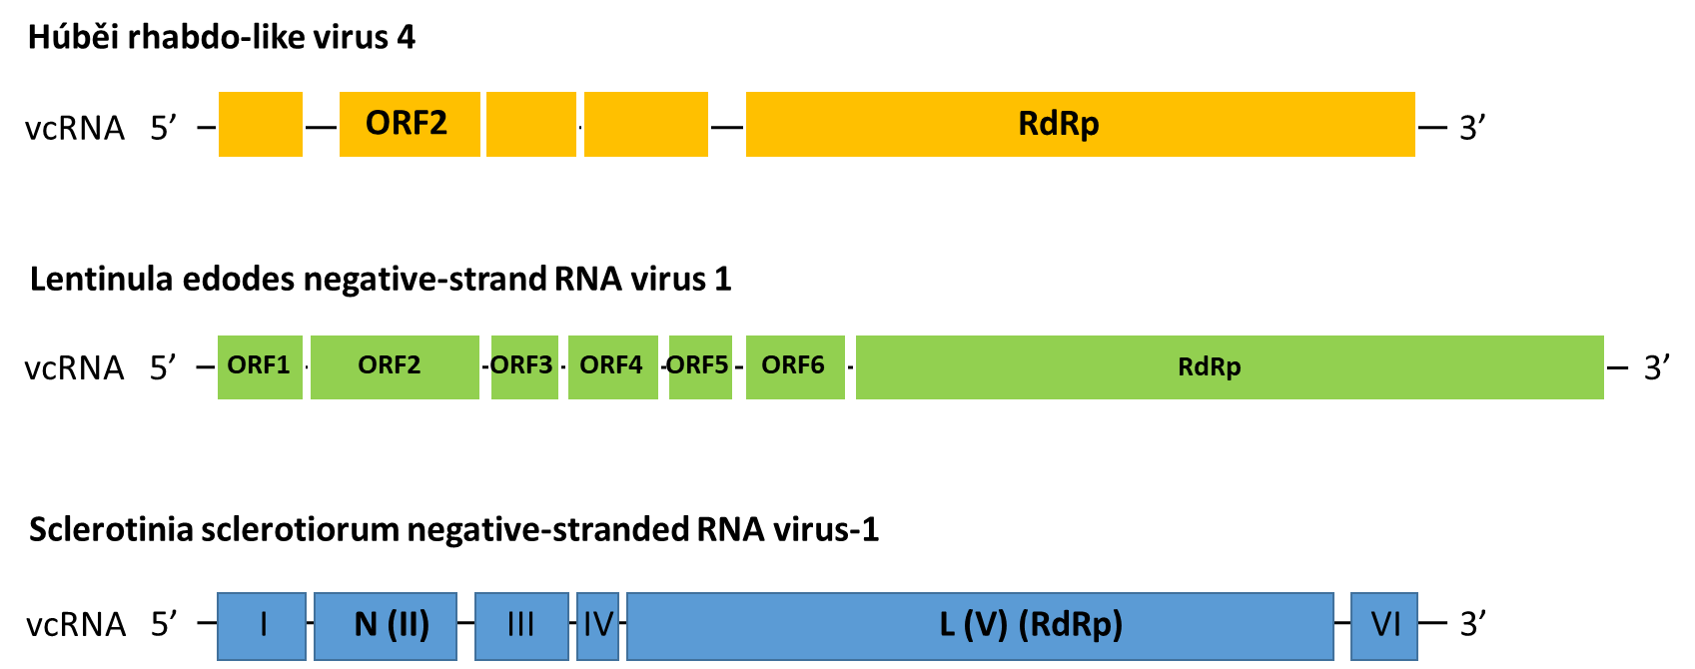

Figure 1. Schematic representation of the genomic organization of Húběi rhabdo-like virus 4 strain arthropod mix13990, Lentinula edodes negative-strand RNA virus 1 strain HG3, and Sclerotinia sclerotiorum negative-stranded RNA virus 1 strain AH98 (the exemplar isolate of the type species of genus Sclerotimonavirus). vcRNA indicate viral complementary RNA. The boxes in the vcRNA represent putative ORFs. This figure was modified from Lin et al. 2019.

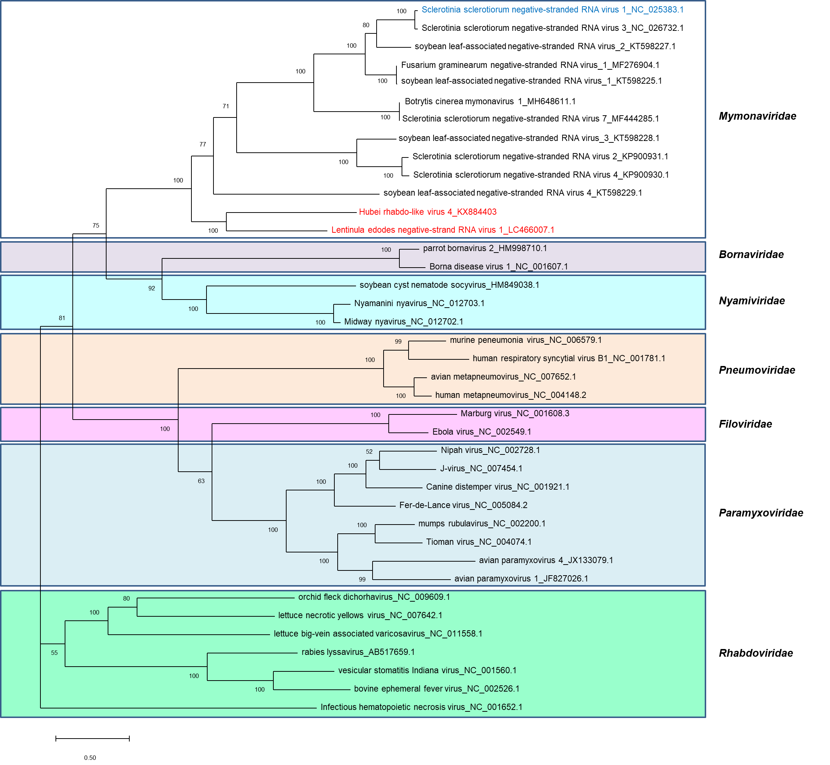

Figure 2. Maximum-likelihood phylogenetic tree based on the core RdRp motifs of mymonaviruses and the selected mononegaviruses from Filoviridae, Pneumoviridae, Paramyxoviridae, Bornaviridae, Nyamiviridae, and Rhabdoviridae families are shown. The position of Sclerotinia sclerotiorum negative-stranded RNA virus 1 is indicated in blue color and the positions of Húběi rhabdo-like virus 4 and Lentinula edodes negative stranded RNA virus 1 are indicated with red color. Numbers at the nodes indicate highly supported bootstrap values over 50% (1000 replicates), the scale bar indicating a value of 0.5.

References:
Kumar S, Stecher G, Tamura K. MEGA7: molecular evolutionary genetics analysis version 7.0 for bigger datasets. Molecular Biology and Evolution. 2016; 33(7):1870-1874.
Lin YH, Fujita M, Chiba S, Hyodo K, Andika IB, Suzuki N, Kondo H. Two novel fungal negative-strand RNA viruses related to mymonaviruses and phenuiviruses in the shiitake mushroom (Lentinula edodes). Virology 2019; 533: 125-136
Liu L, Xie J, ChengJ, Fu Y, Li G, Yi X, Jiang D. Fungal negative-stranded RNA virus that is related to bornaviruses and nyaviruses. Proc Natl Acad Sci USA 2014; 111: 12205-12210.
Maes P, et al. 2019. Taxonomy of the order Mononegavirales: Second update 2018. Archives of Virology, https://doi.org/10.1007/s00705-018-04126-4
Shi M, Lin XD, Tian JH, Chen LJ, Chen X, Li CX, Qin XC, Li J, Cao JP, Eden JS, Buchmann J, Wang W, Xu J, Holmes EC, Zhang YZ. 2016. Redefining the invertebrate RNA virosphere. Nature 540, 539–543

