This Word module should be used for all taxonomic proposals.
Please complete Part 1 and:
either Part 3 for proposals to create new taxa or change existing taxa
or Part 2 for proposals of a general nature.
Submit the completed Word module, together with the accompanying Excel module named in Part 3, to the appropriate ICTV Subcommittee Chair.
The Word module explains and justifies your proposal. The Excel module is a critical document that will be used to implement the proposed taxonomic changes once they are approved and ratified. If proposals presented in the Word module are not presented accurately in the Excel module, the taxonomic changes cannot proceed.
For guidance, see the notes written in blue, below, and the Help Notes in file Taxonomic_Proposals_Help_2019.
Part 1: TITLE, AUTHORS, etc

Code assigned: | 2019.024M
Short title: Create three new species in the genus Orthoreovirus, family Reoviridae
Author(s) and email address(es):
List authors in a single line Archives of Virology citation format (e.g. Smith AB, Huang C-L, Santos, F) |  | Provide email address for each author in a single line separated by semi-colons
Duncan R |  | Roy.duncan@dal.ca
Corresponding author
Roy Duncan, Roy.duncan@dal.ca
List the ICTV study group(s) that have seen this proposal:
A list of study groups and contacts is provided at http://www.ictvonline.org/subcommittees.asp . If in doubt, contact the appropriate subcommittee chair (there are six virus subcommittees: animal DNA and retroviruses, animal ssRNA-, animal ssRNA+, fungal and protist, plant, bacterial and archaeal) |  | ICTV Reoviridae Study Group
ICTV Study Group comments (if any) and response of the proposer:
Date first submitted to ICTV: |  |  | June 19, 2019
Date of this revision (if different to above):

ICTV-EC comments and response of the proposer:

Part 3: PROPOSED TAXONOMY

Name of accompanying Excel module: 2019.024M.A.v1.Orthoreovirus_3newsp.xlsx
Supporting material:

Three of the polythetic criteria for orthoreovirus species demarcation are percent sequence identity, 5’-terminal sequences on the genomic (+)RNA strand that are conserved in all 10 genome segments among viruses of a species but differ among viruses of different species, and phylogenetic relationships of their hosts (Duncan, 1999; Duncan et al., 2004). ICTV guidelines for species differentiation in the more diverged outer capsid clamp protein is >55% amino acid identity between isolates within a species and <35% identity among isolates of different species. For the more conserved core particle clamp protein, guidelines for amino acid identities among viruses within a species are >85% and among viruses of different species are <65%.

A new species of bat reovirus:
As originally proposed by Thalmann et al. (2010), an orthoreovirus isolate from little red flying foxes (Pteropus scapulatus) found in Broome, Australia, fulfills the criteria as a representative of new species. Broome reovirus (BrRV) outer capsid clamp protein shares <27% amino acid identity with the homologous protein from orthoreoviruses of other species (Table 1A), including other reoviruses isolated from fruit bats. The conserved core clamp protein shares <35% amino acid identity with most other orthoreoviruses but shares 40-42% amino acid identity with viruses belonging to the species Reptilian orthoreovirus and Mahlapitsi orthoreovirus (Table 1B). These values fall in the “grey zone”, slightly above the lower demarcation guideline of <35% but well below the upper demarcation guideline of >55%. BrRV also has a 5’-pentanucelotide sequence (Table 2) conserved in all 10 of its genome segments that is distinct from the conserved terminal sequences in all other species. These features define BrRV as a representative of new species, Broome orthoreovirus, that is most closely related to viruses of the species Reptilian orthoreovirus and Mahlapitsi orthoreovirus (Figures 1 and 2).

A new species of reptilian reovirus:
The above polythetic criteria support designation of a recent chelonian orthoreovirus isolate (“CH1197/96”) obtained from a spur-thighed tortoise (Testudo graeca), as a representative of a new species. Currently recognized virus isolates belonging to the species Reptilian orthoreovirus were all obtained from hosts in the order Squamata (snakes, iguanas, lizards). The tortoise isolate (Kugler et al., 2016) is the first reptilian orthoreovirus isolated from a host in the order Testudines (turtles and tortoises). In addition to distinct hosts, the squamate and testudine reovirus isolates have distinct 5’-terminal sequences (Table 2). The chelonian orthoreovirus isolate outer capsid clamp protein shares 45% amino acid identity with the homologous protein from squamate virus isolates belonging to the species Reptilian orthoreovirus (Table 1A), in between the 35% and 55% demarcation guidelines. In comparison, outer capsid clamp protein identities between waterfowl and landfowl virus isolates classified in the Avian orthoreovirus range from 61-70% (Table 1A), the most diversity observed within an orthoreovirus species. The conserved core clamp protein of the chelonian orthoreovirus isolate shares 69% amino acid identity with the homologous protein from squamate virus isolates belonging to the species Reptilian orthoreovirus (Table 1B), slightly above the 65% lower demarcation guideline for a different species but well below the 85% guideline for the same species. In comparison, sequence identities in this conserved core protein for virus isolates belonging to species Avian orthoreovirus from waterfowl and landfowl exceed 90% (Table 1B). None of the other core proteins of the chelonian orthoreovirus isolate exceeds the 85% demarcation point when compared to squamate isolates, although three of these proteins approach this demarcation point with 80-81% amino acid identity (Kugler et al., 2016). Unique 5’-terminal conserved sequences, isolation from hosts in distinct phylogenetic clades, and sequence identities that fall below intra-species guidelines all support designation of the chelonian orthoreovirus as a representative of a new species, Testudine orthoreovirus, that is distinct from the squamate virus isolates belonging to the species Reptilian orthoreovirus.

A new species of avian reovirus with three isolates:
All currently recognized virus isolates classified in the species Avian orthoreovirus were obtained from domesticated waterfowl and landfowl (Galloanserae). The above polythetic criteria support designation of three isolates from Neoaves (wild birds) as distinct virus isolates of a new species. These isolates were obtained from a hooded crow (Corvus corone cornix) (Huhtamo et al., 2007), from various psittaciformes (parrots, parakeets) (de Kloet, 2008), and from a brown eared bulbul (Hypsipetes amaurotis) (Ogasawara et al., 2015). The isolates all share the same 5’-terminal heptanucleotide sequence (GCUUUUC) that differs in the seventh position (GCUUUUU) from the galloanseran virus isolates of Avian orthoreovirus (Table 2). Amino acid identities in their outer capsid clamp protein are 55-56% between these isolates, but only 37-39% when compared to the homologous protein from virus isolates classified in species Avian orthoreovirus (Table 1A). For the more conserved core clamp protein, amino acid identities are 97% between the bulbul and psittaciforme isolates but only 58-60% when compared to virus isolates belonging to species Avian orthoreovirus (Table 1B). However, the crow isolate shares only 65% identity to the other two neoavian isolates, similar to the 65-67% identity with the outer capsid clamp proteins virus isolates belonging to species Avian orthoreovirus and Nelson Bay orthoreovirus (Table 1B). As previously shown (Ogasawara et al., 2015), based on nucleotide phylograms generated using the neighbour-joining method, the neoavian isolates form a monophyletic clade distinct from the Avian orthoreovirus clade in 7 of the 8 genome segments encoding structural proteins, the exception being the genome segment encoding the core capsid clamp protein. The same situation applies in phylograms generated by the maximum likelihood method using amino acid sequence similarities; the outer clamp proteins of neoavian isolates are monophyletic whereas the core clamp proteins are paraphyletic (Figures 1 and 2). These results imply lateral gene transfer by reassortment of the core clamp protein genome segment between galloanseran and neoavian isolates occurred after these viruses diverged from each other. Based on their 5’-terminal sequences, isolation from hosts in distinct phylogenetic clades, and amino acid identities in the majority of their structural proteins, the neoavian isolates are proposed to be representatives of a new species of avian orthoreoviruses, Neoavian orthoreovirus, that is distinct from species Avian orthoreovirus comprising virus isolates from galloanseran hosts.

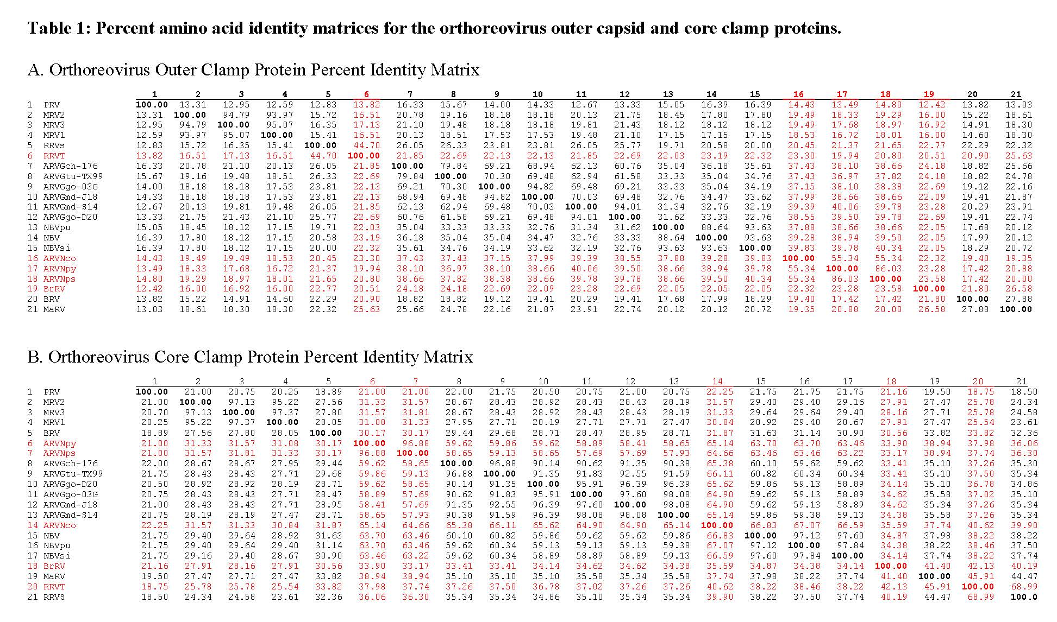
Virus abbreviations: ARVG, avian reovirus galloanseran isolates (isolate from: ch, chicken; tu, turkey; md, Muscovy duck; go, goose; -X indicates isolate identifier); ARVN, avian reovirus neoavian isolates (co, corvid isolate; hy, bulbul isolate; ps, psittacine isolate); BRV, Baboon reovirus; BrRV, Broome reovirus; MaRV, Mahlapitsi reovirus; MRV, Mammalian reovirus (number indicates serotype); NBV, Nelson Bay reovirus; PRV, piscine reovirus; RRVS, reptilian reovirus Squamata isolate; RRVT, reptilian reovirus testudine isolate aka chelonian orthoreovirus. Red text in Table 1 indicates isolates from tentative new species.

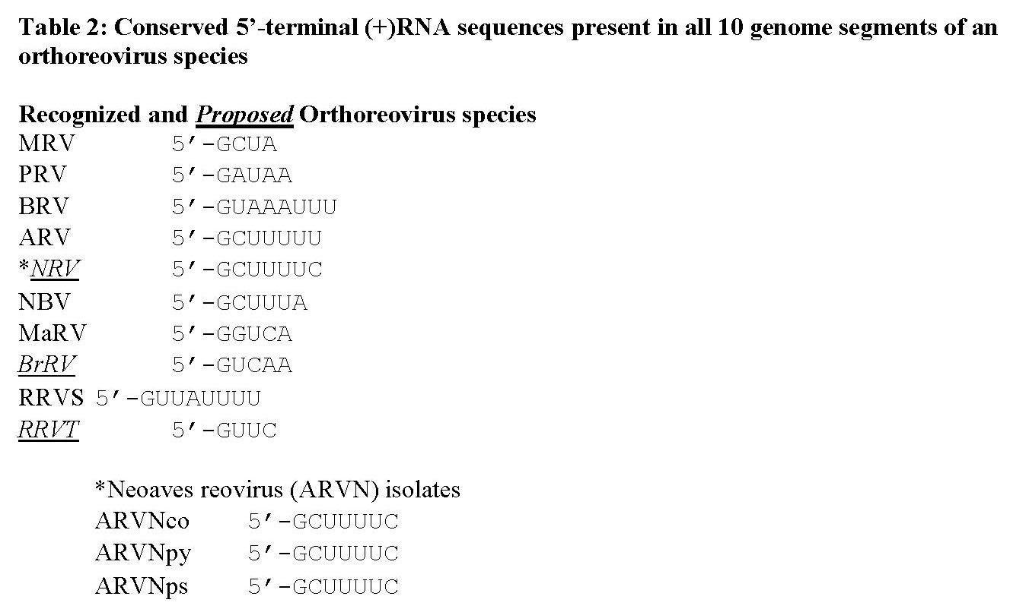

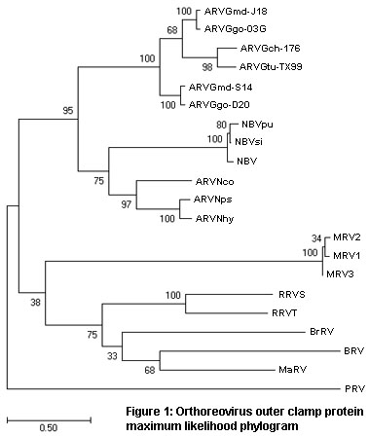

References:
Duncan R. 1999. Extensive sequence divergence and phylogenetic relationships between the fusogenic and nonfusogenic orthoreoviruses: A species proposal. Virology 260: 316-328.
Duncan R, Corcoran J, Shou J, and Stoltz D. (2004). Reptilian reovirus: a new fusogenic orthoreovirus species. Virology 319: 131-140.
Thalmann CM, Cummins DM, Yu M, Lunt R, Pritchard LI, et al. 2010. Broome virus, a new fusogenic Orthoreovirus species isolated from an Australian fruit bat. Virology 402: 26-40.
Kugler R, Marschang RE, Ihasz K, Lengyel G, Jakab F, et al. 2016. Whole genome characterization of a chelonian orthoreovirus strain identifies significant genetic diversity and may classify reptile orthoreoviruses into distinct species. Virus Res 215: 94-98.
Huhtamo E, Uzcátegui NY, Manni T, Munsterhjelm R, Brummer-Korvenkontio M, et al. 2007. Novel orthoreovirus from diseased crow, Finland. Emerg Infect Dis 13: 1967–1969.
Dandar E, Huhtamo E, Farkas SL, Oldal M, Jakab F, et al. 2014. Complete genome analysis identifies Tvarminne avian virus as a candidate new species within the genus Orthoreovirus. J Gen Virol 95: 898-904.
de Kloet SR. 2008. Sequence analysis of four double-stranded RNA genomic segments reveals an orthoreovirus with a unique genotype infecting psittaciformes. Avian Dis 52: 480-486.
Ogasawara Y, Ueda H, Kikuchi N, Kirisawa R. 2015. Isolation and genomic characterization of a novel orthoreovirus from a brown-eared bulbul (Hypsipetes amaurotis) in Japan. J Gen Virol 96: 1777-1786.

