This Word module should be used for all taxonomic proposals.
Please complete Part 1 and:
either Part 3 for proposals to create new taxa or change existing taxa
or Part 2 for proposals of a general nature.
Submit the completed Word module, together with the accompanying Excel module named in Part 3, to the appropriate ICTV Subcommittee Chair.
The Word module explains and justifies your proposal. The Excel module is a critical document that will be used to implement the proposed taxonomic changes once they are approved and ratified. If proposals presented in the Word module are not presented accurately in the Excel module, the taxonomic changes cannot proceed.
For guidance, see the notes written in blue, below, and the Help Notes in file Taxonomic_Proposals_Help_2019.
Part 1: TITLE, AUTHORS, etc

Code assigned: | 2019.018M
Short title: Create one new species in the genus Mivirus (Jingchuvirales: Chuviridae)

Author(s) and email address(es):
List authors in a single line Archives of Virology citation format (e.g. Smith AB, Huang C-L, Santos, F) |  | Provide email address for each author in a single line separated by semi-colons
Wang H, Liu Y, Liu WW, Cao MJ, Wang XF |  | whsmilewh@163.com; liuyan06@caas.cn;  liuwenwen98@163.com; caomengji@cric.cn; xfwang@ippcaas.cn
Author(s) institutional address(es) (optional):
Provide institutional addresses, each on a single line followed by author(s) initials (e.g. University of Woolloomooloo [SAB, HCL])
State Key Laboratory for Biology of Plant Diseases and Insect Pests, Institute of Plant Protection, Chinese Academy of Agricultural Sciences (WH, LY, LWW, WXF)
National Citrus Engineering Research Center, Citrus Research Institute, Southwest University (CMJ)

Corresponding author
Yan Liu; liuyan06@caas.cn
List the ICTV study group(s) that have seen this proposal:
A list of study groups and contacts is provided at http://www.ictvonline.org/subcommittees.asp . If in doubt, contact the appropriate subcommittee chair (there are six virus subcommittees: animal DNA and retroviruses, animal ssRNA-, animal ssRNA+, fungal and protist, plant, bacterial and archaeal) |  | ICTV Mononegavirales Study Group
ICTV Study Group comments (if any) and response of the proposer:
Date first submitted to ICTV: |  |  | June 19, 2019
Date of this revision (if different to above):

ICTV-EC comments and response of the proposer:

Part 3: PROPOSED TAXONOMY

Name of accompanying Excel module: 2019.018M.A.v1.1newsp_Taiyuan_mivirus.xlsx

Tàiyuán leafhopper virus (TYLeV) was discovered in 2017 in a leafhopper (Hemiptera: Cicadellidae: Psammotettix alienus Dahlbom, 1850) in Tàiyuán (太原;), Shānxī Province (山西省), China, and characterized (Wang et al., 2019). The complete genome sequence of TYLeV is available from GenBank (#MH708020).
- A Blastp search of protein sequences (refseq_protein) in the Reference Sequence Database of NCBI indicated that the full-length TYLeV RdRp and nucleoprotein sequences have 33% and 26% identity, respectively, to the proteins of the unclassified Scaldis River bee virus (SRBV) which is related to chuviruses in the genus Mivirus.
- Phylogenetic trees based on the genomic sequence and the RdRp amino acid sequences of chǔviruses and members of the monjiviral sister order Mononegavirales were generated using the neighbor-joining (NJ) and maximum-likelihood (ML) method. Both trees demonstrate that TYLeV indeed clusters within genus Mivirus, family Chǔvirae (Fig. 1) and confirm the relatively close relationship to SRBV.
- The identities of the deduced amino acid sequences of the TYLeV RdRp compared to those of other chǔviruses and mononegaviruses range from 13.6% to 33% (Table 1) based on WebLab (http://weblab.cbi.pku.edu.cn/).

Together, these data indicate that TYLeV represents a new species in the genus Mivirus, family Chǔviridae.

Table 1. RdRp amino acid sequences identities between TYLeV, chǔviruses, and mononegaviruses

Accession no | Virus | Identity (%)
KF893260.1 | Human respiratory syncytial virus | 15.8
NC_006579.1 | Murine pneumonia virus | 16.9
NC_002549.1 | Ebola virus | 17.9
JF828358.1 | Lloviu virus | 17
NC_001906.3 | Hendra virus | 16.4
NC_001498.1 | Measles virus | 14.2
NC_025345.1 | Sunshine Coast virus | 17.1
NC_016136.1 | Potato yellow dwarf virus | 13.7
NC_009609.1 | Orchid fleck virus | 14.9
NC_001542.1 | Rabies virus | 17.8
NC_031259.1 | Líshí spider virus 2 | 17
NC_031270.1 | Tǎchéng tick virus 6 | 17.6
NC_029642.1 | Aquatic bird bornavirus | 13.6
NC_030690.1 | Canary bornavirus 1 | 14.4
NC_031275.1 | Wēnzhōu crab virus 1 | 16.1
NC_012702.1 | Midway virus | 15.7
NC_012703.1 | Nyamanini virus | 14.9
NC_031244.1 | Xīnchéng mosquito virus | 15.1
NC_025383.1 | Sclerotinia sclerotiorum negative-stranded RNA virus 1 | 15.3
AJG39057.1 | Tǎchéng tick virus 4 | 22.10
APG78655.1 | Běihǎi barnacle virus 9 | 19.10
APG78687.1 | Húběi coleoptera virus 3 | 31.00
AJG39041.1 | Bólè tick virus 3 | 20.50
APG78824.1 | Wēnlǐng crustacean virus 14 | 20.80
AJG39044.1 | Chāngpíng tick virus 2 | 20.50
AJG39066.1 | Wēnzhōu crab virus 3 | 19.90
AJG39067.1 | Wǔchāng cockroach virus 3 | 20.10
AJG39060.1 | Wēnzhōu crab virus 2 | 20.00
APG78828.1 | Wēnlǐng crustacean virus 13 | 21.30
AJG39047.1 | Chāngpíng tick virus 3 | 20.90
AJG39058.1 | Tǎchéng tick virus 5 | 20.20
APG78635.1 | Běihǎi hermit crab virus 3 | 23.70
AJG39073.1 | Wǔhàn louse fly virus 7 | 20.80
APG78716.1 | Húběi chuvirus-like virus 1 | 20.90
APG78724.1 | Húběi chuvirus-like virus 3 | 21.00
ALP32028.1 | Imjin River virus 1 | 20.60
AJG39082.1 | Shuāngào lacewing virus | 24.50
AJG39051.1 | Líshí spider virus 1 | 19.90
ANC97697.1 | Lone star tick chǔvirus 1 | 20.50
AJG39070.1 | Wǔhàn louse fly virus 6 | 19.40
AJG39074.1 | Wǔhàn mosquito virus 8 | 20.00
APG78798.1 | Húběi myriapoda virus 8 | 21.50
APG78700.1 | Húběi odonate virus 11 | 20.70
APG78770.1 | Sānxiá atyid shrimp virus 4 | 19.20
AJG39054.1 | Shāyáng fly virus 1 | 28.20
AIY53910.1 | Suffolk virus | 19.90
APG78840.1 | Wēnlǐng crustacean virus 15 | 18.80
AJG39077.1 | Wǔhàn tick virus 2 | 20.10
APG78852.1 | Xinzhou nematode virus 5 | 20.50
KY053857.1 | Scaldis River bee virus | 33

Figure 1. Phylogenetic tree based on the RdRp sequences of chǔviruses and mononegaviruses using the neighbor-joining method and MEGA 7.0. The numbers indicate bootstrap values calculated from 1,000 replicates (Wang et al., 2019). 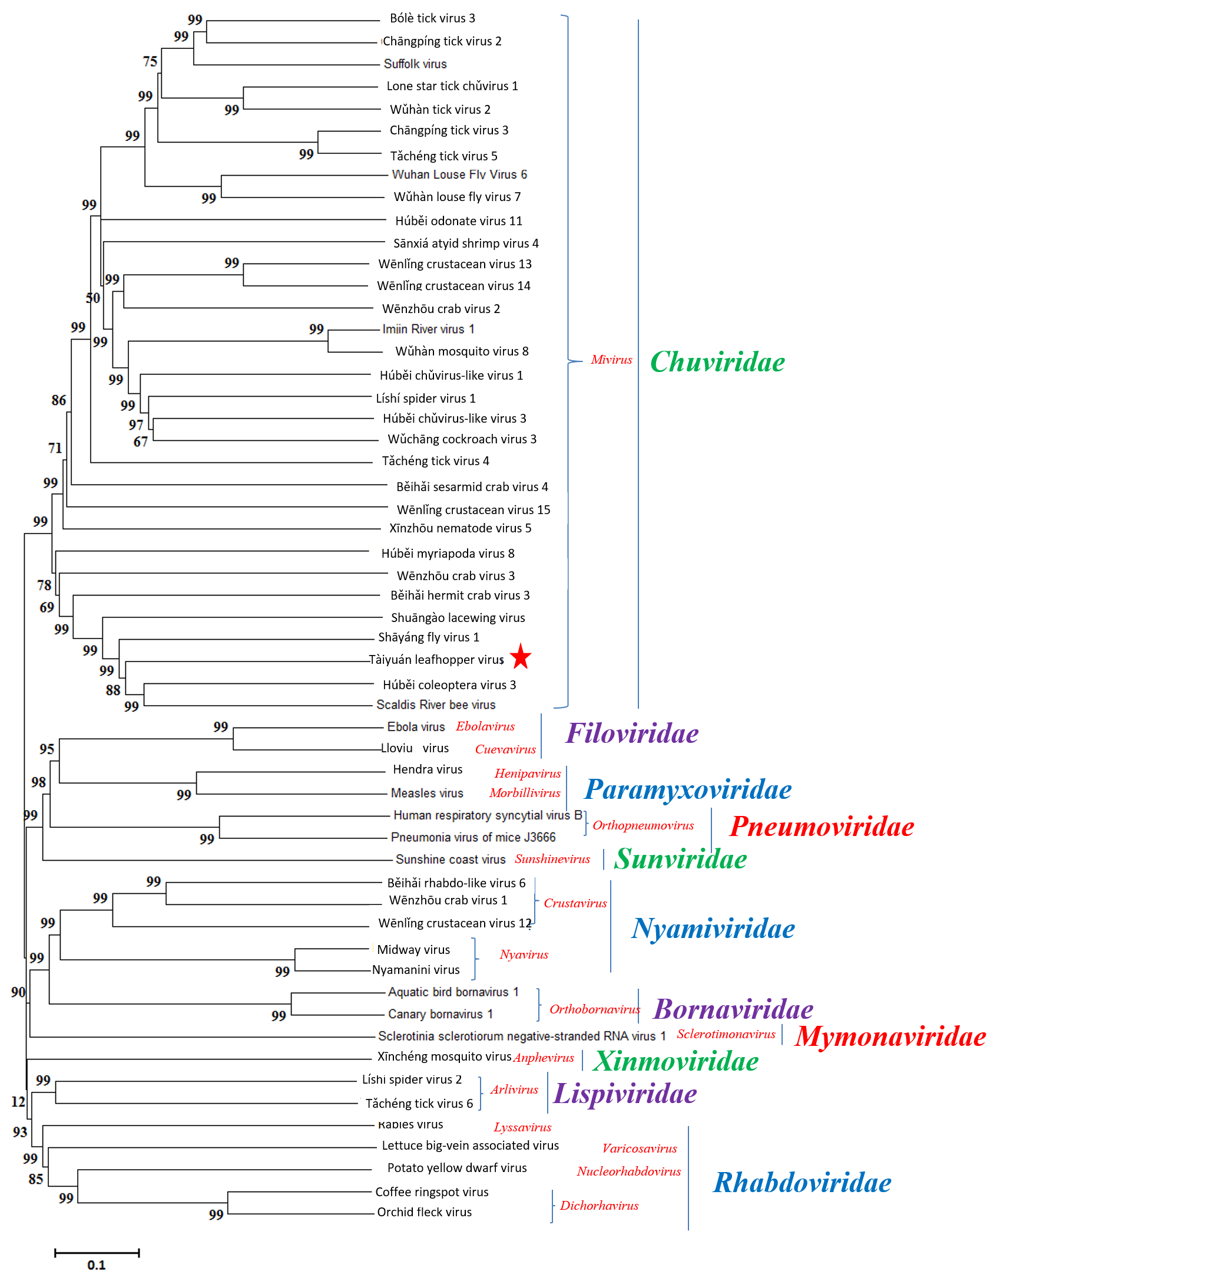

References:
Wang H, Liu Y, Liu WW, Cao MJ, Wang XF. Sequence analysis and genomic organization of a novel chuvirus, Tàiyuán leafhopper virus. Archives of Virology (2019) 164: 617-620

