This Word module should be used for all taxonomic proposals.
Please complete Part 1 and:
either Part 3 for proposals to create new taxa or change existing taxa
or Part 2 for proposals of a general nature.
Submit the completed Word module, together with the accompanying Excel module named in Part 3, to the appropriate ICTV Subcommittee Chair.
For guidance, see the notes written in blue, below, and the help notes in file Taxonomic_Proposals_Help_2018.
Part 1: TITLE, AUTHORS, etc

Code assigned: | 2019.011M |  | (to be completed by ICTV officers)
Short title: Create one new genus including one new species in the mononegaviral family Filoviridae
Author(s):
Wáng, Línfā (王林发); linfa.wang@duke-nus.edu.sg
Shí, Zhènglì (石正丽); zlshi@wh.iov.cn
Yáng Xìnglóu (扬兴娄); yangxl@wh.iov.cn
Kuhn, Jens H.; kuhnjens@mail.nih.gov
Corresponding authors with e-mail addresses:
Wáng, Línfā (王林发); linfa.wang@duke-nus.edu.sg
Shí, Zhènglì (石正丽); zlshi@wh.iov.cn
List the ICTV study group(s) that have seen this proposal:
A list of study groups and contacts is provided at http://www.ictvonline.org/subcommittees.asp . If in doubt, contact the appropriate subcommittee chair (there are six virus subcommittees: animal DNA and retroviruses, animal ssRNA-, animal ssRNA+, fungal and protist, plant, bacterial and archaeal) |  | ICTV Filoviridae Study Group
ICTV Study Group comments (if any) and response of the proposer:
No objections from any member of the ICTV Filoviridae Study Group.

Date first submitted to ICTV: |  |  | 01/13/2019
Date of this revision (if different to above):

ICTV-EC comments and response of the proposer:

Part 3: PROPOSED TAXONOMY

Name of accompanying Excel module: 2019.011M.A.v1.Mengla_dianlovirus.xlxs

In 2015, a new filovirus, Měnglà virus (MLAV; previously designated “BtFilo9447”) was discovered by next generation sequencing in liver tissue of an unspecified Rousettus bat sampled in Měnglà County, Yúnnán Province, China (Yang et al., 2017; Yang et al., 2019). A coding-complete, 18,330-nt-long viral genome sequences was determined and deposited into GenBank; isolation of MLAV has not been reported (Yang et al., 2019). Akin to cuevaviruses, marburgviruses, and ebolaviruses, MLAV encodes seven structural proteins from the standard set of seven filovirus genes (3'-NP-VP35-VP40-GP-VP30-VP24-L-5'). However, the MLAV genome differs from the genomes of cuevaviruses, marburgviruses, and ebolaviruses in the number of gene overlaps (4 versus 5 [cuevaviruses], 2-3 [ebolaviruses], and 1 [marburgviruses]) and transcriptional termination sequence. In contrast to cuevaviruses and ebolaviruses, and similar to marburgviruses, MLAV only encodes a single product from the GP gene (Yang et al., 2019).

Phylogenetic analysis clearly places MLAV into a novel lineage of filoviruses more closely related to marburgviruses than to other filoviruses (Figs. 1 and 2).

Figure 1. Neighbor-joining phylogenetic tree based on deduced amino acid sequences of
filovirus RNA-dependent RNA polymerase (L) protein. Sequences were aligned using ClustalW using Geneious software 10.0.2. The tree was built using MEGA7 (bootstrap value = 1,000). Evolutionary distances were computed using the Poisson correction method and are in depicted as units of the number of amino acid substitutions per site. BDBV, Bundibugyo virus; EBOV, Ebola virus; HUJV, Huángjiāo virus; LLOV, Lloviu virus; MLAV, Měnglà virus; RAVN, Ravn virus; RESTV, Reston virus; SUDV, Sudan virus; TAFV, Taï Forest virus; XILV, Xīlăng virus (Yang et al., 2019).

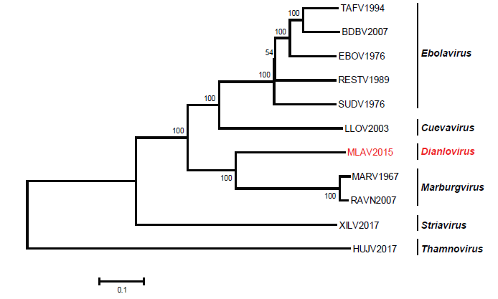

Figure 2. Phylogenetic tree of filoviruses based on genomic sequences. Sequence alignment was performed using ClustalW in Geneious software 10.0.2. The tree was built using MEGA7 using the neighbor-joining method with p-distance model (bootstrap value = 1,000). The scale bar represents the units of the number of base differences per site. BDBV, Bundibugyo virus; EBOV, Ebola virus; HUJV, Huángjiāo virus; LLOV, Lloviu virus; MLAV, Měnglà virus; RAVN, Ravn virus; RESTV, Reston virus; SUDV, Sudan virus; TAFV, Taï Forest virus; XILV, Xīlăng virus. GenBank accession numbers: NC014372 for TAFV1994; NC014373 for BDBV2007; NC002549 for EBOV1976; FJ968794 for SUDV1976; NC004161 for RESTV1989; NC016144 for LLOV2003; Z29337 for MARV1967; FJ750958 for RAVV2007; MG599980 for XILV2017; MG599981 for HUJV2017 (Yang et al., 2019).

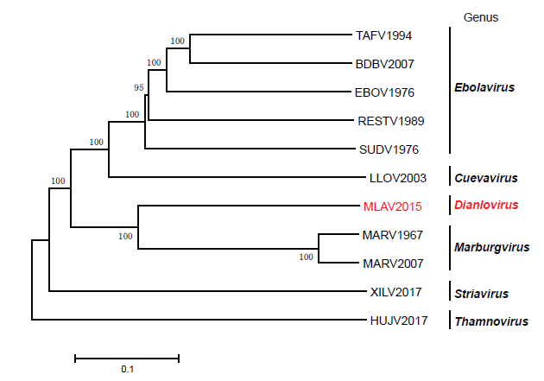

In 2017, the ICTV Filoviridae Study Group established filovirus taxon demarcation criteria based on the US National Center for Biotechnology Information (NCBI) Pairwise Sequence Comparison (PASC) tool. Genus demarcation was set at the 55–58% sequence diversity threshold range and species demarcation was set at the 23–36% sequence diversity threshold. Using RefSeq “type” filovirus genome sequences, an algorithm was established for streamlined filovirus classification (Fig. 3).

Figure 3. Algorithm/flow chart for filovirus classification based on genomics sequence information and PASC-derived sequence demarcation criteria established by the ICTV Filoviridae Study Group (Bào et al.). A putative filovirus genome of interest is compared to the type filovirus RefSeq genome sequence (i.e., that of Marburg virus/H.sapiens-tc/KEN/1980/Mt. Elgon-Musoke) and then sequentially moved through the process until its proper taxonomic placement is revealed or the need to create novel taxa is obvious.

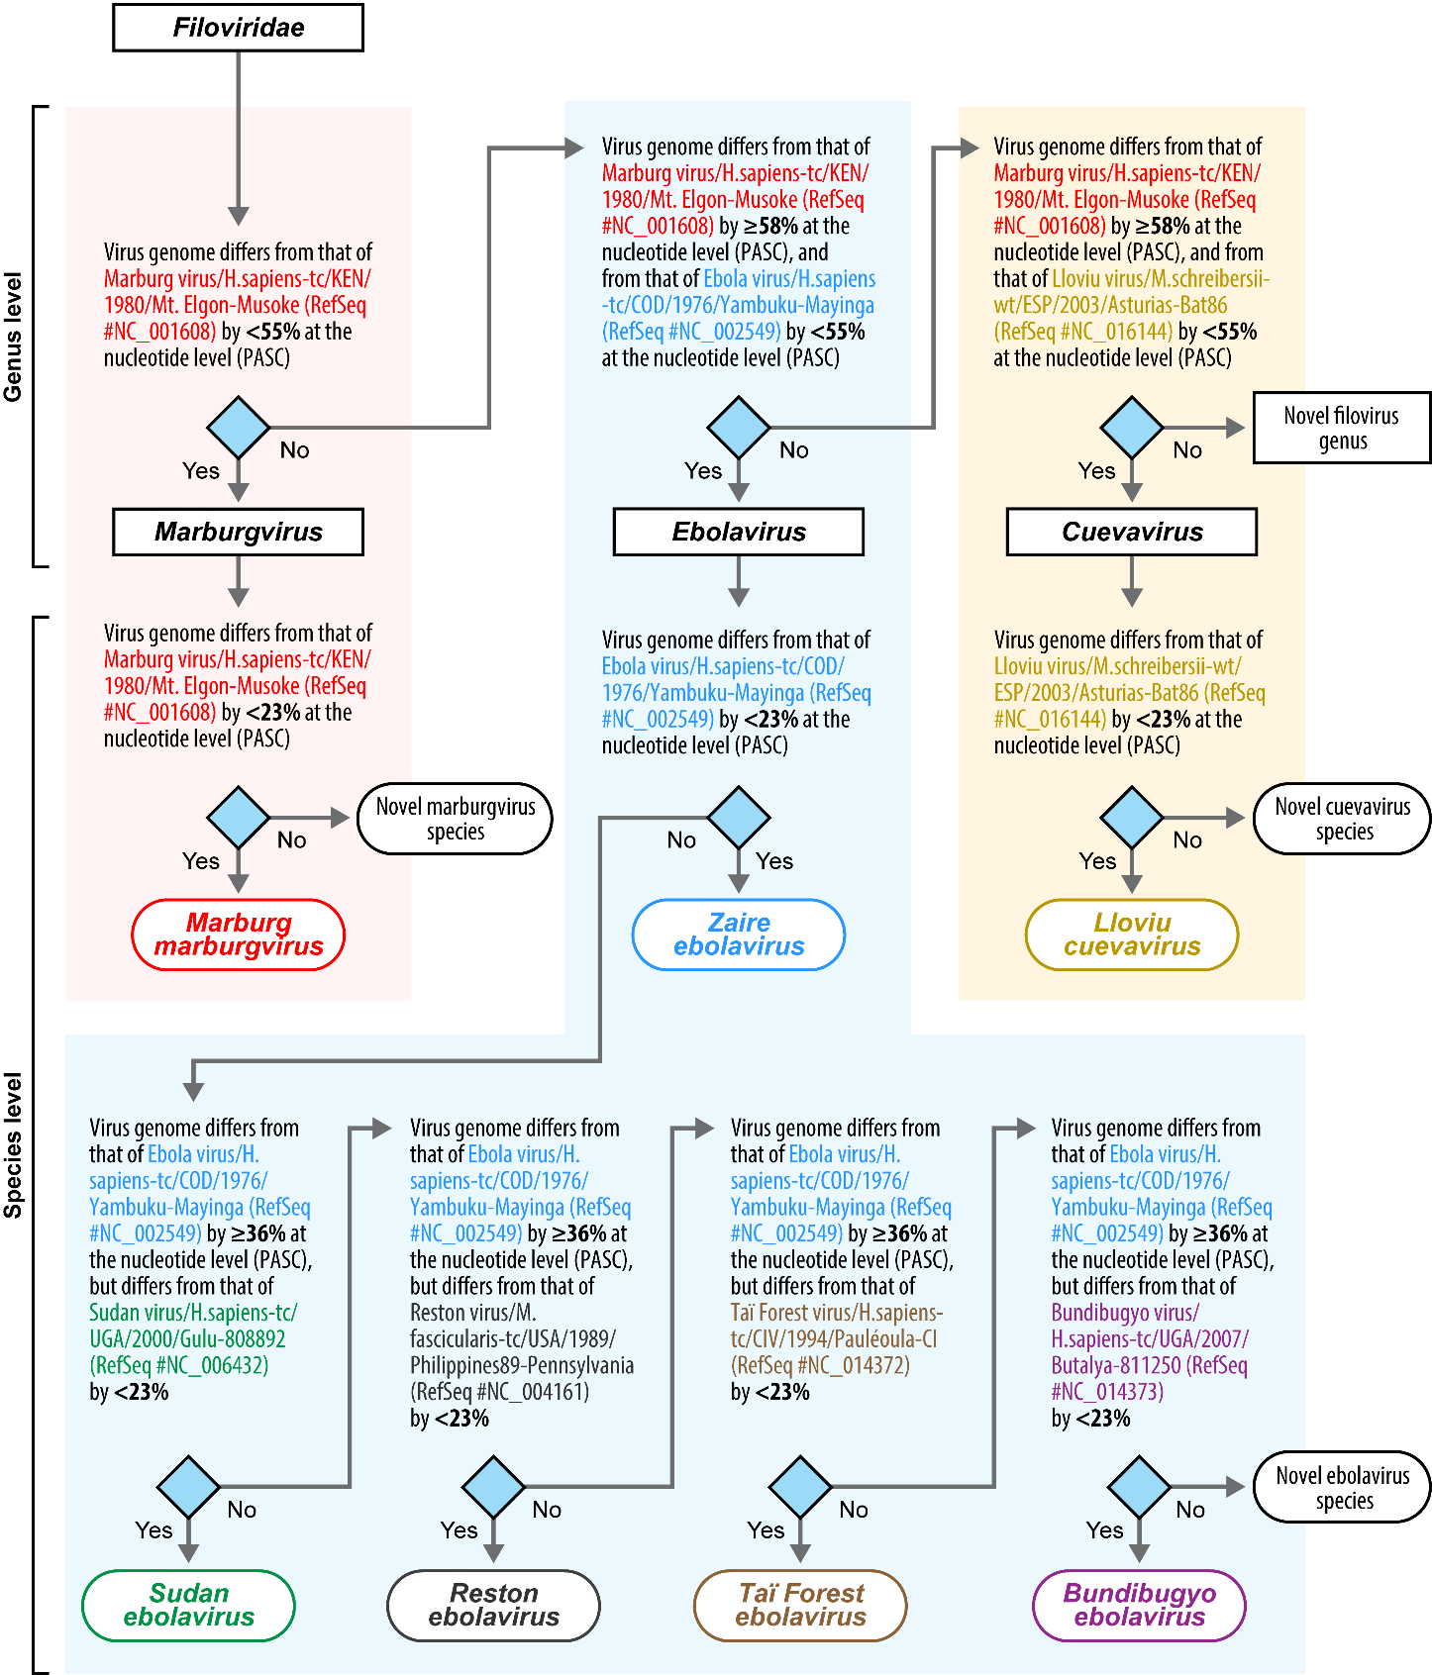

PASC analysis using the complete genome sequences of MLAV revealed that MLAV is most closely related to Marburg virus (43.86% sequence identity) (Fig. 4).

Figure 4. Screenshot of the US National Center for Biotechnology Information (NCBI) Pairwise Sequence Comparison (PASC) tool result after comparing distinct near-complete, coding-complete or complete filovirus genome sequences. Shown is the PASC results for MLAV. Brown bars represent genome pairs assigned to (the three established) different filovirus genera; yellow bars represent genome pairs assigned to (the seven established) separate filovirus species; and green bars represent genome pairs assigned to the same established filovirus species. BLAST: Basic Local Alignment.

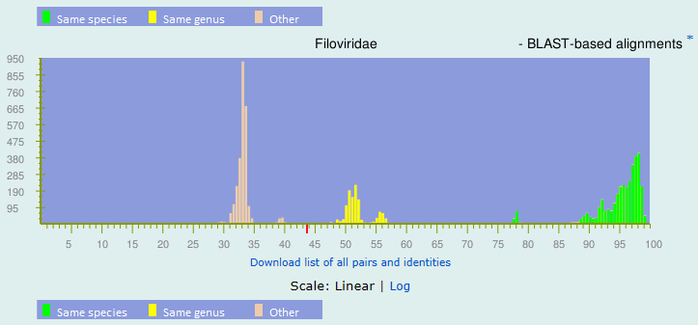

BLAST-based alignments
1 |  | 43.86% |  | gi|361584214|gb|JN408064.1| Marburgvirus|Marburg marburgvirus|Lake Victoria marburgvirus - Leiden
2 |  | 43.76% |  | gi|409194014|gb|JX458851.1| Marburgvirus|Marburg marburgvirus
3 |  | 43.71% |  | gi|254688075|gb|FJ750958.1| Marburgvirus|Marburg marburgvirus
4 |  | 43.65% |  | gi|409193806|gb|JX458825.1| Marburgvirus|Marburg marburgvirus
5 |  | 43.63% |  | gi|34304751|gb|AY358025.2| Marburgvirus|Marburg marburgvirus
6 |  | 43.6% |  | gi|499104175|gb|KC545387.1| Marburgvirus|Marburg marburgvirus
7 |  | 43.59% |  | gi|91177759|gb|DQ447651.1| Marburgvirus|Marburg marburgvirus|Lake Victoria marburgvirus - DRC1999
8 |  | 43.53% |  | gi|409194070|gb|JX458858.1| Marburgvirus|Marburg marburgvirus
9 |  | 43.49% |  | gi|409194030|gb|JX458853.1| Marburgvirus|Marburg marburgvirus
10 |  | 43.49% |  | gi|91177751|gb|DQ447650.1| Marburgvirus|Marburg marburgvirus|Lake Victoria marburgvirus - DRC1999
11 |  | 43.48% |  | gi|254688067|gb|FJ750957.1| Marburgvirus|Marburg marburgvirus
12 |  | 43.36% |  | gi|409194054|gb|JX458856.1| Marburgvirus|Marburg marburgvirus
13 |  | 43.34% |  | gi|777861532|gb|KP985768.1| Marburgvirus|Marburg marburgvirus
14 |  | 43.29% |  | gi|409193822|gb|JX458827.1| Marburgvirus|Marburg marburgvirus
15 |  | 43.2% |  | gi|151564214|gb|EF446132.1| Marburgvirus|Marburg marburgvirus|Lake Victoria marburgvirus - Ci67

Together, these results indicate that MLAV is a representative of a novel filovirus genus and species, here proposed to be named Dianlovirus and Mengla dianlovirus, respectively.

Etymology:
- Měnglà virus: named after 勐腊县 (Měnglàxiàn/Měnglà County) in 云南省 (Yúnnán sheng/Yúnnán Province), China
- Dianlovirus: named after ancient 滇王国 (Diānwángguó/Diān Kingdom) located in today’s Yúnnán Province
- Mengla dianlovirus: after Měnglà virus and Dianlovirus

References:
Bào Y, Amarasinghe GK, Basler CF, Bavari S, Bukreyev A, Chandran K, Dolnik O, Dye JM, Ebihara H, Formenty P, Hewson R, Kobinger GP, Leroy EM, Mühlberger E, Netesov SV, Patterson JL, Paweska JT, Smither SJ, Takada A, Towner JS, Volchkov VE, Wahl-Jensen V, Kuhn JH. Implementation of Objective PASC-Derived Taxon Demarcation Criteria for Official Classification of Filoviruses. Viruses. 2017 May 11;9(5). pii: E106. doi: 10.3390/v9050106. PMID: 28492506.

Yang X-L, Zhang Y-Z, Jiang R-D, Guo H, Zhang W, Li B, Wang N, Wang L, Waruhiu C, Zhou J-H, Li S-Y, Daszak P, Wang L-F, Shi Z-L. Genetically Diverse Filoviruses in Rousettus and Eonycteris spp. Bats, China, 2009 and 2015. Emerg Infect Dis. 2017 Mar;23(3):482-486. doi: 10.3201/eid2303.161119. PMID: 28221123

Yang X-L, Tan CW, Anderson DE, Jiang R-D, Li B, Zhang W, Zhu Y, Lim XF, Zhou P, Liu X-L, Guan W, Zhang L, Li S-Y, Zhang Y-Z, Wang L-F, Shi Z-L. Characterization of a novel filovirus (Měnglà virus) from Rousettus bats in China. Nat Microbiol. 2019 https://doi.org/10.1038/s41564-018-0328-y.

