This Word module should be used for all taxonomic proposals.
Please complete Part 1 and:
either Part 3 for proposals to create new taxa or change existing taxa
or Part 2 for proposals of a general nature.
Submit the completed Word module, together with the accompanying Excel module named in Part 3, to the appropriate ICTV Subcommittee Chair.
For guidance, see the notes written in blue, below, and the help notes in file Taxonomic_Proposals_Help_2018.
Part 1: TITLE, AUTHORS, etc

 | Code assigned: | 2019.010M |  | (to be completed by ICTV officers)
 | Short title: Create one new species in the genus Mammarenavirus (Bunyavirales: Arenaviridae)
 | Author(s):
Fernandes, Jorlan (jorlan@ioc.fiocruz.br)
Guterres, Alexandro (guterres@ioc.fiocruz.br)
Oliveira, Renata C. (reoliveira@ioc.fiocruz.br)
Jardins, Rodrigo (jardim@ioc.fiocruz.br)
Dávila, Alberto MR (davila@ioc.fiocruz.br)
Hewson, Roger (roger.hewson@phe.gov.uk)
Lemos, Elba RS (elba.lemos@ioc.fiocruz.br)

and

Kuhn, Jens H.; kuhnjens@mail.nih.gov
Corresponding author with e-mail address:
Fernandes, Jorlan; jorlan@ioc.fiocruz.br
 | List the ICTV study group(s) that have seen this proposal:
 | A list of study groups and contacts is provided at http://www.ictvonline.org/subcommittees.asp . If in doubt, contact the appropriate subcommittee chair (there are six virus subcommittees: animal DNA and retroviruses, animal ssRNA-, animal ssRNA+, fungal and protist, plant, bacterial and archaeal) |  | ICTV Arenaviridae Study Group
 | ICTV Study Group comments (if any) and response of the proposer:
 | No concerns were voiced by any Study Group member.
 | Date first submitted to ICTV: |  |  | 19/12/2018
 | Date of this revision (if different to above):

ICTV-EC comments and response of the proposer:

Part 3: PROPOSED TAXONOMY

Name of accompanying Excel module: 2019.010M.A.v1.Mammarenavirus_sp_APOV.xlsx

Supporting material:

Aporé virus (APOV) was discovered by next-generation sequencing in pygmy rice rats/colilargos of the species Oligoryzomys mattogrossae sampled in Cassilândia, Mato Grosso do Sul State, Brazil, in October of 2008. A complete genomic sequence (both S and L segments) of APOV is available from GenBank. APOV has not yet been isolated in culture.

The ICTV Arenaviridae Study Group has recommended the use of the PAirwise Sequence Comparison (PASC) tool (https://www.ncbi.nlm.nih.gov/sutils/pasc/viridty.cgi?textpage=overview) for the assessment of novel arenaviruses (Radoshitzky et al.). Cut-off values chosen for classifying arenaviruses belonging to the same species using this tool are >80% and >76% nucleotide sequence identity in the S and L segments, respectively. We therefore performed PASC on APOV.

The closest PASC hit for the APOV S segment is Chapare virus (Chapare mammarenavirus) with 73.37% pairwise identity (i.e., less than 80%), confirming the need for a new mammarenavirus species for which we propose the name Planalto mammarenavirus.

S segment: MF317490
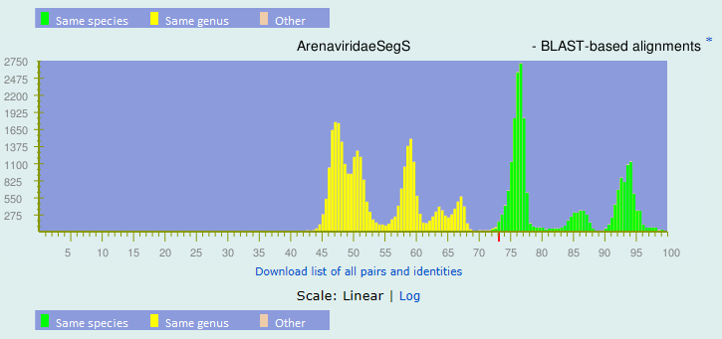
Top matches for gi|1304534347|gb|MF317490.1| Aporé virus strain LBCE 12071 segment S, complete sequence:
BLAST-based alignments
1 |  | 73.37% |  | gi|172088171|ref|NC_010562.1| Mammarenavirus|Chapare mammarenavirus
2 |  | 72.39% |  | gi|52627079|ref|NC_006317.1| Mammarenavirus|Brazilian mammarenavirus
3 |  | 62.35% |  | gi|164607214|ref|NC_010254.1| Mammarenavirus|Cupixi mammarenavirus
4 |  | 61.84% |  | gi|105969671|gb|DQ531488.1| Mammarenavirus|Argentinian mammarenavirus
5 |  | 61.68% |  | gi|114149968|gb|DQ854735.1| Mammarenavirus|Argentinian mammarenavirus
6 |  | 61.62% |  | gi|23452270|gb|AF512834.1| Mammarenavirus|Serra do Navio mammarenavirus
7 |  | 61.6% |  | gi|34365529|ref|NC_005081.1| Mammarenavirus|Argentinian mammarenavirus
8 |  | 61.58% |  | gi|34365532|ref|NC_005078.1| Mammarenavirus|Machupo mammarenavirus
9 |  | 61.46% |  | gi|22901284|gb|AF485258.1| Mammarenavirus|Guanarito mammarenavirus
10 |  | 61.45% |  | gi|45220432|dbj|D10072.2| Mammarenavirus|Argentinian mammarenavirus
11 |  | 61.41% |  | gi|365976992|gb|JN794586.1| Mammarenavirus|Machupo mammarenavirus
12 |  | 61.33% |  | gi|114149961|gb|DQ854733.1| Mammarenavirus|Argentinian mammarenavirus
13 |  | 61.3% |  | gi|114149955|gb|DQ854731.1| Mammarenavirus|Argentinian mammarenavirus
14 |  | 61.29% |  | gi|239736037|gb|GQ121040.1| Mammarenavirus|Argentinian mammarenavirus
15 |  | 61.28% |  | gi|45239320|gb|AY497548.1| Mammarenavirus|Guanarito mammarenavirus

The closest PASC hit for the APOV L segment is Sabiá virus (Brazilian mammarenavirus) with 67.4% pairwise identity (i.e., less than 76%), thereby justifying the creation of a novel species. These interpretations are also supported by phylogenetic studies (Figure 1).

L segment: MF317491

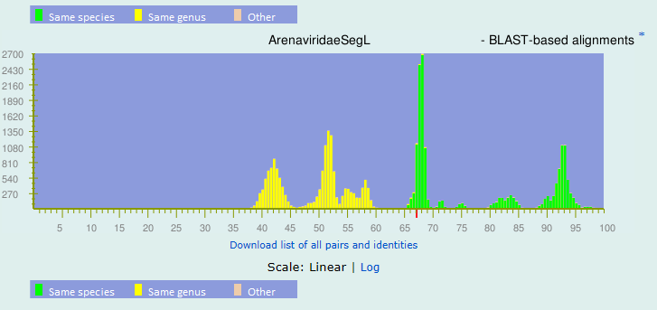
Top matches for gi|1304534350|gb|MF317491.1| Aporé virus strain LBCE 12071 segment L, complete sequence:
BLAST-based alignments
1 |  | 67.4% |  | gi|52627076|ref|NC_006313.1| Mammarenavirus|Brazilian mammarenavirus
2 |  | 67.36% |  | gi|172088174|ref|NC_010563.1| Mammarenavirus|Chapare mammarenavirus
3 |  | 59.93% |  | gi|365976983|gb|JN794583.1| Mammarenavirus|Machupo mammarenavirus
4 |  | 59.78% |  | gi|365976989|gb|JN794585.1| Mammarenavirus|Machupo mammarenavirus
5 |  | 59.65% |  | gi|23334591|ref|NC_004292.1| Mammarenavirus|Tacaribe mammarenavirus
6 |  | 59.36% |  | gi|34365535|ref|NC_005079.1| Mammarenavirus|Machupo mammarenavirus
7 |  | 58.97% |  | gi|375270195|gb|JN714130.1| Mammarenavirus|Argentinian mammarenavirus
8 |  | 58.95% |  | gi|48095756|gb|AY619640.1| Mammarenavirus|Argentinian mammarenavirus
9 |  | 58.81% |  | gi|34365541|ref|NC_005082.1| Mammarenavirus|Guanarito mammarenavirus
10 |  | 58.79% |  | gi|62766429|gb|AY924389.1| Mammarenavirus|Serra do Navio mammarenavirus
11 |  | 58.53% |  | gi|34365526|ref|NC_005080.1| Mammarenavirus|Argentinian mammarenavirus
12 |  | 58.52% |  | gi|164607211|ref|NC_010252.1| Mammarenavirus|Cupixi mammarenavirus
13 |  | 54.17% |  | gi|189026277|ref|NC_010760.1| Mammarenavirus|Latino mammarenavirus
14 |  | 53.48% |  | gi|164607196|ref|NC_010250.1| Mammarenavirus|Oliveros mammarenavirus
15 |  | 50.2% |  | gi|188531120|ref|NC_010703.1| Mammarenavirus|Whitewater Arroyo mammarenavirus
Figure 1. Phylogenetic tree based on mammarenaviruses complete L (A) and S (B) Segments, Bayesian method, using the evolutionary model GTR+G+I. Numbers (≥ 0.7) above branches indicate posterior node probabilities.

Etymology:
- Aporé virus: named after Aporé, a river in Cassilândia, Mato Grosso do Sul State, Brazil.
- Planalto mammarenavirus: named after the nearest locality in Cassilândia municipality, where APOV was discovered, and the genus Mammarenavirus.

References:
GenBank entries, followed by information provided by the virus discoverers.

Radoshitzky SR, et al. Past, present, and future of arenavirus taxonomy. Arch. Virol. 2015;160:1851–1874. doi: 10.1007/s00705-015-2418-y.

