This Word module should be used for all taxonomic proposals.
Please complete Part 1 and:
either Part 3 for proposals to create new taxa or change existing taxa
or Part 2 for proposals of a general nature.
Submit the completed Word module, together with the accompanying Excel module named in Part 3, to the appropriate ICTV Subcommittee Chair.
For guidance, see the notes written in blue, below, and the help notes in file Taxonomic_Proposals_Help_2018.
Part 1: TITLE, AUTHORS, etc

 | Code assigned: | 2019.009M |  | (to be completed by ICTV officers)
 | Short title: Create one new species in the genus Mammarenavirus (Bunyavirales: Arenaviridae)
 | Author(s):
Zhāng, Yǒngzhèn (张永振), zhangyongzhen@icdc.cn
Sironi, Manuela, manuela.sironi@BP.LNF.it
Kuhn, Jens H.; kuhnjens@mail.nih.gov
Corresponding author with e-mail address:
Kuhn, Jens H.; kuhnjens@mail.nih.gov
 | List the ICTV study group(s) that have seen this proposal:
 | A list of study groups and contacts is provided at http://www.ictvonline.org/subcommittees.asp . If in doubt, contact the appropriate subcommittee chair (there are six virus subcommittees: animal DNA and retroviruses, animal ssRNA-, animal ssRNA+, fungal and protist, plant, bacterial and archaeal) |  | ICTV Arenaviridae Study Group
 | ICTV Study Group comments (if any) and response of the proposer:
 | No concerns were voiced by any Study Group member.
 | Date first submitted to ICTV: |  |  | 21/12/2018
 | Date of this revision (if different to above):

ICTV-EC comments and response of the proposer:

Part 3: PROPOSED TAXONOMY

Name of accompanying Excel module: 2019.009M.A.v1.Mammarenavirus_sp_LIJV.xlsx

Supporting material:

Lìjiāng virus (LIJV) was discovered by next-generation sequencing in Chevrier’s field mice (Apodemus chevrieri) sampled around Lìjiāng, Yúnnán Province, China, in July of 2015. A coding-complete genomic sequence (both S and L segments) of LIJV isolate SK is available from GenBank. LIJV has not yet been isolated in culture.

The ICTV Arenaviridae Study Group has recommended the use of the PAirwise Sequence Comparison (PASC) tool (https://www.ncbi.nlm.nih.gov/sutils/pasc/viridty.cgi?textpage=overview) for the assessment of novel arenaviruses (Radoshitzky et al.). Cut-off values chosen for classifying arenaviruses belonging to the same species using this tool are >80% and >76% nucleotide sequence identity in the S and L segments, respectively. We therefore performed PASC on LIJV.

The closest PASC hit for the LIJV-SK S segment is Wēnzhōu virus (Wenzhou mammarenavirus) with 70.63% pairwise identity (i.e., less than 80%), confirming the need for a new mammarenavirus species for which we propose the name Chevrier mammarenavirus.

S segment: MF414202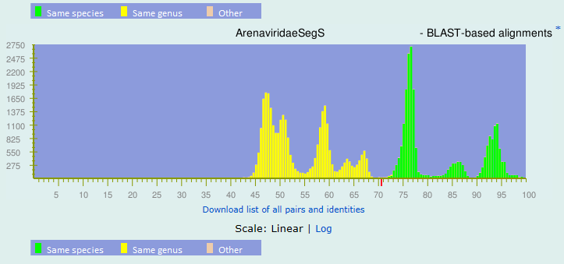
Top matches for gi|1390708426|gb|MF414202.1| Lijiang virus isolate KS4 nonfunctional glycoprotein gene, complete sequence; and nucleoprotein gene, complete cds:
BLAST-based alignments
1 |  | 70.63% |  | gi|734704224|gb|KM051422.1| Mammarenavirus|Wenzhou mammarenavirus|Wenzhou virus 3
2 |  | 70.03% |  | gi|744692901|ref|NC_026018.1| Mammarenavirus|Wenzhou mammarenavirus
3 |  | 69.68% |  | gi|741984931|gb|KM386660.1| Mammarenavirus|Wenzhou mammarenavirus
4 |  | 69.28% |  | gi|570339349|gb|KC669697.1| Mammarenavirus|Loei River mammarenavirus
5 |  | 68.5% |  | gi|570339355|gb|KC669699.1| Mammarenavirus|Loei River mammarenavirus
6 |  | 68.41% |  | gi|570339352|gb|KC669698.1| Mammarenavirus|Loei River mammarenavirus
7 |  | 68.32% |  | gi|734704227|gb|KM051423.1| Mammarenavirus|Wenzhou mammarenavirus|Wenzhou virus 2
8 |  | 65.02% |  | gi|356491217|ref|NC_016152.1| Mammarenavirus|Luna mammarenavirus
9 |  | 64.9% |  | gi|695315210|gb|KM822004.1| Mammarenavirus|Lassa mammarenavirus
10 |  | 64.86% |  | gi|404312010|dbj|AB702940.1| Mammarenavirus|Luna mammarenavirus
11 |  | 64.82% |  | gi|695314701|gb|KM821945.1| Mammarenavirus|Lassa mammarenavirus
12 |  | 64.82% |  | gi|297381012|gb|GU830839.1| Mammarenavirus|Lassa mammarenavirus
13 |  | 64.82% |  | gi|695314018|gb|KM821872.1| Mammarenavirus|Lassa mammarenavirus
14 |  | 64.81% |  | gi|1032562896|gb|KT992425.1| Mammarenavirus|Lassa mammarenavirus
15 |  | 64.79% |  | gi|695315235|gb|KM822010.1| Mammarenavirus|Lassa mammarenavirus

The closest PASC hit for the LIJV-SK L segment is Loei River virus (Loei River mammarenavirus) with 62.11% pairwise identity (i.e., less than 76%), thereby justifying the creation of a novel species.

L segment: MF414201

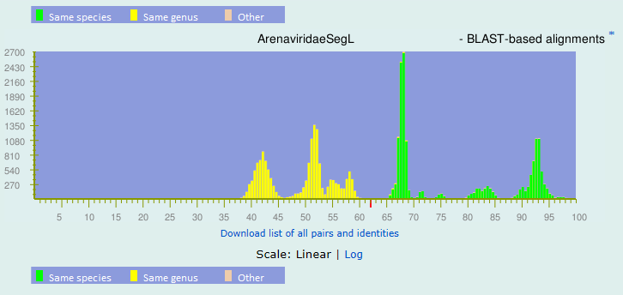
Top matches for gi|1390708422|gb|MF414201.1| Lijiang virus isolate KS4 RNA-dependent RNA polymerase and Z protein genes, complete cds:
BLAST-based alignments
1 |  | 62.11% |  | gi|570339334|gb|KC669692.1| Mammarenavirus|Loei River mammarenavirus
2 |  | 61.88% |  | gi|570339337|gb|KC669693.1| Mammarenavirus|Loei River mammarenavirus
3 |  | 61.38% |  | gi|741984934|gb|KM386661.1| Mammarenavirus|Wenzhou mammarenavirus
4 |  | 60.82% |  | gi|744692911|ref|NC_026019.1| Mammarenavirus|Wenzhou mammarenavirus
5 |  | 60.72% |  | gi|734704221|gb|KM051421.1| Mammarenavirus|Wenzhou mammarenavirus|Wenzhou virus 2
6 |  | 60.36% |  | gi|734704218|gb|KM051420.1| Mammarenavirus|Wenzhou mammarenavirus|Wenzhou virus 3
7 |  | 56.38% |  | gi|56699504|ref|NC_006574.1| Mammarenavirus|Mopeia mammarenavirus|Mopeia virus AN20410
8 |  | 56% |  | gi|356491220|ref|NC_016153.1| Mammarenavirus|Luna mammarenavirus
9 |  | 55.98% |  | gi|695314667|gb|KM821940.1| Mammarenavirus|Lassa mammarenavirus
10 |  | 55.86% |  | gi|399769796|dbj|AB697692.1| Mammarenavirus|Luna mammarenavirus
11 |  | 55.78% |  | gi|695313371|gb|KM821797.1| Mammarenavirus|Lassa mammarenavirus
12 |  | 55.77% |  | gi|349731811|dbj|AB586647.1| Mammarenavirus|Luna mammarenavirus
13 |  | 55.73% |  | gi|695315890|gb|KM822114.1| Mammarenavirus|Lassa mammarenavirus
14 |  | 55.73% |  | gi|695316022|gb|KM822127.1| Mammarenavirus|Lassa mammarenavirus
15 |  | 55.71% |  | gi|49037389|gb|AY628204.1| Mammarenavirus|Lassa mammarenavirus

In phylogenetic analysis, LIJV clusters as a distinct entity in both genomic S and L segment trees (Figure 1):

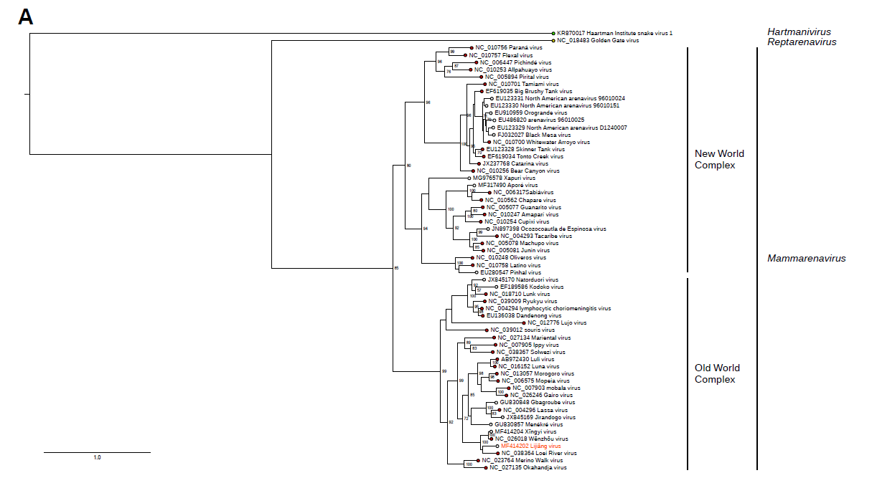

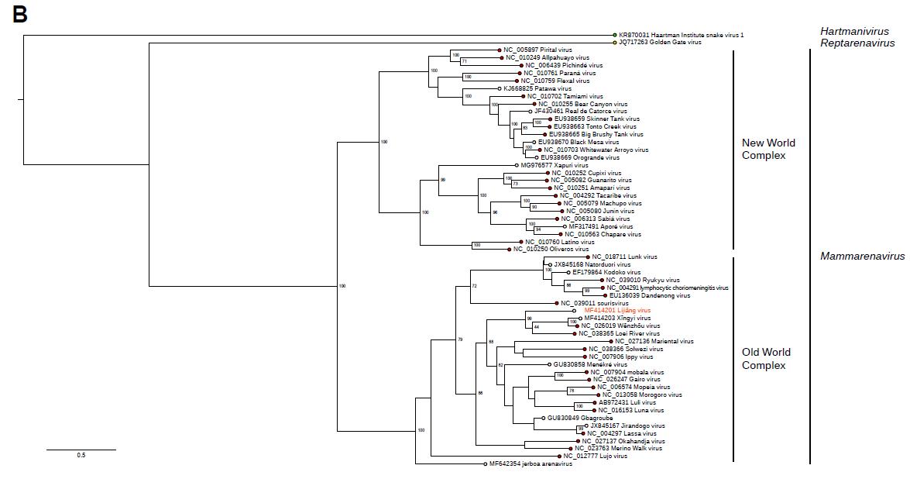

Figure 1. Maximum likelihood phylogenetic trees inferred from PRANK alignments (Löytynoja & Goldman, 2008) of the NP (A) and L (B) amino acid sequences. For both alignments, the best-fit model of protein evolution (LG+G) was selected using ProtTest 3 (v. 3.4.2) (Darriba et al., 2011). Maximum likelihood trees with 1,000 bootstrap replicates were produced using RAxML (v. 8) (Stamatakis, 2014). The percentage of replicate trees in which the associated taxa clustered together in the bootstrap is shown next to branch nodes (when ≥ 70%). The mid-point rooted trees were visualized using FigTree (http://tree.bio.ed.ac.uk/). For NP, sequences of 42 mammarenaviruses assigned to 35 species (red) and 17 unclassified mammarenaviruses (white) were included. For L, the phylogeny includes sequences of 41 mammarenaviruses assigned to 35 species (red) and 12 unclassified mammarenaviruses (white). In both trees, representative viruses of the genera Hartmanivirus and Reptarenavirus are also included.

Etymology:
- Lìjiāng virus: named after 丽江 (Lìjiāng), a city in Yúnnán Province, China.
- Chevrier mammarenavirus: named after Chevrier’s field mouse, the presumed host of LIJV.

References:
GenBank entries, followed by information provided by the virus discoverers; and

Darriba, D., Taboada, G. L., Doallo, R. & Posada, D. (2011). ProtTest 3: fast selection of best-fit models of protein evolution. Bioinformatics 27, 1164-1165.

Löytynoja, A. & Goldman, N. (2008). A model of evolution and structure for multiple sequence alignment. Philos Trans R Soc Lond B Biol Sci 363, 3913-3919.

Radoshitzky, S. R., Bào, Y., Buchmeier, M. J., Charrel, R. N., Clawson, A. N., Clegg, C. S., DeRisi, J. L., Emonet, S., Gonzalez, J.-P., Kuhn, J. H., Lukashevich, I. S., Peters, C. J., Romanowski, V., Salvato, M. S., Stenglein, M. D. & de la Torre, J. C. (2015). Past, present, and future of arenavirus taxonomy. Arch Virol 160, 1851-1874.

Stamatakis, A. (2014). RAxML version 8: a tool for phylogenetic analysis and post-analysis of large phylogenies. Bioinformatics 30, 1312-1313.

