This Word module should be used for all taxonomic proposals.
Please complete Part 1 and:
either Part 3 for proposals to create new taxa or change existing taxa
or Part 2 for proposals of a general nature.
Submit the completed Word module, together with the accompanying Excel module named in Part 3, to the appropriate ICTV Subcommittee Chair.
The Word module explains and justifies your proposal. The Excel module is a critical document that will be used to implement the proposed taxonomic changes once they are approved and ratified. If proposals presented in the Word module are not presented accurately in the Excel module, the taxonomic changes cannot proceed.
For guidance, see the notes written in blue, below, and the Help Notes in file Taxonomic_Proposals_Help_2019.
Part 1: TITLE, AUTHORS, etc

Code assigned: | 2019.017M
Short title: Create one new species (Brno loanvirus) in the genus Loanvirus, family Hantaviridae (Bunyavirales)
Author(s) and email address(es):
List authors in a single line Archives of Virology citation format (e.g. Smith AB, Huang C-L, Santos, F) |  | Provide email address for each author in a single line separated by semi-colons
Straková P, Dufková L, Širmarová J, Salát J, Bartonička T, Klempa B, Pfaff F, Höper D, Hoffmann B, Ulrich RG, Růžek D |  | strakova.p@centrum.cz;dufkoval@vri.cz;sirmarova@vri.cz; salat@vri.cz;bartonic@sci.muni.cz;boris.klempa@savba.sk;  Florian.Pfaff@fli.de;Dirk.Hoeper@fli.de;Bernd.Hoffmann@fli.de;  Rainer.Ulrich@fli.de;ruzekd@paru.cas.cz
Author(s) institutional address(es) (optional):
Provide institutional addresses, each on a single line followed by author(s) initials (e.g. University of Woolloomooloo [SAB, HCL])
Veterinary Research Institute, Brno, Czech Republic (PS, LD, JŠ, JS, DR)
Masaryk University, Brno, Czech Republic (TB)
Slovak Academy of Sciences, Bratislava, Slovakia (BK)
Friedrich-Loeffler-Institut, Greifswald-Insel Riems, Germany (FP, DH, BH, RGU)

Corresponding author
Straková, Petra; strakova.p@centrum.cz
List the ICTV study group(s) that have seen this proposal:
A list of study groups and contacts is provided at http://www.ictvonline.org/subcommittees.asp . If in doubt, contact the appropriate subcommittee chair (there are six virus subcommittees: animal DNA and retroviruses, animal ssRNA-, animal ssRNA+, fungal and protist, plant, bacterial and archaeal) |  | ICTV Hantaviridae Study Group
ICTV Study Group comments (if any) and response of the proposer:
Date first submitted to ICTV: |  |  | 05/19/2019
Date of this revision (if different to above):

ICTV-EC comments and response of the proposer:

Part 3: PROPOSED TAXONOMY

Name of accompanying Excel module: 2019.017N.A.v1_Brno.xlsx

Supporting material:
In 2016/2017, we identified a novel hantavirus in European noctules (Nyctalus noctula) (Strakova et al., 2017). Initial screening with nested PCR targeting a short conserved fragment of the L segment of hantaviruses (Klempa et al., 2006), rendered 2 short sequences (GenBank Accession numbers: KR920359 and KR920360). Next-generation sequencing (IonTorrent, ThermoFisher Scientific) was applied to the positive samples to determine the complete coding sequence of the 3 segments (GenBank Accession numbers: KX845678, KX845679, and KX845680, for the S, M, and L segment, respectively). We named this new bat-borne hantavirus Brno virus (BRNV) after the city it was first discovered, Brno in the Czech Republic. The complete coding sequences are 1269, 3408 and 6432 nt in length for the S, M, and L segment, respectively. Sequence comparison revealed that the three genome segments and the encoded proteins of BRNV showed 54.7–78.3% nucleotide and 44.5–81.7% amino acid sequence identity with other bat-borne hantaviruses, whereas sequence identity with hantaviruses from rodents, shrews, and moles ranged from 50.1 and 64.8% at the nucleotide and from 38.9 and 64.1% at amino acid level.

The most recent species demarcation criteria (proposal 2017.012M), suggested by the ICTV Bunyaviridae Study Group (now ICTV Bunyavirales Study Group), allow the classification solely based on genetic data. It is based on a concatenated multiple sequence alignment of complete amino acid sequences of the N and GPC proteins, which is used to calculate PED (pairwise evolutionary distances) values using WAG amino acid substitution matrix. A virus of the family Hantaviridae is assigned to a distinct species if its PED value greater than 0.1. According to this criterion, BRNV clearly represents a new hantavirus species because the lowest PED value, observed for the most closely related virus, Lóngquán virus (LQUV; species Longquan loanvirus, subfamily Mammantavirinae, family Hantaviridae) is 0.5. Therefore, we propose a creation of a new species named Brno loanvirus in the genus Loanvirus to formally classify BRNV.

To support our data, we performed phylogenetic analyses (for S, M, and L segments) based on the most recent taxonomy of hantaviruses (proposals 2018.010M and 2017.012M). The results are shown in Figures 1–3. Briefly, phylogenetic analyses were done with available sequences of complete coding regions of all three segments and with all genera (Loanvirus, Mobatvirus, Orthohantavirus, Thottimvirus) in the family Hantaviridae. The phylogenetic trees were calculated using BioEdit and MEGA6 (Maximum-Likelihood method, Jukes-Cantor model, Gamma 5 distribution and 1000 bootstrap). BRNV groups with the other bat-borne hantaviruses of the genus Loanvirus, together with LQUV, based on the position of this virus in phylogenetic trees for S and M segment, coding nucleocapsid protein and glycoproteins, respectively. Unfortunately, for LQUV, the complete coding sequence of L segment is not available.

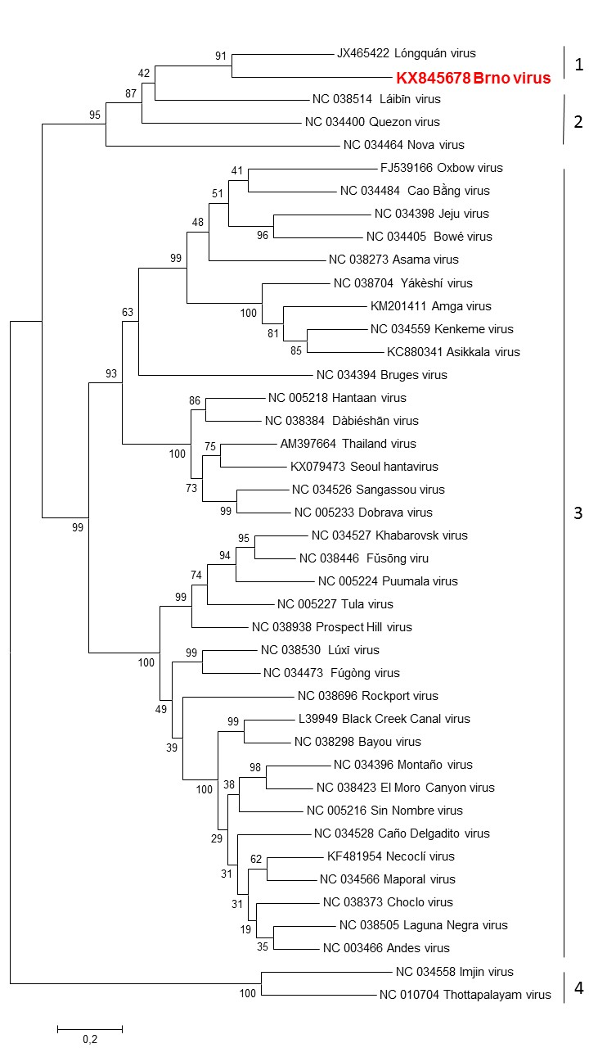
Figure 1: Phylogenetic tree based on coding-complete sequences of S segment of all genera in family Hantaviridae. The novel virus, Brno virus, is highlighted in red and clusters together with other bat-borne and mole-borne hantaviruses. Legend: 1 – Genus Loanvirus, 2 – Genus Mobatvirus, 3 – Genus Orthohantavirus, 4 – Genus Thottimvirus.

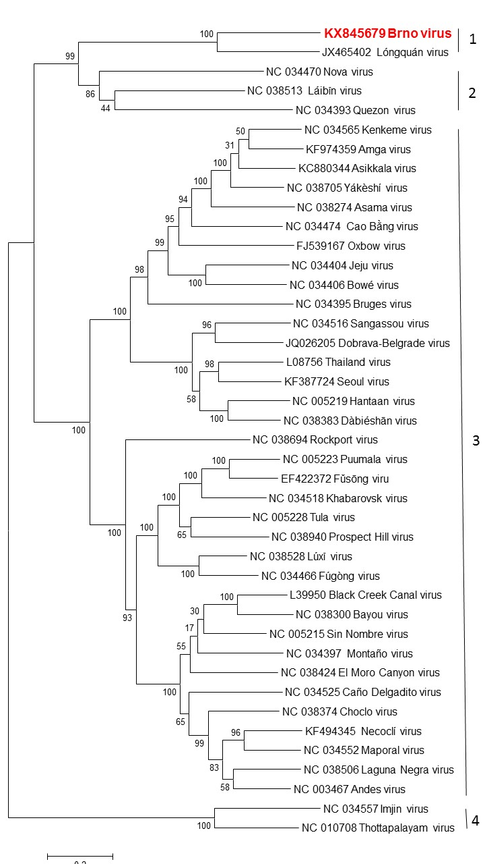

Figure 2: Phylogenetic tree based on coding-complete sequences of M segment of all genera in family Hantaviridae. The novel virus, Brno virus, is highlighted in red and clusters together with other bat-borne and mole-borne hantaviruses. Legend: 1 – Genus Loanvirus, 2 – Genus Mobatvirus, 3 – Genus Orthohantavirus, 4 – Genus Thottimvirus.
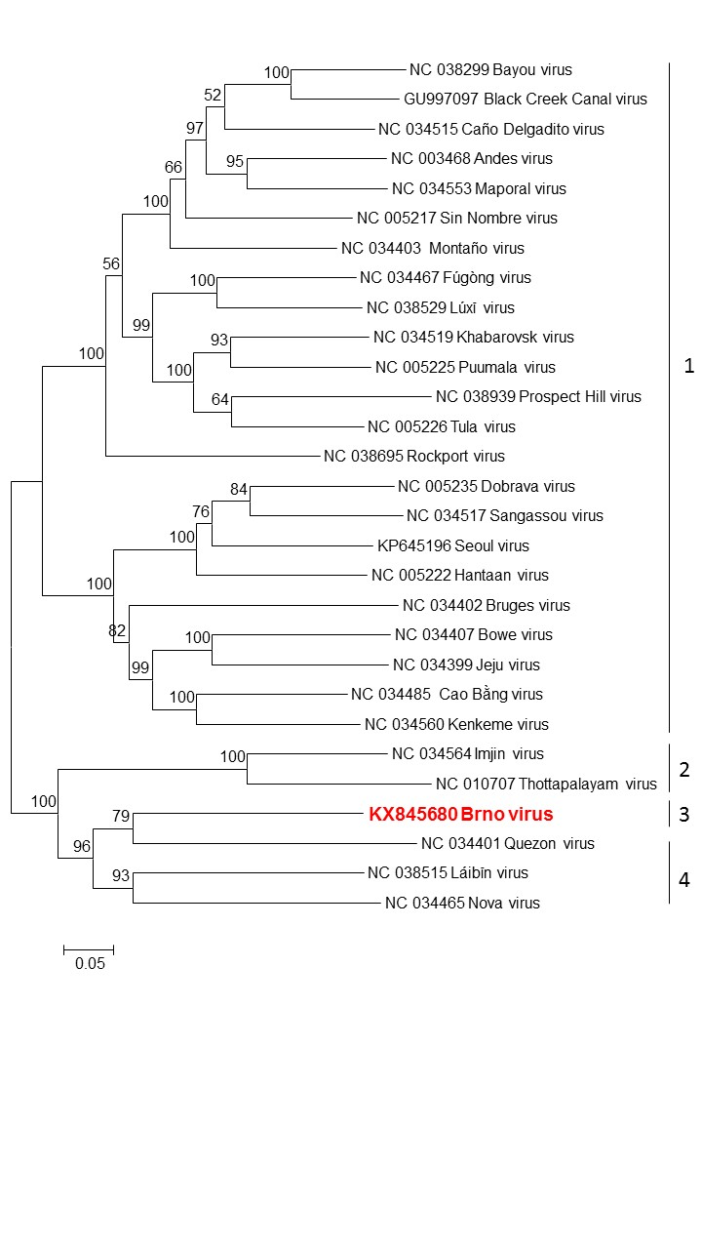

Figure 3: Phylogenetic tree based on available coding-complete sequences of L segment of all genera in family Hantaviridae. The novel virus, Brno virus, is highlighted in red and clusters together with other bat-borne and mole-borne hantaviruses. Legend: 1 – Genus Loanvirus, 2 – Genus Mobatvirus, 3 – Genus Orthohantavirus, 4 – Genus Thottimvirus.

References:
Klempa B., Fichet-Calvet E., Lecompte E., Auste B., Aniskin V., Meisel H., Denys C, Koivogui L, ter Meulen J, Krüger DH. (2006): Hantavirus in African wood mouse, Guinea. Emerg. Infect. Dis. 12: 838-840.
Strakova P., Dufkova L., Sirmarova J., Salat J., Bartonicka T., Klempa B., Pfaff F., Hoper D., Hoffmann B., Ulrich R.G., Ruzek D. (2017): Novel hantavirus identified in European bat species Nyctalus noctula. Inf. Gen Evol. 48: 127-130.

