This Word module should be used for all taxonomic proposals.
Please complete Part 1 and:
either Part 3 for proposals to create new taxa or change existing taxa
or Part 2 for proposals of a general nature.
Submit the completed Word module, together with the accompanying Excel module named in Part 3, to the appropriate ICTV Subcommittee Chair.
The Word module explains and justifies your proposal. The Excel module is a critical document that will be used to implement the proposed taxonomic changes once they are approved and ratified. If proposals presented in the Word module are not presented accurately in the Excel module, the taxonomic changes cannot proceed.
For guidance, see the notes written in blue, below, and the Help Notes in file Taxonomic_Proposals_Help_2019.
Part 1: TITLE, AUTHORS, etc

Code assigned: | 2019.022M
Short title: Move one species from the phenuivirid genus Phlebovirus to the peribunyavirid genus Pacuvirus, and create one novel pacuvirus species
Author(s) and email address(es):
List authors in a single line Archives of Virology citation format (e.g. Smith AB, Huang C-L, Santos, F) |  | Provide email address for each author in a single line separated by semi-colons
Hughes HR, Lambert AJ |  | Ltr8@cdc.gov; ahk7@cdc.gov
Author(s) institutional address(es) (optional):
Provide institutional addresses, each on a single line followed by author(s) initials (e.g. University of Woolloomooloo [SAB, HCL])
Centers for Disease Control and Prevention, Arboviral Disease Branch, Ft. Collins, CO USA (HRH)
Centers for Disease Control and Prevention, Arboviral Disease Branch, Ft. Collins, CO USA (AJL)

Corresponding author
Huges HR; Ltr8@cdc.gov
List the ICTV study group(s) that have seen this proposal:
A list of study groups and contacts is provided at http://www.ictvonline.org/subcommittees.asp . If in doubt, contact the appropriate subcommittee chair (there are six virus subcommittees: animal DNA and retroviruses, animal ssRNA-, animal ssRNA+, fungal and protist, plant, bacterial and archaeal) |  | ICTV Phenuiviridae Study Group, ICTV Peribunyaviridae Study Group
ICTV Study Group comments (if any) and response of the proposer:
Date first submitted to ICTV: |  |  | June 19, 2019
Date of this revision (if different to above):

ICTV-EC comments and response of the proposer:

Part 3: PROPOSED TAXONOMY

Name of accompanying Excel module: 2019.022M.A.v1.2sp_Pacuvirus

Supporting material:
Chilibre and Caimito viruses were isolated in 1969 and 1971, respectively, from sandflies in Panama (Tesh, Chaniotis et al. 1974). Based on serological characterization, these viruses were originally considered members of the genus Phlebovirus (today included in family Phenuiviridae) (Tesh, Peralta et al. 1975, Tesh, Peters et al. 1982). However, recent whole genome sequencing of Chilibre and Caimito viruses (unpublished, GenBank #MK330762, MK330763, and MK330764 [Chilibre virus] and MK330759, MK330760, and MK330761 [Caimito virus]) indicates that these viruses are most closely related to viruses in the genus Pacuvirus, family Peribunyaviridae. Caimito and Chilibre virus genomic segments possess the common pacuvirus organization (S, N ORF; M, Gn-NSm-Gc ORF; L; L ORF). In addition, phylogenetic analyses place Chilibre and Caimito viruses with pacuviruses among other peribunyavirids (Figure 1, Hughes et al. unpublished). Also, BLAST analyses of all nucleotide sequences in GenBank reveal that the proteins encoded by Caimito and Chilibre viruses possess closest identity to those encoded by other pacuviruses: Tapirapé, Pacui, and Rio Preto da Eva viruses (H. Hughes, personal communication).
Pairwise evolutionary distances of the amino acid sequences encoded by concatenated genomes of Chilibre and Caimito viruses compared to the viruses in the genus Pacuvirus suggest Chilibre and Caimito viruses represent distinct species with PED values of greater than 0.1 (Table 1). We propose names Chilibre pacuvirus and Caimito pacuvirus for new species to classify Chilibre virus and Caimito virus respectively.
Figure 1. Bayesian Maximum Clade Credibility trees of Chilibre and Caimito viruses. Nucleotide coding sequences of viruses in the family Peribunyaviridae, Phenuiviridae, and Nairoviridae depicting phylogenies of the (a) S, (b) M, and (c) L segment open reading frames. Chilibre and Caimito viruses are labeled blue. Nucleotide substitution model GTR+G was utilized. Branches are labeled with the posterior probabilities, and scale bar depicts nucleotide substitutions per site. Note the nucleoprotein open reading frame was utilized in the S segment analysis since Chilibre and Caimito viruses do not possess a NSs.

Finally, Cacao virus is currently listed as a second member of Chilibre phlebovirus, together with Chilibre virus. Cacao virus is a bona fide phlebovirus is proposed to be assigned to a novel phlebovirus species in a co-submitted proposal by Marklewitz et al.

a. Small segment
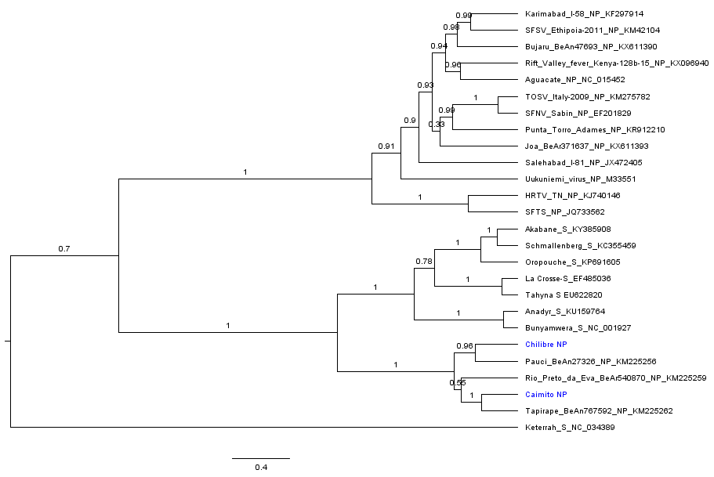

b. Medium segment
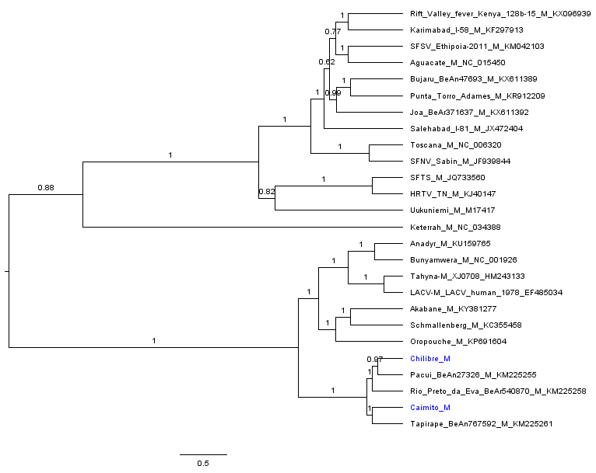
c. Large segment
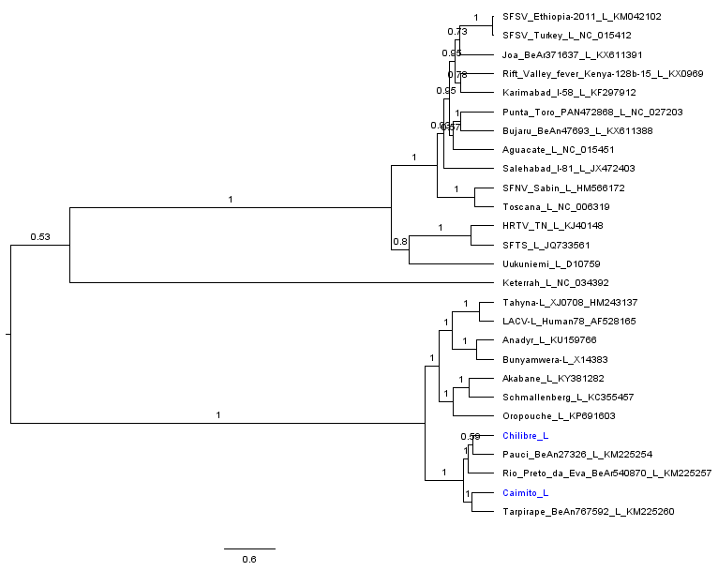
Table 1. Pairwise evolutionary distances of Chilibre and Caimito virus genome nucleotide and protein amino acid sequences compared to those of pacuviruses. Nucleotide comparisons are above the grey line and amino acid comparisons are below the grey line. Each segment (small, medium, or large) as well as concatenated genomes were compared.
 | Segment | Tapirapé | Pacui | Rio Preto da Eva | Chilibre | Caimito
Tapirapé | S |  | 0.397 | 0.388 | 0.396 | 0.333
 | M |  | 0.375 | 0.394 | 0.373 | 0.362
 | L |  | 0.342 | 0.337 | 0.324 | 0.288
 | genome |  | 0.358 | 0.362 | 0.347 | 0.318
Pacui | S | 0.443 |  | 0.356 | 0.325 | 0.374
 | M | 0.393 |  | 0.351 | 0.327 | 0.362
 | L | 0.304 |  | 0.321 | 0.307 | 0.328
 | genome | 0.346 |  | 0.334 | 0.316 | 0.344
Rio Preto da Eva | S | 0.439 | 0.348 |  | 0.358 | 0.373
 | M | 0.439 | 0.369 |  | 0.350 | 0.378
 | L | 0.312 | 0.294 |  | 0.304 | 0.323
 | genome | 0.367 | 0.325 |  | 0.324 | 0.347
Chilibre | S | 0.422 | 0.316 | 0.336 |  | 0.386
 | M | 0.413 | 0.324 | 0.373 |  | 0.373
 | L | 0.293 | 0.278 | 0.280 |  | 0.318
 | genome | 0.346 | 0.297 | 0.317 |  | 0.344
Caimito | S | 0.324 | 0.430 | 0.406 | 0.414
 | M | 0.389 | 0.374 | 0.428 | 0.411
 | L | 0.229 | 0.296 | 0.309 | 0.288
 | genome | 0.294 | 0.334 | 0.360 | 0.342

References:
Tesh, R. B., B. N. Chaniotis, P. H. Peralta and K. M. Johnson (1974). "Ecology of viruses isolated from Panamanian phlebotomine sandflies." Am J Trop Med Hyg 23(2): 258-269.
Tesh, R. B., P. H. Peralta, R. E. Shope, B. N. Chaniotis and K. M. Johnson (1975). "Antigenic relationships among phlebotomus fever group arboviruses and their implication for the epidemiology of sandfly fever." Am J Trop Med Hyg 24(1): 135-144.
Tesh, R. B., C. J. Peters and J. M. Meegan (1982). "Studies on the antigenic relationship among phleboviruses." Am J Trop Med Hyg 31(1): 149-155.

