This Word module should be used for all taxonomic proposals.
Please complete Part 1 and:
either Part 3 for proposals to create new taxa or change existing taxa
or Part 2 for proposals of a general nature.
Submit the completed Word module, together with the accompanying Excel module named in Part 3, to the appropriate ICTV Subcommittee Chair.
The Word module explains and justifies your proposal. The Excel module is a critical document that will be used to implement the proposed taxonomic changes once they are approved and ratified. If proposals presented in the Word module are not presented accurately in the Excel module, the taxonomic changes cannot proceed.
For guidance, see the notes written in blue, below, and the Help Notes in file Taxonomic_Proposals_Help_2019.
Part 1: TITLE, AUTHORS, etc

Code assigned: | 2019.026M
Short title: Create four new genera, create seventy nine new species, rename/move seven species, rename/move three genera and abolish one genus in the family Phenuiviridae, order Bunyavirales
Author(s) and email address(es):
List authors in a single line Archives of Virology citation format (e.g. Smith AB, Huang C-L, Santos, F) |  | Provide email address for each author in a single line separated by semi-colons
Marklewitz M, Palacios G, Ebihara H, Kuhn J, Junglen S |  | marco.marklewitz@charite.de; gustavo.f.palacios.civ@mail.mil; ebihara.hideki@mayo.edu; kuhnjens@mail.nih.gov; sandra.junglen@charite.de
Corresponding author
Marklewitz, Marco; marco.marklewitz@charite.de
List the ICTV study group(s) that have seen this proposal:
A list of study groups and contacts is provided at http://www.ictvonline.org/subcommittees.asp . If in doubt, contact the appropriate subcommittee chair (there are six virus subcommittees: animal DNA and retroviruses, animal ssRNA-, animal ssRNA+, fungal and protist, plant, bacterial and archaeal) |  | ICTV Phenuiviridae Study Group;  ICTV Tenuivirus Study Group; ICTV Plant and Fungal & Protist Virus Subcommittee Chairs
ICTV Study Group comments (if any) and response of the proposer:
Date first submitted to ICTV: |  |  | June 19, 2019
Date of this revision (if different to above): |  |  | October 14, 2019

ICTV-EC comments and response of the proposer:

Part 3: PROPOSED TAXONOMY

Name of accompanying Excel module: 2019.026M.A.v1.Phenuiviridae_4gen79sp.xlsx
This proposal reevaluates the taxonomy of the family Phenuiviridae (Negarnaviricota: Polyploviricotina: Bunyavirales) with particular emphasis on the phenuivirid genus Phlebovirus and unclassified presumed phleboviruses and/or phenuiviruses.

Genus Phlebovirus
Historically, phleboviruses have been classified based on serological cross-reactivity and only those viruses for which serological cross-reactivity results were considered classifiable. Due to rapid increase of viruses that are being discovered using next-generation sequencing and that have not been isolated in culture, and due to increased genomic sequence information on isolated viruses that have not been or cannot be evaluated in serological cross-reactivity tests, there is an urgent need to establish genetic criteria for species demarcation [1]. Currently, the genus Phlebovirus comprises 10 “species complexes” [2]. Investigating the genetic diversity of the viruses belonging to these complexes revealed that viruses with >67% amino acid sequence identity in the genomic RNA-directed RNA polymerase (RdRp)-encoding segment (L segment) are currently considered members of the same species (Supplementary Table 1).

Species demarcation criteria:
Within the order Bunyavirales, sequence-based species demarcation criteria have already been established for the genus Orthobunyavirus (<96% identity in the amino acid sequence of the RdRp) by the ICTV Peribunyaviridae Study Group. To establish similar criteria for the classification of phleboviruses, we analyzed the pairwise amino acid sequence identities of the RdRp (Supplementary Figure 1) among the classified phleboviruses, and unclassified, tentative phleboviruses. To get insight into the naturally occurring diversity of phenuiviruses, we analyzed the intraspecies genetic diversity of Rift valley fever virus (RVFV), as it represents a well-investigated phlebovirus in a phylogenetic solitary position, from which the genomes of numerous strains have been sequenced (n=154) [1]. The analysis of pairwise distances among all available RVFV strains in their RdRp genes revealed maximum pairwise nucleotide and amino acid genetic distances of 5% and 2%, respectively. Further, we compared ecological data (e.g., vector- and host association, geographic distribution) and the phylogenetic relationships among members of all examined taxa to select “sensical” genetic species demarcation criteria. Based on our analyses, we propose to define phlebovirus species demarcation as <95% identity in the amino acid sequence of the RdRp: viruses with <95% sequence identity represent unique species.

Proposed modifications within the genus Phlebovirus:
Our analyses indicate that, by applying the newly proposed demarcation criterion of <95% aa identity among RdRP domains, 53 new phlebovirus species need to be created.

In addition, we propose to abolish the species Frijoles phlebovirus due to the absence of a coding-complete genome sequence for Frijoles virus. Incorporating a co-submitted proposal by Hughes et al., we propose to rename Chilibre phlebovirus as Chilibre pacuvirus and move the species with member Chilibre virus into the peribunyavirid genus Pacuvirus (whereas member Cacao virus is reclassified into a new phlebovirus species). Moreover, since our phylogenetic analyses show that Uukuniemi virus is clustering with other tick-borne viruses in a separate monophyletic clade as a sister clade to the established genus Banyangvirus (proposed to be renamed Bandavirus in a co-submitted proposal by Liang et al.) (Figure 1), we propose to establish a new genus Uukuvirus and to rename phlebovirus species that belong to this new genus accordingly (see below). In addition, we propose several minor taxon name changes to achieve more consistency among phlebovirus species names.

Etymology of newly proposed taxa:
All phlebovirus species names are derived from the respective member virus names.

Proposed genus Uukuvirus
Our comprehensive analysis of all available phenuivirus and phenuivirus-like sequences published in GenBank (full genome or complete CDS) revealed a monophyletic clade of tick-borne phenuiviruses separate from the Phlebovirus and Banyangvirus (Bandavirus) clades that we propose to be called Uukuvirus (revived genus name used previously until the mid-1980s)

Species demarcation criteria:
We propose to define uukuvirus species demarcation as <95% identity in the amino acid sequence of the RdRp: viruses with <95% sequence identity represent unique species.

Proposed species within the genus Uukuvirus:
Our analyses indicate that next to moving and renaming the existing species Uukuniemi phlebovirus into the genus Uukuvirus, 14 novel uukuvirus species need to be established.

Etymology of newly proposed taxa:
All uukuvirus species names are derived from the respective member virus names. The genus name is derived from Uukuniemi virus.

Abolish genus Kabutovirus
We propose to abolish the phenuivirid genus Kabutovirus, and to move and rename the species Kabuto mountain kabutovirus and Huangpi kabutovirus into the genus Uukuvirus.

Abolish genus Wubeivirus
We propose to abolish the phenuivirid genus Wubeivirus and to move and rename the species Dipteran wubeivirus and Dipteran wubeivirus into the genus Phasivirus.

Create species Melon tenuivirus and assign to the genus Tenuivirus
Lecoq et al. have discovered a previously unknown virus in samples from a melon plant showing chlorotic spots and yellowing of the older leaves collected in France in 2011 [3]. The virus has a multipartite genome encompassing eight genome segments. We propose to create the species Melon tenuivirus to accommodate melon chlorotic spot virus.

Etymology of newly proposed tenuivirus species name:
Melon tenuivirus: after melon chlorotic spot virus.

Proposed genus Entovirus
Recently, a phenui-like virus, Entoleuca phenui-like virus 1, has been discovered in the rhizosphere of avocados in Spain using high-throughput sequencing (HTS) [4, 5].
The (-)ssRNA genome is believed to encompass two segments (RNA-1 and RNA-2) and three ORFs have been predicted (one on RNA-1 and two on RNA-2). The deduced gene product encoded by RNA-1 is similar to phenuivirid RdRps. The ORF2b protein encoded by RNA-2 contains a conserved domain typical of phlebovirus and tenuivirus nucleocapsid proteins (N). Analyses of the ORF2a protein of RNA-2 revealed similarities to the putative movement proteins (MPs) of some coguviruses and a hypothetical protein (p2) of Lake Laurel virus. Due to the low similarities to existing phenuivirid taxa, we propose to establish a new genus (Entovirus) to accommodate Entoleuca phenui-like virus 1.

Species demarcation criteria:
We propose to define entovirus species demarcation as <95% identity in the amino acid sequence of the RdRp: viruses with <95% sequence identity represent unique species.

Proposed species within the genus Entovirus:
Creation of the species Entoleuca entovirus.

Etymology of newly proposed taxa:
Entovirus: Derived from the fungi genus Entoleuca where the first entovirus has been discovered.

Entoleuca entovirus: Derived from the member virus Entoleuca phenui-like virus 1 and the fungi genus Entoleuca in which the virus has been detected.

Proposed genus Lentinuvirus
Recently, a phenui-like virus has been discovered infecting shiitake mushrooms (Lentinula edodes) in Japan using HTS [5]. The (-)ssRNA genome is believed to encompass two segments (RNA-1 and RNA-2) and three ORFs have been predicted (one on RNA-1 and two on RNA-2). The deduced gene product encoded by RNA-1 is similar to the phenuivirid RdRps. The ORF2b protein encoded by RNA-2 contains a conserved domain typical of phlebovirus and tenuivirus nucleocapsid proteins (N) Analyses of the ORF2a protein of RNA-2 revealed similarities to the putative movement proteins (MPs) of some coguviruses and a hypothetical protein (p2) of Lake Laurel virus. Due to the low similarities to existing phenuivirid taxa we propose to establish a new genus (Lentinuvirus).

Species demarcation criteria:
We propose to define lentinuvirus species demarcation as <95% identity in the amino acid sequence of the RdRp: viruses with <95% sequence identity represent unique species.

Proposed species within the genus Lentinuvirus:
Creation of the species Lentinula lentinuvirus.

Etymology of newly proposed taxa:
Lentinuvirus: Derived from the fungi genus Lentinula in which the first lentinuvirus has been discovered.

Lentinula entovirus: Obtained from the member virus Lentinula edodes negative-strand RNA virus 2 and the fungus species name Lentinula edodes.

Proposed genus Rubodvirus

Two previously unknow viruses, both having trisegmented genomes, have been discovered using HTS in apple tree samples (Malus sp.) collected in Germany and the United States [6]. The L segment has been predicted to encode the RdRp; the deduced gene product of the ORF on the M segment is similar to movement proteins (MPs), and the S segment may encode the viral nucleocapsid (N). In our analyses, these viruses form a unique clade in the phenuivirid phylogenetic tree, which we propose to be accommodated in a new genus (Rubodvirus, as suggested by the discoverers of the apple viruses).

Species demarcation criteria:
We propose to define rubodvirus species demarcation as <95% identity in the amino acid sequence of the RdRp: viruses with <95% sequence identity represent unique species.

Proposed species within the genus Rubdovirus:
Create species Apple rubodvirus 1 and Apple rubodvirus 2.

Etymology of newly proposed taxa:
Rubodvirus: Acronym derived from the prototype virus Apple rubbery wood virus 1

Apple rubodvirus 1: apple rubbery wood virus 1
Apple rubodvirus 2: apple rubbery wood virus 2

Proposed genus Ixovirus
Several novel viruses have been detected by HTS in ixodid ticks collected in Norway and the United States [7, 8]. The (-)ssRNA genome of the first virus discovered, blacklegged tick phlebovirus 1, is believed to contain two segments (L and S) each predicted to encode one protein. The predicted gene product of the L segment is similar to phenuivirid RdRp and the S segment gene product was predicted to have similarities to the phenuivirid nucleocapsid protein (N). Additional viruses match these characteristics and fall into a single monophyletic clade (Figure 2) that we propose to be accommodated by a new genus (Ixovirus).

Species demarcation criteria:
We propose to define ixovirus species demarcation as <95% identity in the amino acid sequence of the RdRp: viruses with <95% sequence identity represent unique species.

Etymology of newly proposed taxa:
Ixovirus: Stemming from the tick genus Ixodes since member viruses have been discovered in ticks of two species of the genus: Ixodes scapularis and Ixodes ricinus.
Blackleg ixovirus: Derived from the member virus blacklegged tick phlebovirus-1
Norway ixovirus: Stemming from member virus Norway phlebovirus 1
Scapularis ixovirus: Obtained from the tick species name Ixodes scapularis

Genus Coguvirus

The bunyaviral genus Coguvirus has not been assigned to a family within the order Bunyavirales. Our analyses indicate that it should be included into the family Phenuiviridae.

The species Citrus coguvirus is currently the only species of the genus Coguvirus. A second species is being proposed in a separate TP.

Species demarcation criteria:
Currently, the coguvirus species demarcation criterion, selected arbitrarily due to the knowledge of only a single coguvirus, is a threshold of <90% aa identity for the core RdRp. After reviewing the complete CDS of all available phenuivirids and phenui-like viruses and ecological criteria, we propose to define as the species demarcation for the genus Coguvirus as <95% identity in the amino acid sequence of the RdRp: viruses with <95% sequence identity represent unique species.

Proposed modifications within the genus Coguvirus:
Creation of the species Eburi coguvirus (co-submitted proposal by Navarro et al.).

Genus Bandavirus (previously Banyangvirus)
A proposal to change the name of the genus Banyangvirus to Bandavirus has been co-submitted by Liang et al.

Species demarcation criteria:
Species demarcation criteria for bandaviruses have not been proposed. To unify the species demarcation criteria for the entire family Phenuiviridae we propose to apply the same cut-off as proposed here for other genera within the family: <95% identity in the amino acid sequence of the RdRp. Thus, viruses with <95% sequence identity represent unique species within the genus Bandavirus (Supplementary Figure 1).

Proposed modifications within the genus Bandavirus:
Creation of the species Bhanja bandavirus, Hunter Island bandavirus, Kismaayo bandavirus, and Lone Star bandavirus.

Etymology of newly proposed taxa:
Bhanja bandavirus: Stemming from the member virus Bhanja virus
Hunter Island bandavirus: Stemming from the member virus Hunter Island virus
Kismaayo bandavirus: Stemming from the member virus Kismaayo virus [note that the spelling of Kismaayo has been corrected from the previously circulating “Kismayo virus”]
Lone Star bandavirus: Stemming from the member virus Lone Star virus

Final remarks
This proposal is a first, and long overdue step to update the taxonomy of phleboviruses and their immediate relatives in a systematic manner. The authors of this proposal and the members of the ICTV Phenuiviridae and Tenuivirus Study Groups agree that the present and future expansion of the genetic diversity of the family Phenuiviridae will require a constant critical review and likely adjustment of the demarcation criteria proposed here. The Study Groups will also have to decide on how to proceed with species currently represented by incomplete genome sequences, how to eliminate virus name abbreviations that are also in use elsewhere, and whether to consider genome segment reassortants as members of the same or separate species.

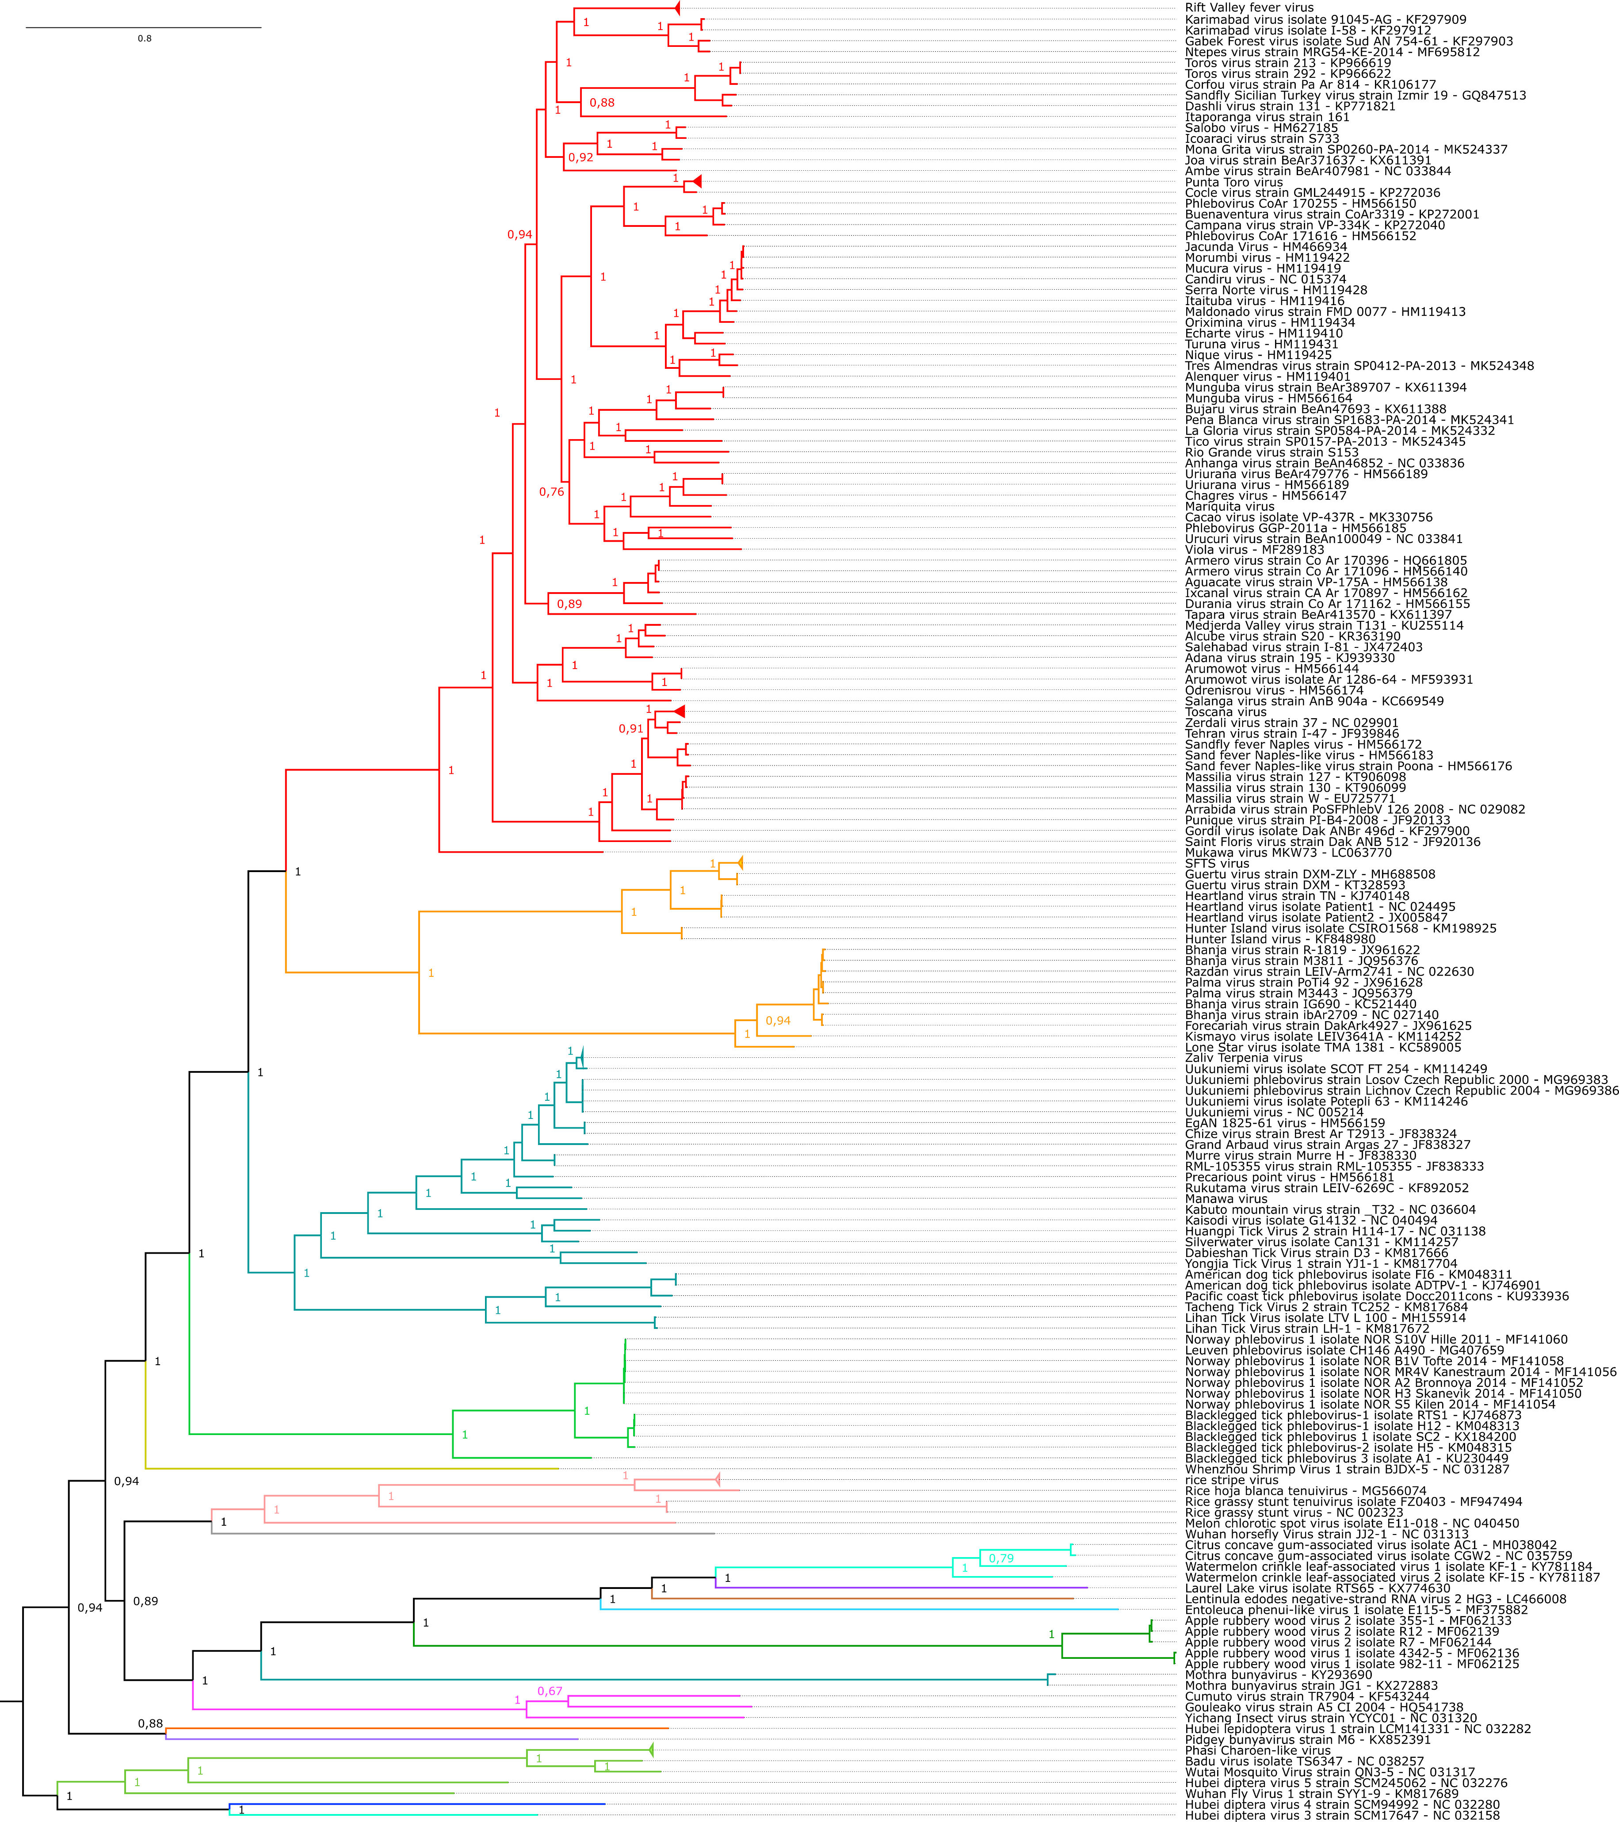

Figure 1: Maximum likelihood (ML) phylogeny of phenuiviruses. Phylogenetic reconstruction is based on a MAFFT-alignment of the RdRp amino acid sequences of phenuiviruses and phenuivirus-like sequences using E-INS algorithm. The ML phylogenetic tree was inferred using RAxML-NG [10]; the numbers on the nodes represent bootstrap values (1,000 replicates). Trees were inferred under the WAG substitution model. Tree branches are proportional to genetic distances between sequences and the scale bars at the top indicate substitutions per amino acid. For all taxa shown here, the complete genome or complete CDS is available at GenBank. Accession numbers are shown next to the respective virus taxon.
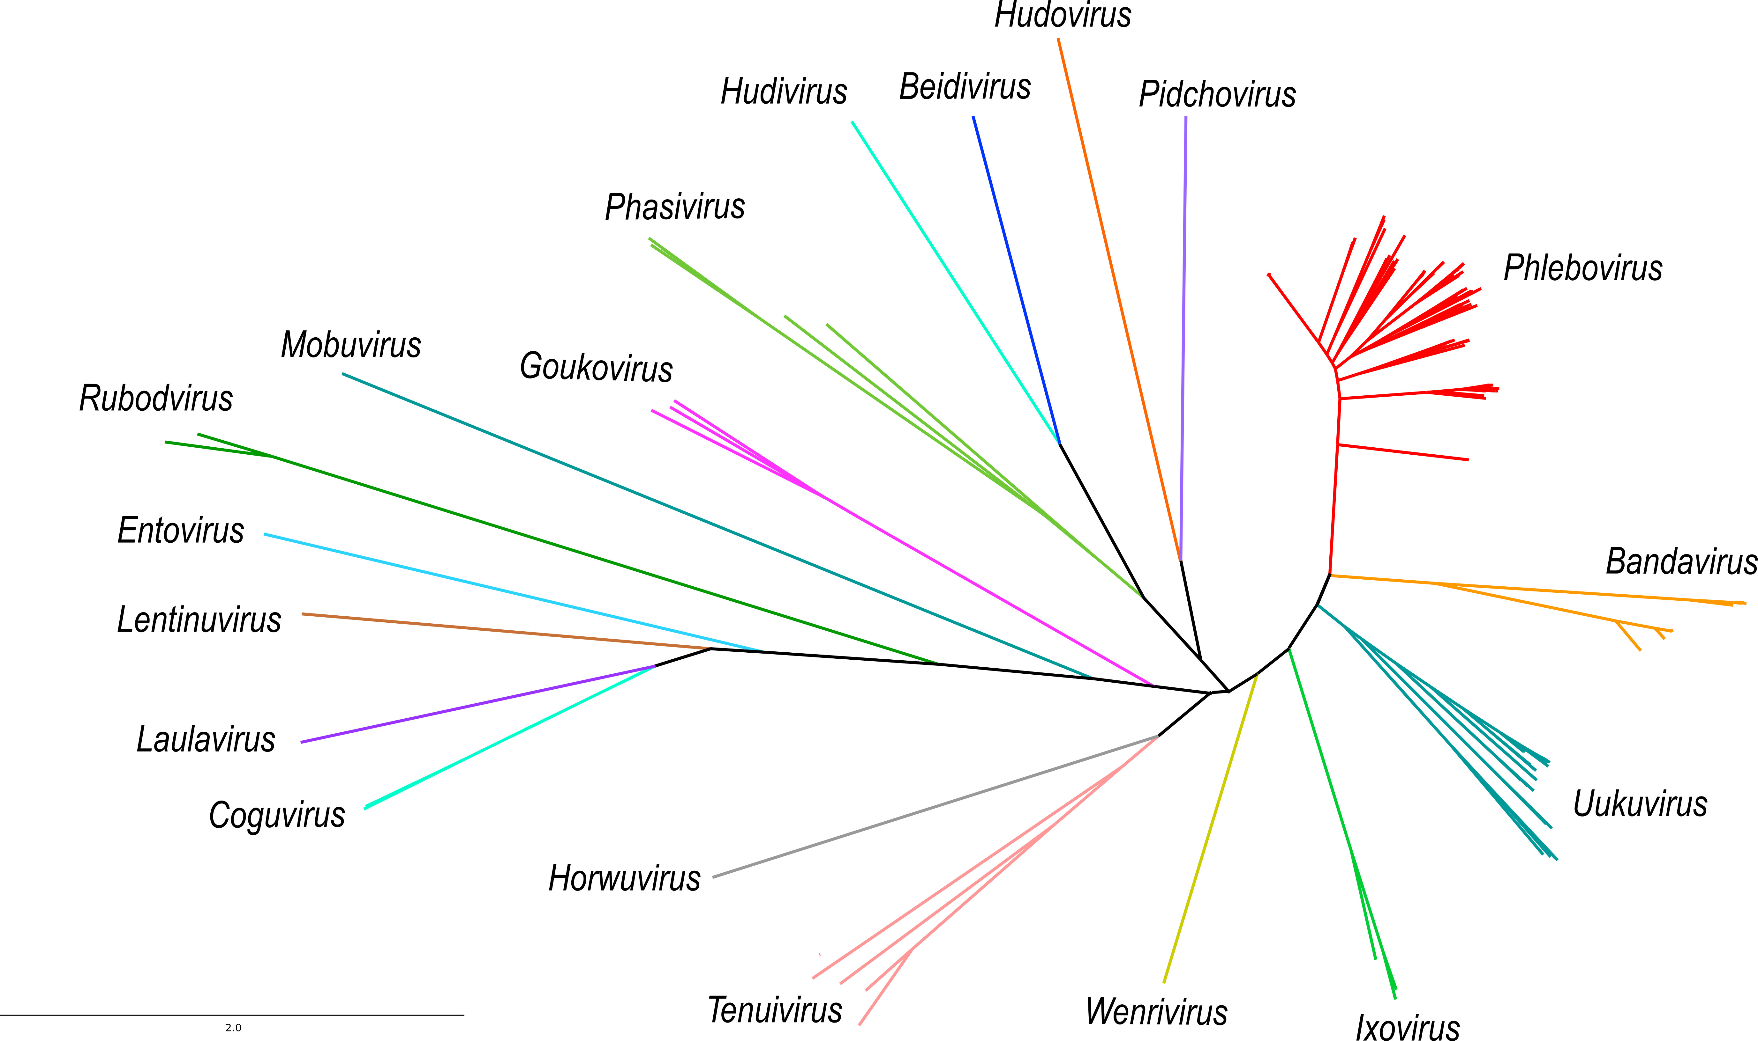

Figure 2: Phylogenetic analysis of established and proposed phenuivirus genera. Phylogenetic reconstruction is based on a MAFFT-alignment of the RdRp amino acid sequences of phenuiviruses and phenuivirus-like sequences using E-INS algorithm. The ML phylogenetic tree was inferred using RAxML-NG performing 1,000 bootstrap replicates [10]. Trees were inferred under the WAG substitution model. Tree branches are proportional to genetic distances between sequences and the scale bars at the bottom indicate substitutions per amino acid. Branches of phenuivirus genera are color coded.

References:
1. Marklewitz M, Dutari LC, Paraskevopoulou S, et al (2019) Diverse novel phleboviruses in sandflies from the Panama Canal area, Central Panama. J Gen Virol. https://doi.org/10.1099/jgv.0.001260

2. Abudurexiti A, Adkins S, Alioto D, et al (2019) Taxonomy of the order Bunyavirales: update 2019. Arch Virol. https://doi.org/10.1007/s00705-019-04253-6

3. Lecoq H, Wipf-Scheibel C, Verdin E, Desbiez C (2019) Characterization of the first tenuivirus naturally infecting dicotyledonous plants. Arch Virol 164:297–301. https://doi.org/10.1007/s00705-018-4057-6

4. Velasco L, Arjona-Girona I, Cretazzo E, López-Herrera C (2019) Viromes in Xylariaceae fungi infecting avocado in Spain. Virology 532:11–21. https://doi.org/10.1016/j.virol.2019.03.021

5. Lin Y-H, Fujita M, Chiba S, et al (2019) Two novel fungal negative-strand RNA viruses related to mymonaviruses and phenuiviruses in the shiitake mushroom (Lentinula edodes). Virology 533:125–136. https://doi.org/10.1016/j.virol.2019.05.008

6. Rott ME, Kesanakurti P, Berwarth C, et al (2018) Discovery of Negative-Sense RNA Viruses in Trees Infected with Apple Rubbery Wood Disease by Next-Generation Sequencing. Plant Dis 102:1254–1263. https://doi.org/10.1094/PDIS-06-17-0851-RE

7. Tokarz R, Williams SH, Sameroff S, et al (2014) Virome Analysis of Amblyomma americanum, Dermacentor variabilis, and Ixodes scapularis Ticks Reveals Novel Highly Divergent Vertebrate and Invertebrate Viruses. J Virol 88:11480–11492. https://doi.org/10.1128/JVI.01858-14

8. Pettersson JHO, Shi M, Bohlin J, et al (2017) Characterizing the virome of Ixodes ricinus ticks from northern Europe. Sci Rep. https://doi.org/10.1038/s41598-017-11439-y

9. Xin M, Cao M, Liu W, et al (2017) Two negative-strand RNA viruses identified in watermelon represent a novel clade in the order Bunyavirales. Front Microbiol. https://doi.org/10.3389/fmicb.2017.01514

10. Kozlov AM, Darriba D, Flouri T, et al (2019) RAxML-NG: a fast, scalable and user-friendly tool for maximum likelihood phylogenetic inference. Bioinformatics. https://doi.org/10.1093/bioinformatics/btz305

