This Word module should be used for all taxonomic proposals.
Please complete Part 1 and:
either Part 3 for proposals to create new taxa or change existing taxa
or Part 2 for proposals of a general nature.
Submit the completed Word module, together with the accompanying Excel module named in Part 3, to the appropriate ICTV Subcommittee Chair.
For guidance, see the notes written in blue, below, and the help notes in file Taxonomic_Proposals_Help_2018.
Part 1: TITLE, AUTHORS, etc

Code assigned: | 2018.011M |  | (to be completed by ICTV officers)
Short title: Re-organization of the family Paramyxoviridae
Author(s):
Balkema-Buschmann, Anne, anne.buschmann@fli.de
Dundon, William G., W.Dundon@iaea.org
Duprex, W. Paul, pduprex@bu.edu
Easton, Andrew J., A.J.Easton@warwick.ac.uk
Fouchier, Ron A. M., r.fouchier@erasmusmc.nl
Kurath, Gael, gkurath@usgs.gov
Lamb, Robert A., ralamb@northwestern.edu
Lee, Benhur, benhur.lee@mssm.edu
Rima, Bertus K., b.rima@qub.ac.uk
Rota, Paul A., par1@cdc.gov
Wáng, Línfā (王林发), linfa.wang@duke-nus.edu.sg
Corresponding author with e-mail address:
Rima, Bertus K., b.rima@qub.ac.uk
List the ICTV study group(s) that have seen this proposal:
A list of study groups and contacts is provided at http://www.ictvonline.org/subcommittees.asp . If in doubt, contact the appropriate subcommittee chair (there are six virus subcommittees: animal DNA and retroviruses, animal ssRNA-, animal ssRNA+, fungal and protist, plant, bacterial and archaeal) |  | ICTV Paramyxoviridae Study Group
ICTV Study Group comments (if any) and response of the proposer:
Date first submitted to ICTV: |  |  | June 6, 2018
Date of this revision (if different to above):

ICTV-EC comments and response of the proposer:

Part 3: PROPOSED TAXONOMY

Name of accompanying Excel module: 2018.011M.N.v1.Paramyxoviridae_rev
Since this proposal involves a reorganization of the family, filling in the spreadsheet based on the old organization of the family makes no sense as it obliterates the structure of the new organization. In the current format of the excel spreadsheet the new arrangements of the data can be easily pasted into the master species list in the required format.
Supporting material:
Since this proposal involves a re-organization of the species in the family Paramyxoviridae for the sake of clarity the text is arranged in a hierarchical order of proposals for (i) three new sub-families, (ii) seven new genera in the subfamilies, (iii) four new species, and (iv) abolition of two species. The proposal is based on the application of one primary criterion, i.e., the place of the species in the topology of a phylogenetic tree based on an alignment of the complete amino acid sequences of the RNA dependent RNA polymerases (RdRps) of representative members of the viral species, containing over 2700 aligned positions. As a secondary criterion, the host organism from which the first isolates were identified has been applied, recognizing that host species jumps are prevalent in the family (Shi et al. 2018). The length of a branch from the node to a specific sequence is the criterion that is used to classify a virus into a taxon.

The advance of metagenomic data sets and the subsequent discovery of large numbers of new virus sequences has led ICTV to decide that classification should be based primarily on nucleotide sequence information and phylogeny (Simmonds et al., 2017) in order to describe the richness of virus biology. In the family Paramyxoviridae, the ICTV Study Group has decided that, since a number of other criteria are no longer applicable or have been applied inconsistently (Rima et al, 2018), the classification of the viruses should now be based on a sequence comparison of the RNA-dependent RNA polymerases (RdRps) of the viruses. This proposal is therefore based on phylogenetic trees based on Clustal V alignments of the RdRps of 71 recognized species in the family. Maximum Likelihood trees were computed with 1000 bootstrap replicates based on a Clustal V alignment prepared with MEGA software with a gap-opening penalty of 5 and a gap extension penalty of 1. The trees were computed taking account of the gaps as both their size and position in the primary amino acid sequences of the RdRp are highly associated with specific taxonomic groups. The position of the RdRp of a specific virus in the tree then determines its classification at three taxonomic levels, i.e., sub-family, genus and species. The RdRp sequence of one virus member of in the Sunviridae (the phylogenetically most closely related family) is included in the tree. (Figure 1). The topology of the Sunshine Coast virus sequence demonstrates that the 71 species in the family are justifiably classified within the one family Paramyxoviridae and do not represent other as yet unassigned families.
Species demarcation criteria are then simply applied as follows. Since the primary criterion is the tree topology, whether or not a virus belongs to the same species becomes a matter of branch length between the nearest node and the tip of the branch. This length is defined as 0.03 in the trees generated as described in the legend to Figure 1.

The outworking of this new RdRp phylogeny-based classification system leads to the following taxonomic proposals for the family Paramyxoviridae in the order Mononegavirales:
- To create a new subfamily Avulavirinae with three new genera proposed to be: Orthoavulavirus (containing 8 species); Metaavulavirus (containing 10 species) and Paraavulavirus (containing 2 species) based on the tree topology. The name is derived from the former genus name Avulavirus in the family.
- To create a new subfamily Rubulavirinae with two new genera proposed to be: Orthorubulavirus (containing 7 species) and Pararubulavirus (containing 9 species) based on the tree topology. The name is derived from the former genus name Rubulavirus in the family.
- To create a new subfamily Orthoparamyxovirinae with five old and two new genera to be: old genera are Respirovirus, Aquaparamyxovirus, Ferlavirus, Henipavirus and Morbillivirus and two new genera are Jeilongvirus, Narmovirus, and Salemvirus based on the tree topology. This set of viruses is the oldest classified set in the family and the name is derived from the name of the family.
- To create a new subfamily Metaparamyxovirinae with one genus containing one species.
- To create 3 new species: Lophuromys jeilongvirus 1; Lophuromys jeilongvirus 2; Myodes jeilongvirus in the genus Jeilongvirus in the subfamily Paramyxovirinae (van Mechelen et al., in preparation).
- To create 1 new species Caprine respirovirus in the genus Respirovirus in the subfamily Paramyxovirinae (Yang et al. 1016).
- To create 1 new species Avian orthoavulavirus 20 in the genus Orthoavulavirus in the subfamily Avulavirinae (Karamendin et al. 2017).
- To create 3 new species in as yet to be assigned subfamilies: Scoliodon paramyxovirus; Cynoglossus paramyxovirus; and Hoplichthys paramyxovirus. These subfamilies were not assigned for the following reasons. The sequences from a single metagenomic assessment (Shi et al. 2018) have still a number of questions relating to the correct assignment of the gene order and the identification of the viral proteins. At present all three are represented by single sequences. A fourth sequence in the paper by Shi et al. (2018) representing a second triplecross lizardfish isolate (accession number MG600061) has an identical RdRp amino acid sequence as the one used in the tree. The study group wishes to await further confirmation and possible identification of further species in the same genus before proceeding with a sub-family and genus assignment. Furthermore, the problem that hybrid sequences originating from separate viruses may have been assembled in a single contiguous genome sequence remains until further confirmation of the data. Currently, the topology of the tree would indicate that these three new species might have to be assigned to separate new sub-families.
- To delete 2 species in the genus Orthorubulavirus in the subfamily Rubulavirinae namely: bat mumps virus and human parainfluenza virus 4B.

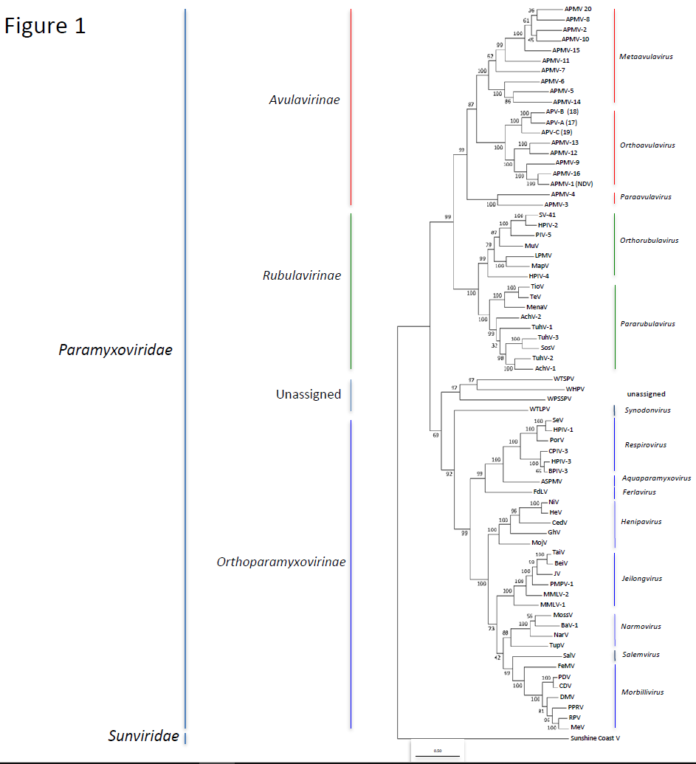

Figure 1 legend:
Molecular Phylogenetic analysis by Maximum Likelihood method
The evolutionary history was inferred by using the Maximum Likelihood method based on the JTT matrix-based model. The tree with the highest log likelihood (-246827.26) is shown. The percentage of trees in which the associated taxa clustered together is shown next to the branches. Initial tree(s) for the heuristic search were obtained automatically by applying Neighbor-Join and BioNJ algorithms to a matrix of pairwise distances estimated using a JTT model, and then selecting the topology with superior log likelihood value. The tree is drawn to scale, with branch lengths measured in the number of substitutions per site. The analysis involved 72 amino acid sequences. There were a total of 2721 positions in the final dataset. Evolutionary analyses were conducted in MEGA7 [Kumar et al. 2016].
Abbreviations: APMV1-16,19,20 avian paramyxovirus types 1-16,19,20; APV-A,B,C Atlantic penguin virus A,B,C; SV-41, simian virus 41; HPIV-1-4, human parainfluenza virus-1-4; PIV-5, parainfluenza virus 5 (aka SV-5); MuV, mumps virus, LPMV, La-Piedad-Michoacán-Mexico virus; MapV, Mapuera virus; TioV, Tioman virus; TeV, Teviot virus; MenaV, Menangle virus; AchiV1-2. Achimoto virus 1-2; TuhV1-3, Tuhoko virus 1-3; SosV, Sosuga virus; WTSPV, Wēnlǐng tonguesole paramyxovirus; WHPV, Wēnlǐng hoplichthys paramyxovirus; WPSSPV, Wēnzhōu pacific spadenose shark paramyxovirus; WTLPV, Wēnlǐng triplecross lizardfish paramyxovirus; SeV, Sendai virus; CPIV-3, caprine parainfluenza virus type 3; BPIV-3, bovine parainfluenza virus type 3; ASPMV, Atlantic salmon paramyxovirus; FdLV, Fer-de-Lance Virus; NiV, Nipah virus, HeV, Hendra virus; CedV, Cedar Virus; GhV, Ghana virus; MojV, Mòjiāng virus; TaiV, Tailam virus; BeiV, Beilong virus; JV, J virus; PMPV1, Pohorje myodes paramyxovirus1; MMLV-1-2, Mount Mabu lophuromys virus 1-2; MossV, Mossman virus; BaV-1, bank vole virus 1; NarV, Nariva virus; TupV, Tupaia paramyxovirus; Salv, Salem virus; FeMV, feline morbillivirus; PDV, phocine distemper virus; CDV, canine distemper virus; DMV, dolphin morbillivirus; PPRV, peste-des-petits-ruminants virus; RPV, rinderpest virus; MeV, measles virus.

Figure 2 indicates why 2 species (bat mumps virus and human parainfluenza virus 4B) were abolished as a result of the fact that their branch length fell below the minimum identified.

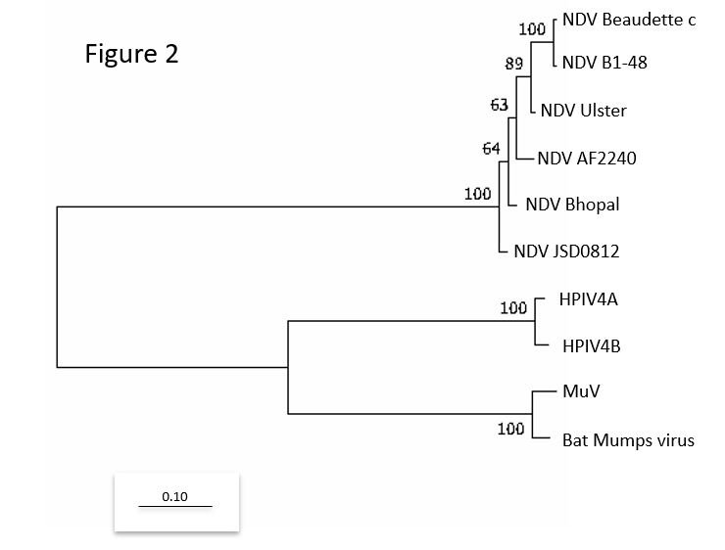
Figure 2 legend: similar to figure 1 except the tree with the highest log likelihood was based on a total alignment of RdRps containing 2249 amino acids.

References:
Karamendin K, Kydyrmanov A, Kasymbekov Y, Asanova S, Daulbayeva K, Seidalina A, et al. (2017) Novel avian paramyxovirus isolated from gulls in Caspian seashore in Kazakhstan. PLoS ONE 12(12): e0190339. https://doi.org/10.1371/journal. pone.0190339

Kumar S., Stecher G., and Tamura K. (2016). MEGA7: Molecular Evolutionary Genetics Analysis version 7.0 for bigger datasets.Molecular Biology and Evolution 33:1870-1874.

Rima et al. (2018). Problems of classification in the family Paramyxoviridae. Archives of Virology, doi.org/10.1007/s00705-018-3720-2

Shi M, Lin XD, Chen X, Tian JH, Chen LJ, Li K, Wang W, Eden JS, Shen JJ, Liu L, Holmes EC, Zhang YZ. (2018). The evolutionary history of vertebrate RNA viruses.
Nature. 556(7700):197-202. doi: 10.1038/s41586-018-0012-7. Epub 2018 Apr 4.

Simmonds P, Adams MJ, Benkő M, Breitbart M, Brister JR, Carstens EB, Davison AJ, Delwart E, Gorbalenya AE, Harrach B, Hull R, King AM, Koonin EV, Krupovic M, Kuhn JH, Lefkowitz EJ, Nibert ML, Orton R, Roossinck MJ, Sabanadzovic S, Sullivan MB, Suttle CA, Tesh RB, van der Vlugt RA, Varsani A, Zerbini FM (2017). Virus taxonomy in the age of metagenomics. Nat Rev Microbiol. 2017 Mar;15(3):161-168. doi:10.1038/nrmicro.2016.177.

Van Mechelen, B, Bletsa M, Vrancken B, Gryseels S, Leirs H, Gouy de Bellocq J, Lemey ,P and Maes P.Discovery of three new Paramyxovirus species in rodents: expansion of the proposed genus 'Jeilong virus'. In preparation?

Yang L et al. (2016). Analysis on a complete genome of a novel caprine parainfluenza virus 3. Infection, Genetics and Evolution 38: 29-34.

