This Word module should be used for all taxonomic proposals.
Please complete Part 1 and:
either Part 3 for proposals to create new taxa or change existing taxa
or Part 2 for proposals of a general nature.
Submit the completed Word module, together with the accompanying Excel module named in Part 3, to the appropriate ICTV Subcommittee Chair.
The Word module explains and justifies your proposal. The Excel module is a critical document that will be used to implement the proposed taxonomic changes once they are approved and ratified. If proposals presented in the Word module are not presented accurately in the Excel module, the taxonomic changes cannot proceed.
For guidance, see the notes written in blue, below, and the Help Notes in file Taxonomic_Proposals_Help_2019.
Part 1: TITLE, AUTHORS, etc

Code assigned: | 2019.020M
Short title: Create one new species in the genus Mammarenavirus (Bunyavirales: Arenaviridae) for a virus found in dipodids

Author(s) and email address(es):
List authors in a single line Archives of Virology citation format (e.g. Smith AB, Huang C-L, Santos, F) |  | Provide email address for each author in a single line separated by semi-colons
de la Torre JC, Buchmeier MJ, Charrel RN, Clegg JCS, Gonzalez J-PJ, Günther S, Hepojoki J, Kuhn JH, Lukashevich IS, Radoshitzky SR, Romanowski V, Salvato MS, Sironi M, Stenglein MD, Wang, J |  | isluka01@louisville.edu; cleggjcs@yahoo.fr; jpgonzalez2808@gmail.com; juanct@scripps.edu; jussi.hepojoki@uzh.ch; manuela.sironi@BP.LNF.it; MSalvato@ihv.umaryland.edu; Mark.Stenglein@ColoState.edu; m.buchmeier@uci.edu; remi.charrel@univ-amu.fr; sheli.r.radoshitzky.ctr@mail.mil; guenther@bni.uni-hamburg.de; victor@biol.unlp.edu.ar; kuhnjens@mail.nih.gov; wangjw28@163.com
Corresponding author
Juan Carlos de la Torre; juanct@scripps.edu
List the ICTV study group(s) that have seen this proposal:
A list of study groups and contacts is provided at http://www.ictvonline.org/subcommittees.asp . If in doubt, contact the appropriate subcommittee chair (there are six virus subcommittees: animal DNA and retroviruses, animal ssRNA-, animal ssRNA+, fungal and protist, plant, bacterial and archaeal) |  | ICTV Arenaviridae Study Group
ICTV Study Group comments (if any) and response of the proposer:
Date first submitted to ICTV: |  |  | June 19
Date of this revision (if different to above):

ICTV-EC comments and response of the proposer:

Part 3: PROPOSED TAXONOMY

Name of accompanying Excel module: 2019.020M.A.v1.1newsp_Alxa_mammarenavirus.xlsx

In 2014, a novel putative mammarenavirus (Bunyavirales: Arenaviridae: Mammarenavirus), tentatively designated RtDs-AreV/IM2014, was discovered in Northern three-toed jerboas (Dipodoidea: Dipodidae: Dipus sagitta Pallas, 1773) sampled in Alxa Left Banner, Inner Mongolia Autonomous Region, China (Wu et al. 2018 Mar; Wu et al. 2018 Oct). Another putative novel mammarenavirus, tentatively designated RtRf-AreV/YN2014, was discovered in Oriental house rats (Muroidea: Muridae: Rattus tanezumi Temminck, 1844) sampled in Yúnnán Province, China (Wu et al. 2018 Oct.).

Near-complete genomic sequences (both S and L segments) for both viruses are available from GenBank. Neither of the two viruses has been isolated in culture.

The ICTV Arenaviridae Study Group has recommended the use of the PAirwise Sequence Comparison (PASC) tool (https://www.ncbi.nlm.nih.gov/sutils/pasc/viridty.cgi?textpage=overview) for the assessment of novel arenaviruses (Radoshitzky et al.). PASC cut-off values chosen for classifying arenaviruses within the same species are >80% and >76% nucleotide sequence identity in the S and L segments, respectively. We performed PASC for both new viruses. Based on PASC analysis, as well as phylogenetic analyses, RtRf-AreV/YN2014 is an isolate of Wēnzhōu virus (species Wenzhou mammarenavirus; PASC S segment: 83.33% identity; L segment: 79.59% identity) and therefore is already classified.

The closest PASC hit for the RtDs-AreV/IM2014 S segment is Lassa virus (Lassa mammarenavirus) with 58.09% pairwise identity (i.e., less than 80%), confirming the need for creating a new mammarenavirus species.

S segment: KY432893.1:

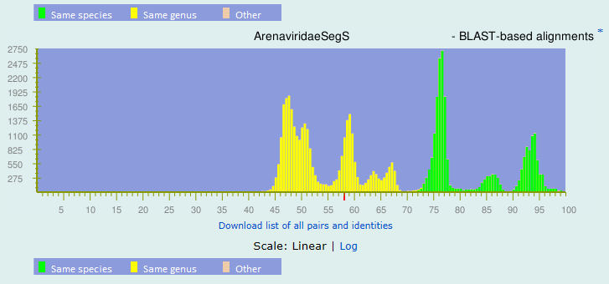
Top matches for gi|1281541309|gb|KY432893.1| Arenavirus sp. isolate RtDs-AreV-IM2014 nucleocapsid protein (NP) gene, partial cds; and glycoprotein precursor (GPC) gene, complete cds:
BLAST-based alignments
1 |  | 58.09% |  | gi|695313785|gb|KM821847.1| Mammarenavirus|Lassa mammarenavirus
2 |  | 58.07% |  | gi|695315495|gb|KM822069.1| Mammarenavirus|Lassa mammarenavirus
3 |  | 58.05% |  | gi|695315304|gb|KM822033.1| Mammarenavirus|Lassa mammarenavirus
4 |  | 57.99% |  | gi|228015596|gb|FJ895882.1| Mammarenavirus|Lymphocytic choriomeningitis mammarenavirus
5 |  | 57.97% |  | gi|695314686|gb|KM821943.1| Mammarenavirus|Lassa mammarenavirus
6 |  | 57.95% |  | gi|695315383|gb|KM822053.1| Mammarenavirus|Lassa mammarenavirus
7 |  | 57.92% |  | gi|695313914|gb|KM821857.1| Mammarenavirus|Lassa mammarenavirus
8 |  | 57.89% |  | gi|695315393|gb|KM822055.1| Mammarenavirus|Lassa mammarenavirus
9 |  | 57.88% |  | gi|695315531|gb|KM822074.1| Mammarenavirus|Lassa mammarenavirus
10 |  | 57.86% |  | gi|695314110|gb|KM821882.1| Mammarenavirus|Lassa mammarenavirus
11 |  | 57.83% |  | gi|695315750|gb|KM822099.1| Mammarenavirus|Lassa mammarenavirus
12 |  | 57.83% |  | gi|695315341|gb|KM822043.1| Mammarenavirus|Lassa mammarenavirus
13 |  | 57.81% |  | gi|383212114|dbj|AB627953.1| Mammarenavirus|Lymphocytic choriomeningitis mammarenavirus
14 |  | 57.8% |  | gi|695314855|gb|KM821965.1| Mammarenavirus|Lassa mammarenavirus
15 |  | 57.8% |  | gi|695313945|gb|KM821861.1| Mammarenavirus|Lassa mammarenavirus

The closest PASC hit for the RtDs-AreV/IM2014 L segment is lymphocytic choriomeningitis virus (Lymphocytic choriomeningitis mammarenavirus) with 52.54% pairwise identity (i.e., less than 76%), thereby justifying the creation of a novel species.

L segment: KY432892.1:

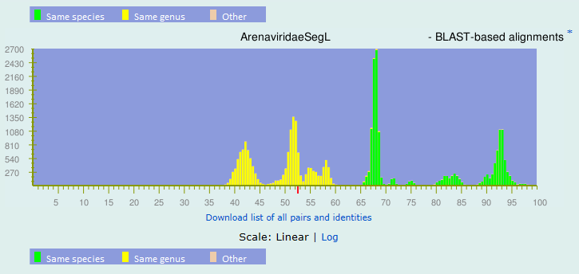
Top matches for gi|1281541306|gb|KY432892.1| Arenavirus sp. isolate RtDs-AreV-IM2014 RNA-dependent RNA polymerase (L) and Z protein (Z) genes, complete cds:
BLAST-based alignments
1 |  | 52.54% |  | gi|258489190|gb|FJ607024.1| Mammarenavirus|Lymphocytic choriomeningitis mammarenavirus
2 |  | 52.18% |  | gi|169641159|gb|EU480453.1| Mammarenavirus|Lymphocytic choriomeningitis mammarenavirus
3 |  | 52.12% |  | gi|258489194|gb|FJ607025.1| Mammarenavirus|Lymphocytic choriomeningitis mammarenavirus
4 |  | 51.96% |  | gi|695315295|gb|KM822030.1| Mammarenavirus|Lassa mammarenavirus
5 |  | 51.94% |  | gi|169641153|gb|EU480451.1| Mammarenavirus|Lymphocytic choriomeningitis mammarenavirus
6 |  | 51.88% |  | gi|570339334|gb|KC669692.1| Mammarenavirus|Loei River mammarenavirus
7 |  | 51.87% |  | gi|258489179|gb|FJ607021.1| Mammarenavirus|Lymphocytic choriomeningitis mammarenavirus
8 |  | 51.84% |  | gi|695313462|gb|KM821809.1| Mammarenavirus|Lassa mammarenavirus
9 |  | 51.83% |  | gi|258489197|gb|FJ607026.1| Mammarenavirus|Lymphocytic choriomeningitis mammarenavirus
10 |  | 51.78% |  | gi|749717245|ref|NC_026247.1| Mammarenavirus|Gairo mammarenavirus
11 |  | 51.61% |  | gi|695315397|gb|KM822056.1| Mammarenavirus|Lassa mammarenavirus
12 |  | 51.61% |  | gi|258489187|gb|FJ607023.1| Mammarenavirus|Lymphocytic choriomeningitis mammarenavirus
13 |  | 51.6% |  | gi|115383203|gb|DQ868486.1| Mammarenavirus|Lymphocytic choriomeningitis mammarenavirus
14 |  | 51.58% |  | gi|695313201|gb|KM821776.1| Mammarenavirus|Lassa mammarenavirus
15 |  | 51.54% |  | gi|570339337|gb|KC669693.1| Mammarenavirus|Loei River mammarenavirus

In phylogenetic analyses, RtDs-AreV/IM2014 clusters as a distinct mammarenavirus (Figure 1).

Figure 1. Mammarenavirus. Maximum likelihood phylogenetic trees inferred from PRANK alignments of the NP (top), GPC (middle), and L amino acid sequences. For the alignments, the best-fit model of protein evolution (LG+G) was selected using ProtTest 3 (v. 3.4.2). Maximum likelihood trees with 1,000 bootstrap replicates were produced using RAxML (v. 8). The percentage of replicate trees in which the associated taxa clustered together in the bootstrap is shown next to branch nodes (when ≥ 70%). The mid-point rooted trees were visualized using FigTree (http://tree.bio.ed.ac.uk/).

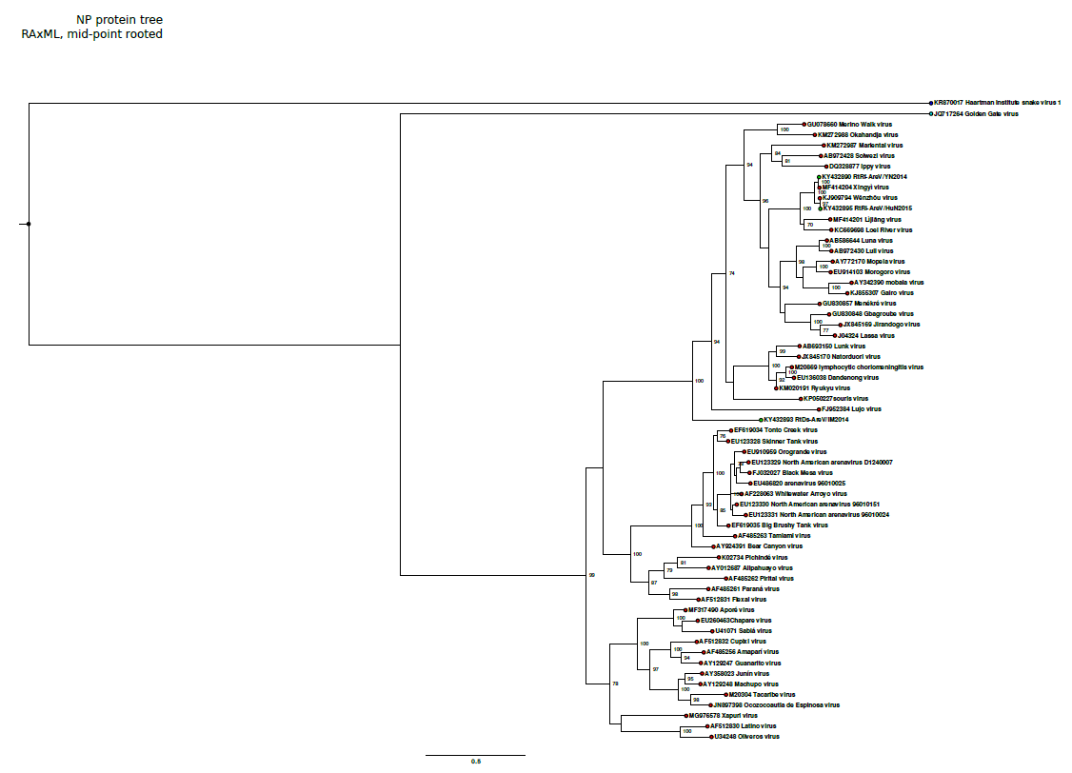

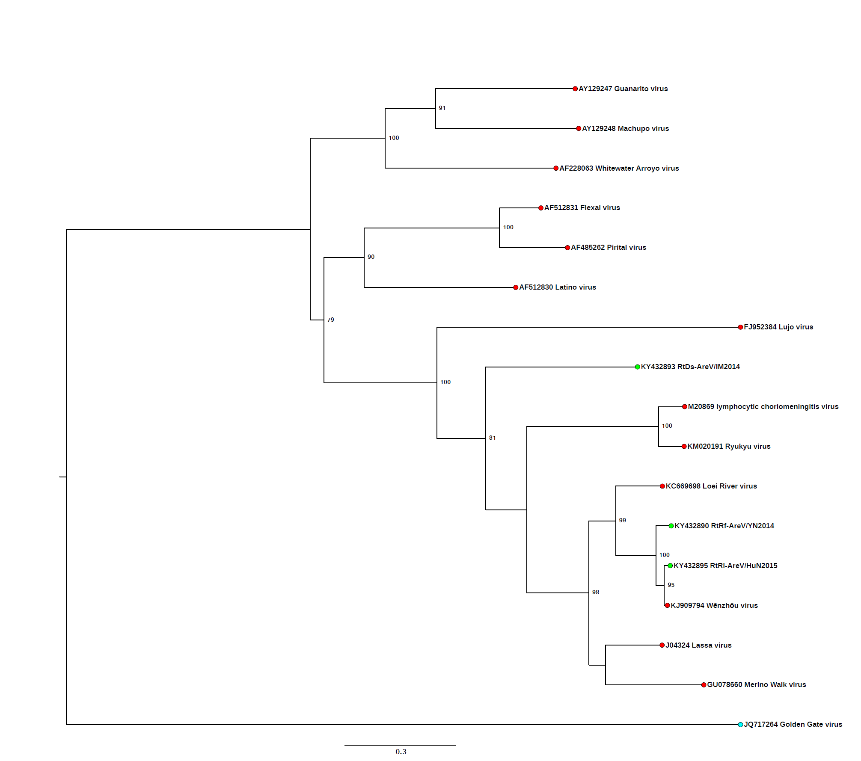

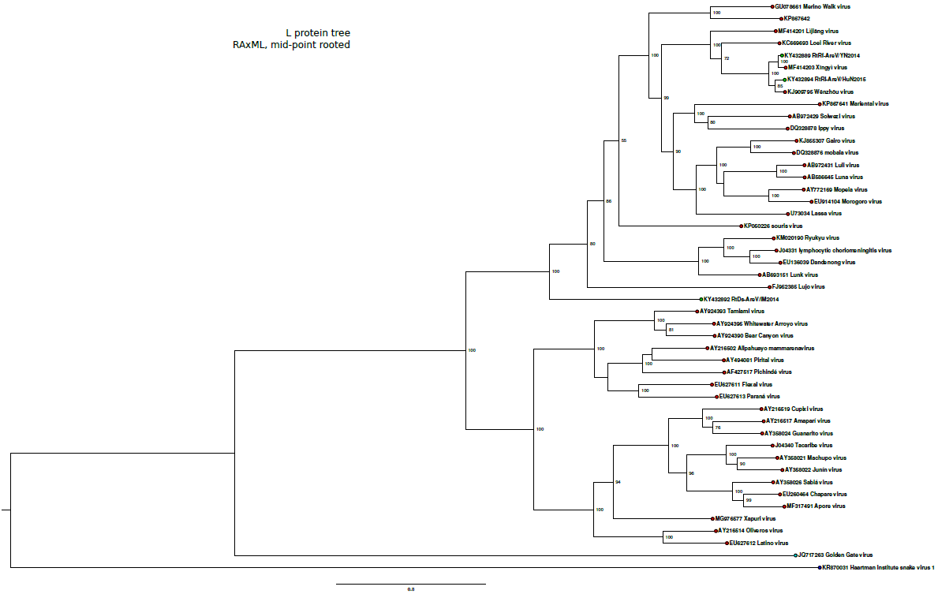

Consequently, we propose the establishment of a novel mammarenavirus species for RtDs-AreV/IM2014 (renamed Alxa virus; ALXV), proposed to be named Alxa mammarenavirus.

Etymology: Alxa virus, Alxa mammarenavirus: named after Alxa Right Banner, a banner in Inner Mongolia Autonomous Region, China, where the virus was discovered.

References:
Radoshitzky SR, Bào Y, Buchmeier MJ, Charrel RN, Clawson AN, Clegg CS, DeRisi JL, Emonet S, Gonzalez JP, Kuhn JH, Lukashevich IS, Peters CJ, Romanowski V, Salvato MS, Stenglein MD, de la Torre JC. Past, present, and future of arenavirus taxonomy. Arch Virol. 2015 Jul;160(7):1851-74. doi: 10.1007/s00705-015-2418-y. PMID: 25935216

Wu Z, Du J, Lu L, Yang L, Dong J, Sun L, Zhu Y, Liu Q, Jin Q. Detection of Hantaviruses and Arenaviruzses [sic] in three-toed jerboas from the Inner Mongolia Autonomous Region, China. Emerg Microbes Infect. 2018 Mar 21;7(1):35. doi: 10.1038/s41426-018-0036-y. PMID: 29559618

Wu Z, Lu L, Du J, Yang L, Ren X, Liu B, Jiang J, Yang J, Dong J, Sun L, Zhu Y, Li Y, Zheng D, Zhang C, Su H, Zheng Y, Zhou H, Zhu G, Li H, Chmura A, Yang F, Daszak P, Wang J, Liu Q, Jin Q. Comparative analysis of rodent and small mammal viromes to better understand the wildlife origin of emerging infectious diseases. Microbiome. 2018 Oct 3;6(1):178. doi: 10.1186/s40168-018-0554-9. PMID: 30285857

