This Word module should be used for all taxonomic proposals.
Please complete Part 1 and:
either Part 3 for proposals to create new taxa or change existing taxa
or Part 2 for proposals of a general nature.
Submit the completed Word module, together with the accompanying Excel module named in Part 3, to the appropriate ICTV Subcommittee Chair.
For guidance, see the notes written in blue, below, and the help notes in file Taxonomic_Proposals_Help_2018.
Part 1: TITLE, AUTHORS, etc

Code assigned: | 2018.017M |  | (to be completed by ICTV officers)
Short title: Expansion of the order Bunyavirales
Author(s):
Maes, Piet, piet.maes@kuleuven.be
Kuhn, Jens H., kuhnjens@mail.nih.gov
Corresponding author with e-mail address:
Maes, Piet, piet.maes@kuleuven.be
List the ICTV study group(s) that have seen this proposal:
A list of study groups and contacts is provided at http://www.ictvonline.org/subcommittees.asp . If in doubt, contact the appropriate subcommittee chair (there are six virus subcommittees: animal DNA and retroviruses, animal ssRNA-, animal ssRNA+, fungal and protist, plant, bacterial and archaeal) |  | ICTV Phasmaviridae, Phenuiviridae, and Peribunyaviridae Study Groups
ICTV Study Group comments (if any) and response of the proposer:
Date first submitted to ICTV: |  |  | June 6, 2018
Date of this revision (if different to above): |  |  | August 31, 2018

ICTV-EC comments and response of the proposer:

Part 3: PROPOSED TAXONOMY

Name of accompanying Excel module: 2018.017M.N.v2.Bunyavirales_2fam5gen

There are numerous unclassified bunyaviruses and bunyavirus-like sequences deposited in GenBank. To reduce the number of unclassified, DEmARC analysis was performed on adapted DEmARC v1.0 scripts (Lauber C and Gorbalenya AE, 2012) implementing a Bayesian maximum clade credibility (MCC) consensus tree as guideline. A Bayesian Markov Chain Monte Carlo method implemented in BEAST (v1.8.4) was used to estimate the maximum clade credibility (MCC) tree after 100 million generations. The dataset used was compiled with significant representative sequences from the current Bunyavirales families and genera (as defined in the latest, 2017 TaxoProp), supplemented with all new coding-complete bunyavirus-like sequences published in 2017 and 2018. The full-length products of the S, M, and L ORFs (nucleocapsid protein, glycoprotein precursor, and polymerase, respectively), were separately aligned with MAFFT. After trimming with Trimal (v1.2) and BMGE (v1.1), alignments were concatenated in one multiple alignment (final alignment size 5340 bps). The estimated consensus MCC tree was used as input and analysis guideline for the DEmARC analysis (adapted v1.0 DEmARC scripts) (Figures 1 and 2). The DEmARC analysis was used to define a species cut-off:

- Make an amino acid concatenated multiple alignment containing the full coding regions of the nucleocapsid protein (S segment), glycoproteins (M segment) and polymerase (L segment)
- Calculate PED values using WAG amino acid substitution matrix (Tree-Puzzle, maximum likelihood parameter)
- A species is defined by a PED value greater than 0.1

The analysis supports taxonomic proposals made elsewhere (highlighted orange in the attached Excel sheet):
- the need for a novel arenavirus genus including two species for novel fish arenaviruses;
- the need for a reorganized family Hantaviridae.

Furthermore, the analysis reveals the need to establish a novel family for trypanosomid protist bunyaviruses (“Leishbuviridae”), the need for five novel orthobunyavirus species, the need for one novel peribunyavirus genus, the need for re-establishment of the family Tospoviridae, the need for a new phasmavirus genus, and the need for expansion of the family Phenuiviridae by three novel genera and addition of a novel species to the genus Banyangvirus.

Etymology of newly proposed taxa:

- Laulavirus: contraction stemming from the type virus of the genus, Laurel Lake virus
- Laurel Lake laulavirus: derived from Laurel Lake virus

- Leishbuviridae: sigil of Leishmania and bunyavirus and family-specific suffix viridae
- Shilevirus: scrambled contraction of Leishmania
- Leptomonas shilevirus: LepmorLBV1 was discovered in the insect trypanosomatid parasite Leptomonas moramango

- Bellavista orthobunyavirus, Enseada orthobunyavirus, Maguari orthobunyavirus, Tataguine orthobunyavirus, Witwatersrand orthobunyavirus: named after the member viruses (Bellavista virus, Enseada virus, Maguari virus, Tataguine virus, Witwatersrand virus, respectively).

- Pacuvirus: contraction stemming from the type virus of the genus, Pacui virus
- Pacui pacuvirus, Rio Preto da Eva pacuvirus, Tapirape pacuvirus: named after the member viruses (Pacui virus, Rio Preto da Eva virus, and Tapirapé virus, respectively).

- Sawastrivirus: contraction stemming from the type virus of the genus, Sānxiá water strider virus 2
- Sanxia sawastrivirus: from Sānxiá water strider virus 2
- Heartland banyangvirus: derived from Heartland virus (and genus Banyangvirus)

- Wenrivirus: sigil of Wēnzhōu shrimp virus 1

- Kabutovirus: derived from Kabuto mountain virus
- Huangpi kabutovirus: derived from Huángpí tick virus 1
- Kabuto mountain kabutovirus: derived from Kabuto mountain virus

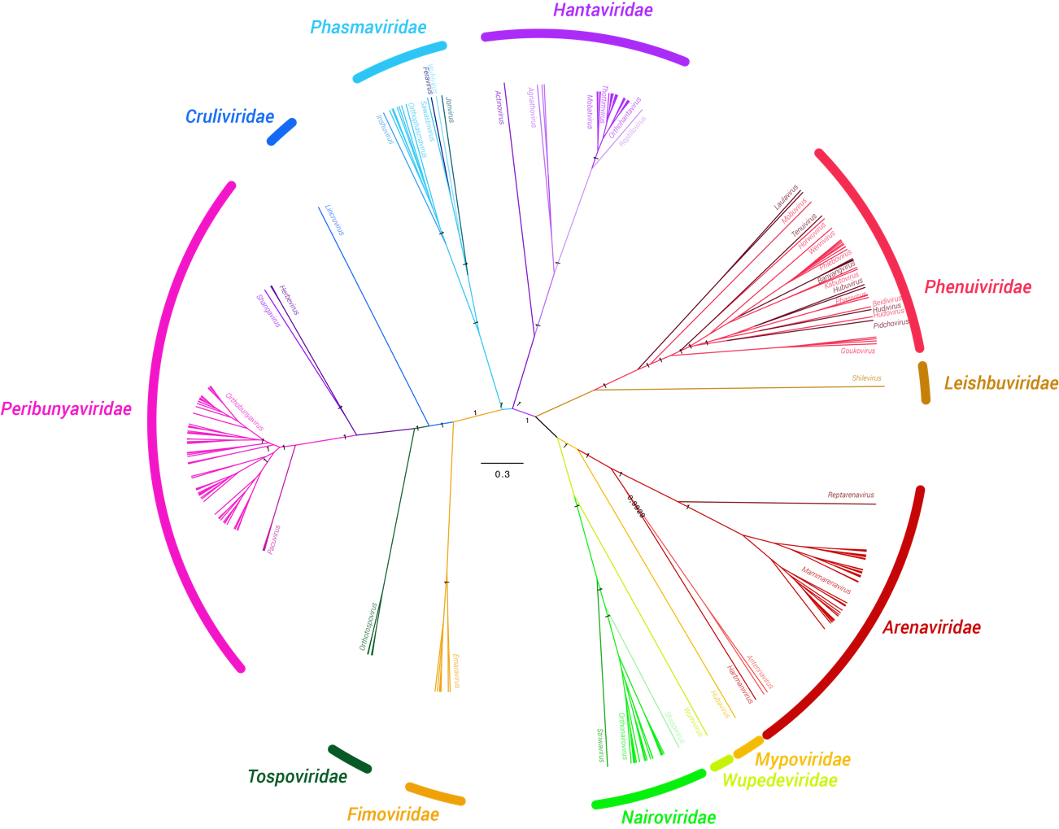

Figure 1: The figure shows a Bayesian MCMC consensus tree showing the different Bunyavirales families and genera according to the DEmARC (v1.0) analysis and estimated using a Bayesian Markov Chain Monte Carlo method implemented in BEAST (v1.8.4) using the WAG amino acid model of amino acid substitutions. Briefly, maximum clade credibility (MCC) trees were determined using TreeAnnotator (v1.8.4) with a burn-in of 10% of the sampled trees. The Markov chain Monte Carlo analysis was run until effective sample sizes above 200 were obtained (100 million generations). The dataset was compiled with significant representative sequences of the current Bunyavirales families and genera, supplemented with all new bunyavirus-like sequences published in 2017 and 2018. This dataset consists of full length products of the S, M, and L ORFs (nucleocapsid protein, glycoprotein precursor and polymerase respectively), separately aligned with MAFFT. After trimming with Trimal (v1.2) and BMGE (v1.1) alignments were concatenated in one multiple alignment (final alignment size 5340 bps). The estimated consensus MCC tree was used as input and analysis guideline for the DEmARC analysis (adapted v1.0 DEmARC scripts).

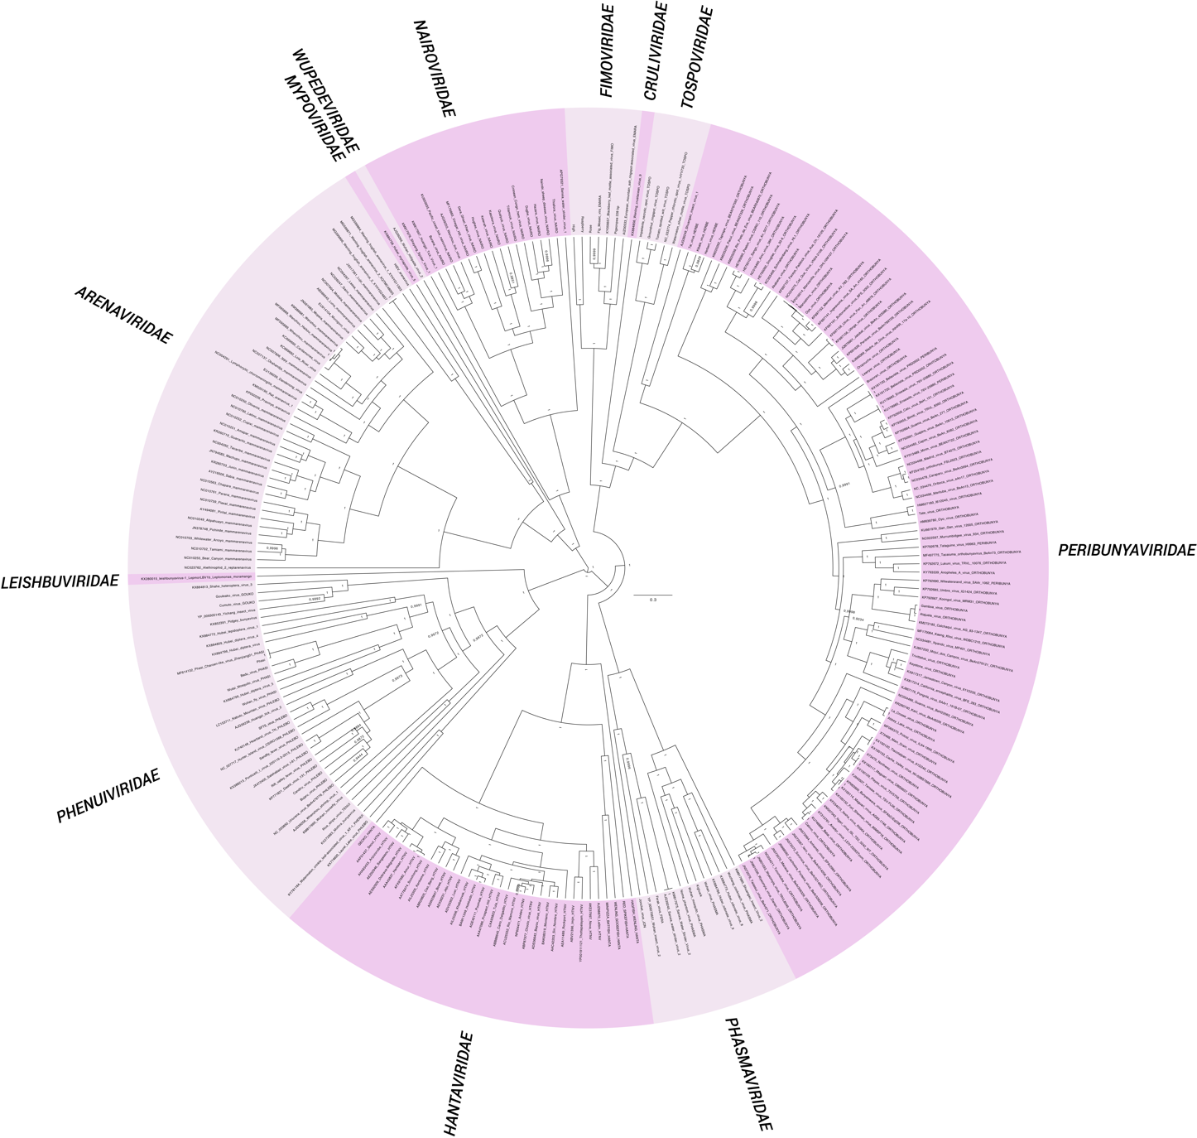

Figure 2: The figure shows a Bayesian MCMC consensus tree showing the different Bunyavirales families and genera according to the DEmARC (v1.0) analysis and estimated using a Bayesian Markov Chain Monte Carlo method implemented in BEAST (v1.8.4) using the WAG amino acid model of amino acid substitutions. Briefly, maximum clade credibility (MCC) trees were determined using TreeAnnotator (v1.8.4) with a burn-in of 10% of the sampled trees. The Markov chain Monte Carlo analysis was run until effective sample sizes above 200 were obtained (100 million generations). The dataset was compiled with significant representative sequences of the current Bunyavirales families and genera, supplemented with all new bunyavirus-like sequences published in 2017 and 2018. This dataset consists of full length products of the S, M a,nd L ORFs (nucleocapsid protein, glycoprotein precursor and polymerase respectively), separately aligned with MAFFT. After trimming with Trimal (v1.2) and BMGE (v1.1) alignments were concatenated in one multiple alignment (final alignment size 5340 bps). The estimated consensus MCC tree was used as input and analysis guideline for the DEmARC analysis (adapted v1.0 DEmARC scripts).

References:
Partitioning the genetic diversity of a virus family: approach and evaluation through a case study of picornaviruses.
Lauber C, Gorbalenya AE.
J Virol. 2012 Apr;86(7):3890-904. doi: 10.1128/JVI.07173-11. Epub 2012 Jan 25.
PMID: 22278230

