This Word module should be used for all taxonomic proposals.
Please complete Part 1 and:
either Part 3 for proposals to create new taxa or change existing taxa
or Part 2 for proposals of a general nature.
Submit the completed Word module, together with the accompanying Excel module named in Part 3, to the appropriate ICTV Subcommittee Chair.
For guidance, see the notes written in blue, below, and the help notes in file Taxonomic_Proposals_Help_2018.
Part 1: TITLE, AUTHORS, etc

Code assigned: | 2018.010M |  | (to be completed by ICTV officers)
Short title: Creation of 4 subfamilies and 3 new genera in the family Hantaviridae (Bunyavirales)
Author(s):
Maes, Piet | piet.maes@kuleuven.be
Calisher, Charles H. | calisher@cybersafe.net
Charbonnel, Nathalie | nathalie.charbonnel@inra.fr
Fulhorst, Charles F. | cfulhors@utmb.edu
Klempa, Boris | boris.klempa@savba.sk
Klingström, Jonas | jonas.klingstrom@ki.se
Song, Jin-won | jwsong@korea.ac.kr
Zhāng, Yǒngzhèn | zhangyongzhen@icdc.cn

Corresponding author with e-mail address:
Maes, Piet | piet.maes@kuleuven.be

List the ICTV study group(s) that have seen this proposal:
A list of study groups and contacts is provided at http://www.ictvonline.org/subcommittees.asp . If in doubt, contact the appropriate subcommittee chair (there are six virus subcommittees: animal DNA and retroviruses, animal ssRNA-, animal ssRNA+, fungal and protist, plant, bacterial and archaeal) |  | ICTV Hantaviridae Study Group
ICTV Study Group comments (if any) and response of the proposer:
Prof. Yǒngzhèn Zhāng opposed the species names of Batfish actinovirus, Spikefish actinovirus, Goosefish actinovirus, Hagfish agnathovirus, and Gecko reptillovirus.

Date first submitted to ICTV: |  |  | June 6, 2018
Date of this revision (if different to above): |  |  | January, 23, 2019

ICTV-EC comments and response of the proposer:

Part 3: PROPOSED TAXONOMY

Name of accompanying Excel module: 2018.010M.N.v3.Hantaviridae_4subfam

Supporting material:

DEmARC/Bayesian MCMC analysis has been done with all available full-length hantavirus-like sequences (complete S and M segment sequences were used for the analysis). Briefly, Bayesian phylogenetic analyses were inferred in BEAST 1.8.4 employing 20 independent MCMC runs with a chain length of 50,000,000 generations. Tree and log files of independent runs of BEAST were combined using LogCombiner 1.8.4, employing a Burn in period of 10%. The Markov chain Monte Carlo analyses were run until effective sample sizes above 200 were obtained. The consensus tree was built with TreeAnnotator 1.8.4 using the maximum clade credibility method and visualized in Figtree. This consensus tree was used as guide tree for the DEmARC analysis (adapted version 1). Based on the DEmARC analysis, species demarcation was calculated and a species cutoff was defined:

- Make an amino acid concatenated multiple alignment containing the full coding regions of the nucleocapsid protein (S segment) and glycoproteins (M segment);
- Calculate PED values using WAG amino acid substitution matrix (Tree-Puzzle, maximum likelihood parameter);
- A species of the genus Hantavirus is defined by a PED value greater than 0.1.

All Hantaviridae species meet the criteria of 0.1 PED threshold to be demarcated as distinct species.
The results are shown in Table 1, Figures 1 and 2. They indicate that overall the taxonomic decisions of last year (establishment of the family and 4 new genera) hold up. However, the resolution of the phylogeny increased significantly and several taxonomic amendments are required to accommodate newly discovered fish and the gecko hantaviruses:
- Four subfamilies (3 new genera) are created (see also Table 1 for an overview of the implemented changes) to accommodate the recently published fish and gecko hantavirus-like sequences (1). There is enough evidence in the original analysis described in the paper of Shi et al. (1) that Repantavirinae, Actantavirinae and Agantavirinae viruses are closely related and ancestral to the mammalian hantaviruses. To acknowledge their relationship with hantaviruses, these viruses are placed in newly created subfamilies of the family (Table 1).

  - The names Actantavirinae/Actinovirus are derived from the fish class Actinopterygii (Kingdom Animalia, Phylum Chordata, Superclass Osteichthyes) or ray-finned fishes, a class of bony fishes.
  - The names Agantavirinae/Agnathovirus are derived from the superclass Agnatha (Kingdom Animalia, Phylum Chordata, Subphylum Vertebrata), a superclass of jawless fish.
  - The names Repantavirinae/Reptillovirus are derived from the class Reptilia.

- 2 new sequences are available on GenBank for Seewis virus (2) and Tigray virus (3), two orthohantaviruses with until recently incomplete sequenced genomes. Our analysis indicated that both viruses ought to be classified into two new species, Seewis orthohantavirus and Tigray orthohantavirus.
- The Amga orthohantavirus species will be abandoned. Amga virus and Seewis virus cluster together in the DEmARC analysis as a single species. Seewis virus sequences have been published (2007) before Amga virus (2016). Therefore, the species Seewis orthohantavirus is retained.

Table 1: Proposed composition of the family Hantaviridae

Family | Subfamily | Genus | Species | Host
Hantaviridae | Actantavirinae | Actinovirus | #3 | Ray-finned fish
 | Agantavirinae | Agnathovirus | #1 | Jawless fish
 | Mammantavirinae | Loanvirus | #1 | Mammalian (bat)
 |  | Mobatvirus | #3 | Mammalian (bat or mole)
 |  | Orthohantavirus | #36 | Mammalian (rodent)
 |  | Thottimvirus | #2 | Mammalian (shrew)
 | Repantavirinae | Reptillovirus | #1 | Reptile

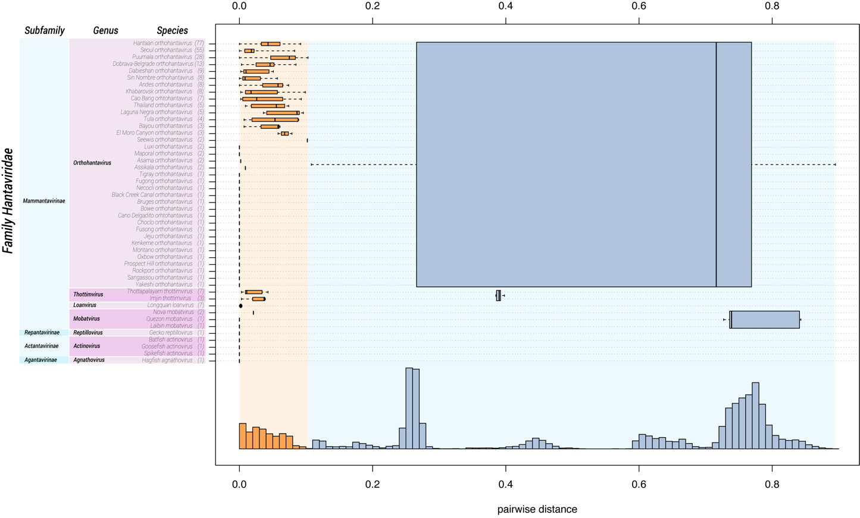
Figure 1: Intra-family genetic divergence in three-level hierarchical clustering of hantaviruses by DEmARC (version 1.0). Levels are defined by the three strongest PED thresholds. The number of viruses in the identified clusters are shown in brackets. All identified clusters correspond to monophyletic groups. Box-and-whisker graphs were used to plot distributions of distances between viruses from the same species (orange), and between viruses from different species but the same genus, and between viruses from different genera but the same family (blue). The boxes span from the first to the third quartile and include the median (bold line), and the whiskers (dashed lines) extend to the extreme values. The corresponding part of the PED distribution is shown below.

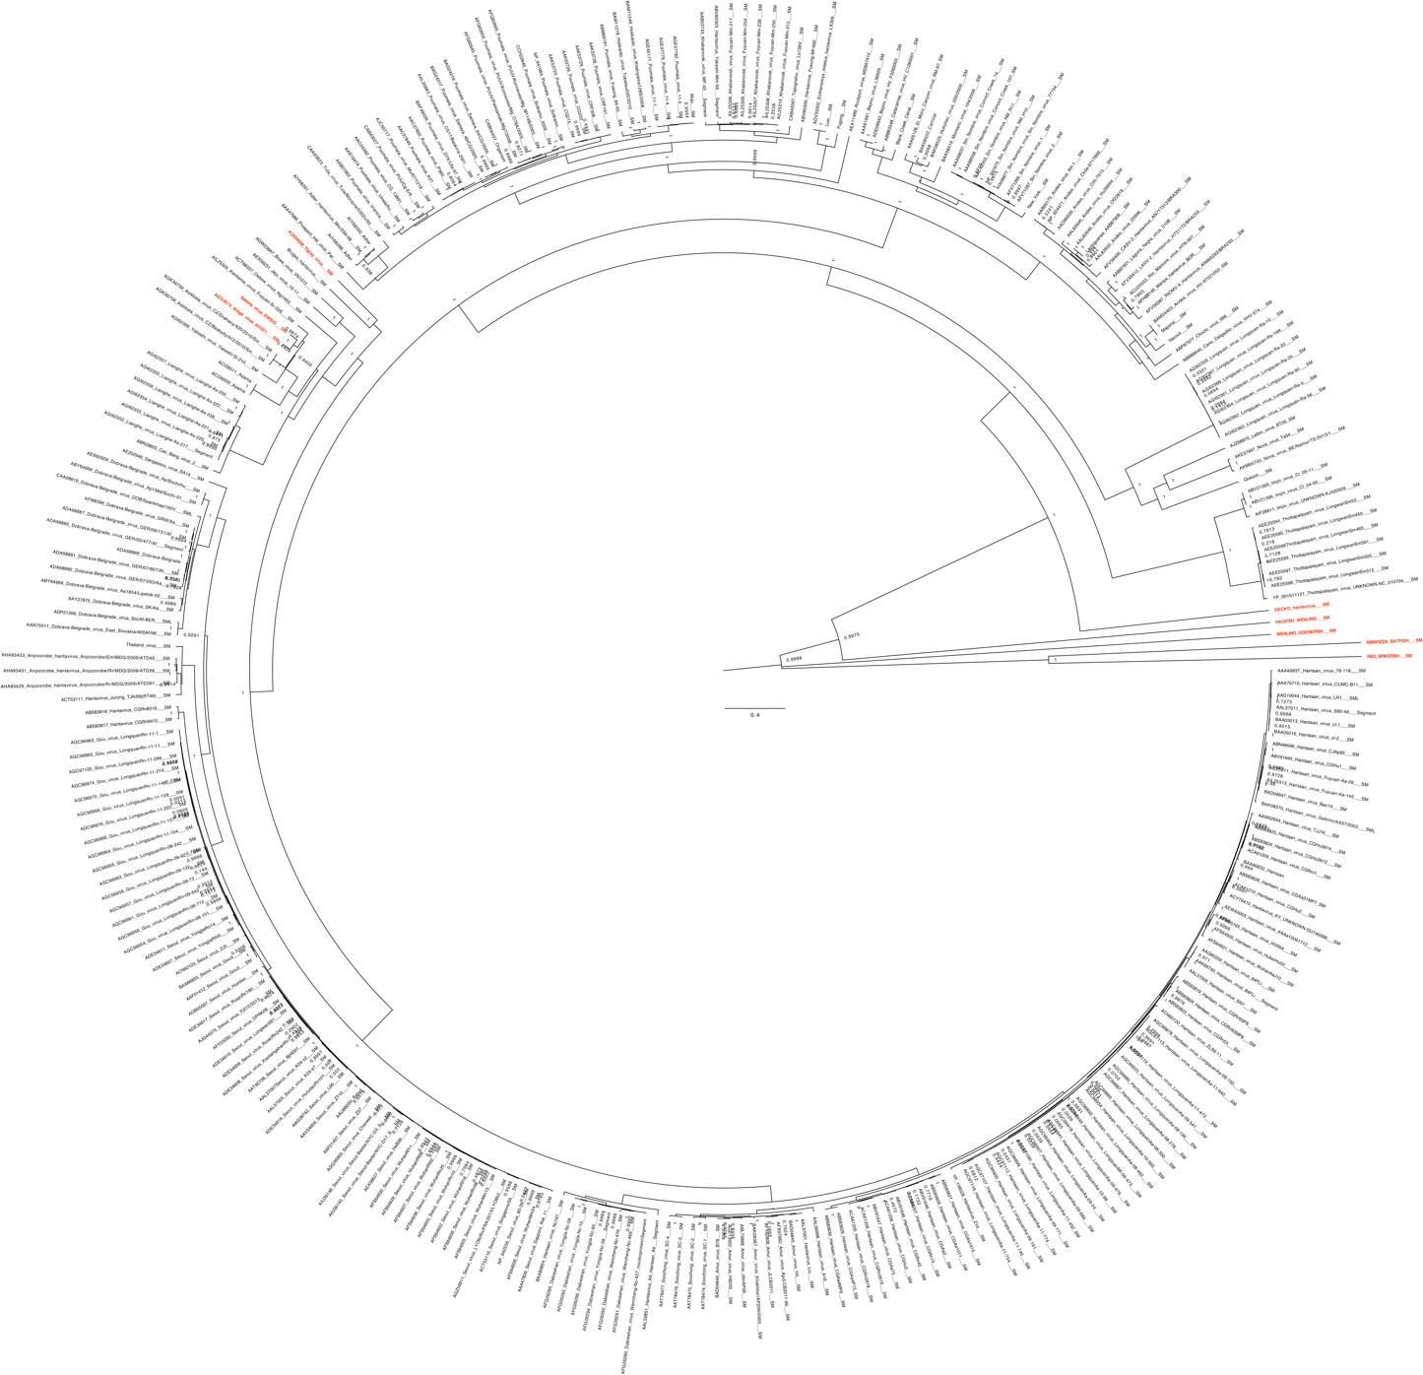
Figure 2: The figure shows a Bayesian MCMC tree estimated using a Bayesian Markov Chain Monte Carlo method implemented in BEAST, using the WAG amino acid model of amino acid substitutions. Maximum clade credibility trees were determined using TreeAnnotator with a burn-in of 10% of the sampled trees. The Markov chain Monte Carlo analyses were run until effective sample sizes above 200 were obtained. The dataset used consists of full-length products of coding regions of the S and M segments (nucleocapsid protein, and glycoprotein precursor respectively) and concatenated in one multiple alignment. New species are marked in red.

References:
- Mang Shi, Xian-Dan Lin, Xiao Chen, Jun-Hua Tian, Liang-Jun Chen, Kun Li, Wen Wang, John-Sebastian Eden, Jin-Jin Shen, Li Liu, Edward C. Holmes & Yong-Zhen Zhang. The evolutionary history of vertebrate RNA viruses. Nature volume 556, pages197–202 (2018).
- Ling J, Smura T, Tamarit D, Huitu O, Voutilainen L, Henttonen H, Vaheri A, Vapalahti O, Sironen T. Evolution and postglacial colonization of Seewis hantavirus with Sorex araneus in Finland. Infect Genet Evol. 2018 Jan;57:88-97.
- Joëlle Goüy de Bellocq, Jana Těšíková, Yonas Meheretu, Dagmar Čížková, Anna Bryjová, Herwig Leirs, Josef Bryja. Complete genome characterisation and phylogenetic position of Tigray hantavirus from the Ethiopian white-footed mouse, Stenocephalemys albipes. Infection, Genetics and Evolution, Volume 45, November 2016, Pages 242-245.

