IThis Word module should be used for all taxonomic proposals.
Please complete Part 1 and:
either Part 3 for proposals to create new taxa or change existing taxa
or Part 2 for proposals of a general nature.
Submit the completed Word module, together with the accompanying Excel module named in Part 3, to the appropriate ICTV Subcommittee Chair.
For guidance, see the notes written in blue, below, and the help notes in file Taxonomic_Proposals_Help_2018.
Part 1: TITLE, AUTHORS, etc

Code assigned: | 2018.012M |  | (to be completed by ICTV officers)
Short title: Move peribunyaviral species Estero Real orthobunyavirus into family Nairoviridae as Estero Real orthonairovirus
Author(s):
Kuhn, Jens H., kuhnjens@mail.nih.gov
Corresponding author with e-mail address:
Kuhn, Jens H., kuhnjens@mail.nih.gov
List the ICTV study group(s) that have seen this proposal:
A list of study groups and contacts is provided at http://www.ictvonline.org/subcommittees.asp . If in doubt, contact the appropriate subcommittee chair (there are six virus subcommittees: animal DNA and retroviruses, animal ssRNA-, animal ssRNA+, fungal and protist, plant, bacterial and archaeal) |  | ICTV Peribunyaviridae and Nairoviridae Study Groups
ICTV Study Group comments (if any) and response of the proposer:
Date first submitted to ICTV: |  |  | June 6, 2018
Date of this revision (if different to above):

ICTV-EC comments and response of the proposer:

Part 3: PROPOSED TAXONOMY

Name of accompanying Excel module: 2018.012M.N.v1.Bunyavirales_spmov

Supporting material:

Estero Real virus (ERV) was isolated in 1980 from Ornithodoros tadaridae ticks collected in El Estero Real, Sancti Spiritus, Cuba (Malkova et al). ERV was classified as an orthobunyavirus based on antigenic serologic cross-reaction with two other orthobunyaviruses, Abras and Zegla viruses, of the Patois serogroup. Recent genomic sequencing of Patois serogroup viruses confirmed all of them to be orthobunyaviruses with the notable exception of ERV. Genome organization, blast, and phylogenetic analyses confirmed ERV to be an orthonairovirus most closely related to, but distinct from, viruses in the species Hughes orthonairovirus (Figure 1, Aguilar et al.).

Figure 1. Family Nairoviridae, maximum likelihood phylogenetic analysis. LG + I + G4 amino acid substitution model for NP (S segment) and G (M segment) proteins and LG + F + I + G4 amino acid substitution model for L/RdRp (L segment) protein.
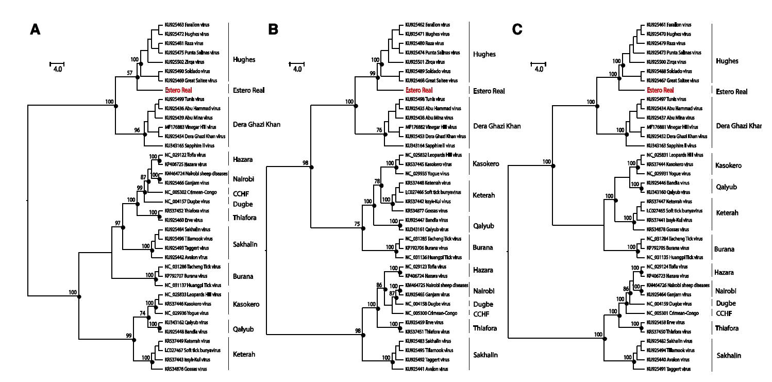

References:
Aguilar PV, Marciel de Souza W, Silvas JA, Wood T, Widen S, Fumagalli MJ, Nunes MRT.
Genetic Characterization of the Patois Serogroup (Genus Orthobunyavirus; Family Peribunyaviridae) and Evidence That Estero Real Virus is a Member of the Genus Orthonairovirus. Am J Trop Med Hyg. 2018 Jun 11. doi: 10.4269/ajtmh.18-0201. [Epub ahead of print]. PMID: 29893199.

Malkova, D., J. Holubova, V. Cerny, M. Daniel, A. Fernandez, J. de la Cruz, M. Herrera, and C.H. Calisher. Estero Real virus: A new virus isolated from argasid ticks, Ornithodoros tadaridae, in Cuba. Acta Virol. 29:247 250, 1985.

