This Word module should be used for all taxonomic proposals.
Please complete Part 1 and:
either Part 3 for proposals to create new taxa or change existing taxa
or Part 2 for proposals of a general nature.
Submit the completed Word module, together with the accompanying Excel module named in Part 3, to the appropriate ICTV Subcommittee Chair.
For guidance, see the notes written in blue, below, and the help notes in file Taxonomic_Proposals_Help_2018.
Part 1: TITLE, AUTHORS, etc

Code assigned: | 2018.014M |  | (to be completed by ICTV officers)
Short title: One (1) new species in the genus Phlebovirus (Bunyavirales: Phenuiviridae)
Author(s):
Keita Matsuno
Hideki Ebihara
Corresponding author with e-mail address:
Hideki Ebihara, Ebihara.Hideki@mayo.edu
List the ICTV study group(s) that have seen this proposal:
A list of study groups and contacts is provided at http://www.ictvonline.org/subcommittees.asp . If in doubt, contact the appropriate subcommittee chair (there are six virus subcommittees: animal DNA and retroviruses, animal ssRNA-, animal ssRNA+, fungal and protist, plant, bacterial and archaeal) |  | ICTV Phenuiviridae Study Group
ICTV Study Group comments (if any) and response of the proposer:
Date first submitted to ICTV: |  |  | June 6, 2018
Date of this revision (if different to above):

ICTV-EC comments and response of the proposer:

Part 3: PROPOSED TAXONOMY

Name of accompanying Excel module: 2018.014M.N.v1.Phlebovirus_sp
Supporting material:

A novel virus, called Mukawa virus (abbreviated MKWV) was found in Mukawa, Hokkaido, Japan in female ticks (species Ixodes persulcatus), and isolated/characterized by electron microscopy, full-genome sequencing, and virological characterizations in vitro and in vivo. A coding-complete/complete genome sequence was deposited in GenBank (accession numbers: LC063768, LC063769, and LC063770). The sequencing analyses demonstrated that the sequences of the L, M, and S termini of MKWV were identical to corresponding conserved sequences among viruses belonging to genus Phlebovirus (i.e., 3'-UGUGU and ACACA-5') [Ref. 1]. The phylogenetic trees constructed from the full-length nucleotide sequences of the L, M, and S genome segments revealed that MKWV shares a most recent, common ancestor with the mosquito/sandfly-borne phleboviruses, which belong to the species Bujaru phlebovirus, Candiru phlebovirus, Chilibre phlebovirus, Frijoles phlebovirus, Punta Toro phlebovirus, Rift Valley fever phlebovirus, Salehabad phlebovirus, and Sandfly fever Naples phlebovirus, rather than with tick-borne phleboviruses belonging to the species Uukuniemi phlebovirus or to banyangviruses such as SFTSV [Figures 1-3]. The phylogenetic distance based on L and N identified that the viruses most closely related to MKWV are Saint Floris virus (SAFV) and Arumowot virus (AMTV), respectively [Figure 4 and 5], both of which belong to the species Karimabad phlebovirus and Salehabad phlebovirus, respectively. In addition, the amino acid sequence divergence analysis based on L and N high divergences between MKWV, SAFV, and AMTV (44.2-48.7%). Despite the fact that MKWV is phylogenetically closely related to mosquito/sandfly-borne phleboviruses, MKWV exhibited limited replication ability in Aedes albopictus (mosquito)-, and sandfly-derived cells, but a higher level of replication in Ixodes (tick)-derived cells [Ref 1]. These data justify creating a novel species for MKWV.

Figure 1. The full-length sequence of the L segment of MKWV was used to construct a phylogenetic tree of the genus Phlebovirus using MrBayes. Posterior probability is indicated on each branch
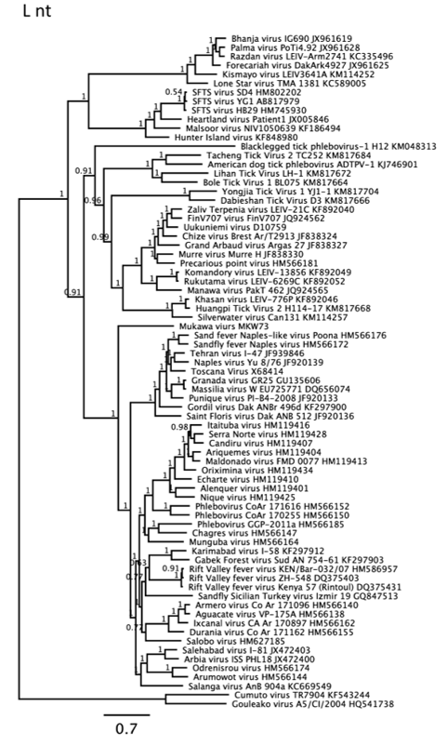

Figure 2. The full-length sequence of the M segment of MKWV was used to construct a phylogenetic tree of the genus Phlebovirus using MrBayes. Posterior probability is indicated on each branch.
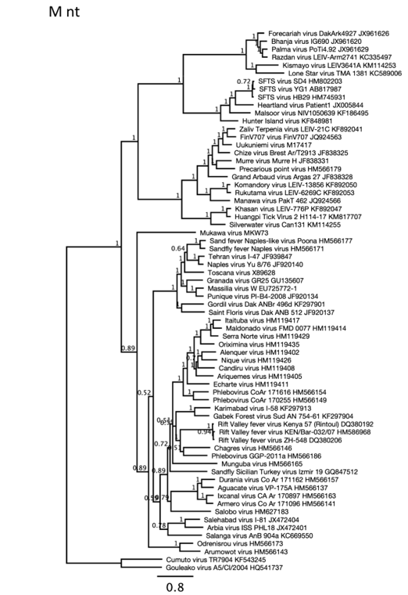

Figure 3. The full-length sequence of the S segment of MKWV was used to construct a phylogenetic tree of the genus Phlebovirus using MrBayes. Posterior probability is indicated on each branch.
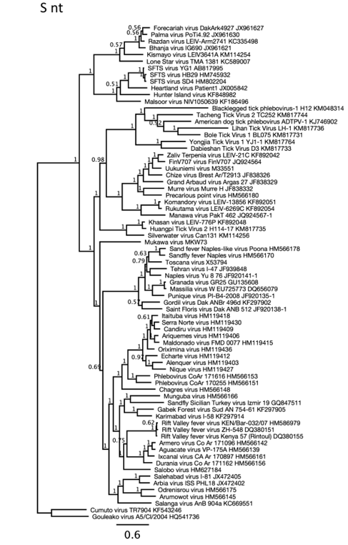

Figure 4. Phylogenetic analysis of functional domains of MKWV L protein. The deduced amino acid sequence of the L protein of MKWV was used to align with the other L protein sequences. The multiple sequence alignment was manually edited to extract conserved regions, including functional domains that are conserved among bunyavirus RNA polymerases. The extracted alignment of 150-amino-acid sequences was used to construct a phylogenetic tree of the genus Phlebovirus using MrBayes. Posterior probability is indicated on each branch.
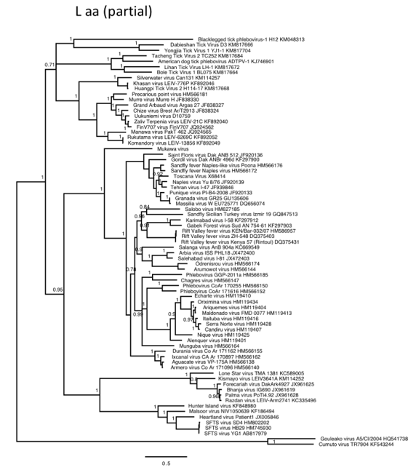

Figure 5. Phylogenetic analysis of MKWV N protein. The deduced amino acid sequence of the N protein of MKWV was used to construct a phylogenetic tree of the genus Phlebovirus using MrBayes. Posterior probability is indicated on each branch.

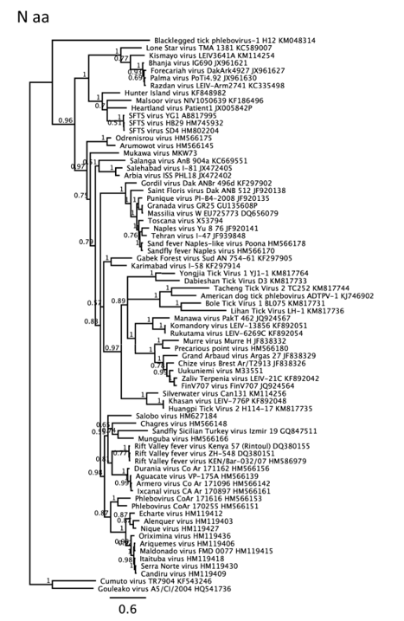

Figure 6. Phylogenetic analysis of MKWV NSs protein. The deduced amino acid sequence of the NSs protein of MKWV was used to construct a phylogenetic tree of the genus Phlebovirus using MrBayes. Posterior probability is indicated on each branch.
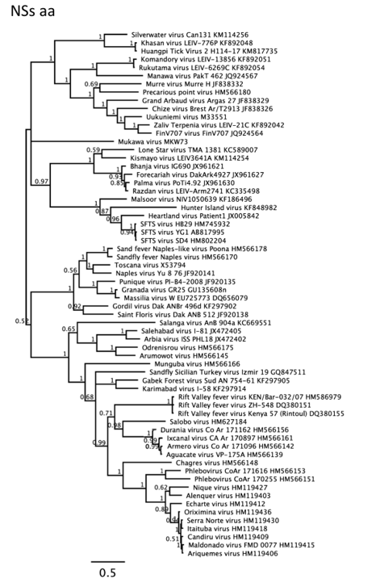

References:
Matsuno K, Kajihara M, Nakao R, Nao N, Mori-Kajihara A, Muramatsu M, Qiu Y,
Torii S, Igarashi M, Kasajima N, Mizuma K, Yoshii K, Sawa H, Sugimoto C, Takada
A, Ebihara H. The Unique Phylogenetic Position of a Novel Tick-Borne Phlebovirus
Ensures an Ixodid Origin of the Genus Phlebovirus. mSphere. 2018 Jun 13;3(3).
pii: e00239-18. doi: 10.1128/mSphere.00239-18. Print 2018 Jun 27. PubMed PMID:
29898985; PubMed Central PMCID: PMC6001614.

