This Word module should be used for all taxonomic proposals.
Please complete Part 1 and:
either Part 3 for proposals to create new taxa or change existing taxa
or Part 2 for proposals of a general nature.
Submit the completed Word module, together with the accompanying Excel module named in Part 3, to the appropriate ICTV Subcommittee Chair.
For guidance, see the notes written in blue, below, and the help notes in file Taxonomic_Proposals_Help_2018.
Part 1: TITLE, AUTHORS, etc

Code assigned: | 2018.008M |  | (to be completed by ICTV officers)
Short title: Thirty-eight new species within the genus Orthobunyavirus
Author(s):
Amy J. Lambert, ahk7@cdc.gov
Scott Adkins, scott.adkins@ars.usda.gov
Sergey Alkhovsky, salkh@yandex.ru
Martin Beer, Martin.Beer@fli.de
Carol Blair, Carol.Blair@ColoState.EDU
Charles H. Calisher, calisher@cybersafe.net
Mike Drebot, mike.drebot@canada.ca
Holly R. Hughes, ltr8@cdc.gov
Márcio R.T. Nunes, marcionenesbrasil@yahoo.com.br
Marco Marklewitz, marco.marklewitz@charite.de
Xiǎohóng Shí (石晓宏), Xiaohong.Shi@glasgow.ac.uk
Corresponding author with e-mail address:
Holly R. Hughes, ltr8@cdc.gov (alternative contact, Amy J. Lambert, ahk7@cdc.gov)
List the ICTV study group(s) that have seen this proposal:
A list of study groups and contacts is provided at http://www.ictvonline.org/subcommittees.asp . If in doubt, contact the appropriate subcommittee chair (there are six virus subcommittees: animal DNA and retroviruses, animal ssRNA-, animal ssRNA+, fungal and protist, plant, bacterial and archaeal) |  | The authors listed above comprise the ICTV Peribunyaviridae Study Group
ICTV Study Group comments (if any) and response of the proposer:
Date first submitted to ICTV: |  |  | June 6, 2018
Date of this revision (if different to above):

ICTV-EC comments and response of the proposer:

Part 3: PROPOSED TAXONOMY

Name of accompanying Excel module: 2018.008M.N.v1.Orthobunyavirus_38sp
Supporting material:
additional material in support of this proposal
The purpose of this proposal is to refine the taxonomic resolution of the genus Orthobunyavirus to better represent the breadth and diversity of viruses captured therein by defining and applying a new species demarcation criterion. To achieve this, coding-complete genomes of each named virus of the Bunyamwera, California, Simbu, and Wyeomyia groups, comprehensively described as of 1 May 2018, were downloaded from GenBank. S, M, and L, as well as concatenated ORFs were codon aligned with Clustal Omega. Alignments were subjected to the model fit program in MEGA 7. Percent identities were calculated using the p-distance model with rates G+I (as determined in the model fit) and a complete deletion of missing data. Phylogenies were inferred using BEAST 1.8.4 with the LG+G+I model (as determined in the model fit), a relaxed log normal molecular clock, and a constant coalescent tree model. MCMC consisted of 10 million generations to reach an ESS of 200 or greater.
To determine a demarcation criterion for speciation that best represents the diversity of represented orthobunyaviruses, varied criteria, including the current published sequence-based demarcation criterion (<90% N protein) from the 9th report to the ICTV were evaluated against the above described battery of segment-specific and concatenated ORFs. Resultant species lists were reviewed with regard to published phylogenetic, serological, clinical, host, geographic and vector ranges [1-7]. Based on these analyses, we propose to define species demarcation for the genus Orthobunyavirus as <96% identity in the amino acid sequence of the L segment (i.e., viruses with <96% identity represent unique species). Here, we present data to define 48 species (38 new) within the Bunyamwera, California, Simbu, and Wyeomyia groups (65 total viruses analyzed, see Excel sheet “Orthobunyavius percent identity-final) by application of this L segment criterion. Furthermore, our analyses suggest that this criterion can be applied to the broader Orthobunyavirus genus as part of future efforts for additional speciation. Finally, it is important to emphasize that there is a consensus among the ICTV Peribunyaviridae Study Group that a growing body of orthobunyavirus genomic data will justify an ongoing critical review of this and alternative criteria for speciation in the coming years.

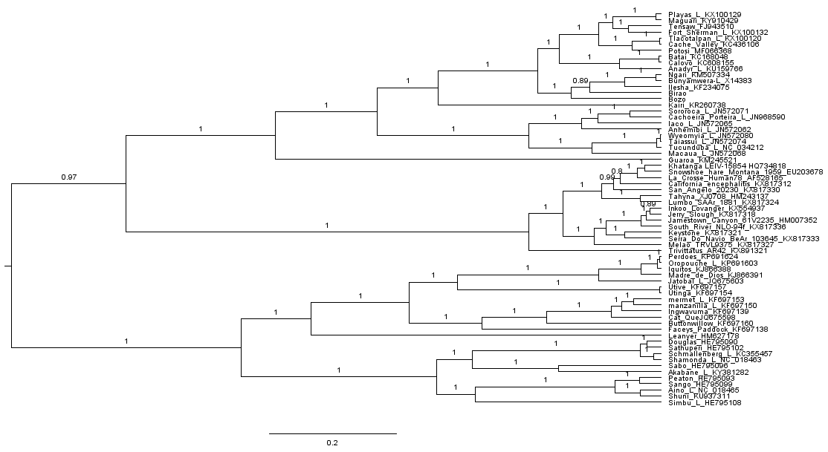
Figure. Maximum clade credibility tree of the RNA-dependent RNA polymerase from Bunyamwera, Wyeomyia, California, and Simbu groups of the genus Orthobunyavirus. Posterior probabilities are shown on each branch. Viruses are labelled with strain and GenBank accession number.

References:
1. Beaty, B.J. and C.H. Calisher, Bunyaviridae--natural history. Curr Top Microbiol Immunol, 1991. 169: p. 27-78.
2. Calisher, C.H., The Bunyaviridae, ed. R.M. Elliot. 1996: Plenum Press.
3. Ladner, J.T., et al., Genomic and phylogenetic characterization of viruses included in the Manzanilla and Oropouche species complexes of the genus Orthobunyavirus, family Bunyaviridae. J Gen Virol, 2014. 95(Pt 5): p. 1055-66.
4. Chowdhary, R., et al., Genetic characterization of the Wyeomyia group of orthobunyaviruses and their phylogenetic relationships. J Gen Virol, 2012. 93(Pt 5): p. 1023-34.
5. Goller, K.V., et al., Schmallenberg virus as possible ancestor of Shamonda virus. Emerg Infect Dis, 2012. 18(10): p. 1644-6.
6. Hughes, H.R., et al., Full genomic characterization of California serogroup viruses, genus Orthobunyavirus, family Peribunyaviridae including phylogenetic relationships. Virology, 2017. 512: p. 201-210.
7. Gerrard, S.R., et al., Ngari virus is a Bunyamwera virus reassortant that can be associated with large outbreaks of hemorrhagic fever in Africa. J Virol, 2004. 78(16): p. 8922-6.

