This form should be used for all taxonomic proposals. Please complete all those modules that are applicable.
For guidance, see the notes written in blue and the separate document “Help with completing a taxonomic proposal”

Please try to keep related proposals within a single document.

Part 1: TITLE, AUTHORS, etc

Code assigned: | 2017.012M |  |  |  | (to be completed by ICTV officers)
Short title: Taxonomic expansion and reorganization of the order Bunyavirales
Modules attached  (Modules 1, 4 and either 2 or 3 are required. |  | 1 2 3 4
Author(s):
Piet Maes
Sergey Alkhovsky
Martin Beer
Thomas Briese
Michael J. Buchmeier
Charles H. Calisher
Rémi Charrel
Il Ryong Choi
Christopher S. Clegg
Juan Carlos de la Torre
Jospeh L. DeRisi
Michele Digiaro
Hideki Ebihara
Sébastien Emonet
Toufic Elbeaino
Jean-Paul Gonzalez
Anne-Lise Haenni
Rakesh Jain
Gilda Jonson
Sandra Junglen
Richard Kormelink
Amy Lambert
Igor S. Lukashevich
Giovanni P. Martelli
Nicole Mielke-Ehret
Hans-Peter Muehlbach
Marcio R. T. Nunes
Clarence J. Peters
Alexander Plyusnin
Sheli R. Radoshitzky
Victor Romanowski
Maria S. Salvato
Takahide Sasaya
Connie Schmaljohn
Yukio Shirako
Mark D. Stenglein
Robert B. Tesh
Taiyun Wei
Shyi-Dong Yeh
Yongzhen Zhang
Xueping Zhou
Jens H. Kuhn
Corresponding authors with e-mail addresses:
Piet Maes, piet.maes@kuleuven.be
Jens H. Kuhn, kuhnjens@mail.nih.gov
List the ICTV study group(s) that have seen this proposal:
A list of study groups and contacts is provided at http://www.ictvonline.org/subcommittees.asp . If in doubt, contact the appropriate subcommittee chair (there are six virus subcommittees: animal DNA and retroviruses, animal ssRNA-, animal ssRNA+, fungal and protist, plant, bacterial and archaeal) |  |  | ICTV Arenaviridae, Bunyaviridae, Emaravirus, Tenuivirus, and Tospovirus Study Groups
The ICTV Arenaviridae, Bunyaviridae, Emaravirus, Tenuivirus, and Tospovirus Study Groups and the additional authors of this TaxoProp have seen and discussed this proposal and agreed to its submission to the ICTV Executive Committee based on majority votes of support by individual Study Group members or the absence of (dissenting) votes.
ICTV Study Group comments (if any) and response of the proposer:
N/A
Date first submitted to ICTV: |  |  |  | June 8, 2017
Date of this revision (if different to above): |  |  |  | August 11, 2017

ICTV-EC comments and response of the proposer:
EC49 decision:
Uc: Add genome maps (or links); provide derivation of genus names; consider use of "-associated" in some species names.

Part 2: PROPOSED TAXONOMY
In 2016, the ICTV Bunyaviridae, Emaravirus, and Tenuivirus Study Groups have taken initial steps to taxonomically reorganize/reclassify bunyaviruses and bunya-like viruses using a global DEmARC analysis/Bayesian MCMC phylogeny (TaxoProp 2016.030a-vM “Create a new order, Bunyavirales, to accommodate nine families (eight new, one renamed) comprising thirteen genera)”. This effort led to the official establishment of the order Bunyavirales by the ICTV/IUMS in March 2017 (Adams et al.).
Since the beginning of these efforts, numerous bunya-like viruses have been discovered in invertebrates (Li et al., Makhsous et al., Shi et al.). The majority of these viruses has not been isolated in tissue culture, nor is much information available about them other than complete, coding-complete, or fragmented genomic sequences. The ICTV recently decided that viruses are classifiable based on coding-complete/complete genomic sequences alone (Simmonds et al.). Thus, we repeated the DEmARC/Bayesian MCMC analysis of 2016 with all those new viruses included for which complete or coding-complete alignable genome sequences have been deposited into GenBank (see accompanying Excel spreadsheet). Briefly, Bayesian phylogenetic analyses were inferred in BEAST 1.8.2 employing 20 independent MCMC runs with a chain length of 25,000,000 generations. Tree and log files of independent runs of BEAST were combined using LogCombiner 1.8.2, employing a Burn in period of 10%. The Markov chain Monte Carlo analyses were run until effective sample sizes above 200 were obtained. The consensus tree was built with TreeAnnotator 1.8.2 using the maximum clade credibility method and visualized in Figtree (http://tree.bio.ed.ac.uk/software/figtree/).
The results of this analysis are shown in Figures 1 and 2. They indicate that overall the taxonomic decisions of 2016 (establishment of the order and several new families, including emaraviruses and tenuiviruses) hold up. However, the resolution of the phylogeny increased significantly and several major taxonomic amendments are required:
- three monogeneric families (Feraviridae, Jonviridae, and Tospoviridae) need to be abandoned and their genera need to be moved into existing families
- three new families need to be established for highly divergent Chinese viruses
- the family Arenaviridae needs to be included in the order Bunyavirales
- 19 new genera need to be established
These results are also in line with analyses published by others (Gutteres et al., Li et al., Shi et al.) and are confirmed by a global RNA virus RdRp analysis (co-submitted proposal to establish a phylum for negative-sense RNA viruses).

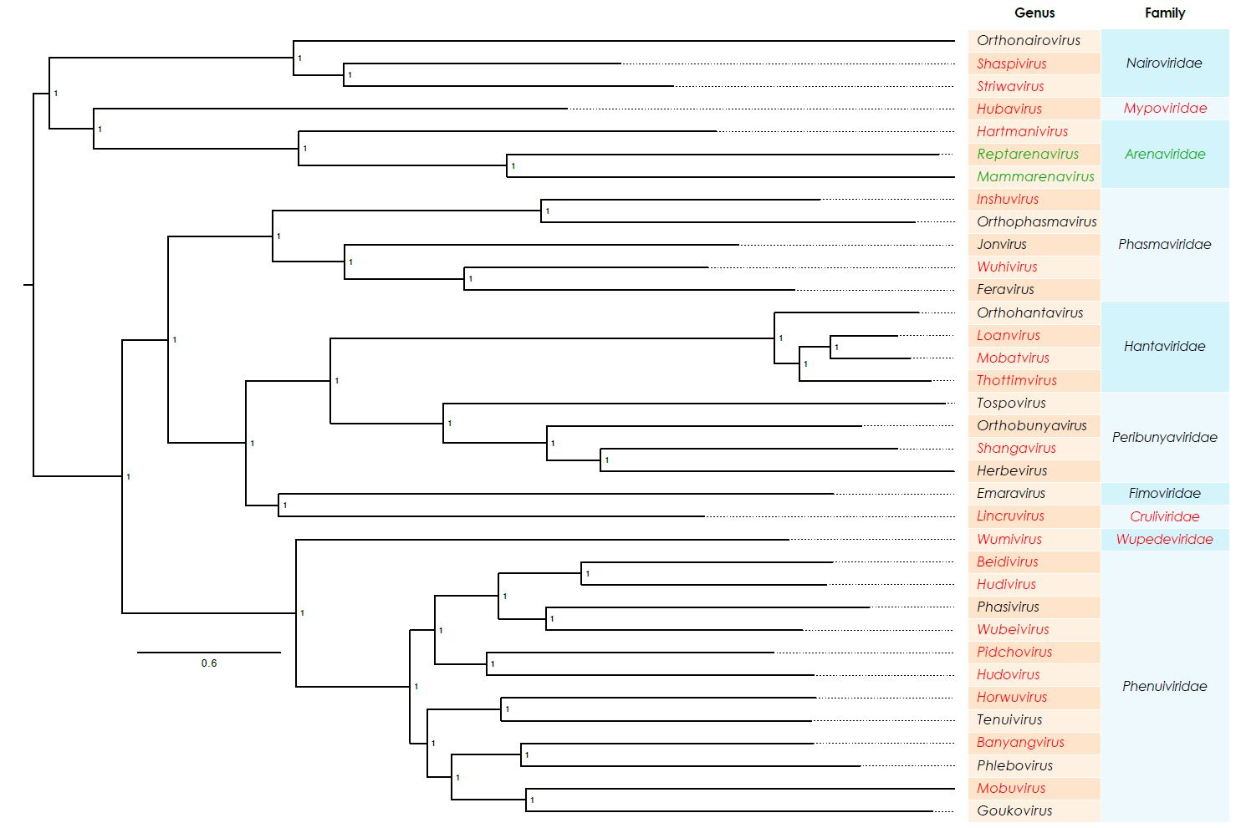
Figure 1. The figure shows a Bayesian MCMC tree estimated using a Bayesian Markov Chain Monte Carlo method implemented in BEAST, using the WAG amino acid model of amino acid substitutions. Maximum clade credibility trees were determined using TreeAnnotator with a burn-in of 10% of the sampled trees. The Markov chain Monte Carlo analyses were run until effective sample sizes above 200 were obtained. The dataset used consists of full length products of coding regions of the S, M, and L segments (nucleocapsid protein, glycoprotein precursor, and RNA-dependent RNA polymerase, respectively) or in the case of arenavirus S and L segments and concatenated in one multiple alignment. The dashed boxes show the proposed family delineation as calculated with DEmARC version 1.0. The DEmARC method is an approach for partitioning the genetic diversity of a virus family /genus within a hierarchically organized framework. The developed approach can provide quantitative support for both the delineated classification levels and the inferred taxa by objectively devising the number and values of thresholds on family genetic divergence at each level in a rational and family/genus-wide manner. Genetic divergence is quantified by pairwise evolutionary distances (PEDs) estimated by maximum likelihood inference on a multiple alignment of proteins. Numbers over each main node represents the Bayesian Posterior probabilities. The number below the bar (0.6) corresponds to the amino acid distance between sequences.

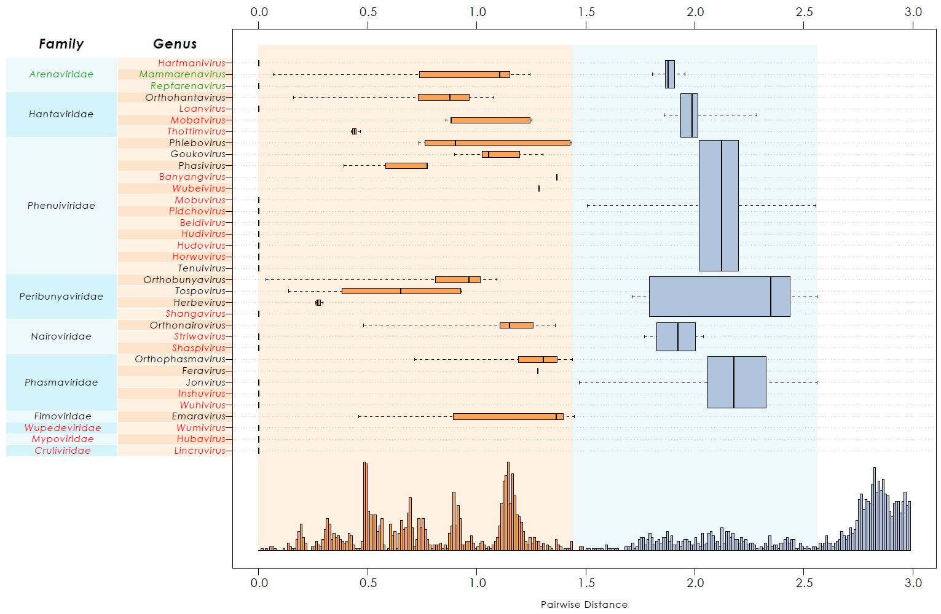
Figure 2: Intra-order genetic divergence in three-level hierarchical clustering of bunyaviruses by DEmARC (version 1.0). Levels are defined by the three strongest PED thresholds. The number of viruses in the identified clusters are shown in brackets. All identified clusters correspond to monophyletic groups. Box-and-whisker graphs were used to plot distributions of distances between viruses from the same genus (orange), and between viruses from different species but the same genus (blue), and between viruses from different genera but the same family (blue). The boxes span from the first to the third quartile and include the median (bold line), and the whiskers (dashed lines) extend to the extreme values. The corresponding part of the PED distribution is shown below.

Name of accompanying spreadsheet: 2017.012M.N.v1.Bunyavirales_rev
Please display the taxonomic changes you are proposing on the accompanying spreadsheet module 2017_TP_Template_Excel_module. Submit both this and the spreadsheet to the appropriate ICTV Subcommittee Chair.

Part 4: APPENDIX: supporting material

For genome maps of most viruses proposed to be classified here see Li et al. (https://elifesciences.org/articles/05378) and Shi et al.

Etymology of proposed genus and family names:
- Banyangvirus: Banyang: sigil of Bhanja virus and Huaiyangshan virus; virus: suffix for a genus
- Beidivirus: Beidi: sigil of Húběi diptera virus 3; virus: suffix for a genus
- Cruliviridae: Cruli: sigil of Crustacean lincruvirus; viridae: suffix for a family
- Horwuvirus: Horwu: sigil of Wǔhàn horsefly virus; virus: suffix for a genus
- Hubavirus: Huba: sigil of Húběi myriapoda virus 5; virus: suffix for a genus
- Hudivirus: Hudi: sigil of Húběi diptera virus 4; virus: suffix for a genus
- Hudovirus: Hudo: sigil of Húběi lepidoptera virus 1; virus: suffix for a genus
- Inshuvirus: Inshu: sigil of Shuāngào insect virus 2; virus: suffix for a genus
- Lincruvirus: Lincru: sigil of Wēnlǐng crustacean virus 9; virus: suffix for a genus
- Loanvirus: Loan: sigil of Lóngquán; virus: suffix for a genus
- Mobatvirus: Mobat: sigil of mole and bat; virus: suffix for a genus
- Mobuvirus: Mobu: sigil of Mothra virus and bunyavirus; virus: suffix for a genus
- Mypoviridae: Mypo: sigil of Húběi myriapoda virus 5; viridae: suffix for a family
- Pidchovirus: Pidcho: derived from Pidgey virus; virus: suffix for a genus
- Shangavirus: Shanga: sigil of Shuāngào insect virus 1; virus: suffix for a genus
- Shaspivirus: Shaspi: sigil of Shāyáng spider virus 1; virus: suffix for a genus
- Striwavirus: Striwa: sigil of Sānxiá water strider virus 1; virus: suffix for a genus
- Thottimvirus: Thottim: derived from Thottopalayam; virus: suffix for a genus
- Wubeivirus: Wubei: sigil of Wǔhàn fly virus 1 and Húběi diptera virus 5; virus: suffix for a genus
- Wuhivirus: Wuhi: sigil of Wǔhàn insect virus 2; virus: suffix for a genus
- Wumivirus: Wumi: sigil of Wǔhàn millipede virus 2; virus: suffix for a genus
- Wupedeviridae: Wupede: sigil of Wǔhàn millipede virus 2; viridae: suffix for a family

References:

Changes to taxonomy and the International Code of Virus Classification and Nomenclature ratified by the International Committee on Taxonomy of Viruses (2017).
Adams MJ, Lefkowitz EJ, King AMQ, Harrach B, Harrison RL, Knowles NJ, KropinskiAM, Krupovic M, Kuhn JH, Mushegian AR, Nibert M, Sabanadzovic S, Sanfaçon H, Siddell SG, Simmonds P, Varsani A, Zerbini FM, Gorbalenya AE, Davison AJ.
Arch Virol. 2017 Aug;162(8):2505-2538. doi: 10.1007/s00705-017-3358-5. [Epub ahead of print]
PMID: 28434098

New bunya-like viruses: Highlighting their relations.
Guterres A, de Oliveira RC, Fernandes J, de Lemos ER, Schrago CG.
Infect Genet Evol. 2017 Apr;49:164-173. doi: 10.1016/j.meegid.2017.01.019. Epub 2017 Jan 19.
PMID: 28111322

Unprecedented genomic diversity of RNA viruses in arthropods reveals the ancestry of negative-sense RNA viruses.
Li CX, Shi M, Tian JH, Lin XD, Kang YJ, Chen LJ, Qin XC, Xu J, Holmes EC, ZhangYZ.
Elife. 2015 Jan 29;4. doi: 10.7554/eLife.05378.
PMID: 25633976

Genome Sequences of Three Novel Bunyaviruses, Two Novel Rhabdoviruses, and One Novel Nyamivirus from Washington State Moths.
Makhsous N, Shean RC, Droppers D, Guan J, Jerome KR, Greninger AL.
Genome Announc. 2017 Feb 16;5(7). pii: e01668-16. doi: 10.1128/genomeA.01668-16.
PMID: 28209840

Redefining the invertebrate RNA virosphere.
Shi M, Lin XD, Tian JH, Chen LJ, Chen X, Li CX, Qin XC, Li J, Cao JP, Eden JS, Buchmann J, Wang W, Xu J, Holmes EC, Zhang YZ.
Nature. 2016 Nov; 540(7634): 539–543. doi: 10.1038/nature20167. [Epub ahead of print]
PMID: 27880757

Consensus statement: Virus taxonomy in the age of metagenomics.
Simmonds P, Adams MJ, Benkő M, Breitbart M, Brister JR, Carstens EB, Davison AJ, Delwart E, Gorbalenya AE, Harrach B, Hull R, King AM, Koonin EV, Krupovic M, KuhnJH, Lefkowitz EJ, Nibert ML, Orton R, Roossinck MJ, Sabanadzovic S, Sullivan MB, Suttle CA, Tesh RB, van der Vlugt RA, Varsani A, Zerbini FM.
Nat Rev Microbiol. 2017 Mar;15(3):161-168. doi: 10.1038/nrmicro.2016.177. Epub 2017 Jan 3. Review.
PMID: 28134265

