This Word module should be used for all taxonomic proposals.
Please complete Part 1 and:
either Part 3 for proposals to create new taxa or change existing taxa
or Part 2 for proposals of a general nature.
Submit the completed Word module, together with the accompanying Excel module named in Part 3, to the appropriate ICTV Subcommittee Chair.
For guidance, see the notes written in blue, below, and the help notes in file Taxonomic_Proposals_Help_2018.
Part 1: TITLE, AUTHORS, etc

Code assigned: | 2019.007M |  | (to be completed by ICTV officers)
Short title: Create one new species in the genus Ebolavirus (Mononegavirales: Filoviridae)
Author(s):
Tracey Goldstein; tgoldstein@ucdavis.edu
Simon J. Anthony; sja2127@cumc.columbia.edu
Bird, Brian; bhbird@ucdavis.edu
Gbakima, Aiah; gbakimaaa2009@gmail.com
Jambai, Amara; amarajambai@yahoo.com
Wells, Heather; hlw2124@cumc.columbia.edu

and

the ICTV Filoviridae Study Group:
Amarasinghe, Gaya; gamarasinghe@wustl.edu
Basler, Christopher; cbasler@gsu.edu
Bavari, Sina; sina.bavari.civ@mail.mil
Bukreyev, Alexander A.; abukreye@utmb.edu
Chandran, Kartik; kartik.chandran@einstein.yu.edu
Crozier, Ian; ian.crozier@nih.gov
Dolnik, Olga; Dolnik@staff.uni-marburg.de
Dye, John M.; John.m.dye1.civ@mail.mil
Formenty, Pierre B. H.; formentyp@who.int
Griffiths, Anthony; ahgriff@bu.edu
Hewson, Roger; roger.hewson@phe.gov.uk
Kobinger, Gary; Gary.Kobinger@crchudequebec.ulaval.ca
Kuhn, Jens H.; kuhnjens@mail.nih.gov
Leroy, Eric M.; eric.leroy@ird.fr
Mühlberger, Elke; muehlber@bu.edu
Netesov, Sergey V. (Нетёсов, Сергей Викторович); netesov.s@nsu.ru
Palacios, Gustavo; gustavo.f.palacios.ctr@mail.mil
Pályi, Bernadett; palyi.bernadett@oki.antsz.hu
Pawęska, Janusz T.; januszp@nicd.ac.za
Smither, Sophie; sjsmither@mail.dstl.gov.uk
Takada, Ayato (高田礼人); atakada@czc.hokudai.ac.jp
Towner, Jonathan S.; jit8@cdc.gov
Wahl, Victoria; Victoria.Wahl@NBACC.DHS.GOV
Corresponding author with e-mail address:
Kuhn, Jens H.; kuhnjens@mail.nih.gov
List the ICTV study group(s) that have seen this proposal:
A list of study groups and contacts is provided at http://www.ictvonline.org/subcommittees.asp . If in doubt, contact the appropriate subcommittee chair (there are six virus subcommittees: animal DNA and retroviruses, animal ssRNA-, animal ssRNA+, fungal and protist, plant, bacterial and archaeal) |  | ICTV Filoviridae Study Group
ICTV Study Group comments (if any) and response of the proposer:
Date first submitted to ICTV: |  |  | 10/29/2018
Date of this revision (if different to above):

ICTV-EC comments and response of the proposer:

Part 3: PROPOSED TAXONOMY

Name of accompanying Excel module: 2019.007M.A.v1.Bombali_ebolavirus.xlxs
Supporting material:

Recently, a new filovirus, Bombali virus (BOMV), was discovered by consensus PCR in oral and rectal swab samples collected in 2016 from little free-tailed bats (Chaerephon pumilus) and Angola free-tailed bats (Mops condylurus) in Sierra Leone. Two complete BOMV genome sequences were determined and have been deposited to GenBank; isolation of BOMV has not been reported (Goldstein & Anthony et al.).

Phylogenetic analysis clearly places BOMV in to the genus Ebolavirus of the mononegaviral family Filoviridae (Fig. 1).

Figure 1. Phylogeny of BOMV. a–g, Phylogenetic analysis of each BOMV structural protein (deduced amino acid sequence) compared to those of other filoviruses: EBOV (Ebola virus, species Zaire ebolavirus, genus Ebolavirus), BDBV (Bundibugyo virus, species Bundibugyo ebolavirus, genus Ebolavirus), TAFV (Taï Forest virus, species Tai Forest ebolavirus, genus Ebolavirus), SUDV (Sudan virus, species Sudan ebolavirus, genus Ebolavirus), RESTV (Reston virus, species Reston ebolavirus, genus Ebolavirus), LLOV (Lloviu virus, species Lloviu cuevavirus, genus Cuevavirus), and MARV (Marburg virus, species Marburg marburgvirus, genus Marburgvirus). (a–g). h, Phylogenetic analysis of the BOMV genome compared to those of other filoviruses. Sequences were edited using Geneious (version 9.1.7; https://www.geneious.com/) and aligned with CLUSTALW (https://www.genome.jp/tools-bin/clustalw). Bayesian coalescent phylogenetic analysis was implemented using BEAST (http://beast.community/tree_priors). Nucleotide substitution models were chosen using jModelTest (https://github.com/ddarriba/jmodeltest2) and a Yule process speciation model. Each analysis was run for 1,000,000 generations. Maximum clade credibility trees were generated using the TreeAnnotator program in BEAST and edited using FigTree. Alignments and trees were created separately for each gene and a concatenation was used for the complete genome. The nucleotide alignment of the ebolavirus genomes was screened for recombination using the seven algorithms in the Recombination Detection Program (version 4.87; http://web.cbio.uct.ac.za/~darren/rdp.html). The ebolavirus nucleotide alignment was analysed for evidence of selection using the SLAC, FEL, MEME and FUBAR algorithms, executed in Datamonkey (http://datamonkey.org/) and with the M7 and M8 codon models in codeml (Phylogenetic Analysis by Maximum Likelihood (PAML) package; http://abacus.gene.ucl.ac.uk/software/paml.html). The codon models in PAML were implemented using both a gene-specific tree for each gene and a species-level tree (the concatenated alignment tree). Model fit was compared using a likelihood ratio test (χ2d.f. = 2). To visualize the variation in selective pressure across the genome, the empirical Bayes posterior mean ω ± credible interval was plotted for each codon position and colour-coded according to the posterior probability of ω > 1 (ω < 1 indicates purifying selection, ω > 1 indicates positive selection).” Figure and method taken from (Goldstein & Anthony et al.).

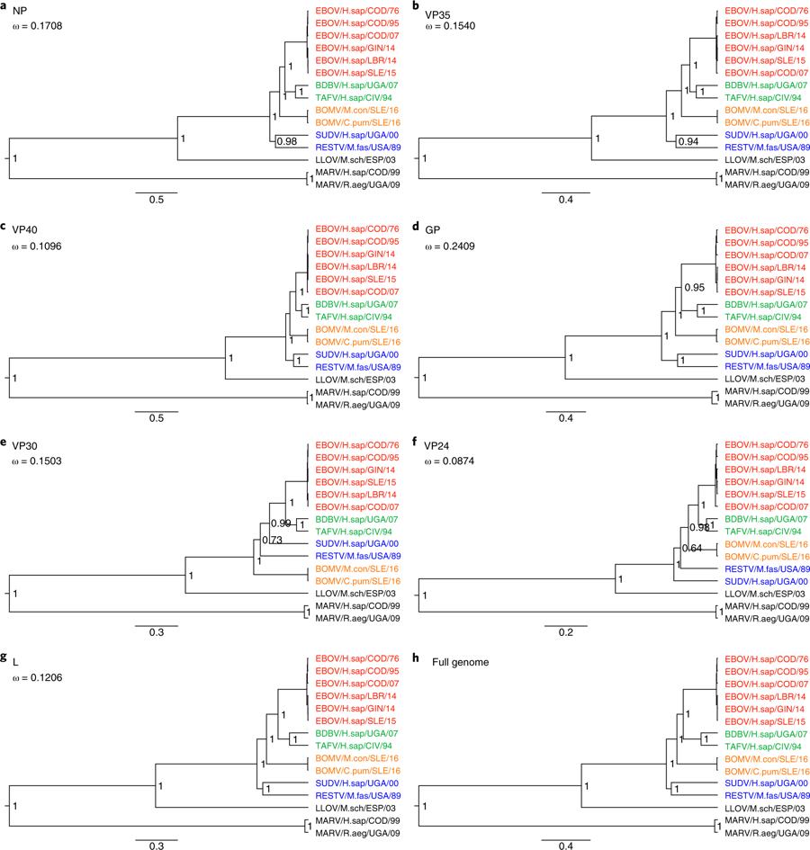

In 2017, the ICTV Filoviridae Study Group established filovirus taxon demarcation criteria based on the US National Center for Biotechnology Information (NCBI) Pairwise Sequence Comparison (PASC) tool. Genus demarcation was set at the 55–58% sequence diversity threshold range and species demarcation was set at the 23–36% sequence diversity threshold. Using RefSeq “type” filovirus genome sequences, an algorithm was established for streamlined filovirus classification (Fig. 2).

Figure 2. Algorithm/flow chart for filovirus classification based on genomics sequence information and PASC-derived sequence demarcation criteria established by the ICTV Filoviridae Study Group (Bào et al.). A putative filovirus genome of interest is compared to the type filovirus RefSeq genome sequence (i.e., that of Marburg virus/H.sapiens-tc/KEN/1980/Mt. Elgon-Musoke) and then sequentially moved through the process until its proper taxonomic placement is revealed or the need to create novel taxa is obvious.

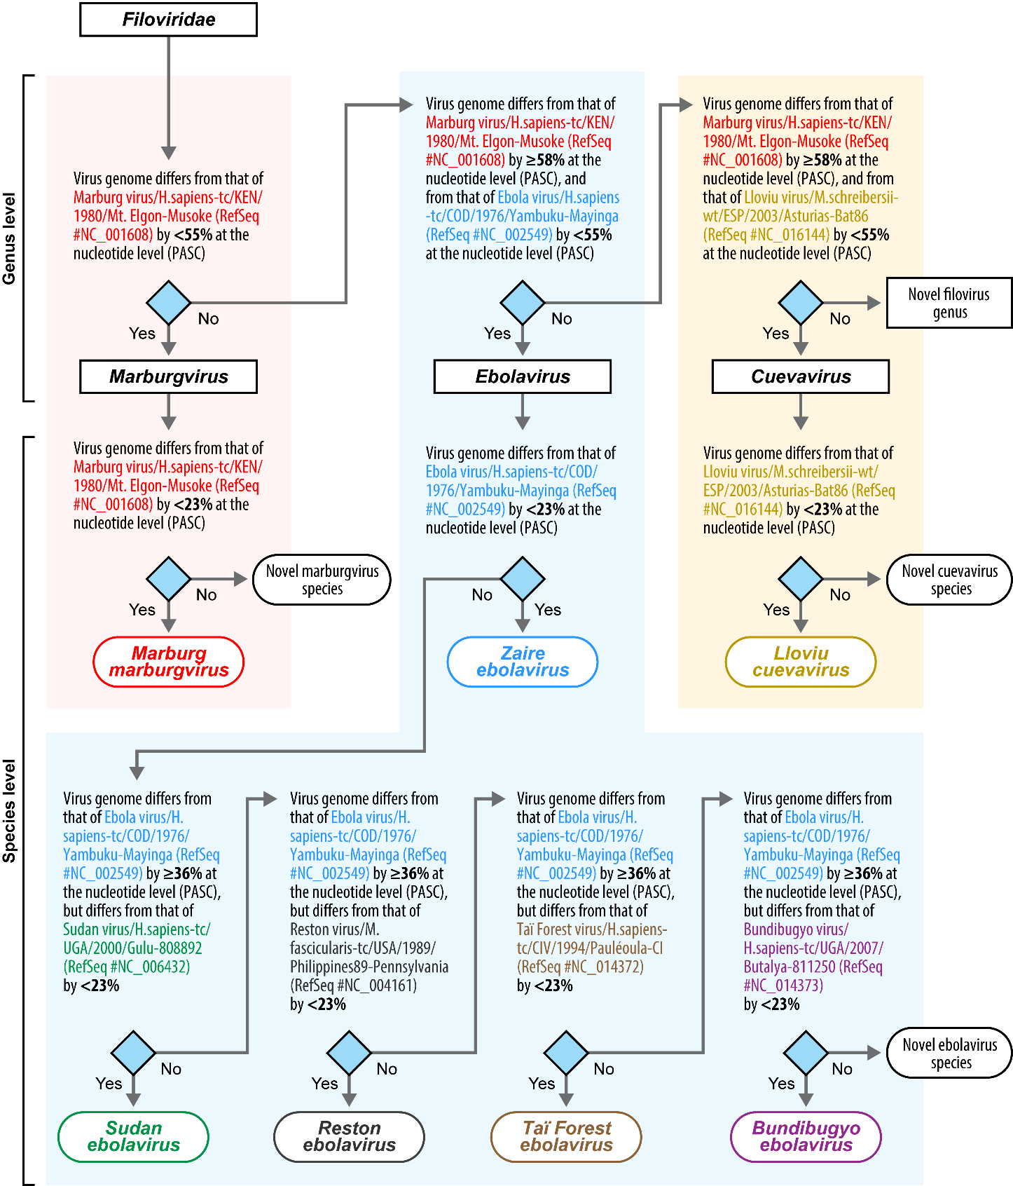

PASC analysis using the complete genome sequences of BOMV revealed that BOMV is most closely related to Bundibugyo virus (53.04% sequence identity) and then to all other ebolaviruses (≈52% sequence identity) (Fig. 3).

Figure 3. Screenshots of the US National Center for Biotechnology Information (NCBI) Pairwise Sequence Comparison (PASC) tool result after comparing distinct near-complete, coding-complete or complete filovirus genome sequences. Shown is the PASC results for BOMV. Brown bars represent genome pairs assigned to (the three established) different filovirus genera; yellow bars represent genome pairs assigned to (the seven established) separate filovirus species; and green bars represent genome pairs assigned to the same established filovirus species. BLAST: Basic Local Alignment.

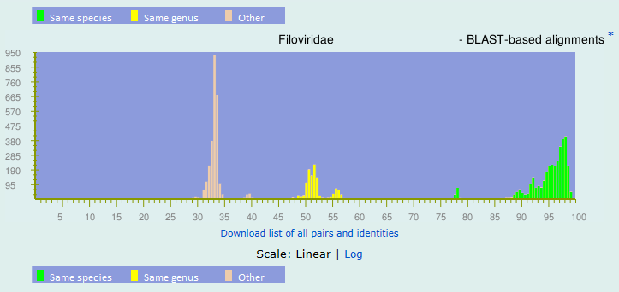

Top matches for gi|1214737037|gb|MF319185.1|
BLAST-based alignments
1 |  | 100% |  | gi|1473233420|ref|NC_039345.1| Ebolavirus|unclassified Ebolavirus|Bombali ebolavirus
2 |  | 99.14% |  | gi|1214737047|gb|MF319186.1| Ebolavirus|unclassified Ebolavirus|Bombali ebolavirus
3 |  | 53.04% |  | gi|499104232|gb|KC545393.1| Ebolavirus|Bundibugyo ebolavirus
4 |  | 52.88% |  | gi|302315369|ref|NC_014372.1| Ebolavirus|Tai Forest ebolavirus
5 |  | 52.83% |  | gi|1237087244|gb|MF599516.1| Ebolavirus|Zaire ebolavirus
6 |  | 52.83% |  | gi|1237087254|gb|MF599517.1| Ebolavirus|Zaire ebolavirus
7 |  | 52.82% |  | gi|1237087300|gb|MF599522.1| Ebolavirus|Zaire ebolavirus
8 |  | 52.8% |  | gi|1237087157|gb|MF599507.1| Ebolavirus|Zaire ebolavirus
9 |  | 52.79% |  | gi|1237087177|gb|MF599509.1| Ebolavirus|Zaire ebolavirus
10 |  | 52.79% |  | gi|1237087147|gb|MF599506.1| Ebolavirus|Zaire ebolavirus
11 |  | 52.66% |  | gi|973431317|gb|KU296327.1| Ebolavirus|Zaire ebolavirus
12 |  | 52.66% |  | gi|302371213|ref|NC_014373.1| Ebolavirus|Bundibugyo ebolavirus
13 |  | 52.63% |  | gi|33860540|gb|AY354458.1| Ebolavirus|Zaire ebolavirus
14 |  | 52.52% |  | gi|685509613|gb|KM519951.1| Ebolavirus|Zaire ebolavirus
15 |  | 52.52% |  | gi|973433588|gb|KU296628.1| Ebolavirus|Zaire ebolavirus

Together, these results indicate that BOMV is a representative of a novel ebolavirus species, here proposed to be named Bombali ebolavirus (named after Sierra Leona’s Bombali District, in which BOMV was discovered).

References:
Bào Y, Amarasinghe GK, Basler CF, Bavari S, Bukreyev A, Chandran K, Dolnik O, Dye JM, Ebihara H, Formenty P, Hewson R, Kobinger GP, Leroy EM, Mühlberger E, Netesov SV, Patterson JL, Paweska JT, Smither SJ, Takada A, Towner JS, Volchkov VE, Wahl-Jensen V, Kuhn JH. Implementation of Objective PASC-Derived Taxon Demarcation Criteria for Official Classification of Filoviruses. Viruses. 2017 May 11;9(5). pii: E106. doi: 10.3390/v9050106. PMID: 28492506.

Goldstein T, Anthony SJ, Gbakima A, Bird BH, Bangura J, Tremeau-Bravard A, Belaganahalli MN, Wells HL, Dhanota JK, Liang E, Grodus M, Jangra RK, DeJesus VA, Lasso G, Smith BR, Jambai A, Kamara BO, Kamara S, Bangura W, Monagin C, Shapira S, Johnson CK, Saylors K, Rubin EM, Chandran K, Lipkin WI, Mazet JAK. The discovery of Bombali virus adds further support for bats as hosts of ebolaviruses. Nat Microbiol. 2018 Oct;3(10):1084-1089. doi: 10.1038/s41564-018-0227-2. Epub 2018 Aug 27. PMID: 30150734.

