This form should be used for all taxonomic proposals. Please complete all those modules that are applicable.
For guidance, see the notes written in blue and the separate document “Help with completing a taxonomic proposal”

Please try to keep related proposals within a single document.

Part 1: TITLE, AUTHORS, etc

Code assigned: | 2017.016M |  |  |  | (to be completed by ICTV officers)
Short title: Taxonomic expansion and reorganization of the order Mononegavirales
Modules attached  (Modules 1, 4 and either 2 or 3 are required. |  | 1 2 3 4
Author(s):
Maes, Piet, piet.maes@kuleuven.be
Song, Timothy, timosong@gmail.com
Stenglein Mark, Mark.Stenglein@ColoState.edu
Janusz Paweska, januszp@nicd.ac.za
Qisheng Song, songq@missouri.edu
Gongyin Ye, chu@zju.edu.cn
Zhang, Yongzhen, zhangyongzhen@icdc.cn

and the ICTV Mononegavirales Study Groups:
Kuhn, Jens H., kuhnjens@mail.nih.gov
Dietzgen, Ralf G., r.dietzgen@uq.edu.au
Easton, Andrew J., A.J.Easton@warwick.ac.uk
Kurath, Gael, gael_kurath@usgs.gov
Nowotny, Norbert, Norbert.Nowotny@vu-wien.ac.at
Rima, Bertus K., b.rima@qub.ac.uk
Rubbenstroth, Dennis, Dennis.Rubbenstroth@uniklinik-freiburg.de
Vasilakis, Nikos, nivasila@utmb.edu
Walker, Peter, Peter.Walker@uq.edu.au

and the ICTV Nyamiviridae Study Group:
Dietzgen, Ralf G., r.dietzgen@uq.edu.au
Domier, Leslie L., ldomier@uiuc.edu
Ghedin, Elodie, Elodie.ghedin@nyu.edu
Jiang, Daohong, daohongjiang@mail.hzau.edu.cn
Kuhn, Jens H., kuhnjens@mail.nih.gov
Vasilakis, Nikos, nivasila@utmb.edu
Wang, David, davewang@borcim.wustl.edu
Corresponding authors with e-mail addresses:
Piet Maes, piet.maes@kuleuven.be
Jens H. Kuhn, kuhnjens@mail.nih.gov
List the ICTV study group(s) that have seen this proposal:
A list of study groups and contacts is provided at http://www.ictvonline.org/subcommittees.asp . If in doubt, contact the appropriate subcommittee chair (there are six virus subcommittees: animal DNA and retroviruses, animal ssRNA-, animal ssRNA+, fungal and protist, plant, bacterial and archaeal) |  |  | ICTV Bornaviridae, Filoviridae, Mononegavirales, Nyamiviridae, Paramyxoviridae, and Rhabdoviridae, Study Groups
ICTV Study Group comments (if any) and response of the proposer:
N/A
Date first submitted to ICTV: |  |  |  | June 8, 2017
Date of this revision (if different to above): |  |  |  | August 11, 2017

ICTV-EC comments and response of the proposer:
EC49 decision:
Uc: Add genome maps (or links); provide derivation of genus names; consider use of "-associated" in some species names.

Part 2: PROPOSED TAXONOMY
Name of accompanying spreadsheet: 2016.016M.N.v1.Mononegavirales_rev
Please display the taxonomic changes you are proposing on the accompanying spreadsheet module 2017_TP_Template_Excel_module. Submit both this and the spreadsheet to the appropriate ICTV Subcommittee Chair.

Part 4: APPENDIX: supporting material
As of 2017, the order Mononegavirales includes eight families and five unassigned genera (Adams et al., Amarasinghe et al.). From 2015 on, numerous mononega-like viruses (including the so-called “chŭviruses”) have been discovered in invertebrates, fungi, and plants (Fauver et al., Li et al., Longdon et al., Marzano et al., Shi et al.). The majority of these viruses have not been isolated in tissue culture, nor is much information available about them other than complete, coding-complete, or fragmented genomic sequences. The ICTV recently decided that viruses are classifiable based on coding-complete/complete genomic sequences alone (Simmonds et al.). Thus, we performed DEmARC/Bayesian MCMC analysis of all classified and unclassified mononegaviruses for which complete or coding-complete alignable genome sequences have been deposited into GenBank (see accompanying Excel spreadsheet). A dataset of all mononegavirus sequences was constructed with using complete RNA-dependent RNA polymerase (L) amino acid sequences and these sequences were aligned with MAFFT v7.123. Bayesian phylogenetic relationships were inferred in BEAST2 employing 10 independent MCMC runs with a chain length of 50,000,000 generations using full amino acid polymerase sequences. Tree and log files of independent runs of BEAST were combined using LogCombiner 2.4.5, employing a Burn-in period of 10%. Markov chain Monte Carlo analyses were run until effective sample sizes above 200 were obtained. A consensus tree was built with TreeAnnotator 2.4.5 using the maximum clade credibility method and visualized in FigTree v1.4.0. A DEmARC-mediated analysis of genomic variation (version 1.0) was used to set order-wide demarcation criteria for the different ranks. Only PED thresholds with a clustering cost of zero, CC=0 and monophyletic clustering under these thresholds in the Bayesian maximum clade credibility summary tree were retained.
The primary results of this analysis are shown in Figure 1 and confirmed a global RNA virus RdRp palm domain analysis (see co-submitted Phylum TaxoProp). They indicate that overall the past taxonomic decisions (establishment of the order with eight families) hold up. However, the resolution of the phylogeny increased significantly and several major taxonomic amendments are required:
- four new families need to be established. One of those families (“chŭviruses”) is proposed to also constitute a new order (“Jingchuvirales”, see co-submitted Phylum TaxoProp) because the genomic organization of “chŭviruses” is fundamentally different from all other viruses in the order Mononegavirales (all of which have genomes with the core structure 3´-N-P-M-G-L-5´);
- All five free-floating mononegaviral genera (Anphevirus, Arlivirus, Chengtivirus, Crustavirus, and Wastrivirus) can be assigned to families and some of them need to be merged; and
- the nyamiviral genus Peropuvirus needs to be moved into a new family.
Higher-resolution trees for the individual families are shown in Figures 2–7. We proposed each new family to be monogeneric including several novel species.

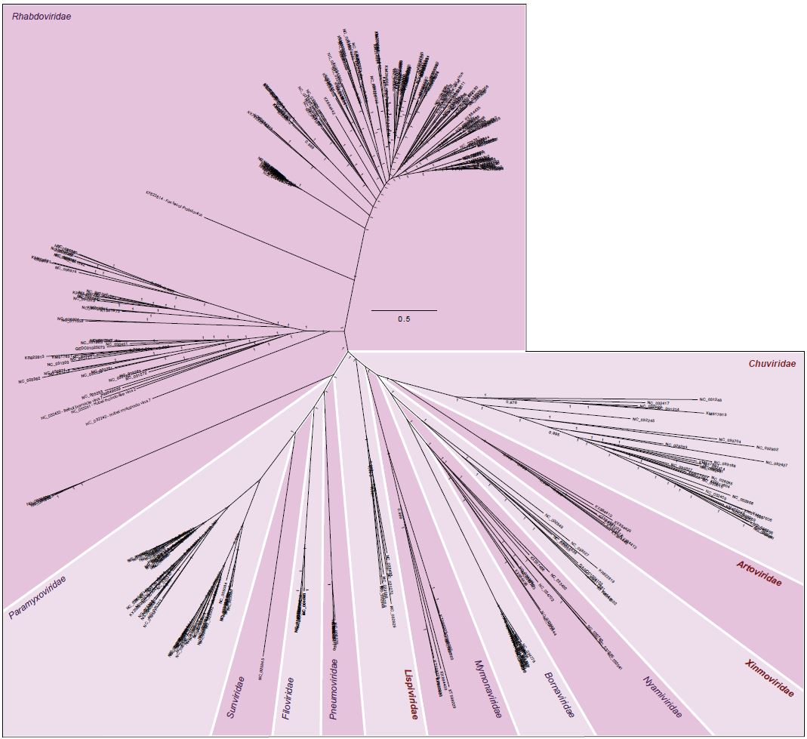
Figure 1. The order Mononegavirales and its sister order encompassing “chŭviruses”. New family-level taxa are depicted in red.

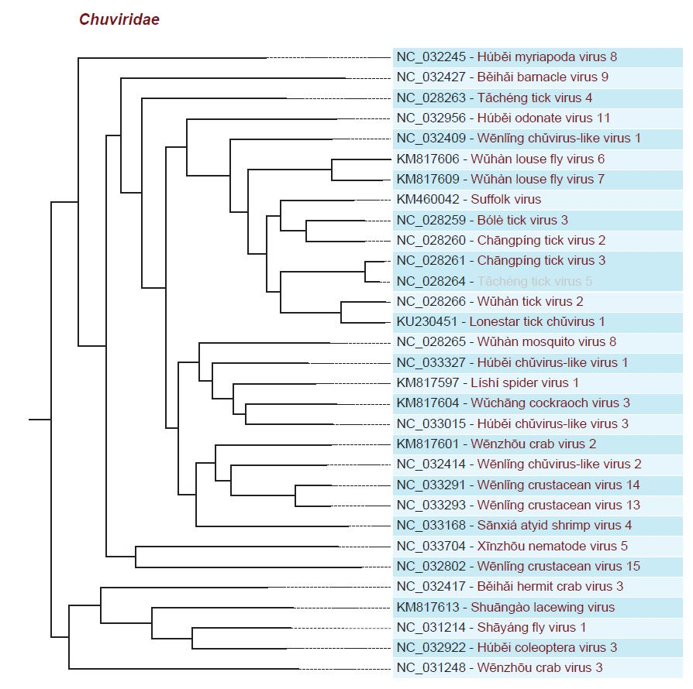

Figure 2. Proposed monogeneric family “Chuviridae” (included in the proposed order “Jingchuvirales”, see also co-submitted Phylum TaxoProp). Viruses that should be assigned to novel species are depicted red.

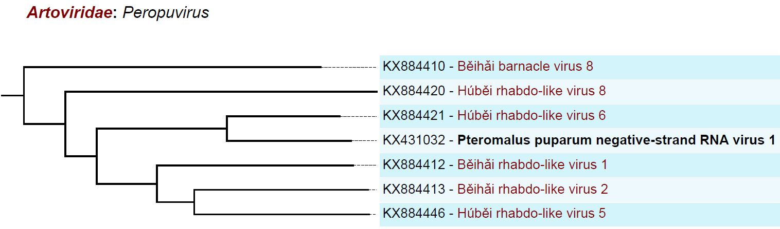
Figure 3. Proposed monogeneric family “Artoviridae” including the genus Peropuvirus (formerly Nyamiviridae). Viruses that should be assigned to novel species are depicted red.

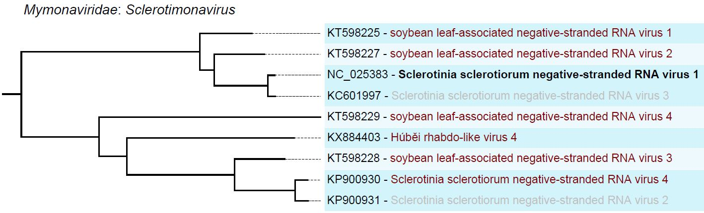
Figure 4. Existing monogeneric family Mymonaviridae. Viruses that should be assigned to novel species are depicted red.

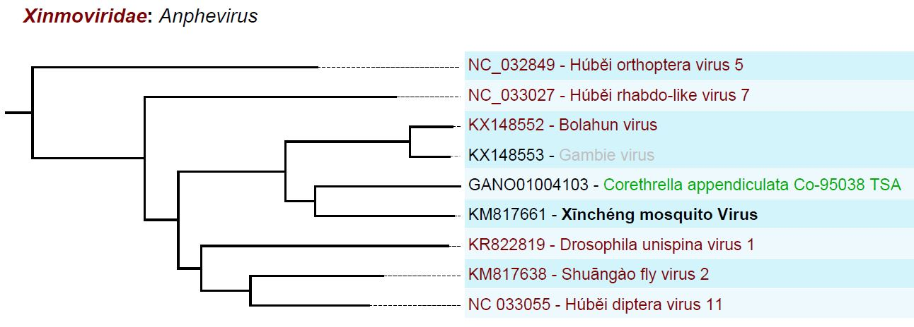
Figure 5. Proposed monogeneric family “Xinmoviridae” absorbing the previously free-floating genus Anphevirus. Viruses that should be assigned to novel species are depicted red. Green: “xīnmoviral” sequence from a transcriptional shotgun assembly (TSA) not yet proposed to represent a novel species (whether TSA-derived sequences are classifiable has yet to be discussed).

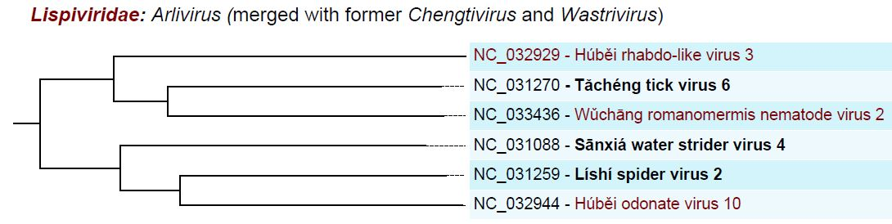
Figure 6. Proposed monogeneric family “Lispiviridae”, absorbing the previously free-floating genera Chengtivirus and Wastrivirus. Viruses that should be assigned to novel species are depicted red.

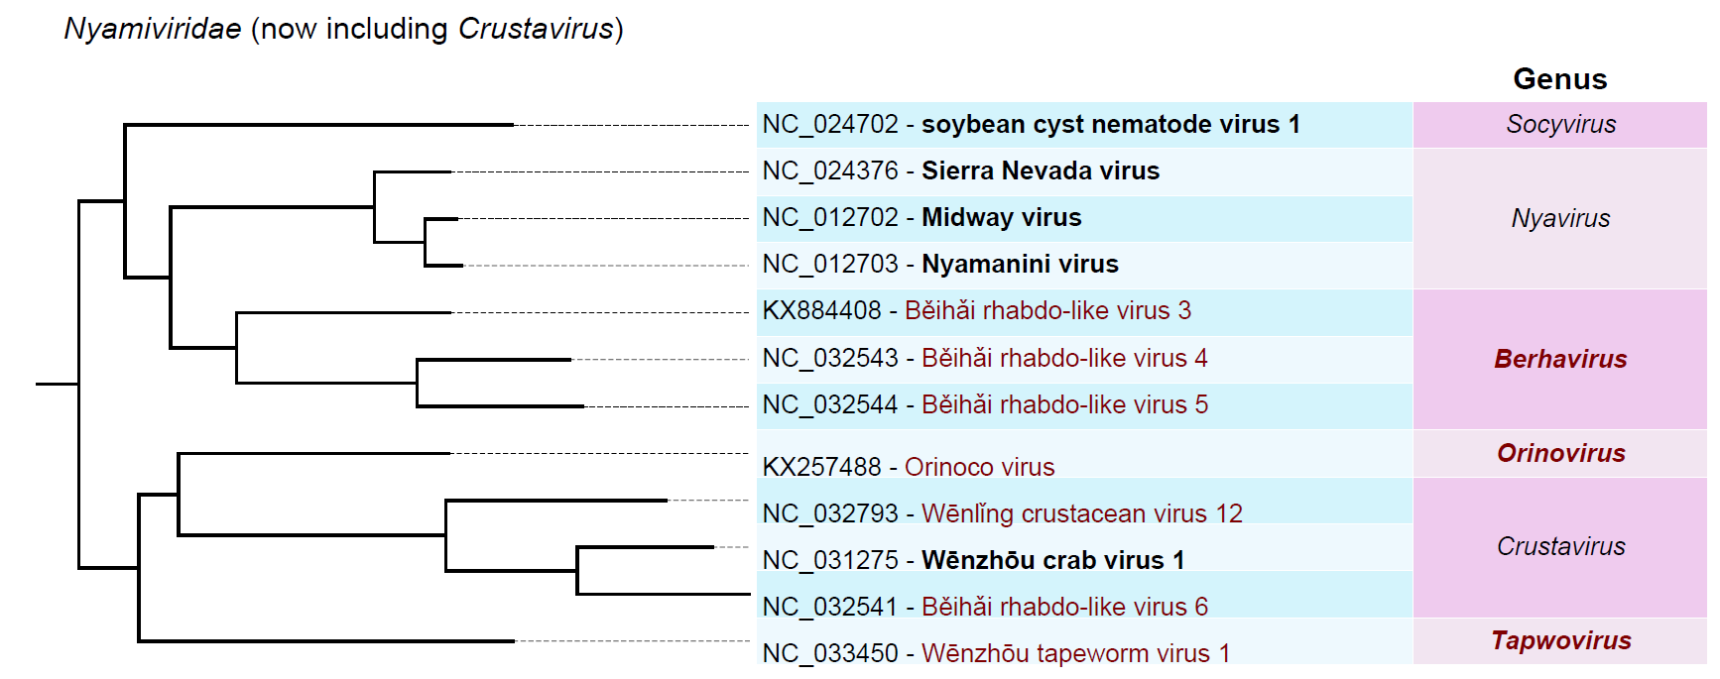
Figure 7. Existing family Nyamiviridae, absorbing the previously free-floating genus Crustavirus, expanded by three new genera (bold red), and reduced by one genus (Peropuvirus, moved into “Artoviridae”). Viruses that should be assigned to novel species are depicted red.

For genome maps of most viruses proposed to be classified here see Li et al. (https://elifesciences.org/articles/05378) and Shi et al.

Etymology of proposed genus and family names:
- Orinovirus: Orino: derived from Orinoco virus; virus: suffix for a genus
- Tapwovirus: Tapwo: sigil of Wēnzhōu tapeworm virus 1; virus: suffix for a genus
- Berhavirus: Berha: sigil of Běihǎi rhabdo-like virus 3; virus: suffix for a genus
- Xinmoviridae: Xinmo: sigil of Xīnchéng mosquito virus; viridae: suffix for a family
- Lispiviridae: Lispi: sigil of Lĭshì spider virus 2; viridae: suffix for a family
- Artoviridae: Arto: sigil of arthropod; viridae: suffix for a family

References:
Taxonomy of the order Mononegavirales: update 2017.
Amarasinghe GK, Bào Y, Basler CF, Bavari S, Beer M, Bejerman N, Blasdell KR, Bochnowski A, Briese T, Bukreyev A, Calisher CH, Chandran K, Collins PL, Dietzgen RG, Dolnik O, Dürrwald R, Dye JM, Easton AJ, Ebihara H, Fang Q, Formenty P, Fouchier RA, Ghedin E, Harding RM, Hewson R, Higgins CM, Hong J, Horie M, James AP, Jiāng D, Kobinger GP, Kondo H, Kurath G, Lamb RA, Lee B, Leroy EM, Li M, Maisner A, Mühlberger E, Netesov SV, Nowotny N, Patterson JL, Payne SL, Paweska JT, Pearson MN, Randall RE, Revill PA, Rima BK, Rota P, Rubbenstroth D, Schwemmle M, Smither SJ, Song Q, Stone DM, Takada A, Terregino C, Tesh RB, Tomonaga K, Tordo N, Towner JS, Vasilakis N, Volchkov VE, Wahl-Jensen V, Walker PJ, Wang B, Wang D, Wang F, Wang LF, Werren JH, Whitfield AE, Yan Z, Ye G, Kuhn JH.
Arch Virol. 2017 Apr 7. doi: 10.1007/s00705-017-3311-7. [Epub ahead of print]
PMID: 28389807

Changes to taxonomy and the International Code of Virus Classification and Nomenclature ratified by the International Committee on Taxonomy of Viruses (2017).
Adams MJ, Lefkowitz EJ, King AMQ, Harrach B, Harrison RL, Knowles NJ, KropinskiAM, Krupovic M, Kuhn JH, Mushegian AR, Nibert M, Sabanadzovic S, Sanfaçon H, Siddell SG, Simmonds P, Varsani A, Zerbini FM, Gorbalenya AE, Davison AJ.
Arch Virol. 2017 Aug;162(8):2505-2538. doi: 10.1007/s00705-017-3358-5. [Epub ahead of print]
PMID: 28434098

West African Anopheles gambiae mosquitoes harbor a taxonomically diverse virome including new insect-specific flaviviruses, mononegaviruses, and totiviruses.
Fauver JR, Grubaugh ND, Krajacich BJ, Weger-Lucarelli J, Lakin SM, Fakoli LS 3rd, Bolay FK, Diclaro JW 2nd, Dabiré KR, Foy BD, Brackney DE, Ebel GD, Stenglein MD.
Virology. 2016 Nov;498:288-99. doi: 10.1016/j.virol.2016.07.031. Epub 2016 Sep 15.
PMID: 27639161

Unprecedented genomic diversity of RNA viruses in arthropods reveals the ancestry of negative-sense RNA viruses.
Li CX, Shi M, Tian JH, Lin XD, Kang YJ, Chen LJ, Qin XC, Xu J, Holmes EC, ZhangYZ.
Elife. 2015 Jan 29;4. doi: 10.7554/eLife.05378.
PMID: 25633976

The evolution, diversity and host associations of rhabdoviruses.
Longdon B, Murray GGR, Palmer WJ, Day JP, Parker DJ, Welch JJ, Obbard DJ, Jiggins FM.
Virus Evol. 2015 Nov 13;1:vev014. doi: 10.1093/ve/vev014.

Novel mycoviruses discovered from metatranscriptomics survey of soybean phyllosphere phytobiomes.
Marzano SY, Domier LL.
Virus Res. 2016 Feb 2;213:332-42. doi: 10.1016/j.virusres.2015.11.002. Epub 2015 Nov 4.
PMID: 26547008

Identification of Diverse Mycoviruses through Metatranscriptomics Characterization of the Viromes of Five Major Fungal Plant Pathogens.
Marzano SY, Nelson BD, Ajayi-Oyetunde O, Bradley CA, Hughes TJ, Hartman GL, Eastburn DM, Domier LL.
J Virol. 2016 Jul 11;90(15):6846-63. doi: 10.1128/JVI.00357-16. Print 2016 Aug 1.
PMID: 27194764

Redefining the invertebrate RNA virosphere.
Shi M, Lin XD, Tian JH, Chen LJ, Chen X, Li CX, Qin XC, Li J, Cao JP, Eden JS, Buchmann J, Wang W, Xu J, Holmes EC, Zhang YZ.
Nature. 2016 Nov; 540(7634): 539–543. doi: 10.1038/nature20167. [Epub ahead of print]
PMID: 27880757

Consensus statement: Virus taxonomy in the age of metagenomics.
Simmonds P, Adams MJ, Benkő M, Breitbart M, Brister JR, Carstens EB, Davison AJ, Delwart E, Gorbalenya AE, Harrach B, Hull R, King AM, Koonin EV, Krupovic M, KuhnJH, Lefkowitz EJ, Nibert ML, Orton R, Roossinck MJ, Sabanadzovic S, Sullivan MB, Suttle CA, Tesh RB, van der Vlugt RA, Varsani A, Zerbini FM.
Nat Rev Microbiol. 2017 Mar;15(3):161-168. doi: 10.1038/nrmicro.2016.177. Epub 2017 Jan 3. Review.
PMID: 28134265

