Part 1:TITLE, AUTHORS, etc

Code assigned: | 2019.027M
Short title: Create three new species and rename two species in the genus Coltivirus, family Reoviridae
Author(s) and email address(es):
Yadav PD, Whitmer SLM, Sarkale P, Nyayanit DA, Lakra R, Anita Aich, Nichol ST, Mourya DT |  | hellopragya22@gmail.com; evk3@cdc.gov; prasadsarkale123@rediffmail.com; nyayanit.dimpal@gmail.com;  rajenlakra72@gmail.com;  anitaaich2008@gmail.com;  stn1@cdc.gov; dtmourya@gmail.com
Author(s) institutional address(es) (optional):
ICMR-National institute of Virology [PDY, PS, DAN, RL, AA, DTM]
Viral Special Pathogens Branch, Centers for Disease Control and Prevention [SLMW, STN]

Corresponding author
Mourya DT; dtmourya@gmail.com
List the ICTV study group(s) that have seen this proposal:
A list of study groups and contacts is provided at http://www.ictvonline.org/subcommittees.asp . If in doubt, contact the appropriate subcommittee chair (there are six virus subcommittees: animal DNA and retroviruses, animal ssRNA-, animal ssRNA+, fungal and protist, plant, bacterial and archaeal) |  | ICTV Reoviridae Study Group
ICTV Study Group comments (if any) and response of the proposer:
Date first submitted to ICTV: |  |  | June 19, 2019
Date of this revision (if different to above):

ICTV-EC comments and response of the proposer:

Part3: NEW SPECIES

Name of accompanying Excel module: 2019.027M.A.v1.Coltivirus_3newspren2sp.xlsx

A novel virus, named Kundal virus (KUNDV) was isolated from Hyalomma tick pools. This virus was characterized using electron microscopy, SDS-PAGE, and next-generation sequencing (NGS) methods. KUNDV inclusion bodies consisted of a granular matrix containing the inner capsid of the virion, morphology similar to viruses of the Reoviridae family. The SDS-PAGE analyses of KUNDV lead to retrieval of 12 nucleotide segments in length ranging from 4.3-0.6Kbps (Figure 1), characteristics similar to viruses of the reovirid Coltivirus genus [1]. Complete coding regions of KUNDV were obtained and deposited in the Genbank. The accession numbers of the sequences are MH327935; MH327936; MH327937; MH327938; MH327939; MH327940; MH327941; MH327942; MH327943; MH327944; MH327945; MH327946. Similarly, two new viruses were isolated from Duke of Abruzzi's free-tailed bats (Chaerephon aloysiisabaudiae) and Haemaphysalis flava ticks, named Taï Forest reovirus (TFRV) [2] and Tarumizu tick virus (TarTV) [3] respectively and have, characteristics similar to coltiviruses.
Using electron microscopy and NGS methods, nucleotide sequences of 10 segments of TFRV were obtained in length ranging from 4.3-0.9Kbps. The sequences were deposited by the authors in the Genbank with the accession number KX989543; KX989544; KX989545; MF511051; MF511052; MF511053; MF511054; KX989546; MF511055; MF511056 [2]. Electron microscopy, agarose gel electrophoresis and the NGS method lead to the retrieval of nucleotide sequences of 12 segments for the three different strains of TarTV ranging in length from 4.3-0.8Kbps. The sequences were deposited by the authors in Genbank under accession number LC275144; LC275145; LC275146; LC275147; LC275148; LC275149; LC275150; LC275151; LC275152; LC275153; LC275154; LC275155; LC275156; LC275157; LC275158; LC275159; LC275160; LC275161; LC275162; LC275163; LC275164; LC275165; LC275166; LC275167; LC275168; LC275169; LC275170; LC275171; LC275172; LC275173; LC2751754; LC275175; LC275176; LC275177; LC275178; LC275179 [3].
RNA-directed RNA polymerases encoded by VP1 genes in viruses belonging to the Reoviridae family have an amino acid identity greater than 26-33%. The newly characterized virus, KUNDV, has an RdRp amino acid identity in the range of 56.7-62.7% with respect to other reovirids. The amino acid identities for TFRV and TarTV range between 56.6-65.7% and 56.8-65.1% respectively, with other coltivirus members. Further, KUNDV and TarTV share a nucleotide identity in the range of 37.2-43.6%, and 46.3-50.4%, respectively in the conserved VP12 gene, which for coltiviruses is demarcation at >89%. The amino acid identities are also less for VP6, VP7, and VP12 (35.5%, 42.1%, and 31.4%) compared to the recommended species demarcation criteria in the genus. The amino acid identity for VP6 of TFRV ranges from 12.6-33.2%. The amino acid identities for VP6, VP7, and VP12 of TarTV range 12.1-35%, 5.7-26.4%, and 19.6-30.8% respectively. Reference VP1 gene sequences downloaded from Genbank and were used to perform the phylogenetic analysis. ClustalW algorithm, as implemented in the MEGA software version 7.0, was used to generate the alignment. A maximum-likelihood method using general time reversible model + Gamma+ I (GTR+G+I) substitution model and a bootstrap of 1000 replication to assess the statistical robustness were used to generate the evolutionary tree. The phylogenetic tree generated using the VP1 gene separates coltiviruses into two clusters [1]. Colorado tick fever virus (CTFV) and Eyach virus (EYAV) together form one cluster, whereas KUNDV, TFRV, and TarTV belong to a distinct clusters that demonstrate to have a different ancestral node compared to CTFV/EYAV clades (Figure 2). These data thus suggest that KUNDV, TFRV, and TarTV have characteristics distinct from currently classified coltiviruses and hence deserve to be the founding members of a new coltivirus species.

Supporting evidence:

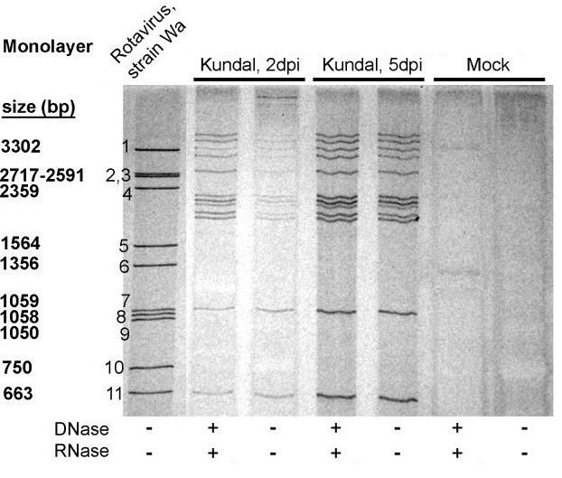
Figure 1: dsRNA segment lengths for Kundal virus. Cells were infected with Kundal virus [2 or 5 dpi] or mock-infected and unprotected nucleic acids from cell monolayers were digested with DNase and RNase, or left untreated. dsRNA from rotavirus, strain Wa, was added as a molecular marker (Figure adapted from [1]).

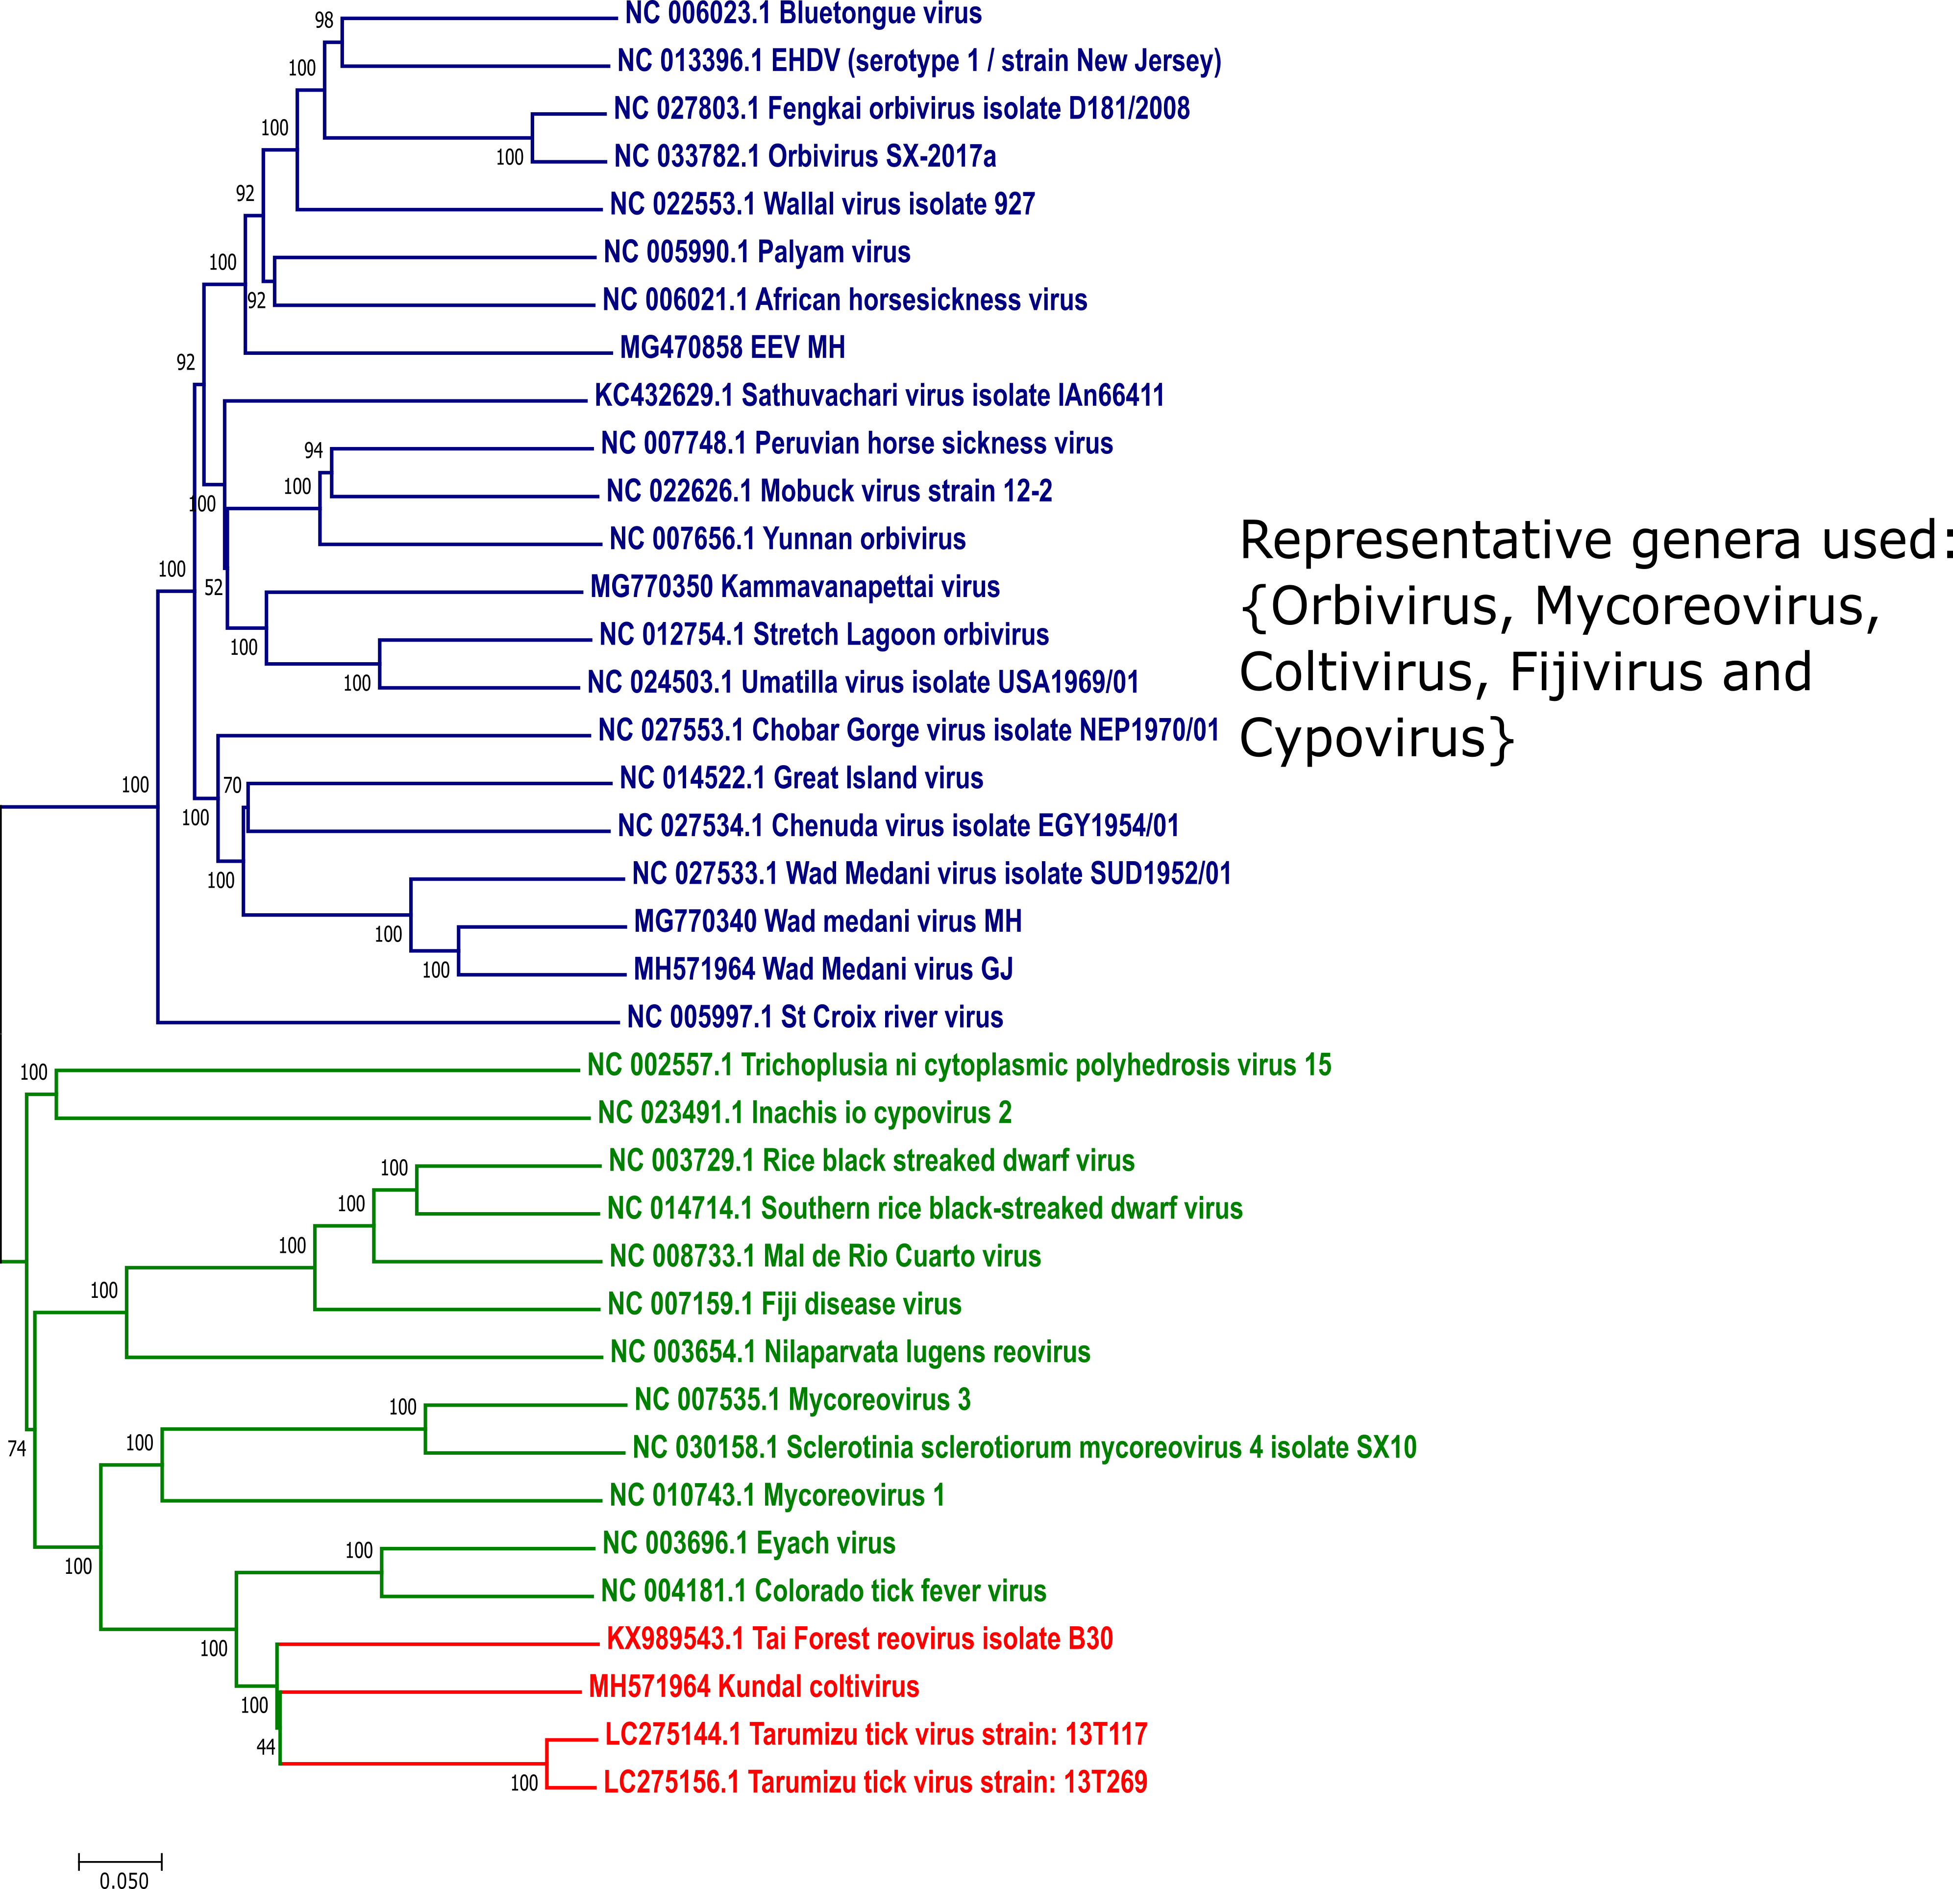
Figure 2 Phylogenetic analyses of members of the Reoviridae family using the polymerase (VP1) gene. The sequences of viruses belonging to Sedoreovirinae and Spinareovirinae subfamilies are depicted in blue color and green color, respectively. The KUNDV, TRFV and TarTV sequences are depicted in red color (Figure adapted from [1].

References:
1. Yadav PD, Whitmer SLM, Sarkale P, et al (2019) Characterization of Novel Reoviruses Wad Medani virus (Orbivirus) and Kundal (Coltivirus) collected from Hyalomma antolicum ticks in India during CCHF surveillance. Journal of Virology JVI.00106-19. https://doi.org/10.1128/JVI.00106-19
2. Weiss S, Dabrowski PW, Kurth A, et al (2017) A novel Coltivirus-related virus isolated from free-tailed bats from Côte d'Ivoire is able to infect human cells in vitro. Virol J. 18;14(1):181. doi: 10.1186/s12985-017-0843-0.

3. Fujita R, Ejiri H, Lim CK, et al (2017) Isolation and characterization of Tarumizu tick virus: A new coltivirus from Haemaphysalis flava ticks in Japan. Virus Res.15;242:131-140. doi: 10.1016/j.virusres.2017.09.017.

