This Word module should be used for all taxonomic proposals.
Please complete Part 1 and:
either Part 3 for proposals to create new taxa or change existing taxa
or Part 2 for proposals of a general nature.
Submit the completed Word module, together with the accompanying Excel module named in Part 3, to the appropriate ICTV Subcommittee Chair.
For guidance, see the notes written in blue, below, and the help notes in file Taxonomic_Proposals_Help_2018.
Part 1: TITLE, AUTHORS, etc

Code assigned: | 2018.009M |  | (to be completed by ICTV officers)
Short title: Five (5) new species in the genus Orthophasmavirus

Author(s):
Matthew J. Ballinger (mattball@uvic.ca)
Roy A. Hall (roy.hall@uq.edu.au)
Stanley A. Langevin (slangevi@uw.edu)
Alex Pauvolid-Corrêa (pauvolid@gmail.com)
Sandra Junglen (Sandra.junglen@charite.de)
Corresponding author with e-mail address:
Sandra Junglen (Sandra.junglen@charite.de)
List the ICTV study group(s) that have seen this proposal:
A list of study groups and contacts is provided at http://www.ictvonline.org/subcommittees.asp . If in doubt, contact the appropriate subcommittee chair (there are six virus subcommittees: animal DNA and retroviruses, animal ssRNA-, animal ssRNA+, fungal and protist, plant, bacterial and archaeal) |  | ICTV Phasmaviridae SG
ICTV Study Group comments (if any) and response of the proposer:
Date first submitted to ICTV: |  |  | June 6, 2018
Date of this revision (if different to above):

ICTV-EC comments and response of the proposer:

Part 3: PROPOSED TAXONOMY

Name of accompanying Excel module: 2018.009M.N.v1.Phasmavirus_5sp

Five new phasmaviruses have been found in various invertebrates (Shi et al., 2016; Makhsous et al., 2017; Schoonvaere et al., 2016). The coding complete genome sequences of these viruses have the same genome organization as those of classified phasmaviruses. Genetic and phylogenetic distances suggest that five novel phasmaviruses species have to be established for these viruses (Table 1 and Figure 1). The deduced amino acid sequences of the complete RdRp genes of the five viruses are at least 30% distant from any other described phasmavirus. Pairwise distances of the third conserved region of RdRp proteins range from 15-63% (see Table 1).

Supporting material:
additional material in support of this proposal
Species demarcation criteria have so far not been established for the family Phasmaviridae. We propose to use the same species demarcation criteria as for the other insect-associated bunyaviruses: jonviruses, feraviruses, herbeviruses, goukoviruses, and phasiviruses. Species demarcation criteria should be based on a ≈1 kb sequence fragment containing the core polymerase domain (premotif A to motif E) of the third conserved region of the L protein. These motifs can be aligned between all members of the order Bunyavirales and would allow comparative species demarcation criteria for all families and genera of the entire order. Moreover, as the motifs are highly conserved between all bunyaviruses, amplification of this genome region from new viruses is facilitated. Species demarcation criteria of other viral families are also based on the replicative genes/domains and have been shown to be suitable criteria.

Species should be defined on the criterion that the ≈1 kb sequence fragment containing the core polymerase domain (premotif A to motif E) of the third conserved region of the L protein should be less than 90% identical on the amino acid level compared to that of any other described phasmavirus.

This <90% aa identity threshold for the core polymerase domain is in agreement with the aa identity values for the so far established bunyavirus species within the established families and genera.

Table 1: Pairwise distances of phasmavirus RdRp proteins.

 | Culex orthophasmavirus | Wǔhàn mosquito virus 2 | Ganda orthophasmavirus | Wǔchāng cockroach virus 1 | Odonate orthophasmairus | Qingling orthophasmavirus | Wǔhàn mosquito virus 1 | Seattle orthophasmavirus | Kigluaik phantom virus | Nome phantom virus
Culex orthophasmavirus
Wǔhàn mosquito virus 2 | 15
Ganda orthophasmavirus | 44 | 43
Wǔchāng cockroach virus 1 | 44 | 43 | 35
Odonate orthophasmairus | 40 | 40 | 35 | 37
Qingling orthophasmavirus | 41 | 42 | 37 | 38 | 24
Wǔhàn mosquito virus 1 | 43 | 42 | 38 | 39 | 35 | 38
Seattle orthophasmavirus | 47 | 49 | 39 | 41 | 38 | 39 | 40
Kigluaik phantom virus | 40 | 39 | 42 | 41 | 40 | 41 | 37 | 45
Nome phantom virus | 46 | 54 | 55 | 52 | 55 | 47 | 51 | 56 | 53
Shuangao insect  virus 2 | 59 | 60 | 59 | 61 | 57 | 61 | 58 | 59 | 60 | 63

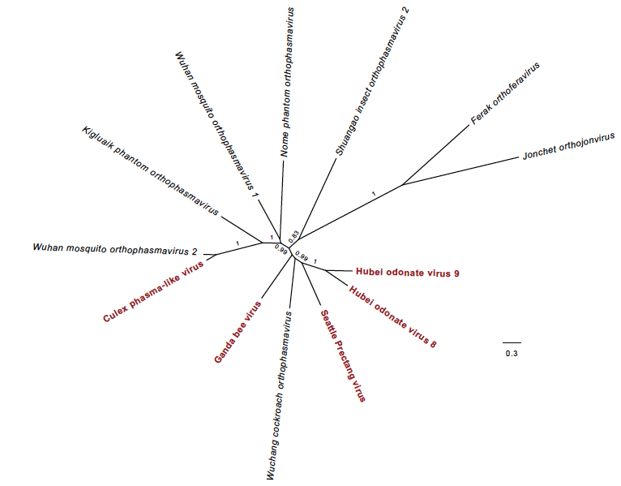

Figure 1. Phylogenetic relationships among phasmavirids and phasmavirid-like viruses
An unrooted maximum-likelihood phylogram constructed from an alignment of L protein amino acids. Tips are labeled with taxonomic classifications or assigned names for each taxon. Numbers labeling branches indicates SH-like support values or 0.8 or greater. Unclassified phasmavirid-like sequences are shown in red.

References:
Shi M, Lin X-D, Tian J-H, Chen L-J, Chen X, Li C-X, et al. Redefining the invertebrate RNA virosphere. Nature. 2016; 1–12. doi:10.1038/nature20167

Makhsous N, Shean RC, Droppers D, Guan J, Jerome KR, Greningera AL. Genome Sequences of Three Novel Bunyaviruses, Two Novel Rhabdoviruses, and One Novel Nyamivirus from Washington State Moths. Genome Announc. 2017;5. doi:10.1128/genomeA.01668-16

Schoonvaere K, De Smet L, Smagghe G, Vierstraete A, Braeckman BP, De Graaf DC. Unbiased RNA shotgun metagenomics in social and solitary wild bees detects associations with eukaryote parasites and new viruses. PLoS One. 2016;11. doi:10.1371/journal.pone.0168456

