This form should be used for all taxonomic proposals. Please complete all those modules that are applicable (and then delete the unwanted sections).
For guidance, see the notes written in blue and the separate document “Help with completing a taxonomic proposal”

Please try to keep related proposals within a single document; you can copy the modules to create more than one genus within a new family, for example.

MODULE 1: TITLE, AUTHORS, etc

Code assigned: | 2015.002aM |  | (to be completed by ICTV officers)
Short title: Two (2) new species in the genus Bornavirus
(e.g. 6 new species in the genus Zetavirus)
Modules attached  (modules 1 and 9 are required) |  | 1 2 3 4 5  6 7 8 9
Author(s) with e-mail address(es) of the proposer:
The ICTV Bornaviridae Study Group:
Rubbenstroth, Dennis | Chair | Germany | Dennis.Rubbenstroth@uniklinik-freiburg.de
Briese, Thomas | Member | USA | thomas.briese@columbia.edu
Duerrwald, Ralf | Member | Germany | Ralf.Duerrwald@idt-biologika.de
Horie, Masayuki | Member | Japan | mhorie@vet.kagoshima-u.ac.jp
Kuhn, Jens H. | Member | USA | kuhnjens@mail.nih.gov
Nowotny, Norbert | Member | Austria | NorbertNowotny@gmx.at
Payne, Susan | Member | USA | SPayne@cvm.tamu.edu
Schwemmle, Martin | Member | Germany | martin.schwemmle@uniklinik-freiburg.de
Tomonaga, Keizo | Member | Japan | tomonaga@virus.kyoto-u.ac.jp

and:
Krisztian Banyai, bkrota@hotmail.com
Yiming Bao, bao@ncbi.nlm.nih.gov

Szilvia Farkas, fszilvi@yahoo.com
Szilvia Marton, marton.szilvia@agrar.mta.hu

List the ICTV study group(s) that have seen this proposal:
A list of study groups and contacts is provided at http://www.ictvonline.org/subcommittees.asp . If in doubt, contact the appropriate subcommittee chair (fungal, invertebrate, plant, prokaryote or vertebrate viruses)

ICTV-EC or Study Group comments and response of the proposer:
Date first submitted to ICTV: | June 15, 2015
Date of this revision (if different to above):

MODULE 2: NEW SPECIES

creating and naming one or more new species.
If more than one, they should be a group of related species belonging to the same genus. All new species must be placed in a higher taxon. This is usually a genus although it is also permissible for species to be “unassigned” within a subfamily or family. Wherever possible, provide sequence accession number(s) for one isolate of each new species proposed.
Code | 2015.002aM |  |  | (assigned by ICTV officers)
To create 2 new species within:
Fill in all that apply.
- If the higher taxon has yet to be created (in a later module, below) write “(new)” after its proposed name.
- If no genus is specified, enter “unassigned” in the genus box.
Genus: |  | Bornavirus
Subfamily:
Family: |  | Bornaviridae
Order: |  | Mononegavirales
Name of new species: |  |  | Representative isolate: |  |  |  | GenBank sequence accession number(s)
Elapid 1 bornavirus  Psittaciform 2 bornavirus |  |  | Loveridge's garter snake virus 1 (LGSV-1) [ex RBV-1]  Parrot bornavirus 5 (PaBV-5) |  |  |  | KM114265  KR612223
Reasons to justify the creation and assignment of the new species:
- Explain how the proposed species differ(s) from all existing species.
  - If species demarcation criteria (see module 3) have previously been defined for the genus, explain how the new species meet these criteria.
  - If criteria for demarcating species need to be defined (because there will now be more than one species in the genus), please state the proposed criteria.
- Further material in support of this proposal may be presented in the Appendix, Module 9
Until early 2015 the family Bornaviridae consisted of one genus (Bornavirus) with a single species (Borna disease virus) originating from mammalian hosts. However, since 2008 several bornaviruses have been discovered in avian and reptilian hosts. Very recently, the taxonomy was adapted to this increased variability (see newest taxonomy release by the ICTV). The family remains mono-generic, but four new species (Passeriform 1 bornavirus, Passeriform 2 bornavirus, Psittaciform 1 bornavirus, Waterbird 1 bornavirus) were established to accommodate the majority of known avian bornaviruses. Furthermore, the species “Borna disease virus” was renamed “Mammalian 1 bornavirus”. Additional viruses, including the reptilian “Gabon viper virus 1” (“GaVV-1”), remain unclassified due to lack of sufficient biological and sequence data (Kuhn et al., 2015). Criteria for species demarcation are based on genomic characteristics, including PAirwise Sequence Comparison (PASC) (Bao et al., 2012, 2014), in combination with biological characteristics, such as antigenic relationship (Zimmermann et al., 2014) and natural host range (Kuhn et al., 2015). In agreement with these additional criteria, the range of the species differentiation cut-off for PASC of coding-complete genome sequences was defined as 71 to 75% (Kuhn et al., 2015).

By now, three new bornaviruses have been discovered, of which “parrot bornavirus 8” (PaBV-8) (Philadelpho et al., 2014) has to remain unassigned due to insufficient sequence data. “Avian bornavirus mallard” (“ABV-MALL”), was isolated from mallards (Anas platyrhynchos, order Anseriformes) in the USA (Guo et al., 2014) and a coding-complete genome of the isolate was deposited to GenBank (KJ756399). The highest nucleotide identity of this sequence is 72.9% to aquatic bird bornavirus 1 (species Waterbird 1 bornavirus), which is within the range of the previously defined species differentiation cut-off of 71 to 75%and above the maximal nucleotide identity between members of two established species, which is 71.0% between canary bornavirus 2 (CnBV-2, species Passeriform 1 bornavirus) and aquatic bird bornavirus 1 (ABBV-1, species Waterbird 1 bornavirus). The known host range of “ABV-MALL” is compatible with the host range of ABBV-1, the only member of species Waterbird 1 bornavirus, which has been detected in anseriform (geese and swans) (Guo et al., 2012; Payne et al., 2011) and charadriiform birds (Kuhn et al., 2015). Serological data for “ABV-MALL” is not available, but deduced amino acid sequence identities with ABBV-1 are similar to those of members of other species, suggesting a strong antigenic relationship (see attached Excel file). Phylogenetic analysis places both viruses on the same branch (Figures 2 & 3). Based on these data we propose adjusting the defined species differentiation cut-off to 72% nucleotide sequence identity and including “ABV-MALL” in the species Waterbird 1 bornavirus. We further suggest using “aquatic bird bornavirus 2” (ABBV-2) as the new designation of “ABV-MALL” (Table 2).

The third novel bornavirus, tentatively termed “reptile bornavirus 1” (“RBV-1”), was identified in a museum sample originating from a wild-caught Loveridge´s garter snake (Elapsoidea loveridgei) in Tanzania (Stenglein et al., 2014). No isolate of this virus exists, but the coding-complete genome sequence has been determined (KM114265). The nucleotide sequence identity of this genome to other bornavirus genomes is 58.2 to 59.6%, which is well below the defined species differentiation cut-off of 72%. Together with its origin from a reptile, rather than birds or mammals, establishment of a novel species is appropriate. The maximal nucleotide identity of the “RBV-1” genome is slightly lower than the minimal nucleotide identity between members of the established species included in the genus Bornavirus (62.0% between Borna disease virus 1 [BoDV-1] and parrot bornavirus 1 [PaBV-1]), which we think does not justify establishing a new genus for this virus without additional supporting data.
In summary, we propose affiliating “RBV-1” to a new species “Elapid 1 bornavirus” within the genus Bornavirus. To distinguish “RBV-1” from GaVV-1, which is likewise of reptilian origin, we suggest ”Loveridge´s garter snake virus 1” (LGSV-1) as the new virus designation (Kuhn et al., 2015).

Furthermore, very recently a coding-complete genome (KR612223) has been published for parrot bornavirus 5 (PaBV-5) (Marton et al., 2015). PaBV-5 had been discovered already in 2008 but remained unclassified due to lack of sufficient sequence information (Kuhn et al., 2015). PaBV-5 clusters separately from other known bornaviruses (Figure 2 & 3) and PASC analysis revealed the maximal identity of the PaBV-5 genome sequence with any known bornavirus genome to be below the species differentiation cut-off (68% to CnBV-2, species Passeriform 1 bornavirus). Thus we propose establishing the new species “Psittaciform 2 bornavirus” to accommodate PaBV-5.

MODULE 9: APPENDIX: supporting material

additional material in support of this proposal
References:
Bao, Y., Chetvernin, V., Tatusova, T., 2012. PAirwise Sequence Comparison (PASC) and its application in the classification of filoviruses. Viruses 4, 1318-1327.
Bao, Y., Chetvernin, V., Tatusova, T., 2014. Improvements to pairwise sequence comparison (PASC): a genome-based web tool for virus classification. Arch Virol 159, 3293-3304.
Guo, J., Covaleda, L., Heatley, J., Baroch, J., Tizard, I., Payne, S., 2012. Widespread avian bornavirus infection in mute swans in the Northeast United States. Vet. Med. Res. Rep. 3, 49-52.
Guo, J., Shivaprasad, H.L., Rech, R.R., Heatley, J.J., Tizard, I., Payne, S., 2014. Characterization of a new genotype of avian bornavirus from wild ducks. Virol. J. 11, 197.
Kuhn, J.H., Durrwald, R., Bao, Y., Briese, T., Carbone, K., Clawson, A.N., deRisi, J.L., Garten, W., Jahrling, P.B., Kolodziejek, J., Rubbenstroth, D., Schwemmle, M., Stenglein, M., Tomonaga, K., Weissenbock, H., Nowotny, N., 2015. Taxonomic reorganization of the family Bornaviridae. Arch. Virol. 160, 621-632.
Marton S., Banyai K., Gal J., Ihasz K., Kugler R, Lengyel G., Jakab F., Bakonyi T., Farkas S.L., 2015. Coding-complete sequencing classifies parrot bornavirus 5 into a novel virus species. Arch. Virol. (in press).
Payne, S., Covaleda, L., Jianhua, G., Swafford, S., Baroch, J., Ferro, P.J., Lupiani, B., Heatley, J., Tizard, I., 2011. Detection and characterization of a distinct bornavirus lineage from healthy Canada geese (Branta canadensis). J. Virol. 85, 12053-12056.
Philadelpho, N.A., Rubbenstroth, D., Guimaraes, M.B., Piantino Ferreira, A.J., 2014. Survey of bornaviruses in pet psittacines in Brazil reveals a novel parrot bornavirus. Vet. Microbiol. 174, 584-590.
Stenglein, M.D., Leavitt, E.B., Abramovitch, M.A., McGuire, J.A., DeRisi, J.L., 2014. Genome Sequence of a Bornavirus Recovered from an African Garter Snake (Elapsoidea loveridgei). Genome Announc 2.
Zimmermann, V., Rinder, M., Kaspers, B., Staeheli, P., Rubbenstroth, D., 2014. Impact of antigenic diversity on laboratory diagnosis of Avian bornavirus infections in birds. J. Vet. Diagn. Invest. 26, 769-777.

Annex:
Include as much information as necessary to support the proposal, including diagrams comparing the old and new taxonomic orders. The use of Figures and Tables is strongly recommended but direct pasting of content from publications will require permission from the copyright holder together with appropriate acknowledgement as this proposal will be placed on a public web site. For phylogenetic analysis, try to provide a tree where branch length is related to genetic distance.

Table 1. Sequences used for PASC analysis
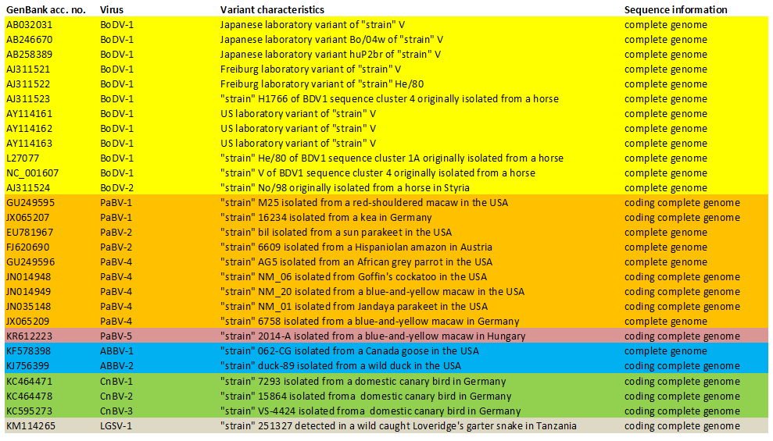

Figure 1. Histogram of Bornaviridae PASC analysis. Distribution of pairwise identities among complete sequences of 17 viruses in the family Bornaviridae. The histogram is colored as if the taxonomy proposed here was accepted by the ICTV and then adopted by NCBI. Peaks above 72% identity (green) represent genome pairs belonging to the same species. Peaks below 71% identity (yellow) represent genome pairs belonging to different species but the same genus. X-axis, percentage of identity; y-axis, number of genome pairs.
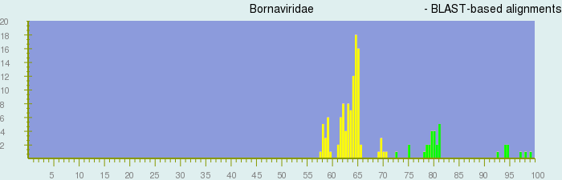
Table 2. Proposed classification and nomenclature of bornaviruses
Family  (name of taxon members) | Genus (name of taxon members) | Species | Virus (virus abbreviation)
Bornaviridae
(bornavirids, bornaviruses)
Bornavirus
(bornaviruses)
 |  | Mammalian 1 bornavirus
 |  |  | Borna disease virus 1 (BoDV-1)
 |  |  | Borna disease virus 2 (BoDV-2)
 |  | Psittaciform 1 bornavirus
 |  |  | parrot bornavirus 1 (PaBV-1)
 |  |  | parrot bornavirus 2 (PaBV-2)
 |  |  | parrot bornavirus 3 (PaBV-3)
 |  |  | parrot bornavirus 4 (PaBV-4)
 |  |  | parrot bornavirus 7 (PaBV-7)
 |  | Passeriform 1 bornavirus
 |  |  | canary bornavirus 1 (CnBV-1)
 |  |  | canary bornavirus 2 (CnBV-2)
 |  |  | canary bornavirus 3 (CnBV-3)
 |  | Waterbird 1 bornavirus
 |  |  | aquatic bird bornavirus 1 (ABBV-1)
aquatic bird bornavirus 2 (ABBV-2)
(ex “genotype ABV-MALL”)
 |  | Passeriform 2 bornavirus
 |  |  | estrildid finch bornavirus 1 (EsBV-1)
 |  | Psittaciform 2 bornavirus
 |  |  | parrot bornavirus 5 (PaBV-5)
 |  | Elapid 1 bornavirus
Loveridge´s garter snake virus 1 (LGSV-1)
(ex “Reptile bornavirus 1” [RBV-1])
 |  | tentative, unclassified bornaviruses
 |  |  | Gaboon viper virus 1 (GaVV-1)
 |  |  | munia bornavirus 1 (MuBV-1)
 |  |  | parrot bornavirus 6 (PaBV-6)
 |  |  | parrot bornavirus 8 (PaBV-8)
¹Type species is underlined.

red new virus, previously unclassified
blue previously classified, now unclassified in agreement with decisions of the ICTV Mononegavirales Study Group to classify only viruses of which at least one isolate and/or (coding-)complete genome sequences exist.

Figure 2. Phylogenetic tree of a 5,571 nt stretch coding for complete N, X, P, M, and G proteins and partial L proteins of 13 bornaviruses (corresponding to pos. 54 to 5,553 of BoDV-1 [U04608]). Phylogenetic neighbor joining analysis was conducted with Geneious 6.1.6. The evolutionary distances were computed using the Jukes-Cantor model. Bootstrap resampling analysis with 1,000 replicates was employed; percentages ≥70% are shown next to the branches.

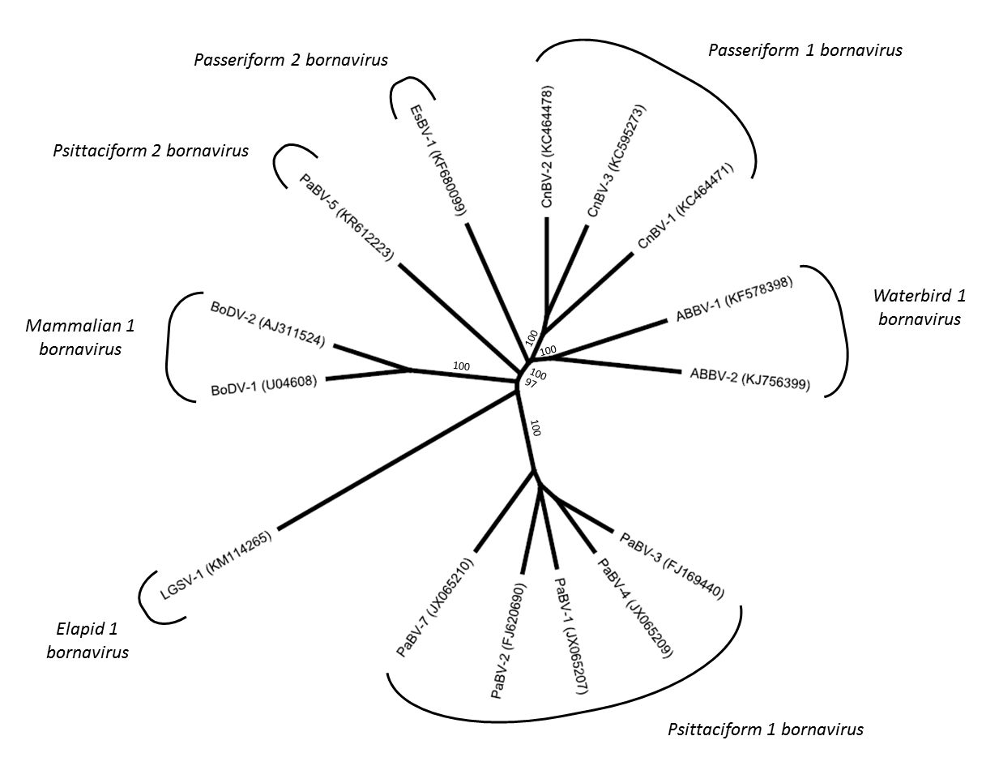

Figure 3. Phylogenetic tree of selected nucleotide sequences (A) or amino acid sequences (B) of the P protein gene of 17 bornaviruses. Phylogenetic neighbor joining analysis was conducted with Geneious 6.1.6. The evolutionary distances were computed using the Jukes-Cantor model. Bootstrap resampling analysis with 1,000 replicates was employed; percentages ≥70% are shown next to the branches. (*) Asterisks indicate bornaviruses not classified due to lack of sufficient sequence information.

(A)
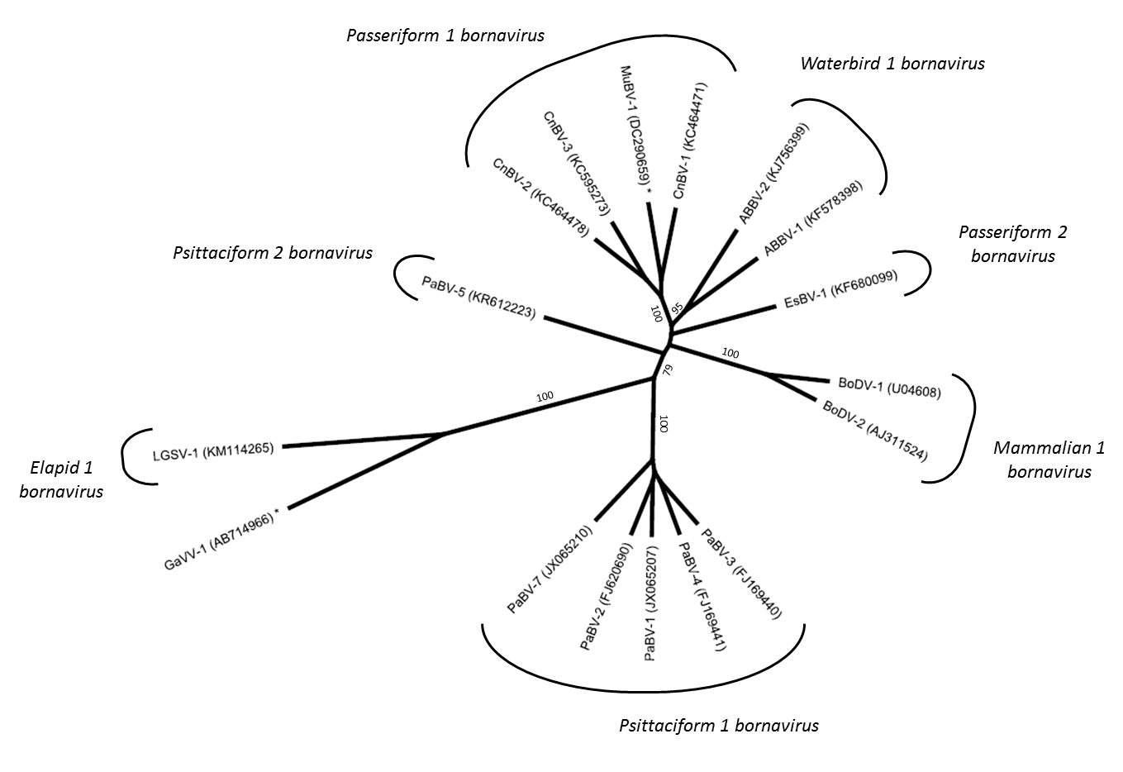

(B)
